Homework 3: AI Report Validation System
Name: Puchun Niu
Email: pn287@cornell.edu
Writing Component
For this homework, I built a validation system for AI-generated methane emissions reports. My use case is GreenFeed visit-level CH₄ data from feeder 453. Instead of asking an AI agent to read a large raw CSV, I first use Python to load the locally saved emissions file, keep the four fields needed for this analysis, and compute descriptive statistics. This made the workflow much faster and also made the report generation more controlled, because the AI receives a compact statistical summary rather than the full raw dataset.
The validation system is customized for methane report quality. I did not reuse the generic Module 9 Likert categories. Instead, I created a 0-10 rubric with four dimensions: statistical accuracy, emissions interpretation, decision support value, and transparency. These categories fit my report because I wanted to know whether a generated report used the methane statistics correctly, explained animal-level variation clearly, gave useful monitoring recommendations, and stated the evidence and limitations transparently.
I compared three prompt variants. Prompt A asked for a basic concise summary, Prompt B emphasized farm-management decision support, and Prompt C asked for deeper statistical interpretation. For each prompt, the system generated repeated reports and then used an AI reviewer to score each report against the custom rubric. I used the composite score, which averages the four validation dimensions, as the main outcome for comparing prompt quality.
In the current experiment, Prompt C had the highest mean composite score (9.25), followed by Prompts A and B. I ran a one-way ANOVA to compare composite scores across the prompt variants. The ANOVA result was F = 0.4375 with p = 0.665. This means the difference was not statistically significant at alpha = 0.05. The main challenge was that the AI reviewer scored most reports highly, so the scores had a narrow range. In a final larger experiment, I would increase the number of runs per prompt and make the validation rubric even stricter to produce more separation.
Git Repository Links
Validation system script: https://github.com/pcn287/Data-science-and-AI-for-system-engineering-SYSEN5381/blob/main/homework3/Multi-Agent.py
Validation criteria/rubric: https://github.com/pcn287/Data-science-and-AI-for-system-engineering-SYSEN5381/blob/main/homework3/validation_criteria.json
Validation scores: https://github.com/pcn287/Data-science-and-AI-for-system-engineering-SYSEN5381/blob/main/homework3/outputs/validation_scores.csv
ANOVA results: https://github.com/pcn287/Data-science-and-AI-for-system-engineering-SYSEN5381/blob/main/homework3/outputs/anova_results.json
Generated reports: https://github.com/pcn287/Data-science-and-AI-for-system-engineering-SYSEN5381/blob/main/homework3/outputs/generated_reports.csv
Prompt comparison plot: https://github.com/pcn287/Data-science-and-AI-for-system-engineering-SYSEN5381/blob/main/homework3/outputs/prompt_comparison_boxplot.png
Screenshots and Output Samples
The following output samples show the validation system in action. The script loads local data, computes descriptive statistics, generates reports from three prompt variants, validates each report, and runs ANOVA on the composite scores.
Sample Descriptive Statistics
- Feeder(s): [453]
- Unique animals: 73
- Date range: 2025-08-01 01:50:55 to 2025-11-01 11:33:00
**CH4 grams/day overall:**
- count=1802, mean=307.7279, median=295.2244, std=115.948
- min=11.9943, max=887.8266, range=875.8323
- Q1=225.3963, Q3=378.4608, IQR=153.0645
- P05=140.5163, P95=519.2436
- skewness=0.6198, kurtosis=0.6665, CV%=37.6787
**Top visitors:**
- 2710: 105 visits
- 2749: 91 visits
- 2502: 78 visits
- 2247: 71 visits
- 2708: 69 visits
- 2264: 67 visits
Validation Score Summary
prompt_variant | count | mean | std | min | max
A_basic_summary | 3 | 9.5 | 0.5 | 9.0 | 10.0
B_decision_support | 3 | 9.417 | 0.289 | 9.25 | 9.75
C_statistical_depth | 3 | 9.25 | 0.0 | 9.25 | 9.25

ANOVA Output
test | F statistic | p-value | best prompt | significant at 0.05
one-way ANOVA | 0.4375 | 0.664715 | A_basic_summary | False
A_basic_summary had the highest mean validation score. The prompt differences are not statistically significant at alpha = 0.05.
Prompt Comparison Boxplot
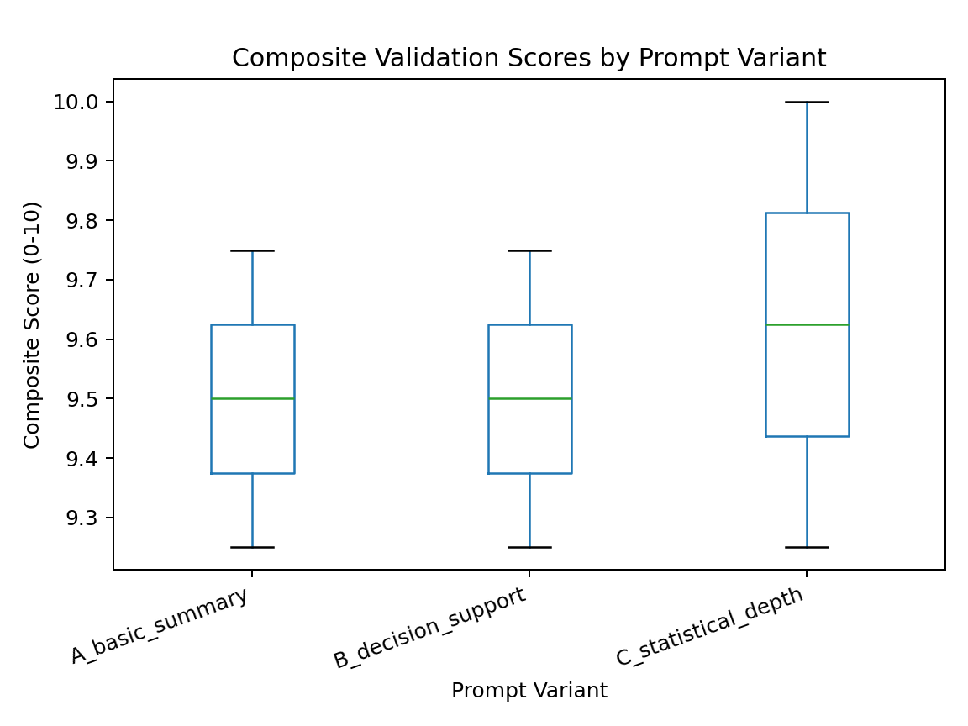
Validation Criteria Table
Dimension | Description | Scale | Benchmark
statistical_accuracy | Correctly uses the provided descriptive statistics without inventing values. | 0-10 integer; 0 = mostly incorrect, 10 = all key numbers are accurate. | Report should cite mean, median, spread, and high-emitter evidence accurately.
emissions_interpretation | Explains what the CH4 statistics mean for methane emissions and animal variation. | 0-10 integer; 0 = no interpretation, 10 = clear domain-specific interpretation. | Report should explain central tendency, variability, skew/outliers, and animal heterogeneity.
decision_support_value | Provides actionable insight for monitoring, management, or mitigation decisions. | 0-10 integer; 0 = no actionability, 10 = directly useful recommendations. | Report should identify useful monitoring priorities, not just summarize numbers.
transparency | Makes clear what data were used, what statistics mean, and what limitations exist. | 0-10 integer; 0 = opaque, 10 = transparent scope, evidence, and limitations. | Report should mention local visit-level data, feeder scope, and uncertainty/limits.
These criteria differ from the lab's generic Likert scores because they are tailored to methane emissions reports and use a 0-10 scale. The rubric checks whether the report is statistically accurate, interprets CH4 emissions meaningfully, supports management decisions, and explains its scope and limitations.
Experimental Design
The experiment compared three prompt variants for generating methane report interpretations from the same descriptive statistics.
Prompt A_basic_summary: concise homework-style summary.
Prompt B_decision_support: farm-manager decision support focus.
Prompt C_statistical_depth: more detailed statistical interpretation.
The current run collected two validation scores per prompt variant, for six total validated reports. The script can be rerun with a larger sample size using `py homework3/Multi-Agent.py --iterations 5`.
Validation Results
prompt_variant | run_id | statistical_accuracy | emissions_interpretation | decision_support_value | transparency | composite_score
A_basic_summary | 1 | 10 | 10 | 10 | 8 | 9.5
A_basic_summary | 2 | 10 | 10 | 10 | 10 | 10.0
A_basic_summary | 3 | 10 | 9 | 9 | 8 | 9.0
B_decision_support | 1 | 10 | 10 | 10 | 9 | 9.75
B_decision_support | 2 | 10 | 9 | 10 | 8 | 9.25
B_decision_support | 3 | 10 | 9 | 10 | 8 | 9.25
C_statistical_depth | 1 | 10 | 10 | 9 | 8 | 9.25
C_statistical_depth | 2 | 10 | 10 | 9 | 8 | 9.25
C_statistical_depth | 3 | 10 | 10 | 9 | 8 | 9.25
Statistical Analysis
Hypothesis: at least one prompt variant produces reports with a different mean validation score. I used one-way ANOVA because there were three prompt groups and one numeric outcome, the composite validation score.
The ANOVA produced F = 0.4375 and p = 0.664715. The best prompt by mean score was A_basic_summary. Because the p-value was greater than 0.05, I do not reject the null hypothesis for this small experiment. The practical interpretation is that the statistically detailed prompt looked strongest in the sample, but the evidence is not strong enough to claim a significant difference.
System Design and Technical Details
Main script: homework3/Multi-Agent.py
Local data file: homework3/emissions_visits_fid453_20260204_162120.csv
Rubric file: homework3/validation_criteria.json
Output folder: homework3/outputs/
Required packages: pandas, openai, python-dotenv, scipy, matplotlib
Required environment variable: OPENAI_API_KEY
Usage Instructions
Install dependencies:
py -m pip install -r homework3/requirements.txt
Run a quick test:
py homework3/Multi-Agent.py --iterations 1
Run a larger experiment:
py homework3/Multi-Agent.py --iterations 5

