Data Science and AI for Systems Engineering: APIs, Apps, and Analytics for Cloud Systems
Name: Puchun Niu
Email: pn287@cornell.edu
Homework 2: AI Agent System with RAG and Tools
Writing Component:
This project is a small two-agent workflow for analyzing GreenFeed methane and carbon dioxide data. The first part of the script handles data collection and cleanup: it tries to pull visit records from the C-Lock API, and if that fails it falls back to a local CSV so the analysis can still run. After loading, it formats dates, keeps the important fields, and applies a retrieval rule so we only keep animal-days with enough visits (I used a minimum-visit threshold). That gives a cleaner subset for analysis and avoids building conclusions from very sparse days.
The second part is the reporting/modeling stage. Agent 1 prepares a compact context object (rag_payload) that includes summary statistics, per-animal aggregates, and a small sample of rows. Agent 2 then uses that context to write the narrative report, and when CO2 is available it calls a Python tool that fits a linear mixed model (CH4 ~ CO2 with random intercepts by animal). The model output is passed back into the report step, so the final output is not just descriptive tables but also an interpretable statistical relationship. If the API key is missing or the model call fails, the script still returns a deterministic fallback report so the pipeline does not break.
A few design choices were important in practice. First, I separated retrieval/filtering from language generation so the LLM sees a controlled, documented subset instead of raw full data every time. Second, I capped LMM observations to keep runtime and token usage reasonable. Third, I had to handle noisy console output from statsmodels (repeated convergence/singularity warnings), so I reduced that to one concise message while still printing the model summary itself. The main challenge was balancing transparency and readability: I wanted enough output to show what each step did (Agent 1, RAG, Agent 2, function call) without flooding the terminal with debug text.
Git Repository Links:

Screenshots/Outputs:
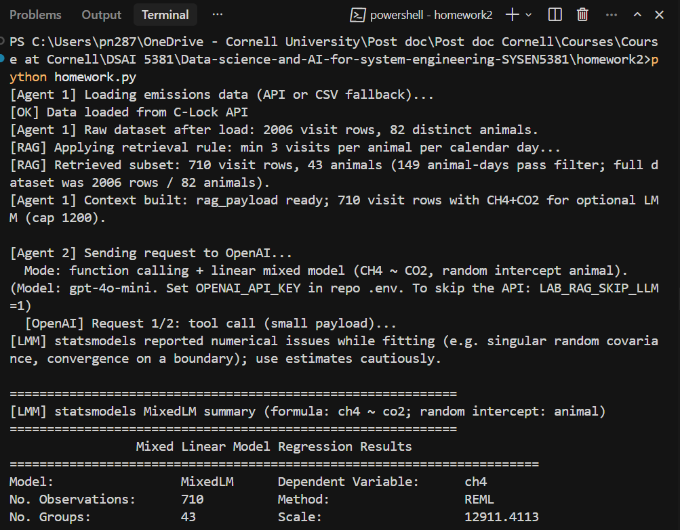
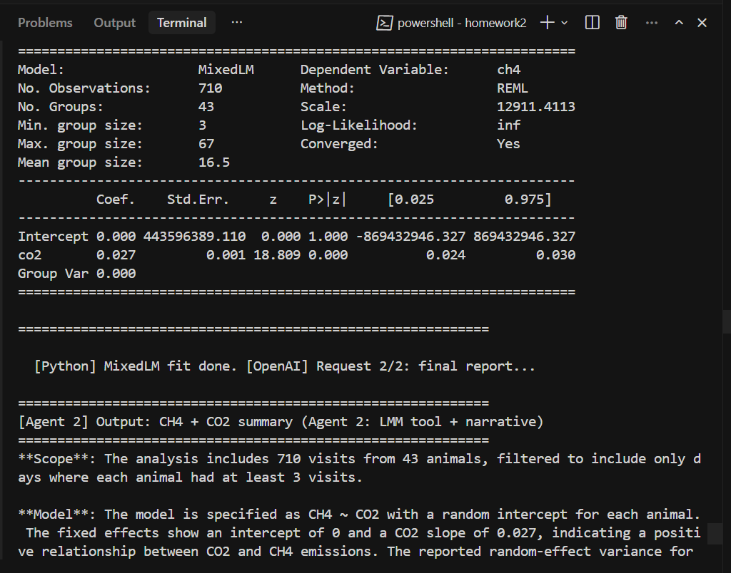
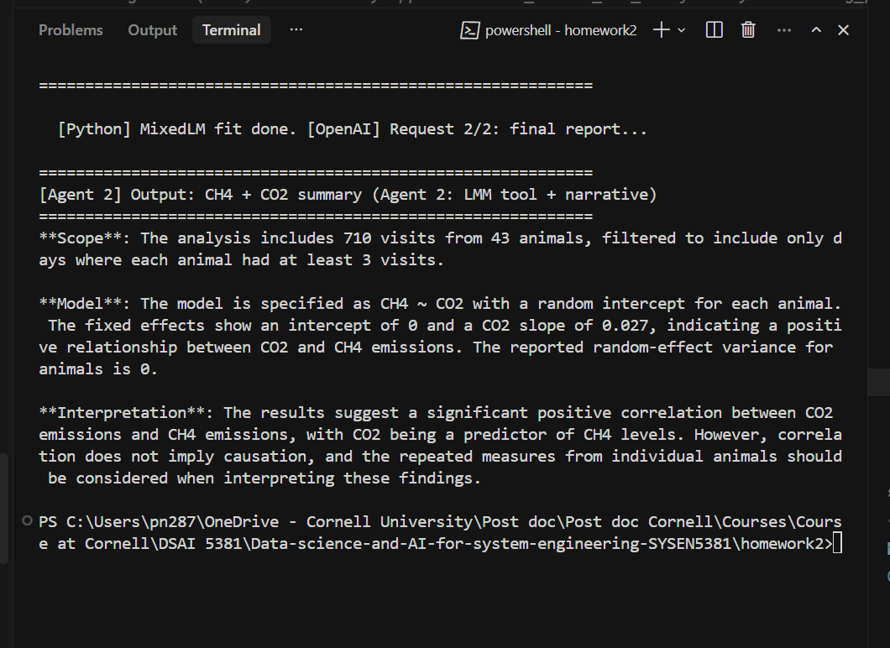

Documentation:
Please find description workflow, technical details and usage instructions in on github.

