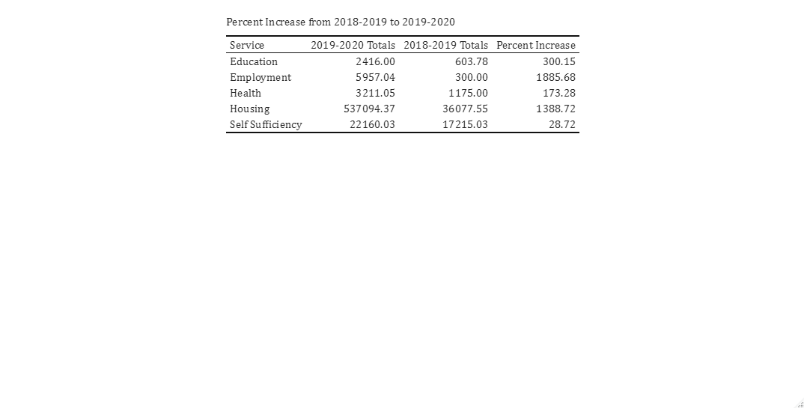

CSBG saw an increase in all programs service cost provided from fiscal year 2018-2019 to fiscal year 2019-2020, the largest of which was in Employment services which saw a 1885.7% increase. The smallest was in Self Sufficiency which increased 28.72%.

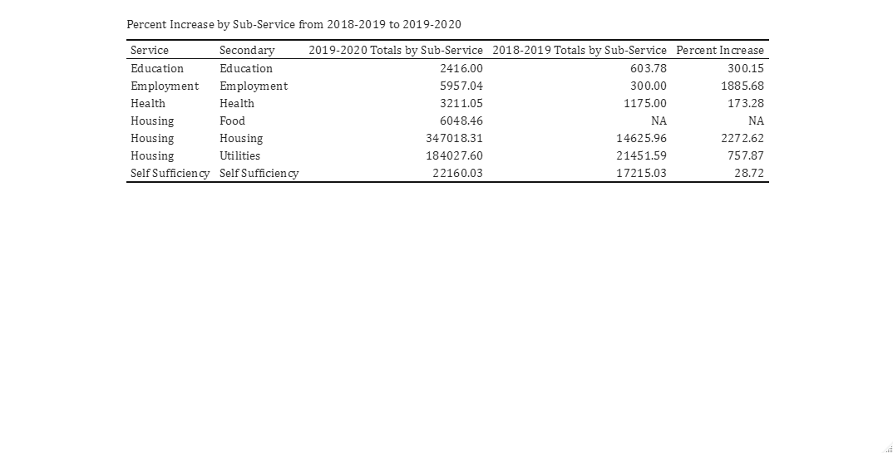

When looking at the types of services provided, the largest percent increase was in Housing services for Rent/Mortgage Payments, with a 2272.6% increase in activity service cost provided.

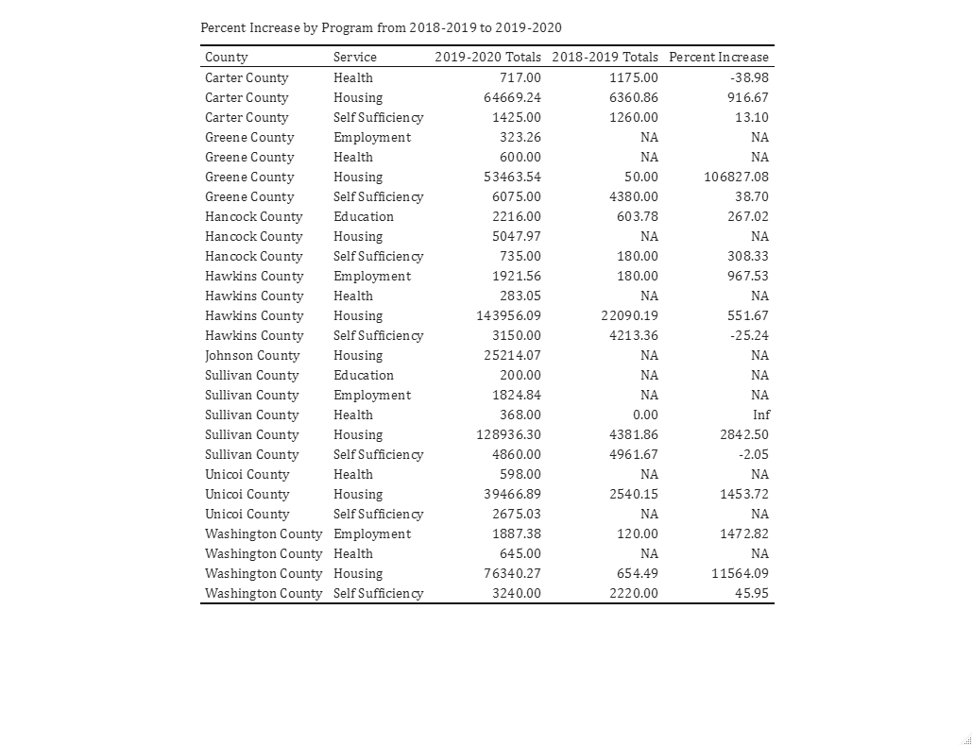

When broken down by County, the largest percent increase from Fiscal Year 2018-2019 to Fiscal Year 2019-2020 was in Greene County Housing, with over 100,000% increase in Activity Service Cost Provided. Carter County Health, and Sullivan and Hawkins County Self Sufficiency were the only programs that saw a decrease in Activity Service Cost Provided.

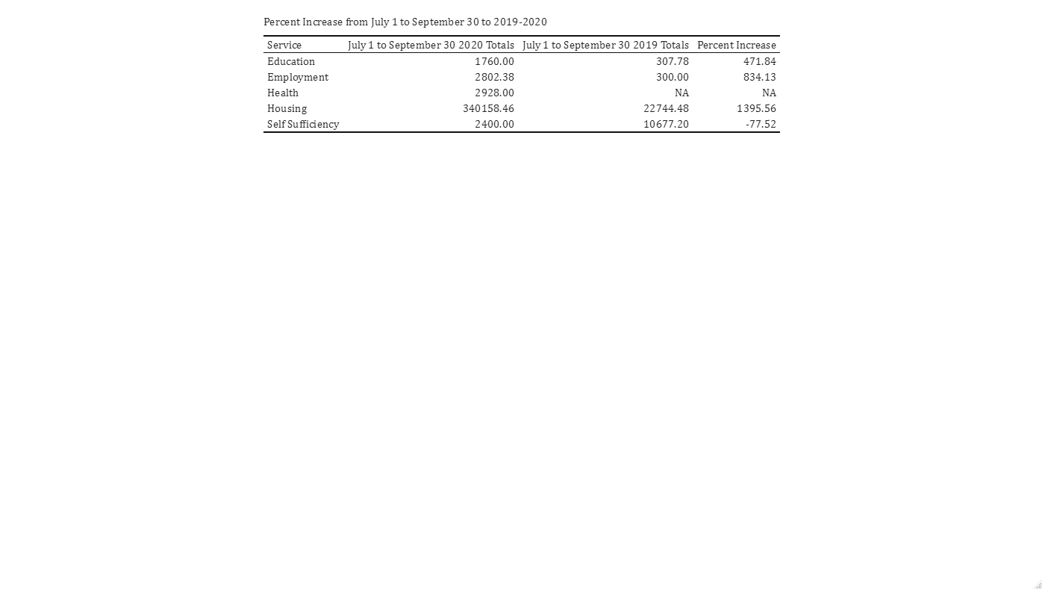

From July 1-September 30 2019 to July 1-September 30 2020, all programs saw an increase in Activity Service Cost Provided with the exception of Self Sufficiency, with decreased by 77.5%. Housing saw the largest increase with 1395.6%.

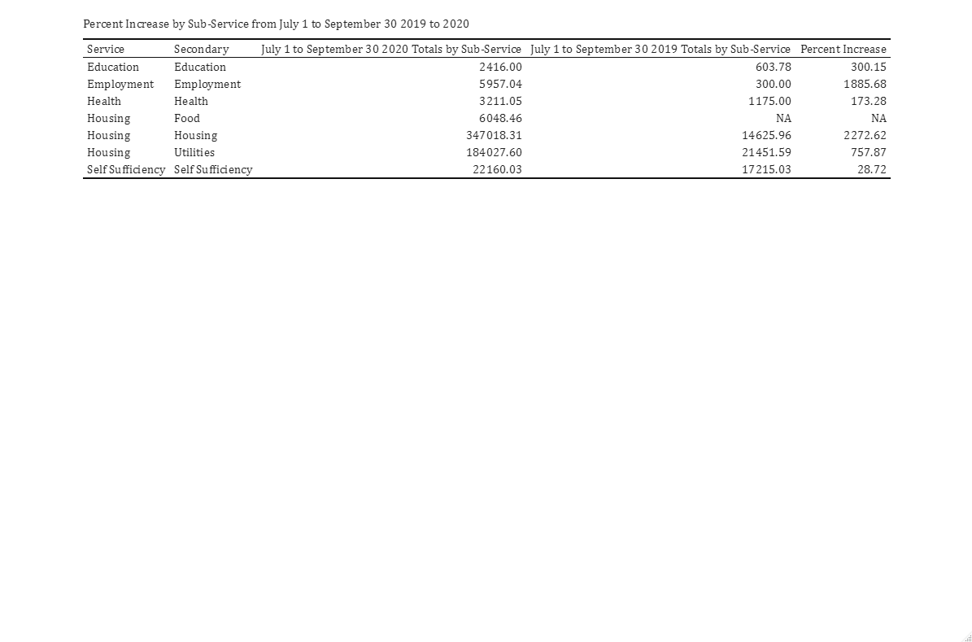

All programs saw an increase in Activity Service Cost Provided during this time period, with the largest coming from Housing involving Rent/Mortgage Payments, which saw a 2272.6% increase.

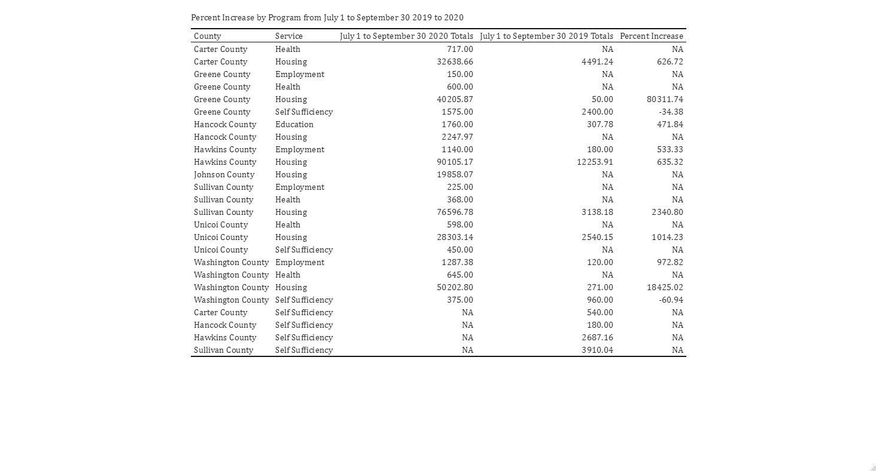

When broken down by County, the largest percent increase in Service Type from July 1-September 30 2019 to July 1-September 30 2020 was in Greene County Housing involving Rent/Mortgage Payments, with an increase of over 80,000%. Only two County Program Services saw a decrease, Greene County and Washington County Self-Sufficiency with -34.4% and -60.9% respectively.

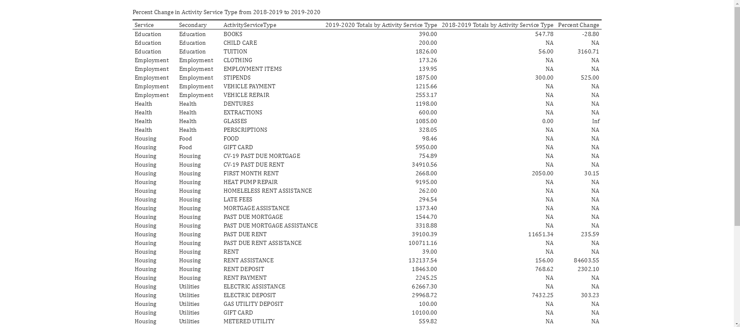

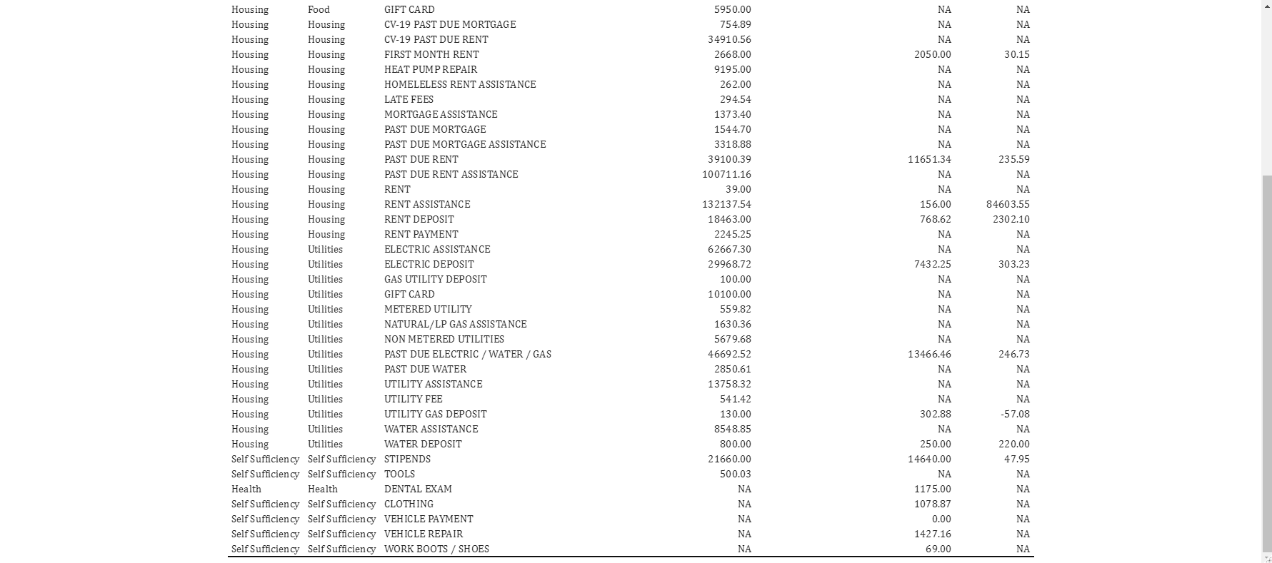

Included this for completeness, the percentage increases don’t match up well because of the changes in programs/program names, but the totals are there if you need them.