First, download the script ,startup.sh ,from https://github.com/pcollins2USI/SoftwareDevCS483.git
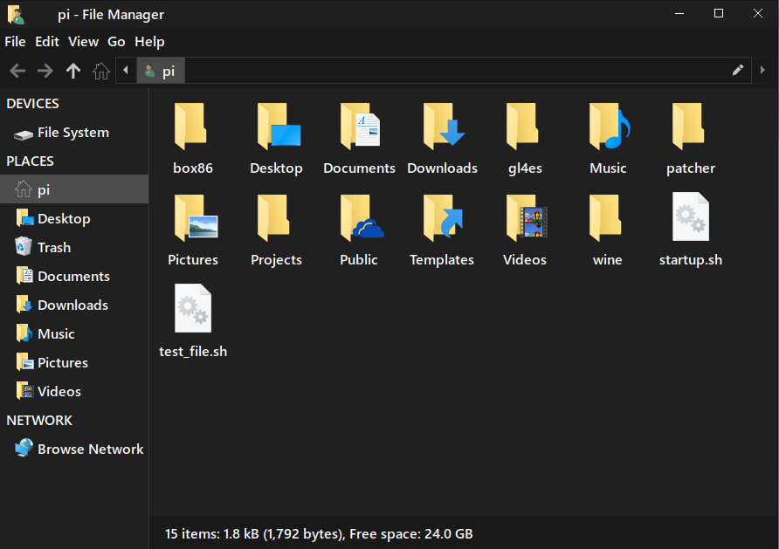
Second, open terminal and the command, “sudo bash ~/startup.sh”
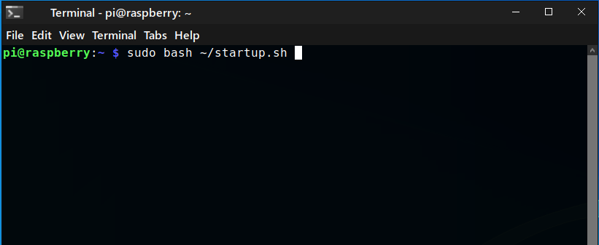

After following the prompts, the script will create, start the startup services, and reboot the pi. It also checks if “onboard” is installed and if not it installs it. If you resize onboard it will be remembered on next boot. You will have to configure onboard and the theme shown in the image below is called “Blackboard”.
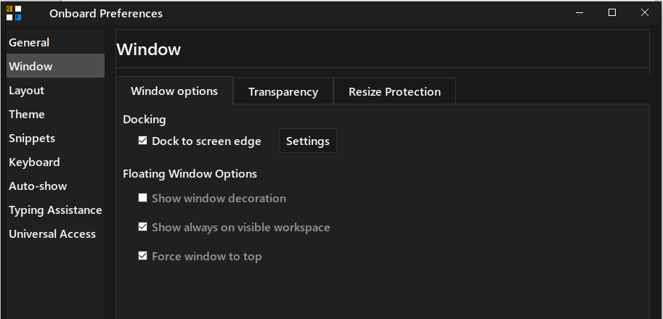
The result of the script are shown in the last image at startup.
