Modeling notes: bearded seals

**Multivariate normal vs. univariate normal**

The multivariate normal in log space seems to have issues converging. Working in log space can also result in issues, particularly for UDs where expectations can be really low and then we’re taking the log of a very small number. The log of zero is… well, negative infinity.

On the other hand, using univariate normal tends to really overinflate precision.

**Objective function types**

Weighted least squares estimation tends to be a lot more stable, particularly when there is an upper bound set for weights (i.e., instead of using unbounded 1/Variance calculations). However, it appears that abundance estimates might be negatively biased using this approach, and that we are *considerably* underpredicting large abundance values. Perhaps this is because it penalizes large deviations more when applied on the real scale? Bias seems to be slightly worse with iterative reweighting, which places higher weight on the UD objective function. It may be worth experimenting with e.g., count data only, as N should be estimable from those data alone (one would think!) – different objective functions might be compared.

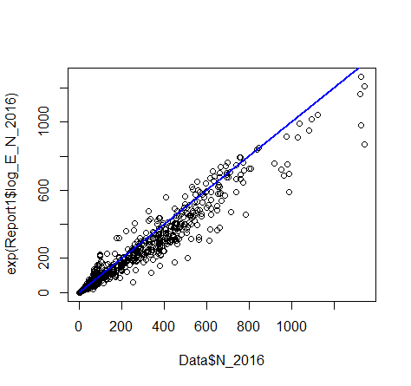

**Experiment 1: turn off everything but aerial survey data**

For this one, I first set likelihood components to other data sources to zero for fit_bearde_sim_aerial_only.cpp, and fixed Beta_acc to zero in sim_estimate_integrated_model_est_aerial_only.R. 10 simulations had a mean abundance estimate of 477K (truth = 500K), with SE of mean = 6000. So, clearly negatively biased.

**Experiment 2: turn off everything but aerial survey data, fix aerial survey estimates to true values**

N-hat: 520,622. Strange!! ???

**Experiment 3: Set beta’s to true values, compare expected abundance to true values**

Okay, so estimated abundance is 514,611 when beta’s set to true values!

TRACKED DOWN ERROR: WRONG TIME INDEX FOR CHUKCHI AERIAL SURVEYS IN .CPP!! Getting correct values now.

**Experiment 1b: turn off everything but aerial survey data fixing time stamp error.**

Now we’re trying to isolate whether there’s something inherently biased in our inference procedure, which currently uses weighted least squares on the real scale. Results of 10 simulations: N_hat (mean) = 461K, SD(mean) = 6K so clear bias. Worse than before, but that’s because we solved the time stamp mismatch.

**Experiment 2b: turn off everything but aerial survey data, fix aerial survey estimates to true values**

N-hat = Truth!

**Experiment 1c: Check to make sure aerial survey estimates not persistently biased from truth**

Looks like aerial survey estimates are unbiased; on average 1.6% higher over 10 simulations. Note one (sim =8) Chukchi estimate was REALLY high; probably want to do some error trapping in a full blown simulation study to prevent these from impacting results.

**Experiment 4: Try Poisson likelihood**

Unbiased!

So, it appears that weighted least squares on the real scale is a poor choice for count data. Now, how would we handle iterative reweighting? I think the best idea would be to just use oversdispersion instead, which implicitly alters the contribution of the likelihood. For example, with lots of overdisperson there isn’t as much information about habitat effects… and this should be implicitly propagated into joint inference. Possibilities: negative binomial, iid Gaussian random effects on linear predictor.

**Experiment 5: Aerial + UD only**

Keeping the Poisson for aerial survey data for the moment, let’s add in the weighted sum of squares objective function for UDs and see what happens.

Estimates look okay, but total objective function components suggest aerial survey data may overwhelm the UD objective function…

**Experiment 6: Aerial + UD only, Tweedie for Aerial**

I thought maybe the Tweedie might be a good way to accommodate overdispersion for the count data – thereby downweighting the aerial survey component. But, estimates blow up when you do this – in a few cases they were in the 550K-600K range, but in 7/10 they were in the 1.0 x e^12 range. Looks like there’s a possibility that the ‘compromise fit’ is the aerial survey data not really fitting at all! This is probably not ideal.

**Experiment 7 - Aerial only, Tweedie for Aerial**

Now estimates are biased low (~400K, SE 10K). Looks like the mean structure is reduced to accommodate overdispersion…

**Experiment 8- Back to MVN, aerial only**

No convergence, terrible estimates

**Experiment 9- Univariate normal, aerial only**

Slightly biased low. N-hat-mean = 486K, SE(mean)=3600

**NOTE ON CHI_SQUARE**

This is probably not the thing to use, since low expectations (e.g. 0.000000001 animals) coupled with “high” predictions (e.g., 0.0001 animals) can result in ridiculously high chi-square summaries. Instead, maybe use z-scores and add extra/subtract variance until e.g. (Pr(abs(Z)>1.64) approx. 0.9).

**Experiment 10- Aerial & UD using univariate normal for Aerial, weighted least squares for UD**

Looks good

**Experiment 11- Kitchen sink**

Looks good.

**Experiment 12- Dirichlet model for UDs**

Next up I tried the Dirichlet for UDs since we’re dealing with simplexes and it’s a natural choice for that. In this case, I just used a Monte Carlo procedures similar to a Bayesian p-value to set the overall dirichlet weights. Basically, we have UD_observed ~ Dirichlet( Pi_st * wt_ud). So wt_ud controls the overall variance of the Dirichlet. Then we compare SSQ(UD_observed, Pi_st) with a distribution for SSQ(data_rep,Pi_st) where data_rep is simulated given trial levels of wt_ud. The idea is to get a similar SSQ for observed data as for simulated data in order to figure out what wt_ud should be. Seems to work using a very simple stochastic optimization method tailored to the specific problem, though might be difficult to adapt to a more general setting.

**SIMULATION STUDY DESIGN**

It would probably be good to do a small simulation study to see how this stuff works. Perhaps look at bias and MSE of total abundance estimates, and MSE of spatial distribution maps for (1) 1 data source only (aerial surveys?), (2) all data sources with naïve weights, and (3) an iterative reweighting scheme.

I went down this path, but it seems that the Dirichlet weighting can greatly impact results, and in many cases leads to non-converging abundance estimates and/or ones that have high positive bias. If this is to succeed (and to show improved performance relative to ‘aerial only’ – it may be worth going back to wLS for UD data).