CS 4481 Assignment 1
Patrick Cookson
25040911

All samples shown here can be recreated by running 'assignment1TestCases'.

PBM Images

./assignment1 1 512 512 pbmImage1.pbm 0

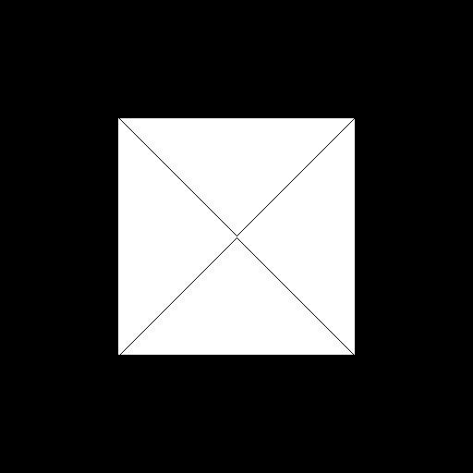

./assignment1 1 512 1024 pbmImage2.pbm 0

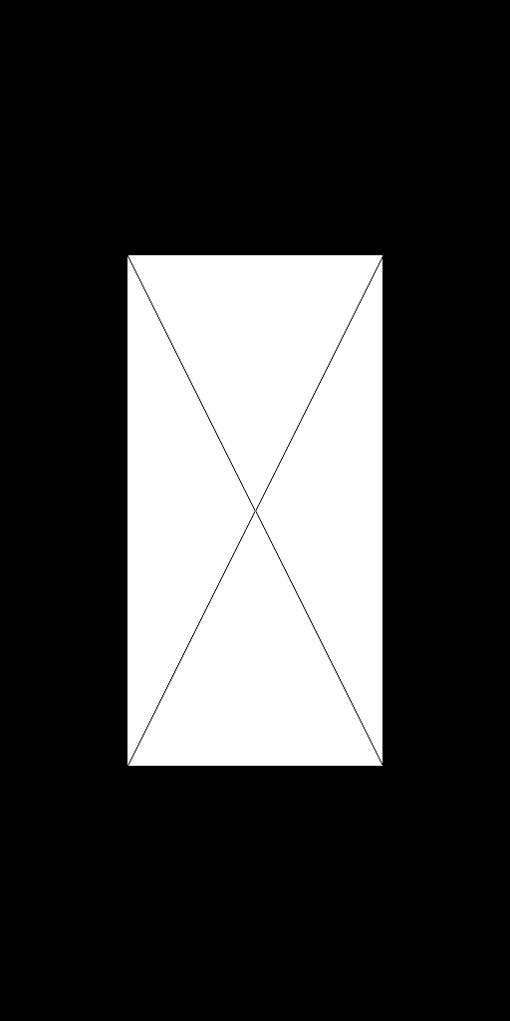

./assignment1 1 1024 512 pbmImage3.pbm 0

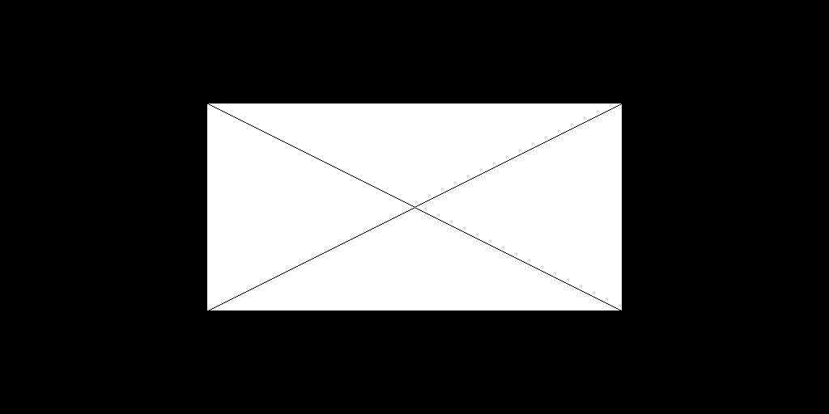

What will happen to PBM images when set to 120 x 4 and 4 x 120?

With these dimensions, the white rectangle in the center becomes only two pixes high or wide respectively. This means that the lines drawn only take one pixel and appear to go directly vertical or horizontal. Below are the two images.

120 x 4

4 x 120

PGM

./assignment1 2 512 512 pgmImage1.pgm 0

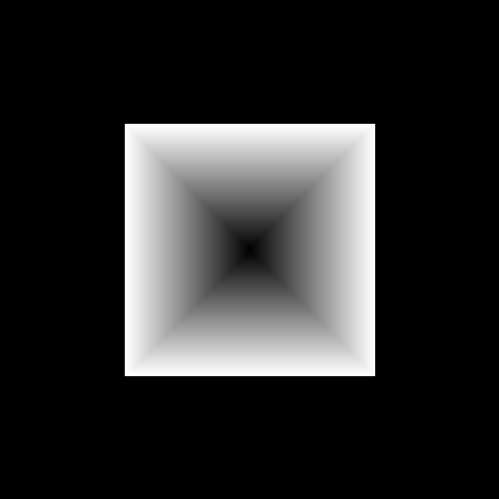

./assignment1 2 512 1024 pgmImage2.pgm 0

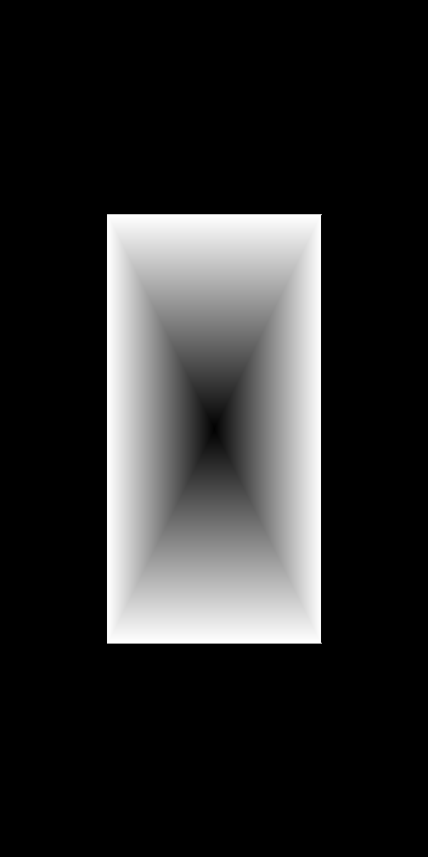

./assignment1 2 1024 512 pgmImage3.pgm 0
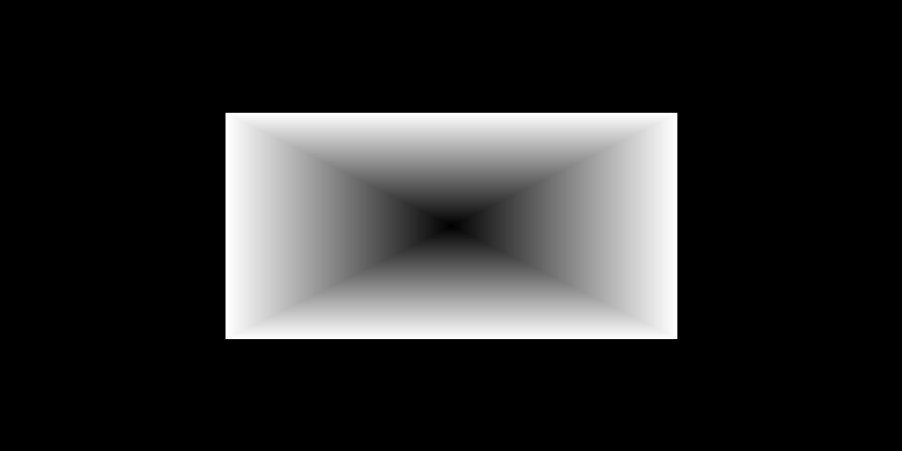

What will happen to PGM images when set to 120 x 4 and 4 x 120?

The images will look very similar to the PBM images except they will have a very slight gray color in the center which will be around the halfway mark of the maximum gray value input.

120 x 4

4 x 120

PPM

./assignment1 3 600 600 ppmImage1.ppm 0

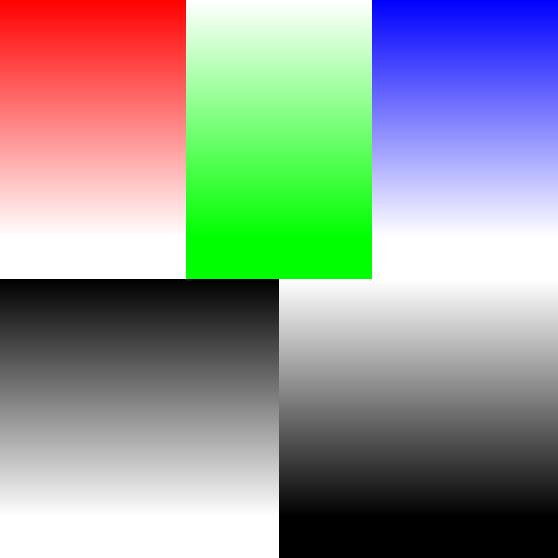

./assignment1 3 600 1200 ppmImage2.ppm 0
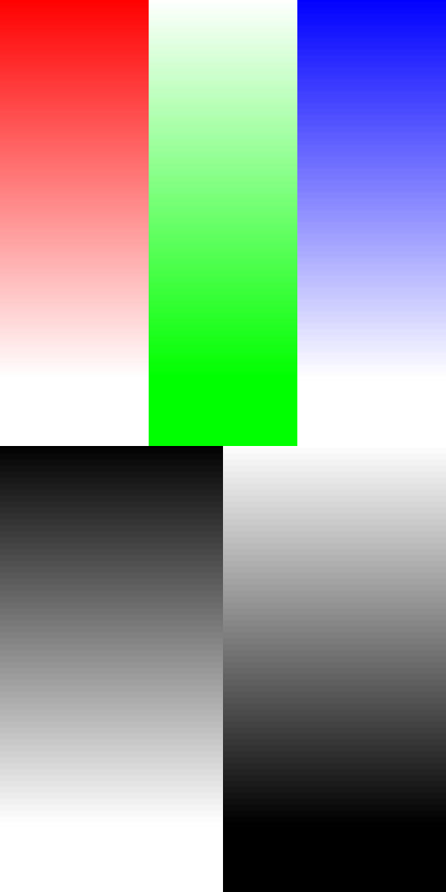

./assignment1 3 1200 600 ppmImage3.ppm 0
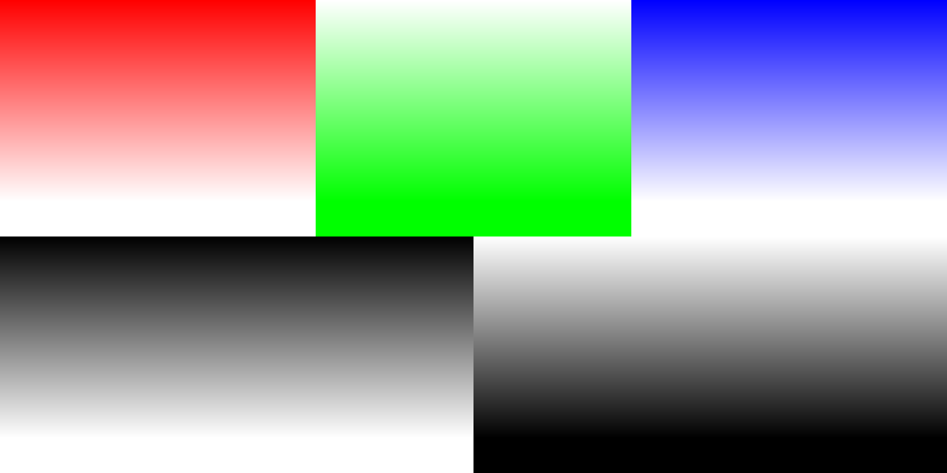

What will happen to PPM images in 120 x 6 and 6 x 120?

With ppm images, in 6 x 120, each color section will be just one pixel, but you will be able to see the pixel values increase or decrease in color. In 120 x 6, the colors won't have space to gradually increase, so it will be two pixels of color and then a pixel of white.

120 x 6

6 x 120

Make three gray scale images of question 3

Using red as base for gray scale makes red appear all white – 600 x 1200

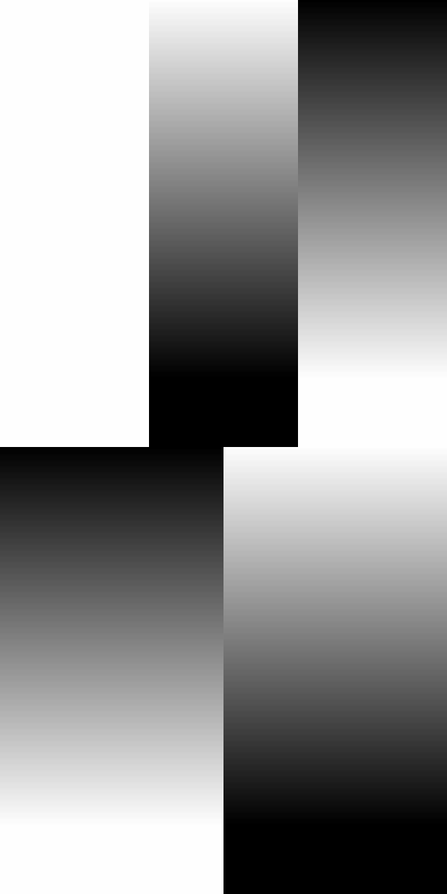

Using green as gray scale base makes green appear white.
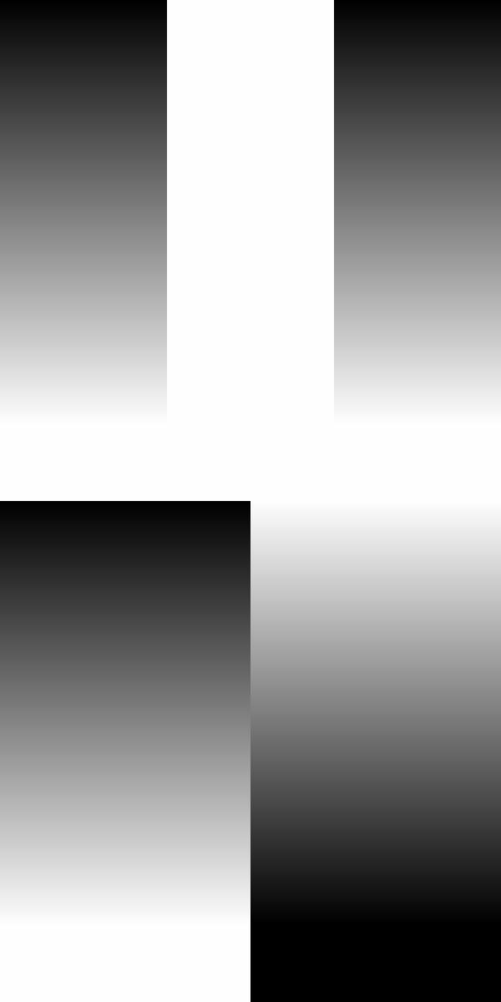

Using blue as gray scale as base makes blue appear white

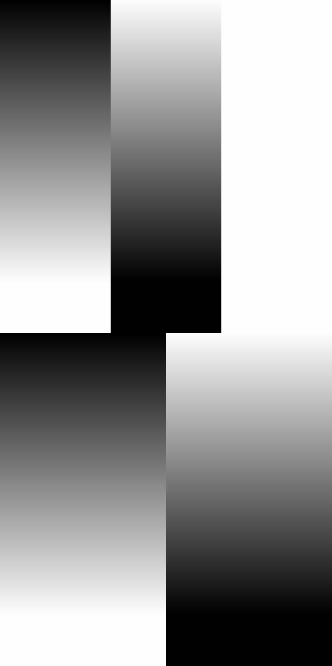

Flowcharts

PBM Flowchart
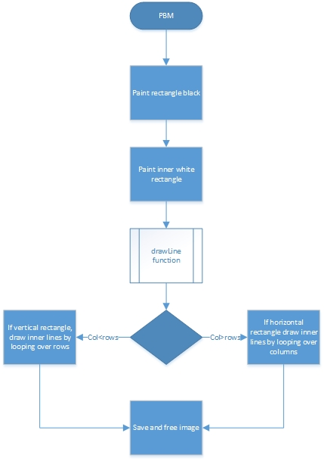

PGM Flowchart
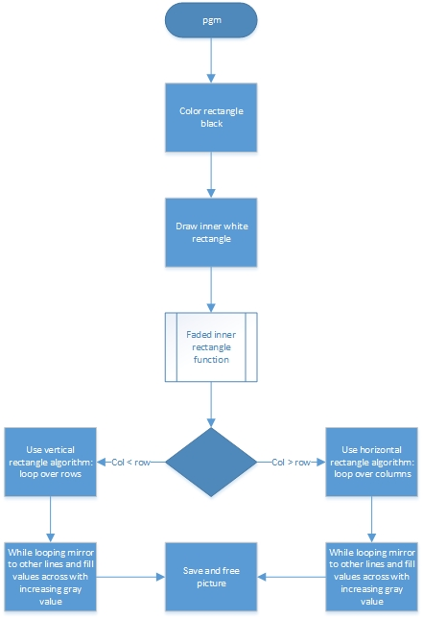

PPM Flowchart
