Boat Graphs

Illustration 1: Boats offset - 256 search buffer

Illustration 2: Boats offset - 1024 search buffer

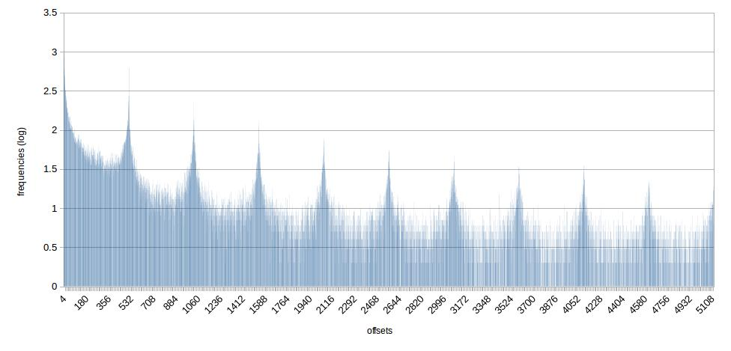Illustration 3: Boats offsets - 5120 search buffer

Illustration 4: boats repeating - 256 search buffer

Illustration 5: boats repeating - 1024 search buffer

Illustration 6: boats repeating - 5120 search buffer

Camera Charts

Illustration 7: Camera offsets - 256 search buffer

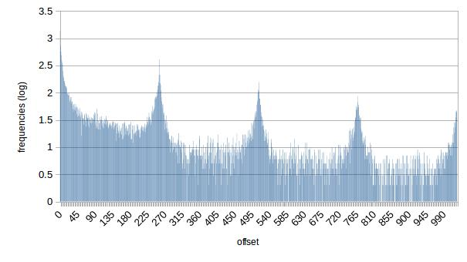Illustration 8: Camera offset - 1024 search buffer

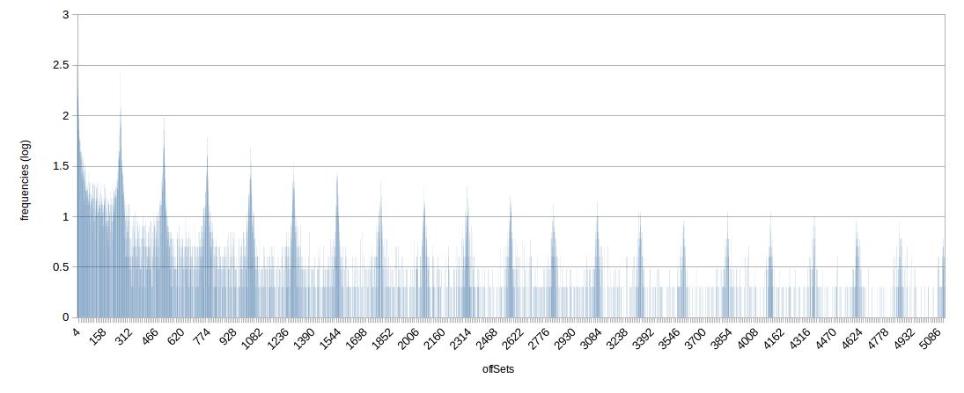Illustration 9: Camera offset - 5120 search buffer

Illustration 10: Camera repeating - 256 search buffer

Illustration 11: Camera repeating - 1024 search buffer

Illustration 12: Camera repeating - 5120 search buffer

Times in microseconds:
Encoding time for camera256.comp: 65486
Encoding time for camera1024.comp: 88476
Encoding time for camera5120.comp: 316197

Decoding time for camera256.comp: 14753
Decoding time for camera1024.comp: 12850
Decoding time for camera5120.comp: 8792

Encoding time for boats256.comp: 137278
Encoding time for boats1024.comp: 335376
Encoding time for boats5120.comp: 1343221

Decoding time for boats256.comp: 74539
Decoding time for boats1024.comp: 57391
Decoding time for boats5120.comp: 46114

