Note sur la doc Xilinx Coresight

Chapitre 28 de la doc

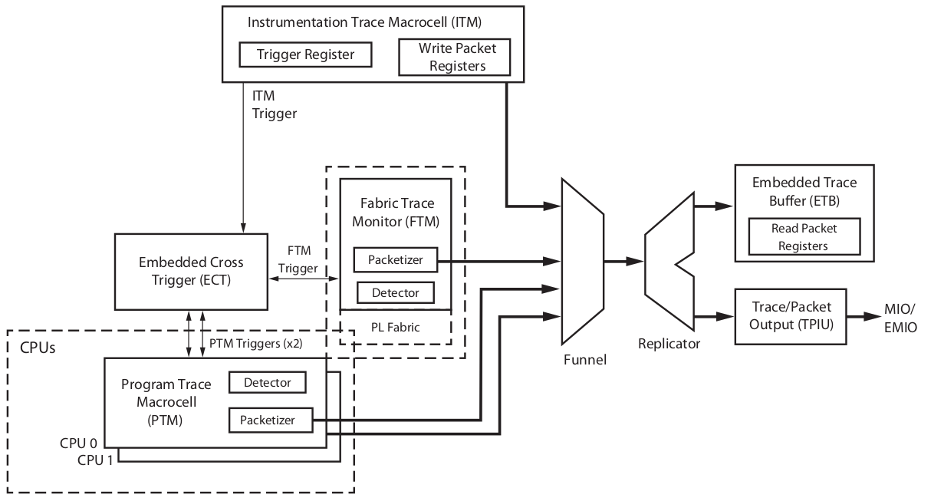
Pour rappel, 4 classes de composants :
- Access and control: DAP, ECT
- Trace source: PTM, FTM, ITM
- Trace link: Funnel, Replicator
- Trace sink: ETB, TPIU

- PTM. The PTM is the block for tracing processor execution flow.
- ITM. The ITM is the block for software to generate a trace (printf style debugging).
- Funnel. The funnel is the block for merging trace data from multiple sources into a single stream.
- ETB. The ETB is the on-chip storage of trace data (4KB).
- TPIU. The TPIU is the block for outputting trace data to the PL or to chip pinout.

EMIO supports 32-bit data at a single data rate clock that is sourced from the PL as an EMIO input.
MIO supports 16-bit data at a double data rate clock sourced by the clock generator and driven out
on MIO.

Memory mapping des registres : voir tableau

