**Revision History**

|  |  |  |  |  |  |
| --- | --- | --- | --- | --- | --- |
| **Document Name** | **Detail** | **Status** | **Date** | **View able** | **Reviewer& Responsible** |
| **TCS-Project Plan_0.1.docx** | -Introduction  -Schedule and Milestones | Draft | 10/4/14 | Siraprapa W. | Worrasete T.  Peerapong C. |
| **TCS-Project Plan_0.2.docx** | -Update Introduction  -Infrastructure  -Quality Planning  -Estimated Effort and Costs  -Version Control Strategy | Draft | 8/4/14 | Siraprapa W. | Worrasete T.  Peerapong C. |
| **TCS-Project Plan_0.3.docx** | -Update Infrastructure  -Management Procedures  -Estimate Duration of Tasks | Draft | 27/4/14 | Siraprapa W. | Worrasete T.  Peerapong C. |
| **TCS-Project Plan_0.4.docx** | -Update Quality Planning  -Identification of Project Risks | Draft | 28/4/14 | Siraprapa W. | Worrasete T.  Peerapong C. |
| **TCS-Project Plan_0.5.docx** | -Appendix | Draft | 3/4/14 | Siraprapa W. | Worrasete T.  Peerapong C. |

**Contents**

1. Introduction 4

1.1. Acronyms and Definition 4

1.2. User’s Information 4

2. Project Description 4

2.1. Project Overview 4

2.2. Scope 5

2.3. Architecture 5

2.4. Methodology 6

2.5. Work Product 6

2.5.1. Deliverable Items 6

2.5.2. Non-Deliverables Items 7

2.6. Acceptance Criteria 8

2.7. Project Estimation 8

2.7.1. Duration 8

2.7.2. Cost 9

2.7.3. Project Schedule 10

2.8. Project Team Structure 12

2.9. Environment 13

2.9.1. Development Environment 13

2.9.2. Production Environment 13

2.9.3. Test Environment 14

2.10. Test Plan 15

2.11. Backup Plan 16

2.12. Monitoring and Control 16

2.12.1. Re-Plan Procedure 16

2.12.2. Team Meeting 16

3. Quality Plan 17

3.1. Product Operation Factors 17

3.2. Product Revision Factors 17

3.3. Product Revision Factors 17

3.4. Review 17

4. Software Development Standard 18

4.1. ISO29110 for Very Small Entity (VSE) 18

4.2. Project Management (PM) 18

4.3. Software Implementation (SI) 19

5. Configuration Management 19

5.1. Naming Conversion 19

5.2. Project Repository 19

5.3. Configuration Item Table 20

5.4. Change Management 20

6. Risk Management 20

# Introduction

Our project is the project from SE499 (Senior Project), which consists of two members. Team collaboration system for mobility water monitoring is the idea to increase the value of the water monitoring process to have more efficiency. The system can share the information of the team members which is controlled by the team leader. The team leader can create a location and assigns the responsibility of the team members in each point on the map. Therefore, the collector is unnecessary to ask the team leader about his responsibility in the project. The application can help the team leader to trace all of the collectors to prove that they actually do the water sampling. The system can make further convenience of the connection between team leader and team members. The prompt message can be sent to each other in a bidirectional way, if the team leader needs his team member to recollect the water sampling. In this project, the developers determine to create team collaboration system on both web application and mobile application and also extended functions of the existing mobile software to have further completion for team collaboration.

## Acronyms and Definition

| **Acronyms** | **Definition** |
| --- | --- |
| PMP | Project Management Plan |
| SRS | Software Requirements Specification |
| SDD | Software Design Document |
| TCS | Team Collaboration System for Mobility Water Monitoring |
| PM | Project Manager |
| SA | System Analyst |
| CM | Configuration Manager |

## User’s Information

| **Name** | **Responsibility** |
| --- | --- |
| ดร.เกตุ | Provides the requirements for this project |
| N/A | To be an administrator of the system |
| N/A | To be an user of the system |

# Project Description

## Project Overview

There are many different ways to keep track of monitoring the water quality. In the past, whenever where the collectors need to measure the quality of water source, they have to go outside to collect some water sampling of the target area. The problem is the center does not know the results of monitoring at that time. Carrying the water sampling from field to the laboratory spends too many times. The element of the water can change can change before you arrive to the laboratory if the survey area is far. The reason leads to develop the application to analyze and evaluate the water quality.

Center of Excellence for Innovation in Analytical Science and Technology (I-ANALY-S-T) has developed the modern chemical analysis for water quality using the technology in chemical analysis combines with the modern information technologies, which can check the quality of water sources rapidly by considering the water quality indices, namely (pH), temperature, conductivity, (Do), (Turbidity), (TDS), the nitrate, ammonia, phosphate and the (COD).

Although, there is technology on mobile application, I-ANALY-S-T found the difficult to trace back the water sampling from the collectors. We do not know that the collectors actually collect the water sampling of the target area. So that, the solution of this problem is to create a new system cover the team collaboration of one water sources using more than one collector collect water sampling to look for the various area in each of water sources. The system can solve the problem of using mobile to monitor water source on another area.

## Scope

The TCS is developed in both mobile application and web application and also extended functions of the existing mobile software to have further completion for team collaboration. There are 7 main features of TCS are shown below:

Feature1: Authentication system on web application

Feature2: Authentication system on mobile application

Feature3: Project Management

Feature4: Map location management

Feature5: Result Presentation

Feature6: Messaging System

Feature7: Extension of existing application

## Architecture

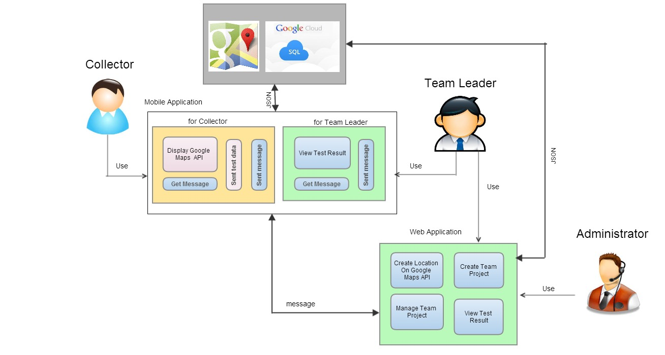

The figure as shown above is the overview of Team collaboration system for mobility water monitoring system. There are 3 parts in the system consist of Mobile Application for Collector, Mobile application for team leader and Web application for admin and the team leader. Mobile Application for Collector is the existing software which the collector tests the sample of water and send the test result to the GoogleSQL. Mobile Application for Team Leader provides the result presentation which retrieves the test result from the GoogleSQL. Finally, Web Application that provide for Administrator and Team Leader. Administrator can create and manage the team project. Team leader can create the location on Google Maps to collector and view the details of the test result. The message sends to each other between team leader and collector.

## Methodology

The TCS project is developed using Iterative life cycle model which is the concept of dividing the work into small pieces.

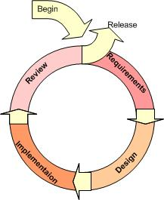

An iterative model is used to reduce the risk of development. The development begins by specifying and implementing just part of the software, which can then be reviewed in order to identify further requirements. During each of iteration, the development module goes through the requirements, design, and implementation and testing phases. Each subsequent release of the module adds function to the previous release. The process continues till the complete system is ready as per the requirement.

An iterative life cycle model can accommodate changes by stakeholder feedback to refine requirements and design. The developers can build and improving the product step by step causes we can track the defects at the early stages.

## Work Product

### Deliverable Items

| **No** | **Work Product** | **Type** | **No. of copies** | **Date** |
| --- | --- | --- | --- | --- |
| 1 | Project Proposal | Hard Copy | 4 | 26/3/2014 |
| 2 | The Progress Report I   * Project Management Plan version 1.0 * Software Requirements Specification version 1.0 * Software Design Document version 1.0 * Test Case/Test Result version 1.0 * Traceability Record version 1.0 | Hard Copy | 3 | 28/5/2014 |
| 3 | The Progress Report II   * Software Requirements Specification version 2.0 * Software Design Document version 2.0 * Test Case/Test Result version 2.0 * Traceability Record version 2.0 | Hard Copy | 3 | 17/7/2014 |
| 4 | The Progress Report III (Show Pro)   * Software Requirements Specification version 3.0 * Software Design Document version 3.0 * Test Case/Test Result version 3.0 * Traceability Record version 3.0 | Hard Copy | 3 | 11/9/2014 |
| 5 | The Final Progress Report   * Software Requirements Specification version 4.0 * Software Design Document version 4.0 * Test Case/Test Result version 4.0 * Traceability Record version 4.0 | Hard Copy | 3 | 2/10/2014 |
| 6 | Source Code version 1.0 | Software | 3 | 2/10/204 |

### Non-Deliverables Items

| **No** | **Work Product** | **Type** |
| --- | --- | --- |
| 1 | 30 seconds video presentation | Soft Copy |
| 2 | 5 minutes video presentation | Soft Copy |
| 3 | Poster presentation | Hard Copy |

## Acceptance Criteria

| **No** | **Acceptance Criteria** | **Date** | **Responsibility** |
| --- | --- | --- | --- |
| 1 | Progress I  All documents in deliverable items no.2 are submitted and presented to committee members |  |  |
| 2 | Progress II  All documents in deliverable items no.3 are submitted and presented to committee members |  |  |
| 3 | Progress III  All documents in deliverable items no.4 are submitted and presented to committee members |  |  |
| 4 | Final Report  All documents in deliverable items no.5 are submitted and presented to committee members |  |  |
| 5 | Participation of SE Show Pro 2014 |  |  |
| 6 | Source Code need to be submitted and sign of by committee members |  |  |

## Project Estimation

### Duration

| **Milestone** | **Task** | **Milestone Criteria** | **Planned date** |
| --- | --- | --- | --- |
| 1 | Proposal | -Topic defined | February |
| 2 | Proposal Report | - Proposal reviewed  - Proposal submitted  - Proposal presentation | March |
| 3 | Progress Report I | - Software Requirements Specification  - Software Design Document  - Test Plan Progress 1  - Implementation Progress 1  - Test Feature Progress 1  - Traceability Record Progress 1  - Progress  report 1 submitted  - Progress report  1 presentation | May |
| 4 | Progress Report II | - Software Requirements Specification  - Software Design Document  - Implementation Progress 2  - Test Feature Progress 2  - Traceability Record Progress 2  - Progress Report 2 submitted  - Progress report 2 presentation | July |
| 5 | Progress Report III | - Software Requirement Specification  - Software Design Document  - Test Plan Progress 3  - Implementation Progress 3  - Test Feature Progress 3  - Traceability Record Progress 3  - Progress  report 3 submitted  - Progress report  3 presentation | October |

Progress Report I

Feature1: Authentication system on web application

Feature2: Authentication system on mobile application

Feature3: Project management

Progress Report II

Feature4: Map location management

Feature5: Result presentation

Feature6: Project management

Progress Report III

Feature6: Messaging system

### Cost

|  |  |
| --- | --- |
| **Item** | **Approximately Cost (THB)** |
| Text Book | 2,500 |
| Android Device for testing | 6,000 |
| Document Printing | 2,000 |
| Poster Presentation | 500 |
| **Total** | **11,000** |

### Project Schedule

**Proposal Report**

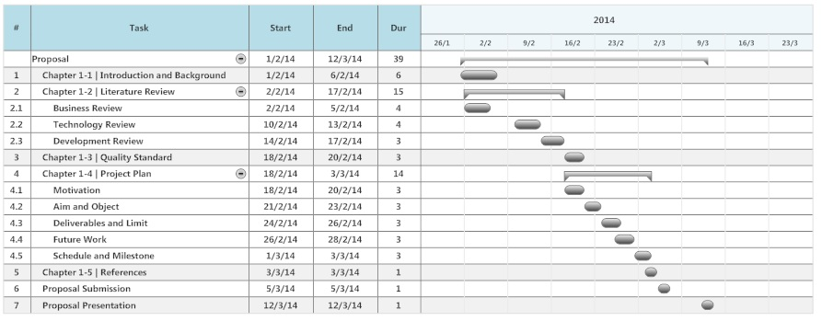

**Progress Report 1**

* Feature#1: Authentication system on web application
* Feature#2: Authentication system on mobile application
* Feature#3: Project management

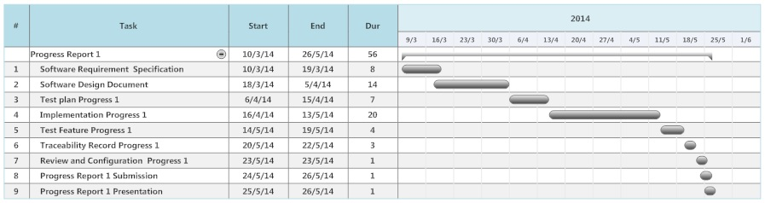

**Progress Report 2**

* Feature#4: Map location management
* Feature#5: Result Presentation
* Feature#7: Extension of existing application

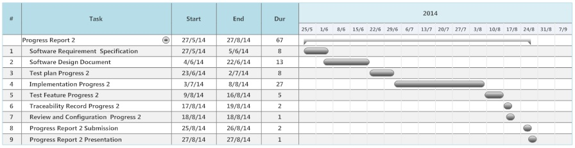

**Progress Report 3**

* Feature#6: Messaging System

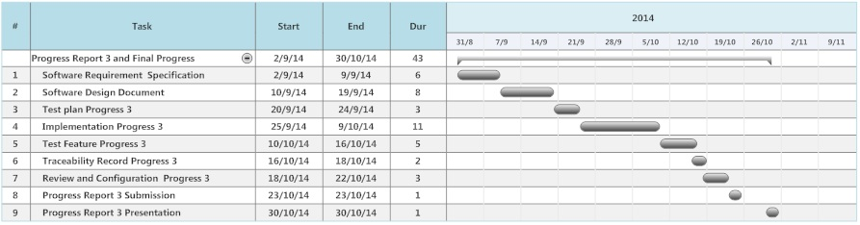

## Project Team Structure



| **No** | **Name** | **Role** | **Responsibility** | **Tel** | **E-mail** |
| --- | --- | --- | --- | --- | --- |
| 1 | Worrasete T. | Project Manager | - Plan the project  - Monitoring and Control  - Resolve the problem |  |  |
| 2 | Worrasete T. | Configuration Manager | - Naming conversion and version control of all work products |  |  |
| 3 | Peerapong C.  Worrasete T. | System Analyst | - Requirements gathering  - Analyze the user requirements to software requirements  - Software Design |  |  |
| 4 | Worrasete T. | Programmer | - Implement the code following the SDD and related to SRS |  |  |
| 5 | Peerapong C. | Tester | - Provide test plan, test case  - Execute the test  - Record and report the test result to PM, SA and programmer |  |  |

## Environment

### Development Environment

|  |  |
| --- | --- |
| Hardware | **Laptop**  Intel® Core™ i5-3317U CPU @ 1.70 GHz  RAM 4 GB  Intel® HD Graphics 4000  Hard disk 500 GB  **For Mobile Device**  Samsung Galaxy S5  Qualcomm Snapdragon 801 CPU 2.5 GHz  RAM 2 GB  Adreno 330 Graphics Processing Unit  Resolution 1920 x 1080 Pixels (Full HD 1080p 432 ppi) |
| Software | **For Laptop**  Internet Explorer 7.0 or later  Google Chrome 35 or later  Mozilla Firefox 12 or later  Safari 6 or later  **For Mobile Device**  TCS application |
| Networking | Broadcom 802.11n Network Adapter  Internet Connection at lease 512Kbps download and 128Kbps Upload Needed |
| Development Tools | **For Laptop**  Gantt Chart  Adobe Photoshop  Git Hub  Source Tree  Visual Paradigm for UML  Eclipse  Android SDK  Microsoft Word  MySQL Server  Web Server |

### Production Environment

|  |  |
| --- | --- |
| Hardware | **Laptop**  Intel® Core™ i5-3317U CPU @ 1.70 GHz  RAM 4 GB  Intel® HD Graphics 4000  Hard disk 500 GB  **For Mobile Device**  Samsung Galaxy S5  Qualcomm Snapdragon 801 CPU 2.5 GHz  RAM 2 GB  Adreno 330 Graphics Processing Unit  Resolution 1920 x 1080 Pixels (Full HD 1080p 432 ppi) |
| Software | **For Laptop**  Internet Explorer 7.0 or later  Google Chrome 35 or later  Mozilla Firefox 12 or later  Safari 6 or later  **For Mobile Device**  TCS application |
| Networking | Broadcom 802.11n Network Adapter  Internet Connection at lease 512Kbps download and 128Kbps Upload Needed |
| Tools | N/A |

### Test Environment

|  |  |  |
| --- | --- | --- |
| System Integration Test | Hardware | **Laptop**  Intel® Core™ i5-3317U CPU @ 1.70 GHz  RAM 4 GB  Intel® HD Graphics 4000  Hard disk 500 GB  **For Mobile Device**  Samsung Galaxy S5  Qualcomm Snapdragon 801 CPU 2.5 GHz  RAM 2 GB  Adreno 330 Graphics Processing Unit  Resolution 1920 x 1080 Pixels (Full HD 1080p 432 ppi) |
| Software | **For Laptop**  Internet Explorer 7.0 or later  Google Chrome 35 or later  Mozilla Firefox 12 or later  Safari 6 or later  **For Mobile Device**  TCS application |
| Networking | Broadcom 802.11n Network Adapter  Internet Connection at lease 512Kbps download and 128Kbps Upload Needed |
| User Acceptance Test | Hardware | **Laptop**  Intel® Core™ i5-3317U CPU @ 1.70 GHz  RAM 4 GB  Intel® HD Graphics 4000  Hard disk 500 GB  **For Mobile Device**  Samsung Galaxy S5  Qualcomm Snapdragon 801 CPU 2.5 GHz  RAM 2 GB  Adreno 330 Graphics Processing Unit  Resolution 1920 x 1080 Pixels (Full HD 1080p 432 ppi) |
| Software | **For Laptop**  Internet Explorer 7.0 or later  Google Chrome 35 or later  Mozilla Firefox 12 or later  Safari 6 or later  **For Mobile Device**  TCS application |
| Networking | Broadcom 802.11n Network Adapter  Internet Connection at lease 512Kbps download and 128Kbps Upload Needed |

## Test Plan

Testing is an important part to ensure that all requirements are developed and able to work without defect. To ensure that the features of software meet all user needs. There are 3 testing levels need to be done in this project which are

1. **Unit Test**

Unit testing is normally performed by developer that developed the program. Unit test always intensively use strategy verify/validate data, negative testing and business Rules/calculation/Exception, Production like data.

Testing individual programs, modules, or components to demonstrate that the work package executes per specification, and validate the design and technical quality of the application. The focus is on ensuring that the detailed logic within the component is accurate and reliable according to pre-determined specifications. Testing stubs or drivers may be used to simulate behavior of interfacing modules.

1. **Integration Test**

After integrate all modules, execute integration test by tester or analyst. Integration test always intensively use strategy application flow, Integration, Security /Authorization/Roles.

1. **Acceptance Test**

Formal testing conducted to determine whether a system satisfies its acceptance criteria and to enable the user to determine whether to accept the system. Software acceptance testing at delivery is usually the final opportunity for the user to examine the software and to seek correctness from the developer for insufficient or incorrect software. Frequently, the software acceptance test is the only time the user is involved in acceptance and the only opportunity the user has to identify deficiencies in a critical software system.

Software acceptance is an incremental process of approving or rejecting software system during development or maintenance, according to how well the software satisfies predefined criteria. For the purpose of software acceptance is the activities of software maintenance are assumed to share the properties of software development.

## Backup Plan

|  |  |
| --- | --- |
| Frequency | Once a week, every Friday |
| Location/Path | /Backup/TCS/* |
| Responsibility | Worrasete T. |
| Method | To backing up the work products, all related repository in development environment need to be duplicated to destination path |

## Monitoring and Control

### Re-Plan Procedure

PM need to monitor the project process performance attributes, work products, deliverables, the actual completion of activities, milestones and compare them against the estimated schedule as documented in the project plan. Any significant deviations for the schedule deviations are identified. PM confirms whether there is delay in the task in critical-path. Effort expended is also monitored throughout the life cycle of the project.

The master plan is updated if at least one of the followings can be seen. Re- planning criteria

* The project scope has changed
* The estimate has changed
* The actual performance significantly has deviated from plan

### Team Meeting

The periodic project review meetings are held as per the frequency defined below. All team members should attend project review meeting and cover the topic of

1. Analyze and discuss the project progress with reference to the planned schedules and resource
2. Discuss the problems of the project, if any
3. Identify areas of slippage and weakness
4. Decide on preventive and corrective actions, if required

The frequency of team meeting is arranged to  Monday  Tuesday   
 Wednesday  Thursday  Friday of  1  2  3  4 week of each month

# Quality Plan

## Product Operation Factors

**Correctness**

The software should provide more than 80% of data as the user requested correctly.

**Usability**

The software should provide understandable and easy-to-use GUI and language.

**Reliability**

The software should perform with more than 80% of usual activities, and with less than 10% of failure.

**Integrity**

The software should be able to identify between authorized and unauthorized users, and also between each type of users.

## Product Revision Factors

**Maintainability**

The software should perform with more than 80% of usual activities, and with less than 10% of failure.

**Testability**

The software should be 100% tested of it defined routine and functionality.

## Product Revision Factors

**Reusability**

More than 50% of the complete software should be able to be reused in the future.

## Review

| **No** | **Stage** | **Work Product** | **Owner** | **Reviewer** | **Date** |
| --- | --- | --- | --- | --- | --- |
| 1 | 1st Progress | Project Plan | Worrasete T. | Peerapong C. |  |
| 2 | 1st Progress | Software Requirements Specification | Worrasete T. | Peerapong C. |  |
| 3 | 1st Progress | Software Design Document | Worrasete T. | Peerapong C. |  |
| 4 | 1st Progress | Test Case | Peerapong C. | Worrasete T. |  |
| 5 | 1st Progress | Traceability Record | Peerapong C. | Worrasete T. |  |
| 7 | 2nd Progress | Software Requirements Specification | Worrasete T. | Peerapong C. |  |
| 8 | 2nd Progress | Software Design Document | Worrasete T. | Peerapong C. |  |
| 9 | 2nd Progress | Test Case | Peerapong C. | Worrasete T. |  |
| 10 | 2nd Progress | Traceability Record | Peerapong C. | Worrasete T. |  |
| 12 | 3rd Progress | Software Requirements Specification | Worrasete T. | Peerapong C. |  |
| 13 | 3rd Progress | Software Design Document | Worrasete T. | Peerapong C. |  |
| 14 | 3rd Progress | Test Case | Peerapong C. | Worrasete T. |  |
| 15 | 3rd Progress | Traceability Record | Peerapong C. | Worrasete T. |  |

# Software Development Standard

## ISO29110 for Very Small Entity (VSE)

ISO 29110 is a guide applies to Very Small Entities (VSEs), enterprise, organization, department or project up to 25 people, dedicated to software development. The Guide provides Project Management and Software Implementation process which integrate practices based on the selection of ISO/IEC12207- Systems and Software Engineering -Software Life Cycle process - guidelines for the content of software life cycle process information products (documentation) standards elements.

## Project Management (PM)

The purpose of the Project Management process is to establish and carry out in a systematic way the tasks of the software implementation project, which allows complying with the project's objectives in the expected quality, time and costs.

PM objectives

PM.O1. The Project Plan for the execution of the project is developed according to the Statement of Work and validated with the Customer. The tasks and resources necessary to complete the work are sized and estimated

PM.O2. Progress of the project is monitored against the Project Plan and recorded in the Progress Status Record. Corrections to remediate problems and deviations from the plan are taken when project targets are not achieved. . Appropriate treatment is taken to correct or avoid the impact of risk. Closure of the project is performed to get the Customer acceptance documented in the Acceptance Record.

PM.O3. The Change Requests are addressed through their reception and analysis. Changes to software requirements are evaluated for cost, schedule and technical impact.

PM.O4. Review meetings with the Work Team and the Customer are held. Agreements are registered and tracked.

PM.O5. Risks are identified as they develop and during the conduct of the project.

PM.O6. A software Version Control Strategy is developed. Items of Software Configuration are identified, defined and baselined. Modifications and releases of the items are controlled and made available to the Customer and Work Team including the storage, handling and delivery of the items.

PM.O7. Software Quality Assurance is performed to provide assurance that work products and processes comply with the Project Plan and Requirements Specification.

**PM Activities**

The Project Management Process has the following activities:

* PM.1 Project Planning
* PM.2 Project Plan Execution
* PM.3 Project Assessment and Control
* PM.4 Project Closure

## Software Implementation (SI)

The purpose of the Software Implementation process is the systematic performance of the analysis, design, construction, integration and tests activities for new or modified software products according to the specified requirements.

**SI objectives**

**SI.O1** Tasks of the activities are performed through the accomplishment of the current Project Plan.

**SI.O2** Software requirements are defined, analyzed for correctness and testability, approved by the Customer, baselined and communicated.

**SI.O3** Software architectural and detailed design is developed and baselined. It describes the software items and internal and external interfaces of them. Consistency and traceability to software requirements are established.

**SI.O4** Software components defined by the design are produced. Unit test are defined and performed to verify the consistency with requirements and the design. Traceability to the requirements and design are established.

**SI.O5** Software is produced performing integration of software components and verified using Test Cases and Test Procedures. Results are recorded at the Test Report. Defects are corrected and consistency and traceability to Software Design are established.

**SI.O6** A Software Configuration, that meets the Requirements Specification as agreed to with the Customer, which includes user, operation and maintenance documentations is integrated, baselined and stored at the Project Repository. Needs for changes to the Software Configuration are detected and related Change Requests are initiated.

**SI.O7** Verification and Validation tasks of all required work products are performed using the defined criteria to achieve consistency among output and input products in each activity. Defects are identified, and corrected; records are stored in the Verification/Validation Results.

**SI activities**

The Software Implementation Process has the following activities:

* SI.1 Software Implementation Initiation
* SI.2 Software Requirements Analysis
* SI.3 Software Architectural and Detailed Design
* SI.4 Software Construction
* SI.5 Software Integration and Tests
* SI.6 Product Delivery

# Configuration Management

## Naming Conversion

The file naming format that we are going to use for all project documents is   
“[Project Name]-[Document Name]-[Version]”

## Project Repository

GitHub provides users free spaces to easily store and share their photos, documents, information, and even source code. It is like a social network for the programmers.

**List of related document and description**

1. Proposal: contains involved proposal document files
2. Project Plan: contains project plan document files
3. SRS: contains software requirements specifications document files
4. Design: contains design document files
5. Test: contains testing document files
6. Traceability Record: contains traceability record files
7. Presentation: contains presentation files
8. Source Code: contains source code of the project
9. GUI: contains the pictures that will be used as Graphic User Interface of the system.
10. Others: contain pictures, involved and interesting information, etc.

## Configuration Item Table

|  |  |  |  |  |  |
| --- | --- | --- | --- | --- | --- |
| **No** | **Item** | **File Name** | **File Type** | **Owner** | **Path** |
| 1 | Project Proposal | TCS-Proposal_V.[version] | .docx | Worrasete T.  Peerapong C. | / TCS /Proposal |
| 2 | Project Management Plan | TCS-ProjectPlan_V.[version] | .docx | Worrasete T. | / TCS /Project Plan |
| 3 | Software Requirements Specification | TCSt-SRS_V.[version] | .docx | Worrasete T. | / TCS /SRS |
| 4 | Software Design Document | TC-SDD_V.[version] | .docx | Worrasete T. | / TCS /Design |
| 5 | Test Case | TCS-TestCase_V.[version] | .docx | Peerapong C. | / TCS /Test |
| 6 | Traceability Record | TCS-TR_V.[version] | .docx | Peerapong C. | /TCS/Traceability Record |

## Change Management

Change Management manages all of the changes in the project during the development process. All of the change requests will be recording into the change management document.

Change management is the process of selecting which changes to encourage, allow, and prevent, according to a set project criteria. This process enables in identifying and managing the origin of the changes, defining critical decision points, and establishing project change management roles and responsibilities.

We have the strategy for manage the changes by following these steps:

1. Identify the change control authority
2. Initiate and record change requests
3. Analyze the change requests
4. Obtain appropriate authorization
5. Track the status of the Change Request to Closure
6. Perform review

# Risk Management

The purpose of risk management is to find and control potential problems as early as possible before they actually happen. To minimize the impacts of risks upon projects by forecasting them, it is required to identify the risks systematically and take proactive measures to mitigate the impacts. To identify the project risk following these steps:

1. Identifying risks
2. Evaluate risk and analyze
3. Preparation of risk preventive / handling plans
4. Monitoring risk management plan

Risk shall be evaluated following the procedure below.

Probability occurrence can be

Almost Certain > 80%

Likely 61 – 80 %

Possible 51 – 60 %

Unlikely 41 – 50 %

Rare <= 40 %

Impact can be

Catastrophic > 80%

Critical 61 – 80 %

Marginal 51 – 60 %

Minor 41 – 50 %

Negligible <= 40 %

|  |  |  |  |  |  |  |
| --- | --- | --- | --- | --- | --- | --- |
|  | | Probability **** | | | | |
| A | B | C | D | E |
| Almost Certain | Likely | Possible | Unlikely | Rare |
| Impact **\*\*** | Ct – Catastrophic | **H** | **H** | **H** | **H** | **M** |
| Cr – Critical | **H** | **H** | **H** | **M** | **M** |
| M – Marginal | **H** | **M** | **M** | **M** | **M** |
| Min – Minor | **M** | **M** | **M** | **L** | **L** |
| N – Negligible | **M** | **M** | **L** | **L** | **L** |

Overall risk can be prioritized

H – High Risk

M – Medium Risk

L – Low Risk

**Project Risk**

|  |  |  |  |  |
| --- | --- | --- | --- | --- |
| **Risk** | **Probability** | **Impact** | **Risk Prioritized** | **Mitigation** |
| Lack of experience | Almost Certain | Catastrophic | High | - Training to the staff who will take the role  - Guidance project by expert or expertise in that topic |
| Time Management | Possible | Marginal | Medium | - Cut off some features  - Split system requirement into phase  Clarify user about the scope of requirement with timeline |
| Requirements creep | Possible | Critical | High | - Gathering user requirements for all. Categorize user requirements, what they need or want. Then, make a confirmation. |
| Server failure | Rare | Catastrophic | Medium | - Create baseline of source code every release and backup following plan |
| Hardware crash | Rare | Catastrophic | Medium | - Create baseline of source code every release and backup following plan |