4.2 Class Diagram Description

CD-01, URS

Class name: DbConnection

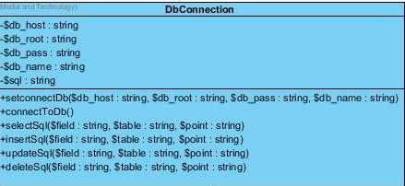

Property

|  |  |  |  |
| --- | --- | --- | --- |
| ID | Name | Description | Remark |
| 1 | $db_host | - | Type: string |
| 2 | $db_root |  | Type: string |
| 3 | $db_pass |  | Type: string |
| 4 | $db_name |  | Type: string |
| 5 | $sql |  | Type: string |

Method

|  |  |  |  |  |
| --- | --- | --- | --- | --- |
| ID | Name | | Description | Remark |
| 1 | setconnectDb() | |  | - |
| 2 | connectToDb() | |  | - |
| 3 | selectSql() | |  | - |
| 4 | insertSql () | |  | - |
| 5 | updateSql() | |  | - |
| 6 | | deleteSql() |  | - |

CD-02, URS

Class name: User

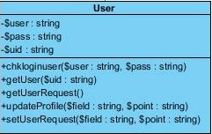

**Property**

|  |  |  |  |
| --- | --- | --- | --- |
| ID | Name | Description | Remark |
| 1 | $user |  | Type : string |
| 2 | $pass |  | Type : string |
| 3 | $uid |  | Type : string |

Method

|  |  |  |  |
| --- | --- | --- | --- |
| ID | Name | Description | Remark |
| 1 | chkloginuser() | Method uses to login for use. | - |
| 2 | getUser() |  | - |
| 3 | getUserRequest() |  | - |
| 4 | updateProfile() | Method uses to update profile for administration. | - |
| 5 | setUserRequest() |  | - |

CD-0, URS

Class name: Member

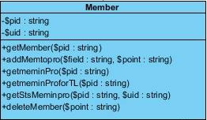

**Property**

|  |  |  |  |
| --- | --- | --- | --- |
| ID | Name | Description | Remark |
| 1 | $pid | - | Type : string |
| 2 | $uid |  | Type string |

**Method**

|  |  |  |  |  |
| --- | --- | --- | --- | --- |
| ID | Name | | Description | Remark |
| 1 | getMember() | |  | - |
| 2 | addMemtopro () | | Method uses to add member to the project | - |
| 3 | getmeminPro() | | Method uses to get member to the project for administration | - |
| 4 | getmeminPro forTL() | | Method uses to get member to the project for team leader | - |
| 5 | getStsMeminpro() | |  | - |
| 6 | | deleteMember () | Method uses to delete member out of the project | - |

CD-04, URS

Class name: Project

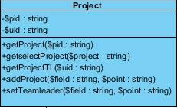

Property

|  |  |  |  |
| --- | --- | --- | --- |
| ID | Name | Description | Remark |
| 1 | $pid | - | Type : string |
| 2 | $uid |  | Type : string |

Method

|  |  |  |  |
| --- | --- | --- | --- |
| ID | Name | Description | Remark |
| 1 | getProject() | Method uses to get the new project | - |
| 2 | getselectProject() |  | - |
| 3 | getProjectTL() | Method uses to get the project for team leader | - |
| 4 | addProject() | Method uses to add the new project | - |
| 5 | setTeamleader() | Method uses to assign team leader for administrater | - |

CD-05, URS

Class name: Facade

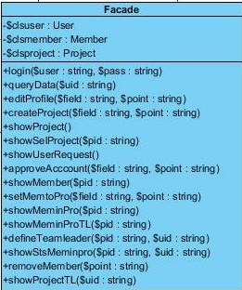

Property

|  |  |  |  |
| --- | --- | --- | --- |
| ID | Name | Description | Remark |
| 1 | $clsuser |  | Type : User |
| 2 | $clsmember |  | Type : Member |
| 3 | $clsproject |  | Type : Project |

Method

|  |  |  |  |  |
| --- | --- | --- | --- | --- |
| ID | Name | | Description | Remark |
| 1 | login() | | Method uses to login | - |
| 2 | queryData() | |  | - |
| 3 | editProfile() | |  | - |
| 4 | createProject () | | Method uses to create the new project for administrator | - |
| 5 | showProject() | |  | - |
| 6 | | showSelProject() |  | - |
| 7 | | showUserRequest() |  |  |
| 8 | | approveAccount() | Method uses to approve member for administrator |  |
| 9 | | showMember() | Method uses to show list of member |  |
| 10 | | setMemtoPro |  |  |
| 11 | | showMeminPro | Method uses to show list of member in each project for administrator |  |
| 12 | | showMeminProTL | Method uses to show list of member in each project for team leader |  |
| 13 | | defineTeamleader | Method uses to assign team leader for administrator |  |
| 14 | | showStsMeminpro | Method uses to show status of each member in the project |  |
| 15 | | removeMember | Method uses to remove member out of the project |  |
| 16 | | showProjectTL() |  | - |