A
Seminar Report
On
DeepVision AI
Submitted by
- Mayank Mali 2505112120085
- Zala Dhruvraj 2505112120009
- Pitroda Priyanshi 2505112120106

as
Partial fulfilment of Semester II
of Master of Computer Applications
for A.Y. 2025-2026

Under the Guidance of
Prof. Saumil Trivedi

Submitted To
Department of MCA
Faculty of IT & Computer Science
Parul University




CERTIFICATE
This is to certify that Mr. Mayank Mali, Enrollment No. 2505112120085 student of Master of Computer Applications and Mr. Zala Dhruvraj, Enrollment No. 2505112120009 student of Master of Computer Applications and Ms. Pitroda Priyanshi, Enrollment No. 2505112120106 student of Master of Computer Applications have satisfactorily completed the Seminar on “DEEP VISION AI” as fulfillment of MCA Semester II.

Seat No.
Date of Submission:

Prof. Saumil Trivedi

Internal Guide Co-ordinator

Department of MCA
Faculty of IT & Computer Science
PARUL University, Vadodara

Abstract
Deep Vision AI is a web application that uses artificial intelligence algorithms to detect if a picture is authentic or created by a machine learning model. This project utilizes technologies like Artificial Intelligence, Computer Vision, and advanced web development skills to deliver image authenticity detection in real time. It deals with deepfake issues, fraudulent identities, and digital tampering on social networks and online sites. The platform lets users upload pictures via the latest drag-and-drop functionality and obtain prediction results right away. A CNN-based model is employed for analysing visual characteristics and textures to classify the image data into real or fake categories. The project's backend is designed using Python and Flask, whereas the frontend was built using React.js, Tailwind CSS, and Vite. It also offers confidence scores, real probabilities, and fake probabilities for each image that has been uploaded. Deep Vision AI boasts a futuristic and responsive UI with cool animation effects and modern design aspects. The platform provides security measures, including file validation, protected uploading, and secured API operations. Deep Vision AI is an innovative application based on artificial intelligence technology that is capable of determining whether an image that is uploaded by the user to the application is authentic or artificially produced using deep learning and computer vision techniques. Given the rise in AI-generated content and technologies for producing deepfakes, the problem of differentiation between authentic and manipulated digital images has become more prevalent, causing problems related to cybersecurity, information falsification, and fake identity generation. To help overcome these problems, Deep Vision AI uses a CNN machine learning algorithm that evaluates image structure and pixel patterns, texture anomalies, and artificial elements to assess image authenticity with great precision. This solution comes with a simple user interface allowing images to be easily dragged and dropped into the application along with a preview capability for checking the uploaded images. After uploading an image, the backend based on the Flask framework executes different steps such as image resizing, normalization, tensor formation, feature extraction, and model inference to produce prediction outputs. Then, the prediction result is returned to the user in the form of real-time outputs containing REAL/FAKE class, confidence percentage, real/fake probability values Thus, it can be noted that the AI application named Deep Vision AI is one of the best examples of practical integration of such concepts as AI, deep learning, and web development.
TABLE OF CONTENTS

No. | Description | Page No.
1. | Introduction | 5
2. | Methodologies | 8
3. | Algorithms / Techniques | 15
4. | Current / Latest R&D Works in the Field | 18
5. | Future Research Directions | 20
6. | Project Demonstration | 22
7. | Bibliography / References | 25

- Introduction
Deep Vision AI is an intelligent image detection solution that uses artificial intelligence, machine learning, deep learning, and computer vision technologies for identifying AI-generated images.
This project involves the creation of an advanced AI web application that would be able to analyse and detect whether the uploaded image is genuine or fake.
By implementing AI, machine learning, and deep learning technologies together with web development concepts, this image detection solution allows users to detect the authenticity of uploaded photos instantly.
With the help of advanced computer vision technology, users can see whether the uploaded image has been artificially generated or manipulated by any means.
- Overview of the Project
The proposed AI image detection solution is developed as a modern full-stack application that will help in identifying and differentiating AI-generated and non-AI-generated images
. In order to differentiate between the two types of images, CNN model will be used in order to analyze image patterns, structural inconsistencies, textures, and other elements that can indicate manipulation of images.
For frontend of this application, React.js, Tailwind CSS, and Vite will be utilized while the backend of this platform will be created with the help of Python programming language with Flask..

- Problem Statement:
Due to the advancements in the field of Artificial Intelligence, and the rise in deepfake technology, the detection of AI-generated images has become challenging.
The use of AI-generated imagery may result in the creation of false identities, spreading of false information, manipulation of digital data, and cybersecurity attacks on existing systems.
The impact of false and manipulated images is greatly felt in social media channels, news, and digital communications, making it hard to verify the authenticity of media content.
- Objectives
To develop an AI-powered system capable of detecting AI-generated and fake images accurately.
• To implement Deep Learning and Computer Vision techniques for image authenticity verification.
• To provide real-time image analysis and prediction results through an efficient web platform.
• To generate confidence scores, real probability, and fake probability for uploaded images.
• To create a modern, responsive, and user-friendly interface for easy image uploading and prediction visualization.

- Importance of Deep Vision:
1. Detection of Manipulated Photos: This project assists in identifying fake AI images and detecting any form of manipulation using deep learning.
2. Prevention of Deception: This project prevents the propagation of misinformation through digital media channels.
3. Cyber Security: This technology safeguards users and organizations from digital threats such as fraud and fake identities.
4. Verification of Media: This technology enables media personnel to detect the authenticity of digital images.
5. Real-time Predictions: The user gets predictions on the image uploaded within a matter of seconds.
6. Application of AI: The project is used as a showcase of the application of AI with Full Stack Web Development.
7.Simple User Interface: The website is equipped with a responsive user interface to facilitate ease of use.
8. Support for Digital Forensics: This technology allows analysts to analyze suspicious digital images.
9. Future Scalability: This project can easily be developed further by adding more capabilities such as video deepfake detection.
10.Education: The project is beneficial in educating developers and students about AI development.
Application Areas
1. Cybersecurity: Can be used to identify any fake images which can be utilized for performing cybercrime and fraud.
2. Verification of Social Media: Helpful in detecting any artificial image or AI-generated content on social media sites.
3. Verification of News: Can help in verifying images that journalists want to use while publishing the news.
4. Digital Forensics: Helpful for analysts when conducting an investigation related to suspicious digital images.
5. Fake Profiles Identification: Helpful in detecting fake profiles with fake images created using the AI technique.
6. Fake Media Content Detection: Helpful for the identification of the manipulated and deepfake media content online.
7. Academic Research Purpose: Can be useful for students and researchers interested in learning about AI, Deep Learning, and Computer Vision.
8. Governmental Organizational Use: Can be used by security agencies to verify the authenticity of digital evidence.
9. Content Moderation on Websites: Helps websites to filter fake and manipulative images uploaded on the website.
10. AI Research and Development: Serves as an effective platform for testing new image detection technologies based on AI.
- Methodologies
1. Image Upload: The user uploads an image on the web application by dragging and dropping the file on the application or selecting from the files folder.

2. Image Validation: The system validates the format, size, and authenticity of the file uploaded on the web application before processing.

3. Image Preprocessing: The preprocessed image undergoes size adjustment, normalization, and conversion to tensor form.

4. Feature Extraction: The CNN model extracts important features of the image such as texture, pixel structure, and visual irregularities.

5. Deep Learning Model Analysis: The deep learning model analyses the image features to identify AI artifacts in the image.

6. Classification: Based on the image pattern learning, the AI model predicts whether an image is real or fake.

7. Confidence Calculation: The system calculates real probability, fake probability, and confidence percentage for accuracy.

Data Processing
- Image Collection
The dataset contains both real images and AI-generated/fake images collected from different sources for training and testing.
- Image Upload and Input
Users upload images through the web application, which are then sent to the backend server for processing.
- Image Resizing
All uploaded images are resized into a fixed dimension so that the CNN model can process them efficiently.
- Normalization
Pixel values of images are normalized to improve model accuracy and training performance.
- Tensor Conversion
The processed image is converted into tensor format, which is required for Deep Learning model input.
- Feature Extraction
The CNN model extracts important visual features from the image for classification.
- Prediction Generation
The extracted features are analyzed to determine whether the image is REAL or FAKE.

Examples of Features Extracted by the CNN Model
- Pixel Patterns
The model analyzes pixel arrangements to identify unnatural image generation patterns.
- Texture Inconsistencies
AI-generated images often contain irregular textures that differ from real images.
- Edge and Boundary Detection
The system checks image edges and object boundaries for artificial distortions.
- Color Distribution
The model examines unusual color combinations and lighting inconsistencies.
- Facial Symmetry Abnormalities
In fake human images, facial structures may appear overly smooth or asymmetrical.
- AI Artifacts
The system detects hidden AI-generated artifacts and synthetic visual traces.
- Noise Patterns
Real and fake images often contain different digital noise characteristics.
- Structural Abnormalities
The model identifies unnatural object shapes or unrealistic image structures.

Advantages of DeepVision AI
- Accurate Fake Image Detection
The system uses Deep Learning and CNN models to accurately identify AI-generated and manipulated images.
- Real-Time Prediction
Users receive instant prediction results after uploading images, improving speed and usability.
- User-Friendly Interface
The platform provides a modern drag-and-drop upload system with responsive and attractive UI design.
- Confidence Score Generation
The system displays confidence percentage, real probability, and fake probability for better analysis.
- Supports Cybersecurity
Helps reduce fake identity creation, misinformation, and digital manipulation.
- Scalable Architecture
The project can be upgraded with future technologies such as video deepfake detection and live camera scanning.
- Cross-Platform Accessibility
The application works on desktop, tablet, and mobile devices due to responsive design.
- Practical AI Implementation
Demonstrates real-world integration of AI, Computer Vision, and Full-Stack Web Development.

Disadvantages of DeepVision AI
- High Computational Requirements
Deep Learning models require powerful hardware and high processing capability for training and inference.
- Large Dataset Dependency
The system requires a large and diverse dataset for accurate model training and prediction.
- Possibility of Incorrect Predictions
The model may sometimes classify real images as fake or fake images as real due to complex patterns.
- Continuous Model Updating Needed
As AI-generated image technology evolves, the model requires regular retraining and updates.
- Training Time is High
CNN models can take significant time for training, especially with large image datasets.
- Internet and Server Dependency
The web application depends on stable server performance and internet connectivity for real-time predictions.
- Security Risks
Uploaded images may involve privacy or security concerns if secure storage and handling are not maintained properly.
- Limited to Image Detection
The current system focuses only on image authenticity detection and does not fully support video or audio deepfake detection yet.

- Evaluation of Model
Evaluating the performance and accuracy of the trained Machine Learning model is called model evaluation. It measures how accurately the Machine Learning model can predict and classify unknown data. Model evaluation is crucial for DeepVision AI because it will determine whether the uploaded image is REAL or FAKE/AI-GENERATED.
Steps Involved in Model Evaluation
Test on Validation Data
After the model has been trained, it is tested using data other than the training dataset.
Prediction Accuracy
Using the CNN model, prediction will be made whether the uploaded image is REAL or FAKE. This will be based on feature extraction like textures and artificial intelligence signatures.
Measure Performance
Predicted values will be compared to actual values.Deployment
Deployment is the process of implementing the trained fraud detection model into real-world financial systems.
Deployment Activities
Deployment activities are the processes involved in making the DeepVision AI model and application available for real-world usage. The deployment phase ensures that the trained AI model can process user-uploaded images, generate predictions, and deliver results efficiently through the web application.
1. Frontend Deployment
The frontend of DeepVision AI is developed using React.js, Vite, Tailwind CSS, and Framer Motion. The frontend interface is deployed on platforms such as Vercel or Netlify to provide fast and responsive user access.
2. Backend Deployment
The backend system is built using Python and Flask. The Flask API is deployed on Render to handle image processing, AI model inference, and API communication.
3. API Integration
The deployed frontend communicates with the backend using REST APIs. When a user uploads an image, the frontend sends the image to the backend prediction API endpoint.
4. Model Integration
The trained CNN model is integrated into the Flask backend so that it can process uploaded images and generate prediction results in real time.
5. Image Upload Handling
The deployment setup includes secure image upload functionality with file validation and temporary image storage for processing uploaded files safely.
6. Real-Time Prediction System
After deployment, the backend processes uploaded images instantly and returns prediction outputs such as REAL or FAKE classification, confidence percentage, and probability scores.
7. Responsive User Interface Deployment
The deployed application supports desktop, tablet, and mobile devices using responsive UI design techniques.
8. Version Control and Project Management
GitHub is used for source code management, version control, and deployment workflow tracking during project development and updates.
9. Security Implementation
Deployment activities also include implementing API protection mechanisms, error handling, secure upload handling, and file validation to maintain system reliability and security.
10. Performance Optimization
The deployed system uses optimized frontend rendering, efficient image preprocessing, and fast API communication to improve speed and user experience.

- Algorithms / Techniques

Algorithms and Techniques Used in DeepVision AI
1. Convolutional Neural Network (CNN) Algorithm
The main algorithm used in DeepVision AI is the Convolutional Neural Network (CNN), which is a Deep Learning algorithm specially designed for image recognition and classification tasks.
Purpose of CNN:
- Detect real and AI-generated images
- Extract image features automatically
- Analyze image patterns and textures
- Identify AI-generated artifacts and abnormalities
Working of CNN:
- Input image is provided to the model
- Convolution layers extract image features
- Pooling layers reduce image dimensions
- Fully connected layers perform classification
- Output layer predicts REAL or FAKE image
Techniques Used in DeepVision AI
1. Deep Learning Technique
Deep Learning is used to train the CNN model for detecting AI-generated images automatically without manual feature selection.
Advantages:
- Learns complex image patterns
- Improves prediction accuracy
- Handles large image datasets efficiently

2. Computer Vision Technique
Computer Vision techniques are used to analyze digital images and detect visual inconsistencies.
Tasks Performed:
- Image analysis
- Pattern recognition
- Texture detection
- Artifact identification

3. Image Preprocessing Technique
Before prediction, uploaded images are preprocessed to improve model performance.
Preprocessing Steps:
- Image resizing
- Pixel normalization
- Tensor conversion
Purpose:
- Standardize input images
- Improve prediction accuracy
- Reduce processing complexity

4. Feature Extraction Technique
The CNN model automatically extracts important visual features from images.
Extracted Features:
- Pixel patterns
- Texture inconsistencies
- AI-generated artifacts
- Structural abnormalities

5. Classification Technique
The extracted features are used to classify images into two categories:
- REAL
- FAKE / AI GENERATED
Output Generated:
- Prediction label
- Confidence percentage
- Real probability
- Fake probability

6. REST API Communication Technique
REST API technology is used for communication between the frontend and backend systems.
Workflow:
- User uploads image
- Frontend sends image to Flask API
- Backend processes image
- Model generates prediction
- Result returned to frontend

7. Responsive UI and Web Development Techniques
Modern frontend technologies are used to create a responsive and interactive interface.
Technologies Used:
- React.js
- Tailwind CSS
- Framer Motion
- Vite
8. Security and Validation Techniques
Security techniques are implemented to ensure safe image handling and reliable system performance.
Security Features:
- File validation
- Secure upload handling
- Error handling
- API protection mechanisms

- Current / Latest R&D Works in the Fiel
Recent research and development in AI-generated image detection focuses on improving the accuracy, robustness, interpretability, and generalization of detection systems. Researchers are developing advanced Deep Learning models, transformer-based architectures, explainable AI systems, and universal detection frameworks to identify increasingly realistic AI-generated images and deepfakes.

.Transformer-Based AI Image Detection
Recent studies are using Vision Transformers (ViTs) and self-distilled transformer models for detecting AI-generated images more effectively than traditional CNN models. These models can capture both local and global image features for better generalization.
Hybrid CNN and Attention Models
Researchers have developed hybrid models combining CNN architectures with attention mechanisms such as Squeeze-and-Excitation (SE) blocks to improve feature extraction and fake image classification accuracy.
Explainable AI (XAI) for Detection
Modern R&D focuses on explainable AI techniques such as Grad-CAM visualization to show which image regions influenced prediction results. This improves transparency and trust in AI detection systems.
Universal AI-Generated Content Detection
Current research aims to create universal detection systems capable of detecting images generated from different AI models such as GANs, Stable Diffusion, DALL·E, Midjourney, and diffusion-based architectures.
Frequency-Domain and Artifact Analysis
Advanced techniques now analyze hidden frequency-domain patterns, compression artifacts, and dark channel prior features to detect synthetic images more accurately.

Semantic Fake Detection
New approaches such as RADAR focus on identifying semantic inconsistencies in generated images, including unrealistic objects, impossible environments, or abnormal structures.
Large-Scale Detection Datasets
Researchers are building large-scale datasets like WildFake to improve training and evaluation of AI-generated image detection models across multiple generative technologies.
Training-Free Detection Methods
Recent studies introduced training-free detection systems such as WaRPAD, which use self-supervised learning and image cropping robustness instead of traditional model training.
AI Watermarking and Verification Systems
Companies like Google are developing AI watermarking technologies such as SynthID Detector to identify AI-generated media using embedded digital signatures.
Commercial AI Detection Platforms
Organizations are expanding AI detection technologies for practical applications in education, journalism, publishing, insurance verification, and cybersecurity.
Human-AI Collaborative Detection Research
Researchers are studying how humans interact with AI detection systems and how factors like age, device type, and user confidence affect fake image identification performance.
Real-World Challenges and Future Research
- Current R&D highlights major challenges such as:
- Detecting unseen AI generators
- Reducing false positives
- Improving robustness on edited images
- Enhancing cross-model generalization
- Building explainable and trustworthy AI systems

- Future Research Directions
Video deepfake detection
• Real-time live camera analysis
• AI-generated audio and text detection
• Blockchain-based media verification
• Cross-platform authenticity verification
• Explainable and interpretable AI systems
• Lightweight mobile AI detection models
• Multi-modal fake content detection systems

- Contributing Fields for Teams

1. Frontend Development
This team was assigned to develop the user interface of DeepVision AI. The main goal of this task is to create an appealing, responsive, and easy-to-use web application.
• UI/UX designing for user-friendly experience
• Web page responsiveness for desktop, tablets, and smartphones
• Creating animations/transitions with Framer Motion
• Implementing drag-and-drop image uploading
• Integration of APIs between frontend and backend
• Futuristic interface using React.js and Tailwind CSS

2. Backend Development
This team was responsible for server-side development, API designing, image processing, and communication with the AI model.

- Contributions:
• Flask API development using Python
• Handling images' uploading and processing
• Backend routing and communication with REST API
• AI model integration with the backend server
• Handling responses/predictions
3. AI/ML Development

This team was responsible for DeepLearning model development for fake images recognition.

- Contributions:
• Creating CNN (Convolutional Neural Network) architecture
• Training image classification model
• Developing features' extraction and preprocessing
• Developing model's inference/prediction mechanism
• Probability and confidence score calculation
• Optimizing AI generated images detection

6. PROJECT DEMONSTRATION
This section demonstrates the working interface and functionality of the DeepVision AI web application. The screenshots below illustrate the user interface, image upload process, prediction system, AI analysis workflow, and responsive design of the platform.
6.1 Landing Page Interface

Figure 6.1: DeepVision AI Landing Page Interface
6.2 Image Upload Interface


Figure 6.2: Image Upload Interface
6.4 REAL Prediction Result
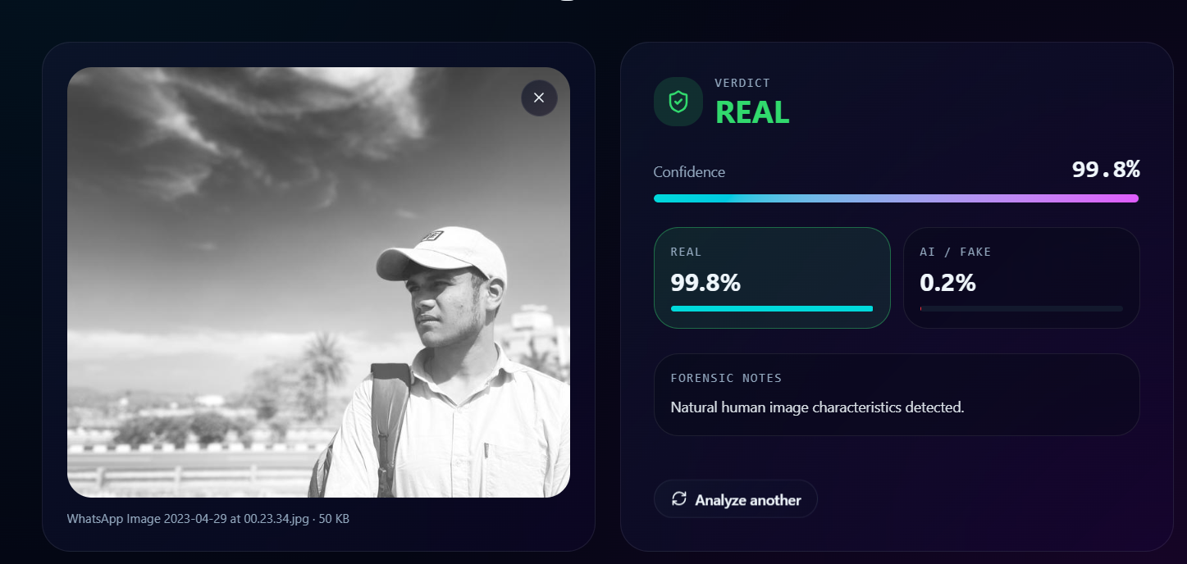

Figure 6.4: REAL Image Prediction Result

6.5 FAKE Prediction Result
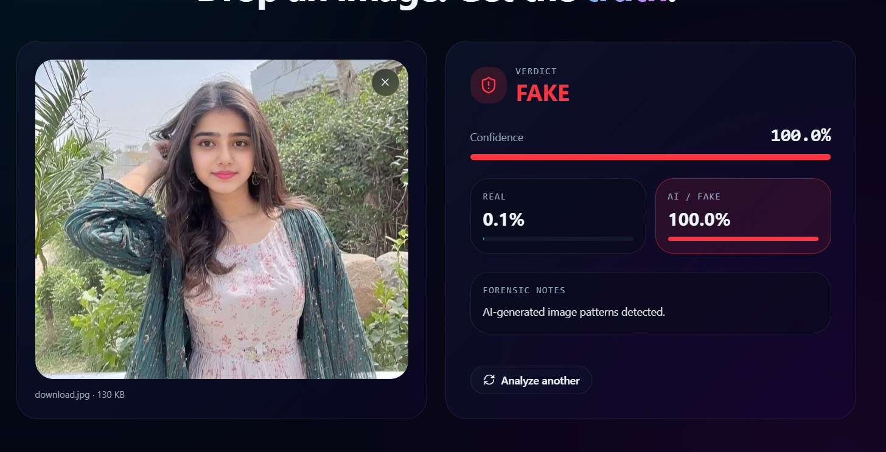
Figure 6.5: FAKE / AI-Generated Image Detection Result

6.6 AI Confidence Analysis
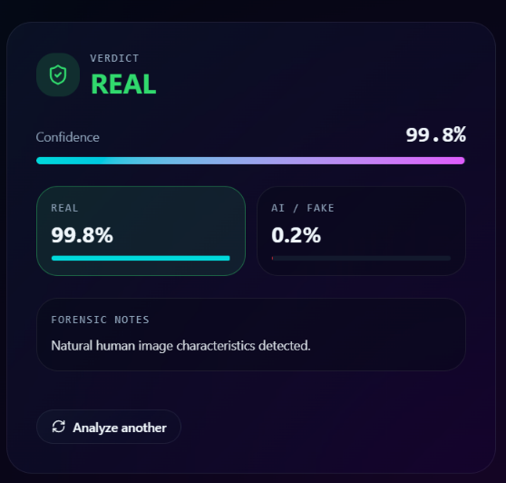
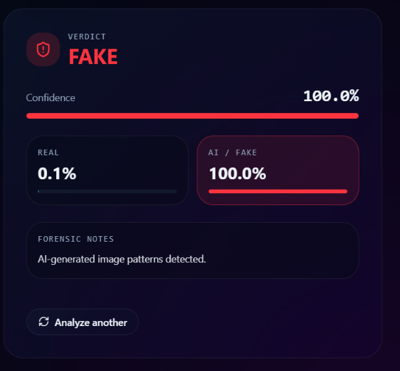

Figure 6.6 shows the AI confidence meter and probability analysis interface.

6.7 Responsive Mobile Interface
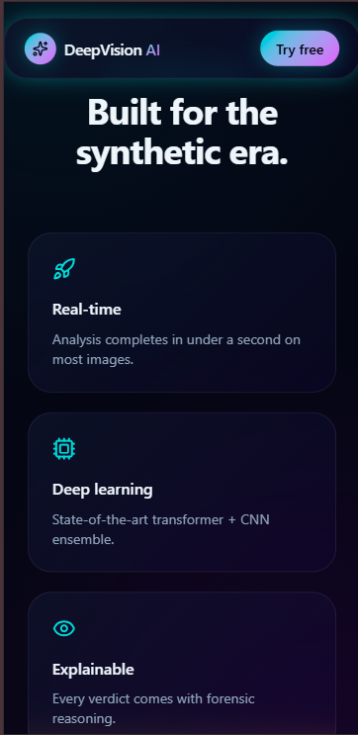
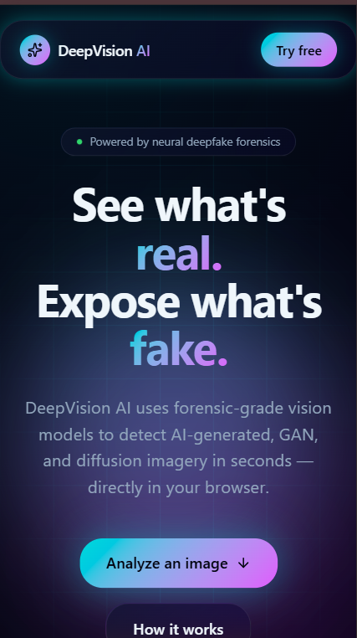

Figure 6.7: Responsive Mobile Interface
7. Bibliography / References
- Ian Goodfellow, Yoshua Bengio, and Aaron Courville, Deep Learning, MIT Press, 2016.
- Richard Szeliski, Computer Vision: Algorithms and Applications, Springer, 2022.
- Simon Haykin, Neural Networks and Learning Machines, Pearson Education, 3rd Edition, 2009.
- Aurelien Geron, Hands-On Machine Learning with Scikit-Learn, Keras, and TensorFlow, O’Reilly Media, 2022.
- Alex Krizhevsky, Ilya Sutskever, and Geoffrey Hinton, “ImageNet Classification with Deep Convolutional Neural Networks,” Advances in Neural Information Processing Systems (NIPS), 2012.
- PyTorch Official Documentation,
PyTorch Documentation
- OpenCV Official Documentation,
OpenCV Documentation
- Flask Official Documentation,
Flask Documentation
- React.js Official Documentation,
React Documentation
- Tailwind CSS Official Documentation,
Tailwind CSS Documentation
- Research Papers on Deepfake Detection and AI-Generated Image Detection from IEEE Xplore and Springer Journals.
- GitHub repositories and online tutorials related to CNN-based image classification and Deep Learning applications.
- Nature Scientific Reports Research Article on AI-generated image detection techniques.
- Sciencedirect Research Articles on deepfake detection, semantic analysis, and frequency-domain artifact detection.
- DeepVision AI Project Documentation and Implementation Report.

