Patrick Crowe

ITMD-411

Lab04

12/12/20

Admin credentials:

* Username: “Patrick Crowe”
* Password: “pac”

User credentials:

* Username: “Joe User”
* Password: “123”

Description:

This library of code is a working bulletin board tool. Users can submit tickets that they’d like everyone in the organization to see. Tickets have an ID and a name associated with them so that people know who’s requesting the change, and they have a description column that outlines the problem and perhaps a way to fix it. The last two columns of each ticket show what day the ticket was made and, if anyone has gotten around to fixing it, what day the ticket request was fulfilled. The software uses a database, so theoretically many users could access the database at once and see the same tickets, despite being on different machines with different hard drives. Every computer shares this database, so everything is synchronized.

If the user who logs in is an admin, they will have the additional opportunity to update a ticket or completely delete it. When an admin updates a ticket, it uses the admin’s name as the ticket_issuer, and the admin can change its description. Deleting a ticket doesn’t just list it as closed, instead it gets completely removed from the table view.

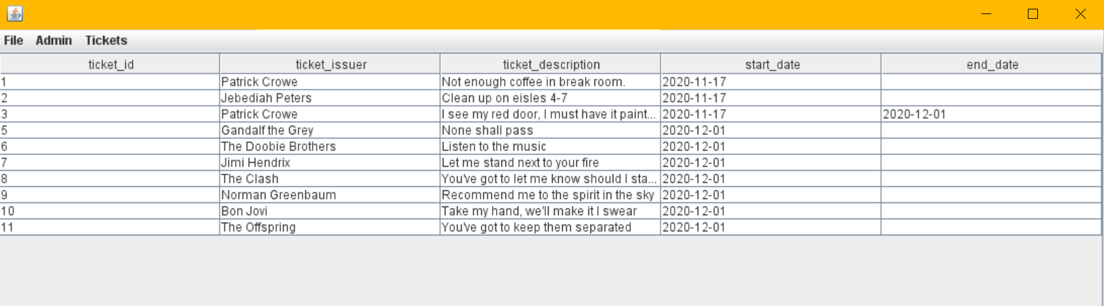

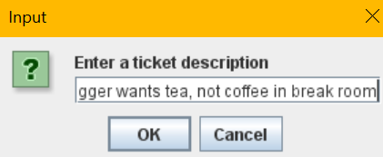



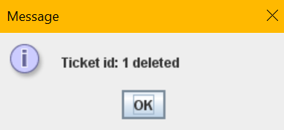

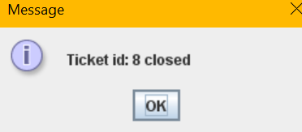

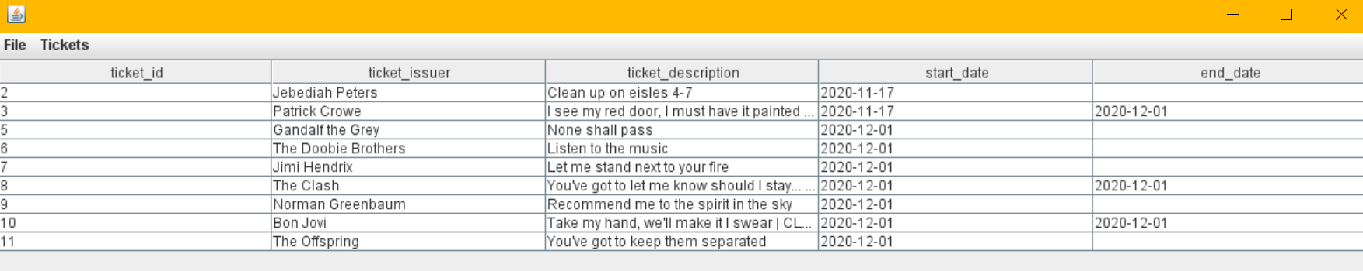

Extra Credit 1 (Git repository):

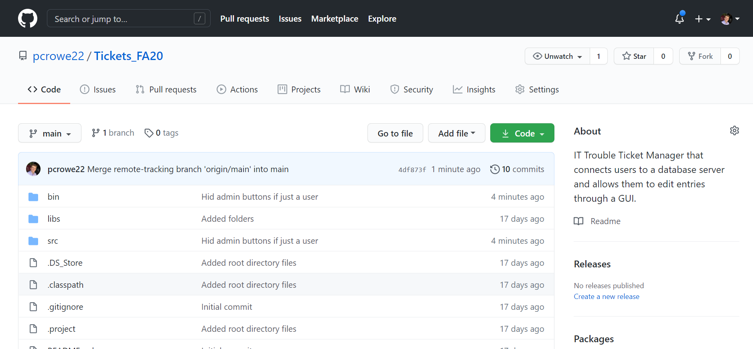

Extra Credit 2 (SQL Prepared Statements):

