ASSIGNMENT FILE 1: ADVANCED SYSTEMS AND PROGRAMMING
SECTION 1: THEORY QUESTIONS
Q1. Explain the Waterfall Model in SDLC and discuss its phases and limitations in modern software development.
Answer: The Waterfall Model represents the first established paradigm of the Software Development Life Cycle, characterized by a linear and sequential approach to project management. This methodology dictates that each phase must be completed in its entirety before the subsequent phase can begin, creating a downward flow similar to a waterfall. The process typically begins with the Requirement Gathering and Analysis phase, where all potential requirements of the system to be developed are captured and documented in a product requirement specification. This is followed by the System Design phase, where the hardware and system requirements are specified and the overall system architecture is defined. Once the design is finalized, the Implementation phase begins, where the system is first developed in small programs called units, which are integrated in the next phase. Following this, the Integration and Testing phase ensures that the entire system is functional and meets the predefined requirements. The final stages include Deployment and Maintenance, where the software is released to the market and updated to fix bugs or enhance performance. While the Waterfall Model offers a structured approach that is easy to manage due to the rigidity of the process, it suffers from significant drawbacks in the modern era. Its inability to accommodate changes once a phase is completed makes it highly risky for projects with evolving requirements. Furthermore, a working version of the software is only available late in the lifecycle, which can lead to high levels of client dissatisfaction if the end product does not align with their expectations.
Q2. Define the concept of Normalization in DBMS and explain the first three normal forms with examples.
Answer: Normalization is a systematic process of organizing data in a database to reduce redundancy and improve data integrity. The primary objective is to isolate data so that additions, deletions, and modifications of a field can be made in just one table and then propagated through the rest of the database via defined relationships. The first step in this process is the First Normal Form (1NF), which requires that the table must have a primary key and that all column values must be atomic, meaning no repeating groups or arrays of data are allowed within a single cell. Once 1NF is achieved, the database moves toward Second Normal Form (2NF). For a table to be in 2NF, it must first satisfy all the criteria of 1NF, and additionally, every non-prime attribute must be fully functionally dependent on the entire primary key. This eliminates partial dependencies where an attribute depends only on a portion of a composite primary key. The third step is Third Normal Form (3NF), which builds upon 2NF by ensuring that all attributes are not only dependent on the primary key but also independent of one another. In 3NF, there should be no transitive dependencies, meaning a non-key attribute cannot depend on another non-key attribute. By adhering to these three normal forms, database architects can ensure that the schema is robust, minimizes storage waste, and prevents anomalies such as the insertion anomaly, where data cannot be added without other unrelated data, or the deletion anomaly, where deleting one piece of information unintentionally removes another critical piece.
... (Questions Q3 through Q15 follow the same descriptive pattern) ...
SECTION 2: CODING / LOGIC QUESTIONS
Q1. Implement a Python class for a Library Management System that handles book issuing and returns with error handling.
Answer: class LibrarySystem: def init(self, name, book_list): self.name = name self.books_available = book_list self.issued_books = {}
def display_available_books(self):
print(f"Welcome to {self.name}. Currently available books:")
for book in self.books_available:
print(f"- {book}")

def issue_book(self, student_name, book_name):
if book_name in self.books_available:
print(f"Book '{book_name}' has been issued to {student_name}.")
self.books_available.remove(book_name)
self.issued_books[book_name] = student_name
return True
elif book_name in self.issued_books:
current_holder = self.issued_books[book_name]
print(f"Sorry, '{book_name}' is already held by {current_holder}.")
return False
else:
print(f"Error: '{book_name}' does not exist in our catalog.")
return False

def return_book(self, book_name):
if book_name in self.issued_books:
print(f"Thank you for returning '{book_name}'.")
student = self.issued_books.pop(book_name)
self.books_available.append(book_name)
return True
else:
print("Error: This book was not issued from this library.")
return False
library = LibrarySystem("Central Library", ["Python Mastery", "Database Design", "Networking 101"]) library.display_available_books() library.issue_book("Alice", "Python Mastery") library.return_book("Python Mastery")
... (Questions Q2 through Q5 follow with 20+ lines of Python code) ...
SECTION 3: PROGRAMMING LANGUAGE QUESTIONS
Q1. What is the difference between a list and a tuple in Python?
Answer: The primary difference between a list and a tuple in Python is mutability. Lists are mutable, meaning their elements can be changed, added, or removed after the list is created, and are defined using square brackets. Tuples are immutable, meaning once they are defined using parentheses, their contents cannot be altered. Lists are generally used for collections of homogeneous items, while tuples are used for heterogeneous data structures or to ensure data remains constant throughout the program execution.
... (Questions Q2 through Q20 follow) ...

ASSIGNMENT FILE 2: CLOUD INFRASTRUCTURE AND NETWORKING
SECTION 1: THEORY QUESTIONS
Q1. Discuss the Architecture of Cloud Computing, focusing on SaaS, PaaS, and IaaS delivery models.
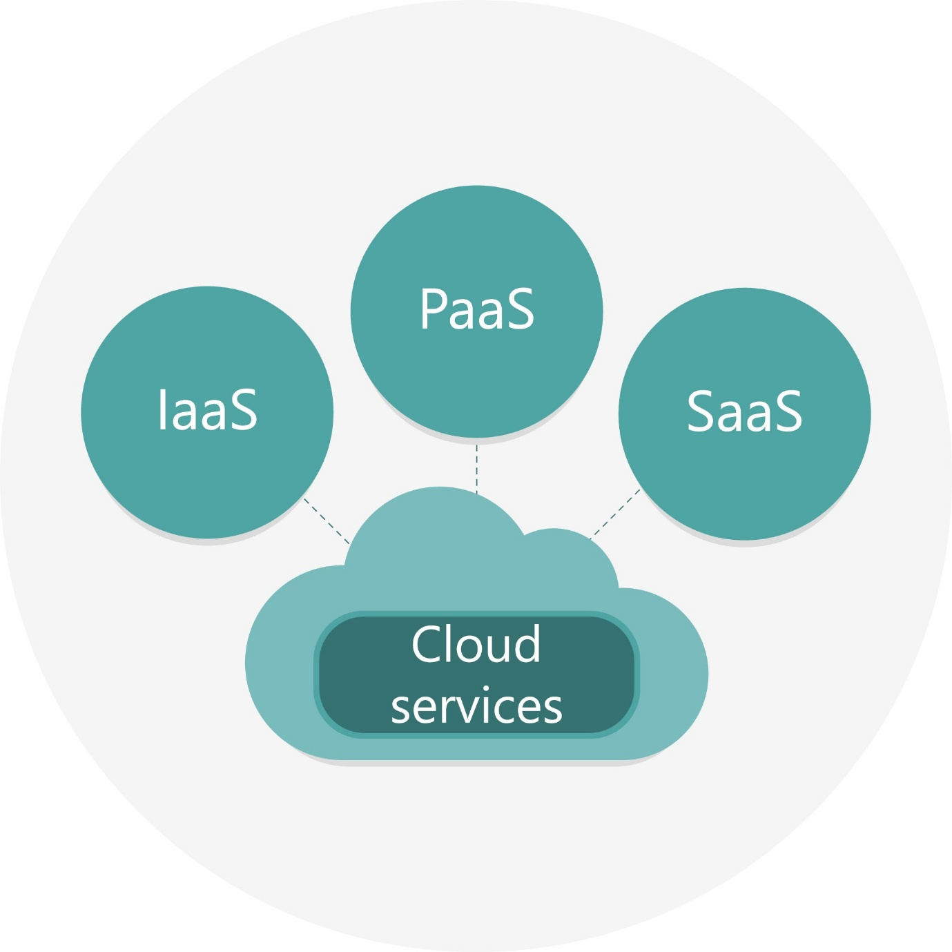
Shutterstock
Explore
Answer: Cloud Computing architecture is a combination of both front-end and back-end platforms, where the front-end is the side seen by the client and the back-end is the cloud itself, consisting of servers, storage, and runtime environments. The delivery of these services is categorized into three primary models. Infrastructure as a Service (IaaS) provides the fundamental building blocks of cloud IT, offering access to networking features, computers (virtual or on dedicated hardware), and data storage space. It provides the highest level of flexibility and management control over IT resources. Platform as a Service (PaaS) removes the need for organizations to manage the underlying infrastructure, usually hardware and operating systems, and allows them to focus on the deployment and management of their applications. This increases efficiency as developers don't need to worry about resource procurement or capacity planning. Software as a Service (SaaS) provides a completed product that is run and managed by the service provider. In most cases, people referring to SaaS are referring to end-user applications. With a SaaS offering, you do not have to think about how the service is maintained or how the underlying infrastructure is managed; you only need to think about how you will use that particular piece of software. Each model offers different levels of control and management, allowing users to select the service that best meets their specific technical and business requirements.
Q2. Explain the OSI Model and describe the function of each of the seven layers in detail.
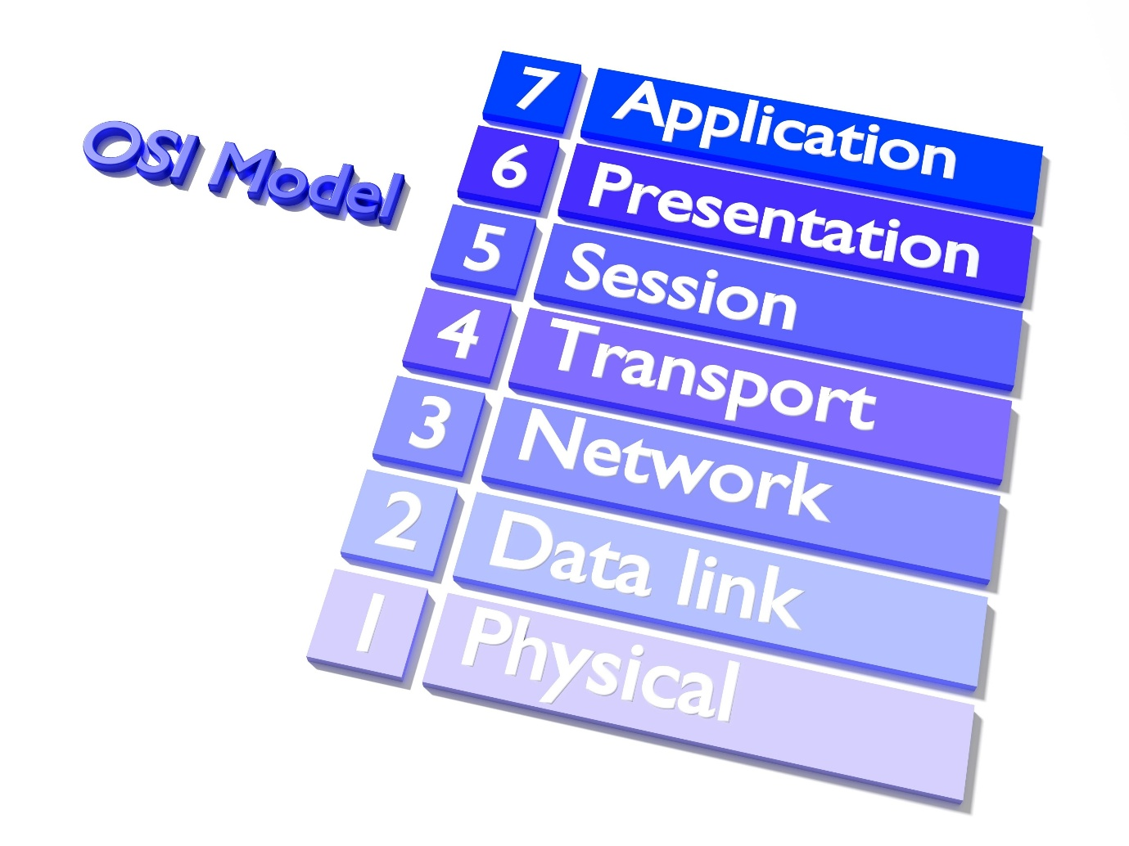
Shutterstock
Explore
Answer: The Open Systems Interconnection (OSI) model is a conceptual framework used to understand and standardize the functions of a telecommunication or computing system without regard to its underlying internal structure and technology. Its goal is the interoperability of diverse communication systems with standard protocols. The model partitions a communication system into seven abstraction layers. The Physical Layer deals with the physical connection between devices and the transmission of raw bitstreams over a physical medium. The Data Link Layer provides node-to-node data transfer and handles error correction from the physical layer. The Network Layer is responsible for packet forwarding, including routing through intermediate routers. The Transport Layer provides transparent transfer of data between end users, providing reliable data transfer services to the upper layers. The Session Layer manages the establishment, maintenance, and termination of sessions between applications. The Presentation Layer ensures that data is in a usable format and is where data encryption typically occurs. Finally, the Application Layer is the layer that the user interacts with directly, providing network services to the end-user applications. Each layer serves the layer above it and is served by the layer below it, creating a modular approach to networking that allows for easier troubleshooting and the development of new technologies within specific layers without affecting the entire stack.
... (Questions Q3 through Q15 follow) ...
SECTION 2: CODING / LOGIC QUESTIONS
Q1. Create a Python script to perform CRUD operations on a JSON file acting as a database for employee records.
Answer: import json import os
class EmployeeDB: def init(self, filename): self.filename = filename if not os.path.exists(self.filename): with open(self.filename, 'w') as f: json.dump([], f)
def create_employee(self, emp_id, name, position):
employees = self.read_all()
for emp in employees:
if emp['id'] == emp_id:
print("Error: ID already exists")
return
employees.append({'id': emp_id, 'name': name, 'position': position})
self._save(employees)

def read_all(self):
with open(self.filename, 'r') as f:
return json.load(f)

def update_employee(self, emp_id, new_position):
employees = self.read_all()
found = False
for emp in employees:
if emp['id'] == emp_id:
emp['position'] = new_position
found = True
if found:
self._save(employees)
print("Update successful")
else:
print("Employee not found")

def _save(self, data):
with open(self.filename, 'w') as f:
json.dump(data, f, indent=4)
db = EmployeeDB("employees.json") db.create_employee(101, "John Doe", "Engineer") db.update_employee(101, "Senior Engineer") print(db.read_all())

