Prison Management
System

ACKNOWLEDGEMENT

With immense pleasure, we record our deep sense of gratitude to our beloved principal Sri G.PRABHAKAR RAO, for permitting us to carry out this project.

We, with extreme jubilance and gratitude, would like to express our regards to
Sri M. SUBRAMANYAM M.Tech, Associate professor and Head of the Department for his constant encouragement and facilities provided to us to complete the project in time.

We heart fully thank gratitude to our guide Ms. O. Anitha, for being the source of inspiration and for her unceasing encouragement in successful completion of the project.

We are also thankful to all the teaching and non-teaching staff of our department who has rendered their kind cooperation in completion of this project work.

Last but not least, we are very thankful to one and all that helped us directly or indirectly in carrying out the project.

SIVA SUBBA NARSAIAH.CH
SUPRIYA.G
PRASANTHI.A
SWATHI.Y
VIJAYA SWAPNA.V

TABLE OF CONTENTS

ACKNOWLEDGEMENT
ABSTRACT
1. INTRODUCTION

2. SYSTEM SPECIFICATIONS

2.1 Hyper Text Markup Language
2.2 JavaScript
2.3 Tomcat Server

3. SYSTEM ANALYSIS

3.1 Existing System
3.2 Proposed System
3.3 Feasibility Analysis

4. SYSTEM REQUIREMENTS

4.1 Hardware Requirements
4.2 Software Requirements
4.3 Functional requirements
4.4 Features

5. SYSTEM DESIGN

5.1 ER Diagrams
5.2 Dataflow Diagrams
5.3 Context Analysis Diagrams

6. SYSTEM IMPLEMENTATION

6.1 List of Tables
6.2 Data Dictionary

7. TESTING

7.1 Code Testing
7.2 Specification Testing
7.3 System Testing
7.4 Unit Testing
7.5 Integrated Testing
7.6 Output Testing

8. CONCLUSION

APPENDIX-1

User Manual

APPENDIX-2

Sample Output Screens

BIBILIOGRAPHY

ABSTRACT
Prisons-together with the police, judiciary and security apparatus-are an integral part of any state as they play an important role with respect to prisoners' right. The Prison Management Systems (PMS) is an application, to give the Jail authorities the right tools to enhance efficiency of the administrative mechanism.
The application has allowed jail authorities to keep details pertaining to inmates, which includes category of the prisoner, criminal record, year of entry, prisoner number, photograph, personal details (age, address, information related to family members, etc), medical details, lodging etc.
This project mainly has the following functional Components
- Nominal Roll, Case Registers,
- Interview requests and In-out register
- Reports and release diary
The Prison Management System allows adopting a systematic and uniform approach to handle information about prisoners. This software also supports a record of movement of inmates inside and outside the jail, including court cases details about action taken during hearings.

Chapter -1

INTRODUCTION

INTRODUCTION

This project is aimed at developing a prison management system that is a collection of registers and reports for the effective management of prisons. This system should contain the modules like nominal roll, case register, parole register, Interview requests, In-out register and an automated release diary generator.

- NOMINAL ROLL: The details of the prisoner and his/her demographic details are captured. A digital photo comprising different views of the prisoner and the list of articles surrendered by prisoner during nominal roll are recorded.

2. CASE REGISTER: All the details of the cases against the prisoner are captured. This includes the sentence details, remand/conviction details, etc.

3. AUTOMATED RELEASE DAIRY: This report displays the list of prisoners to be released on a day, the next day, the next week, the next month, or any given duration of time. The system should consider the reduction of sentence length due to various considerations.

4. PAROLE REGISTER: This module keeps track of all prisoners on parole and provides necessary reports on this data.

5. INTERVIEW REQUESTS AND IN-OUT REGISTER: All interview requests by the relatives of the prisoners are recorded and tracked. An in-out register will track all prisoners and others who move in and out for various reasons. This includes provisions for recording the prisoners sent to courts for hearing.

6. Various status reports and demographical analysis reports are to be generated

What is prison management system?

Technology has evolved to a new stage today and what we could not achieve then in terms of closely monitoring the prisoners can be achieved now.

With the PMS, keeping track of all the inmates becomes easier. Previously inmates had to be checked and re-checked each time they are admitted, discharged or transferred.

Availability of up to date information provides prison officers with on-hand knowledge.

Why prison management system?
Prison management system, significantly increases jail facility efficiency and safety. Our comprehensive system integrates every aspect of jail management from day-to-day operations to inmate processing and tracking.
The system easily produces automated reports, including scheduling which keep personnel informed and prepared for duty.
PMS delivers the information needed to manage jails of virtually all sizes and complexity.

OVERVIEW OF PMS:

Visitor
Jailor
Nominal Roll
Case register
Parole register
Interview requests and In-out register

Release Diary
Prisoner-wise Reports
Visitor-wise Reports

Chapter-2

SYSTEM SPECIFICATIONS

SYSTEM SPECIFICATIONS

2.1 HTML

HTML stands for "Hypertext Markup Language". HTML is a SGML (Standard Generalized Markup Language) application widely used to create web pages. It is basically a formatting language and not a programming language.HTML is a language that is easy to write, easy to understand and highly portable. HTML is not a compiled language and is directly interpreted by a browser.HTML is the set of instructions. Each instruction is called as an element or Markup. It is used to structure and format documents for presentation on the web. HTML enhances ASCII files with markup tags that permit the display of a variety of fonts, images, and highlighting options. It also designates structural elements such as headers, lists, and paragraphs, and provides hypertext links to other documents on the Internet.

In plain English, for those of us who are not programming wizards, it is the language our web browser understands, so that it can display what the author of the page wanted us to see....and we can do some really neat stuff with it.

INTERACTIVE HTML:

HTML tag:

The first and last tags in a document should always be the HTML tags. These are the tags that tell a Web browser where the HTML in your document begins and ends. The absolute most basic of all possible Web documents is:

<Html >
</Html>
That's it. If we were to load such a page into a Web browser, it wouldn't do anything except give us a blank screen, but it is technically a valid Web page.

HEAD

The HEAD tags contain all of the document's header information. When I say "header," I don't mean what appears at the top of the browser window, but things like the document title and so on. Speaking of which...

BODY

BODY comes after the HEAD structure. Between the BODY tags, all of the stuff that gets displayed in the browser window is found. All of the text, the graphics, and links, and so on -- these things occur between the BODY tags.

FORMS

Forms provide a unique feature to HTML. Forms allow you to collect data from the end user and return that data to an executable code. The <FORM> element is used to start a form. The <FORM> element specifies what program to run when the form is submitted and how the data is to be transferred.

Attributes

ACTION-The ACTION attribute specifies what program or HTML file is to be called when the submit button is pressed. The ACTION is specified as a URL.
METHOD-The METHOD attribute specifies the protocol to be used when the client sends data to the server. There are two methods. GET (the default) or POST. Using GET method data is attached to the URL mentioned in ACTION attribute. The data that can be sent here is limited here. Where as in POST the data is posted through environment variables and unlimited amounts of data can be sent.
NAME-The NAME attribute specifies the name of the form with which the elements of the form can be referred to later.

THE <INPUT> ELEMENT

The <INPUT> tag provides some type of data entry in the form depending on the value of its type attribute.

Attributes

NAME-The NAME attribute is used to specify the name of the field.
VALUE-The VALUE attribute is used to specify a default value for the field.
TYPE –The TYPE attribute is used to specify what type of input mechanism is to be drawn on the screen. The permissible values are as follows:
- Text - The TEXT value is one line-text field.
- Password - The PASSWORD value is used for entering a password. The text typed in the box is not displayed.
- Checkbox - The CHECKBOX value provides the user with two choices, selected or not selected.
- Radio - The RADIO value is used to select one of many from a set of choices.
- Hidden - The HIDDEN value is used to hide information on the form. This data is not displayed but is returned to the server when submit button is selected.
- Submit - The SUBMIT value is used to draw a button on the screen that the user can select once the form is completed.
- Reset - The RESET value is used to draw a button on the screen that a user can select to reset the form to its original default values.
- Select - The SELECT value is used to select any one of the available options. It is a drop down list and the values are placed in SELECT using OPTION element.
- Text area - The TEXTAREA allows entering multiple lines of text.

THE <A> ELEMENT

The <A>tag is used to insert a hyperlink. Hyperlink is a feature of HTML, which allows to link to any document or external files from the current page.

Attributes
HREF - HREF stands for "Hypertext REFerence," which is another way of saying, "The location of the file I want to load." Most anchors are in the form <A HREF="URL">, where URL is the location of the resource to which you want the link to point. So the HREF attribute of the Anchor element specifies a URL.

THE <TABLE> ELEMENT

Table allows to create boundaries that make tables position easier in the creation of web pages. The <TABLE> element has four sub elements. They are Table Row<TR>, Table Header<TH>, Table Data<TD> and Caption<CAPTION>.

Attributes:
BORDER – The <BORDER> attribute sets the border of the table.
Cell Spacing- It represents the space between the cells.
Cell Padding – It represents the space between the cell border and the cell contents.
WIDTH – The <WIDTH> attribute sets the width of the table and its cells.

IMAGE TAG:

Images are placed in Web documents using the IMG tag. This tag is empty, and therefore has no closing tag. The basic form of the image tag is <IMG>, but just like <A>, <IMG> by itself is pointless-- it will do nothing.

Visually speaking, images are part of a Web document, but in reality an HTML file and any graphics it refers to are actually all separate files. In other words, one HTML file which has five graphics within it makes a total of six files required to make the page look right. These files are all stored on a Web server, but don't have to all be in the same exact place. (Often, server administrators will set up separate directories for pictures.)

In order to make the IMG tag work, you need to use an SRC attribute. SRC stands for "source," as in, "the source of this graphic." (One way to read a typical image tag is "image source equals...".) The value of SRC is the URL of the graphic you want to have displayed on your Web page. Thus, a typical image tag will take the form:
<IMG SRC="URL of graphic">
The URL of the graphic is just like the URLs used in the anchor tag except in this case the location used is that of the graphic file. A graphic named "blat.gif" located
in the directory "pics" on the server "www.site.edu" would have the URL http://www.site.edu/pics/blat.gif. You can use either relative or full URLs to refer to the graphic file.

2.2 JAVA SCRIPT

Java Script is Netscape’s cross–platform, object-based scripting language for client server application. JavaScript is mainly used as a client side scripting language. This means that JavaScript code is written into an HTML page. When a user requests an HTML page with JavaScript in it, the script is sent to the browser and it's up to the browser to do something with it. JavaScript can be used in other contexts than a Web browser. Netscape created server-side JavaScript as a CGI-language that can do roughly the same as Perl or ASP.
Fortunately most browsers can handle JavaScript nowadays, but of course some browsers do not support some bits of script.
Types of Java Script:
- Navigator Java Script also called client-side Java Script.
- Live Wire Java Script also called server-side Java Script.

Using Java Script, dynamic HTML pages can be created that process user input and maintain persistent data using special objects, files and relational databases. Browser interprets JavaScript statements embedded in an HTML page. Netscape Navigator 2.0 and Internet Explorer 3.0 versions and later recognize Java Script. Through JavaScript Live Connect functionally, application can access Java and CORBA distributed-object applications. Navigator 3.0 and later versions supports Live Connect.

CLIENT-SIDE
ADDITION
(SUCH AS WINDOW AND
HISTORY)
CORE JAVASCRIPT
CORE LANGUAGE
FEATURES SUCH
AS VARIABLE,
FUNCTIONS AND
LIVE CONNECT
CLIENT-SIDE
SERVER-SIDE
ADDITIONS
(SUCH AS SERVER AND
DATABASE)
SERVER-SIDE
Client- side JavaScript
Server-side and client-side share the same core language (ECMA-262), the scripting language standardized by the European standards body which contains core objects, other features like expressions, statements and operators. The main modules of JavaScript are Core and DOM.
Features of JavaScript (JS)
- Browser interprets JavaScript.
- JavaScript is object based and uses built-in, extensible objects and have no classes or inheritance
- JavaScript is loosely typed language
- In JavaScript object reference are checked at runtime
- JavaScript is designed to supplement the capabilities of HTML with script that are capable of responding to web pages events. JSP has access to some extent of aspects of the web browser window.
- JavaScript control browser and content but cannot draw graphics or perform networking.

Client-Side JavaScript Features

Client–side JavaScript has expressly been developed for use in a web browser in conjunction with HTML pages. This has certain consequences for security.

- JavaScript cannot read files from or write them to the file system on the computer. This would be a clear security hazard
- JavaScript cannot execute any other programs. This would also be unacceptable.
- JavaScript cannot establish any connection to whatever computer, except to download a new HTML page or to send mail. This, too, would create unacceptable hazards.

The Client-Side JavaScript also has the following features:
- Controls Document’s appearance and content
- Control the browser
- Interact with the HTML forms
- Interact with the user
- Read and write client state with cookies

Server- Side JavaScript Features

- Embedded in HTML page
- Executed at the server
- Pre-complied for faster response
- Access to Server-side objects
- Encapsulation of the request

2.3 APACHE TOMCAT SERVER
Apache Tomcat is a web container developed at the Apache Software Foundation (ASF). Tomcat implements the servlet and the Java Server Pages (JSP) specifications from Sun Microsystems, providing an environment for Java code to run in cooperation with a web server. It adds tools for configuration and management but can also be configured by editing configuration files that are normally XML-formatted. Tomcat includes its own HTTP server internally.

Environment
Tomcat is a web server that supports servlets and JSPs. The accompanying Tomcat Jasper compiler compiles JSPs into servlets.
The Tomcat servlet engine is often used in combination with an Apache HTTP Server or other web servers. Tomcat can also function as an independent web server. Earlier in its development, the perception existed that standalone Tomcat was only suitable for development environments and other environments with minimal requirements for speed and transaction handling. However, that perception no longer exists; Tomcat is increasingly used as a standalone web server in high-traffic, high-availability environments.
Tomcat is cross-platform, running on any operating system that has a Java Runtime Environment.
The following properties can be specified, either as system properties, or by using a deployer.properties file located in the root folder of the deployed package:
- build: The build folder used will be, by default, ${build}/webapp${path}. After the end of the execution of the compile target, the web application WAR will be located at ${build}/webapp${path}.war.
- Webapp: Folder containing the expanded web application which will be compiled and validated. By default, the folder is myapp.
- Path: Deployed context path of the web application, by default /myapp.
- URL: Absolute URL to the manager web application of a running Tomcat server, which will be used to deploy and undeploy the web application. By default, the deployer will attempt to access a Tomcat instance running on local host, at http://localhost:8080/manager.
- Username: Username to be used to connect to the Tomcat manager.
- password: Password to be used to connect to the Tomcat manager
T A web application which is programmatically developed by the developer is stored in the webapp folder and WEB-INF folder also saved in that location which consists of folder named classes which supports to run application automatically.
The deployer package includes a ready to use Ant script, with the following targets:
- Compile (default): Compile and validate the web application. This can be used standalone, and does not need a running Tomcat server. The compiled application will only run on the associated Tomcat 5.0.x server release, and is not guaranteed to work on another Tomcat release, as the code generated by Jasper depends on its runtime component. It should also be noted that this target will also compile automatically any Java source file located in the /WEB-INF/classes folder of the web application.
- deploy: Deploy a web application (compiled or not) to a Tomcat server
- undeploy: Undeploy a web application
- start: Start web application
- reload: Reload web application
- stop: Stop web application

Chapter -3

SYSTEM ANALYSIS

3. SYSTEM ANALYSIS

System analysis is the first stage according to system development life cycle method. This system analysis is a process that starts with the analyst.

Analysis is the detail study of various operations performed by a system and their relationships within and outside the system. One aspect of analysis is to define the boundaries of the system and determine whether or not a candidate should consider other related systems. During analysis, data is collected from the available file, decision file and transactions handled by the present system.

Logical system models and tools are used in analysis. Training, experience and common sense are required for collection of the information needed to do the analysis.

The various stages of analysis are
• Existing system
• Proposed system
• Feasibility study

3.1 EXISTING SYSTEM:

In the existing system, the jailor has to check the release dairy for releasing dates of the prisoners in order to find the list of prisoners who are going to be released on that particular day.

In the past system, its very complex to find the details of a particular prisoner, visitor as well as case details. This system doesn’t provide security for the data base. Because it can be accessed by any unauthorized person.
In addition to that it cannot manage the details of the parole.

3.2 PROPOSED SYSTEM:

- It is very flexible and saves the time of the staff.
- In the proposed system, it is easy to search the details of a particular prisoner by using the prisoner id which makes the user comfortable while finding the details.
- It provides role based security, providing access based on an individual’s need to know and authority to change data.
- It can also manage the details of the parole like name of reference, address of reference, no of visits etc…….
- In this system, it is very easy to the jailor to know the prisoners who are going to be released on that day by providing alert boxes, as soon as the jailor logins without checking the release dairy separately for the release dates.

3.3 FEASIBILITY STUDY:

Feasibility study is conducted once the problem is clearly understood. The feasibility study which is a high level capsule version of the entire system analysis and design process. The objective is to determine whether the proposed system is feasible or not and it helps us to the minimum expense of how to solve the problem and to determine, if the
problem is worth solving. The following are the three important tests that
have been carried out for feasibility study.

1. Technical Feasibility
2. Economical Feasibility
3. Operation Feasibility

Technical Feasibility:

In the technical feasibility study, one has to test whether the proposed system can be developed using existing technology or not. It is planned to implement the proposed system in JSP. The project entitled “Prison Management” is technically feasible because of the following reasons.
• All necessary technology exists to develop the system.
• The existing system is so flexible that it can be developed further.

Economical Feasibility:

As a part of this, the costs and benefits associated with the proposed systems are to be compared. The project is economically feasible only if tangible and intangible benefits outweigh the cost. We can say the proposed system is feasible based on the following grounds.
• The cost of developing the full system is reasonable.
• The cost of hardware and software for the application is less.

Operational Feasibility:

The project is operationally feasible because there is sufficient support from the project management and the users of the proposed system. Proposed system definitely does not harm and will not produce the bad results and no problem will arise after implementation of the system.

Chapter-4

SYSTEM REQUIREMENTS

4. SYSTEM REQUIREMENTS

4.1 SOFTWARE REQUIREMENTS

Operating System: Windows XP/95/2000
DBMS : SQL server
Web application server: Apache Tomcat 5.0
Others: Servlets, JSP, HTML, JavaScript

4.2 HARDWARE REQUIREMENTS

Processor: Pentium III (minimum)
RAM: 64MB (technology SDRAM)
Cache memory: installed size 512KB
Storage device: 20GB HDD
Display device: 14” color monitor

4.3 FUNCTIONAL REQUIREMENTS:

Functional requirements capture the intended behavior of the system .This behavioral is expressed as services, tasks or functions the system is required to perform.
It uses very low resources while running .It uses java server like TOMCAT.
That can be used freely and also requires the database. We could use SQL server.
Functional components of Prison Management System are
Only two types of users are available in this system visitors and Jailor.

JAILOR:

A system contains login. A login box should appear when the system is invoked. This system provides support for data entry module for nominal roll, case register for each prisoner entering the prison. Whenever jailor enters the username and password he will enter into a new web page that consists of modules. All these are available for jailor only.

Nominal roll:

Whenever the jailor enters the nominal roll module the details of the required prisoner will be displayed and whenever new prisoner enters then the details of the new prisoner will be registered using the registration form. Here, the prisoner details are dynamically updated to the database.

Case register:

Whenever the jailor enters the case register module the details namely case-id, description and type of the particular case will be displayed for a required prisoner.

Automated release dairy generator:

This module displays the list of prisoners who are to be released on that particular date. This also considers the reduction of sentence length based on their conduct and recommendations.
As soon as the jailor logins he will be provided with an alert box which displays the list of prisoners who are to be released on that day.

Parole register:

This module tracks all prisoners on parole and provides necessary reports on this data.

Interview requests and In-out register:

All interview requests by the relatives of the prisoner need to be recorded and tracked. An in-out register track all the prisoners and others who move in and out for various reasons. It also includes in-time and out-time of them.

VISITOR:

Visitor has to enroll his/her details before entering into the prison.

4.4 FEATURES OF PRISON MANAGEMENT SYSTEM

- PMS has only two types of users Visitors, jailor.
- It has Data entry module for nominal roll, case register for each prisoner entering in prison.
- It provides alert box, displaying the list of prisoners to be released on that day.
It has a release dairy module where it displays the list of prisoners to be released on the next day, next month, and next year.
- It supports Interview requests & in-out register modules for visitors.
- It generates visitor reports prisoner wise and visitor wise.

Chapter-5

SYSTEM DESIGN

5.1ENTITY RELATIONSHIP DIAGRAMS

Username
Password
Log-out
Jailor
Nominal Roll
Case Register
Parole Register
Release diary Register
In-out Register
Prisoner id
Last date
Front snap
Address
Entry date
Case id
Prisoner name
Case id
Description
Type
Address of reference
Exit date
Entry date
Name of reference
Prisoner id
JAILOR:
Figure 5.1.2

VISITOR:
Visitor
Visitor
Visit details
Visitorid
Prisoner id
Visit date
End time
Start time
Registered on
Relation to prisoner
No of Visits
Visitor id
Visitorname
Figure 5.1.2

5.2 DATA FLOW DIAGRAMS

It is known that the software can be easily understood by viewing the data flow diagrams. They show how the data flow and how the process is going on. There are different levels of dataflow diagrams. In the context level diagram the input will pass the values and the main process of the project will perform the process and sends the results to the output. The level diagram will show the complete flow of the project. The level diagrams will depend upon the number of modules in the project. For example, if there will be four levels, and if each level has got the sublevels they also can be seen. Each of the work has got its own symbol, with which they can be understood easily. The symbols used in the data flow diagrams are as follows.

Rectangle: It is used for data store

Half Rectangle: It is used for database
store.

JAILOR:

JAILOR
NOMINAL ROLL
IN-OUT REGISTER
PAROLE REGISTER
RELEASE DAIRY
CASE REGISTER
UPDATE DETAILS
VIEW OLD NOMINAL ROLL
ADD NEW NOMINAL ROLL
ADD NEW CASE DETAILS
VIEW OLD CASE DETAILS
NEXT DAY RELEASES
NEXT WEEK RELEASES
NEXT MONTH RELEASES
ADD NEW PAROLES
VIEW OLD PAROLE DETAILS
VISITOR DETAILS
PRISONER DETAILS

Figure 5.2.1

VISITOR:

VISITOR
NEW VISITOR
PREVIOUS VISITOR
ADD DETAILS
ENTERS START & END TIME
ENTERS START & END TIME
Figure 5.2.2

5.3 CONTEXT ANALYSIS DIAGRAM

PMS
Nominal roll
In-out register
Case register
Parole register
Automated diary register
Figure 5.3.1

Chapter-6

SYSTEM IMPLEMENTATION

SYSTEM IMPLEMENTATION

6.1 DATABASE DESIGN

NOMINAL ROLL

No. | Field Name | Data Type | Description
1 | Prisoner id | Integer | Primary key
2 | Case id | Integer | foreign key
3 | Name | Varchar | NOT NULL
4 | Sex | Varchar | NOT NULL
5 | Type | Varchar | NOT NULL
6 | Entry-date | Varchar | NOT NULL
7 | Last-date | Varchar | NOT NULL
8 | Duration of sentence | Integer | NOT NULL
9 | Height | Integer | NOT NULL
10 | Weight | Integer | NOT NULL
11 | Front-snap | Varchar | NOT NULL
12 | Left-snap | Varchar | NOT NULL
13 | Right-snap | Varchar | NOT NULL
14 | Address | Varchar | NOT NULL
15 | Status | Varchar | NOT NULL

CASE REGISTER

No. | Field Name | Data Type | Description
1 | Case id | Integer | Primary key
2 | Description | Varchar | NOT NULL
3 | Type | Varchar | NOT NULL

PAROLE REGISTER

No. | Field Name | Data Type | Description
1 | Prisoner id | Integer | Foreign key
2 | Name of Reference | Varchar | NOT NULL
3 | Address of Reference | Varchar | NOT NULL
4 | Entry-date | Varchar | NOT NULL
5 | Exit-date | Varchar | NOT NULL
6 | Remand frequency days | Integer | NOT NULL
7 | Last remand visit status | Varchar | NOT NULL
8 | Last visited on | Varchar | NOT NULL

VISIT TABLE

No. | Field Name | Data type | Description
1 | Visitor id | Integer | Foreign key
2 | Prisoner id | Integer | Foreign key
3 | Visit date | Varchar | NOT NULL
4 | Start time | Varchar | NOT NULL
5 | End time | Varchar | NOT NULL
6 | Status | Varchar | NOT NULL
7 | Remarks | Varchar | NULL
8 | Type | Varchar | NOT NULL

VISITOR TABLE

No. | Field Name | Data type | Description
1 | Visitor id | Integer | Primary key
2 | Visitor name | Text | NOT NULL
3 | Registered on | Varchar | NOT NULL
4 | Relation to Prisoner | Text | NOT NULL
5 | Age | Integer | NOT NULL
6 | Sex | Char | NOT NULL
7 | No of visits | Integer | NOT NULL
8 | Status | Char | NOT NULL
9 | Remarks | Varchar | NULL

6.2 DATA DICTIONARY:

A set of data descriptions that can be shared by several applications. A data dictionary enables abstraction of services and provisioning action into a database schema. The database defined by the data dictionary is transient and exists in memory only for the duration of the transaction and is called the virtual database (VDB)
Applications manipulate services in the data dictionary by performing permitted sql operations. Medan i3 uses configured rules to interpret these sql
Commands into operations on external network elements such as telephone switches.
The Data dictionary and the VDB are optional in a Medan i3 implementation.

Chapter-7

TESTING

TESTING

Testing is the debugging program is one of the most critical aspects of the computer programming triggers, without programming that works, the system would never produce an output of which it was designed. Testing is best performed when user development is asked to assist in identifying all errors and bugs. The sample data are used for testing. It is not quantity but quality of the data used the matters of testing. Testing is aimed at ensuring that the system was accurately an efficiently before live operation commands.

CODE TESTING:

This examines the logic of the program. For example, the logic for updating various sample data and with the sample files and directories were tested and verified.

SPECIFICATION TESTING:

Executing this specification starting what the program should do and how it should performed under various conditions. Test cases for various situation and combination of condition in all the modules are tested.

SYSTEM TESTING:

Once the individual module testing is completed, modules are assembled and integrated to perform as a system. The top down testing, which began from upper level to lower level module, was carried out to check whether the entire system is performing satisfactorily.

UNIT TESTING:

In the unit testing we test each module individually and integrate with the overall system. Unit testing focuses verification efforts on the smallest unit of software design in the module. This is also known as module testing. The module of the system is tested separately. This testing is carried out during programming stage itself. In the testing step each module is found to work satisfactorily as regard to expected output from the module. There are some validation checks for fields also. For example the validation check is done for varying the user input given by the user which validity of the data entered. It is very easy to find error debut the system.

INTEGRATED TESTING:

Data can be lost across an interface, one module can have an adverse effort on the other sub functions, when combined, may not produce the desired major functions.
Integrated testing is the systematic testing for constructing the uncover errors within the interface. The testing was done with sample data. The developed system has run successfully for this sample data. The need for integrated test is to find the overall system Performance.

OUTPUT TESTING:

After performance of the validation testing, the next step is output testing. The output displayed or generated by the system under consideration is tested by asking the user about the format required by system. The output format on the screen is found to be correct as format was designed in the system phase according to the user needs. Hence the output testing does not result in any correction in the system.

Chapter-8

CONCLUSION

CONCLUSION

This project has all the features necessary to maintain prisoners in a jail. It can maintain the list of prisoners in that jail and also the list of visitors, who visit the jail to meet the prisoners. It even maintains the list of cases. All these details can be easily accessed which makes it much flexible. It can be centralized so that it can be used all over the country.
Administrators with an efficient and comprehensive management system that benefits every aspect of your everyday operations.
With a superior jail management system users can:
- Increase jail efficiency with customized modules to handle visitation, officer logs, sentencing, adjustments and classifications.
- Save time and eliminate errors with easily accessible information
- Find what you need and eliminate re-entry with advanced search capabilities
- Uniquely and consistently manage across multiple facilities
- Effectively manage visitors
- Customize your facilities own pre-determined codes
- Accurately and uniformly enter data
- Conduct fast path booking procedure

Appendix-1

USER MANUAL

SERVLETS

INTRODUCTION:

Servlets are protocol and platform independent server side modules, written in java that execute on the server side of the web connection. Just like an Applet, it dynamically extends the functionality of a web server. The servlet API wraps up the HTTP protocol so we can put java on the server side of the HTTP connection and deals with the client in HTML and HTTP.
Servlets are:
- Portable
- Extensible
- Persistent
- Robust

SERVLET ARCHITECTURE OVERVIEW

Servlet
Generic Servlet
HTTP Servlet
Your custom
Servlet

DESCRIPTION:

The basic architecture contains an interface and two classes, Servlet, Generic Servlet and HTTP Servlet respectively. When a servlet accepts a call from a client, it receives two objects.
A ServletRequest, which encapsulates the communication from the client to the server.
A ServletResponse, which encapsulates the communication from the server to the client.
JSDK provides all class libraries for creating Servlets Life Cycle. There are three methods to the Servlets life cycle. They are
init( )
service ( )
destroy ( )

LIFE CYCLE OF A SERVLET
Life cycle of a servlet is depicted below:
init()
service()

destroy()
Client
(Browser)

Request
Response
These methods are implemented by Servlets and invoked at a specific time by the server.
The Servlets API contains two packages for building Servlets. They are
Javax.servlet
Javax.servlet.http
The javax.servlet Package (contd ...)

A brief description of the classes and interfaces are as follows:

Class/Interface Name | Description
HTTPServlet class | Provides a HTTP specific implementation of the Servlet interface.
HTTPServletRequest interface | Provides methods to process requests from the clients.

Javax.servlet:
It contains number of interfaces and classes that establish the framework in which Servlet operate.
The interfaces are:
Servlet : Declares life cycle for the servlet.
ServletConfig : Allows servlets to get initialization parameters.
ServletContext : Enables servlets to log events and access information about their environment.
ServletRequest : Used to read the data from a client request.
ServletResponse : Used to write the data to a client response.
SingleThreadModel : Indicates that the Servlet is threading safe.

The Classes are:
Generic servlet : Implements the Servlet and ServletConfig Interfaces.
ServletInputSream : Provides an input stream for reading request from a client.
ServletOutputStream : Provides an output stream for writing request from a client.
ServletException : Indicates that a Servlet error occurred.
Unavailable Exception : Indicates that Servlet is permanently or temporarily unavailable.

Javax.Servlet.http:
Its functionality makes it to build servlet that works with HTTP request and response. It contains no. of interfaces and classes that establish the framework in which servlet operate.
The interfaces are:
HttpServletRequest : Enables servlets to read data from a Http request
HttpServletResponse : Enable to write data to a Http response.
HttpSession : Allows session data to be read and written.
HttpSessionBindingListener: Informs an object that it is bound to or unbound from a session.
HttpSessionContext : Allows Session to be managed.

JAVA SERVER PAGES

INTRODUCTION:

JSP technology enables you to mix regular static html with dynamically generated content from servlets. Separating the static html from the dynamic content provides a number of benefits over servlets alone.

Why use JSP

JSP is easy to learn and allows developers to quickly produce web sites and application in an open and standard way. JSP is based on java, an object-oriented language. Jsp offers a robust platform for web development.

Main reasons to jsp:
- multi platform
- component reuse by using java beans and Ejb
- Advantages of java

We can take one jsp file and move it to another platform, web server or Jsp servlet engine.

JSP compared to ASP

Jsp and asp are fairly similar in the functionality that they provide. Jsp may have slightly higher learning curve. Both allow embedded code in an html page, session variables Platform i.e., NT, JSP can operate on any platform that conforms to the J2EE specification. Jsp allow component reuse by using java beans and ejbs. Asp provides the use of Com/activeX controls.

JSP compared to servlets:

A servlet is java class that provides special server side service. It is hard to write HTML code in servlets. In servlets you need to have lots of println statement to generate HTML.

DESCRIPTION:

JSP looks like html, but they get compiled into java servlets the first time they are invoked. The resulting servlet is a combination of the html from the jsp file and embedded dynamic content specified by the new tags. That is not to say that jsps must contain html. Some of them contain only java code; this is particularly useful when the jsp is responsible for a particular task like maintaining application flow.

Everything in sp can be broken into 2 categories:
1. Elements that are processed on the server.
2. Template data, or everything other than elements, that the engine processing the jsp ignores.

A jsp page is executed by a jsp engine or container, which is installed on a web server, or on an application server. When the client asks for a jsp resource the engine wraps up that request and response object to incorporate the communication with the client. The container then wraps up the underlying layer for a jsp that of a servlet implementation. The abstractions of the request and response are the same as the javax.servlet.ServletRequest and javax.servlet.ServletReesponse respectively.

JSP ARCHITECTURE:

JSP are built on top of sun’s servlet technology. JSP is essentially an html page with special jsp tags embedded. These JSP tags can contain java code. The JSP file extension is .JSP rather than .htm or .html. The JSP engine parses the .JSP and creates a java servlet source file. It then compiles the source file into a class file, this is done the first time and this why the JSP is probably slower the first time it is accessed. Any time after this, the special compiled servlet is executed and is therefore returns faster.

STEPS REQUIRED FOR A JSP REQUEST:

- The user goes to a web site made using jsp. The user goes to a jsp page. The web browser makes the request via the internet.
- The jsp request gets sent to the web server
- The web server recognizes that the file required is special (.jsp), therefore passes the jsp file to the jsp servlet engine.
- If the jsp file has been called the first time, the jsp file is parsed, otherwise go to step 7
- The next step is to generate a special servlet form the jsp file. The entire html required is converted to println statements.
- The servlet source code is compiled into a class
- The servlet is instantiated, calling the init and service methods
- Html from the servlet output is sent via the internet
- Html results are displayed on the user’s web browser.
Servlets are server-side java programs that can be deployed on a web server.
The servlet interface provides the basic frame work for coding servlets.

Java Server Pages, SQL, HTML Forms and Databases

This section examines how to communicate with a database from Java. We have already seen how to interface an HTML Form and a JSP. Now we have to see how that JSP can talk to a database. The objectives of this section are to understand how to:

- Administratively register databases.
- Connect a JSP to an Access database.
- Insert records in a database using JSP.
- Inserting data from HTML Form in a database using JSP.
- Delete Records from Database based on Criteria from HTML Form.
- Retrieve data from a database using JSP – result sets.
- Apply SQL operations like sort, create table, and remove table, delete, and Access-based arithmetic functions.

JSP Declarations:

Used to define page level variables and methods are placed with in the <%!and %> tags and always end with a semicolon.
Example:
<%!
int i=0;
int j=0;
int z=0;%>

JSP Scriptlets:

Consists of valid code snippets enclosed with in the <% and %> JSP tags.
Example:
To accept the user name and display the name 10 times:
<%@ page import=”java.util.*” %>
<%@ page import=”java” %>
<HTML><BODY>
<%out.println(“<HTML>”);
out.println (“<BODY>”);
out.println (“<BODY>”);
out.println (“<HTML>”) ;%>
</BODY></HTML>

JSP Expressions:

Used to directly insert values into the output
Example :< %=msg %>

JSP Implicit Objects:

Are predefined variables that can be included in JSP expressions and scriptlets can be created:
1. Implicitly by using directives.
2 .Explicitly by using standard actions.
3. Directly by declaring objects with in scriptlets.

Include variables such as
PAGE: To represent the current instance of the jsp page.
REQUEST: To represent an object of HTTP Servlet request used to retrieve the request data.
RESPONSE: To represent an object of HTTP servlet response used to write the HTML response output.
JSP Actions:

<jsp: useBean> : To find and load an existing bean.
Attributes used are: ID, class, scope and Bean name.
<jsp: getProperty>: To retrieve the property of the specified bean and direct it as output.
Attributes used are: Name and Property.
<jsp: setProperty>: To set the property of specified bean.
Attributes used are: Name, Property, Value and Param.
<jsp: forward> : To forward a request to a different page.
Attribute used is Page.
<jsp: param> : Used as a sub attribute with jsp: include and jsp: forward to pass additional request parameters.
Attributes used are Name and Value.
<jsp: include> : To insert a file into a particular jsp page.
Attributes used are Page and Flush.

JDBC

INTRODUCTION:

Database clients use database drivers to send sql statements to database servers and to receive result sets and other response from the servers. Java applications and applets use jdbc drivers to communicate with database servers.

DESCRIPTION:

The fundamental issues encountered when writing any database application are
1. Creating a database
We can either create a database outside of java, via tools supplied by database vendor or via SQL statements fed to the database from a java program.
2. Connecting to an ODBC data source:
An ODBC data source is a database that is registered with the ODBC driver .In java we can use either the JDBC to ODBC bridge or JDBC and vendor specific bridge to connect to the data source.
3. Inserting information into a database:
Again, we can enter data outside of java using database specific tools or
With SQL statements sent by java program.
4. Selectively retrieving information we can use SQL commands from java we get results and then use java to display or manipulate that data.
5. Establishing a connection:
The first thing you need to do is establishing connection with the DBMS you want to use. This involves two steps:
1: Loading Drivers
2: Making Connections

Loading drivers:

For loading a driver we use the static method forName of the class.
Syntax:
Class.forName (“sun.jdbc.odbc.JdbcOdbcDriver “);
Making Connections:

The getConnection method is used for the connection. DriverManager class provides this method. The parameters for the getConnection method URL of the database, login name and password. This method returns the connection object.

Syntax:
Connection con=DriverManager.getConnection (url,”MyloginName”,”Mypassword”);
Connection interface is a connection (session) with a specific database.

Creating a statement:

To create a statement object, use the createStatement() method from the connection object. Statement interface is the object used for executing a static SQL statement and obtaining the results produced by it.
There are two main methods in the statement class. They are

- executeQuery:

This method takes one argument, the SQL statement to be executed, and returns an object of type ResultSet .This method is used for executing queries which will return a set of data. Example SELECT statement.

2. executeUpdate:

This method, again, takes one argument, which is SQL statement to be executed.
The difference between executeQuery and executeUpdate is that executeUpdate is for executing statements that change data in the database. Example INSERT, UPDATE.
A PreparedStatement is used for SQL statements that are executed multiple times with different values. It is precompiled, reducing the overhead of parsing SQL statements on every execution.

ResultSet:

ResultSet is a table of data representing a database resultset. The ResultSet object is a primary interface for fetching information from the database. It has two main features.
1. It can step through set of rows returned, and it can return the value for a specific column in that row. It starts before the first element, and we can use next method to step through the rest of elements.
2. The next method returns true if the ResultSet was able to step to the next results. That is to say, there are results to read. If no rows were returned, next will return false.

Appendix-2

OUTPUT SCREENS

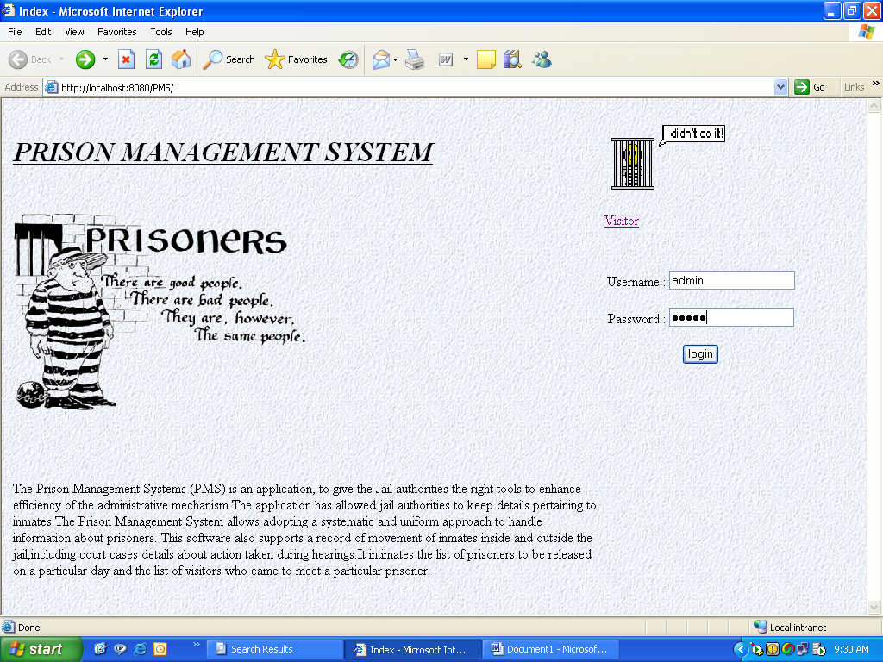

Login for Jailor

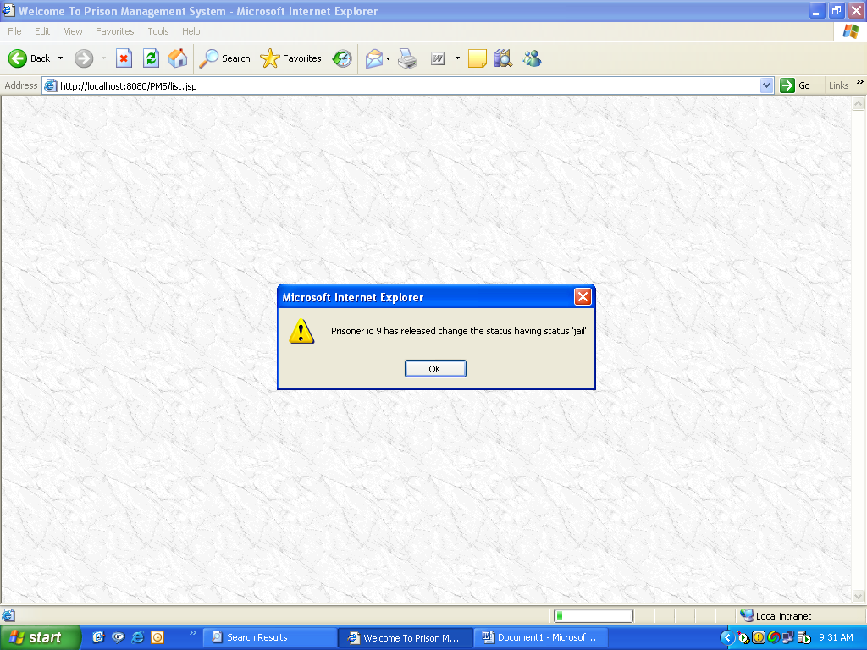

Alert specifying Today Releases

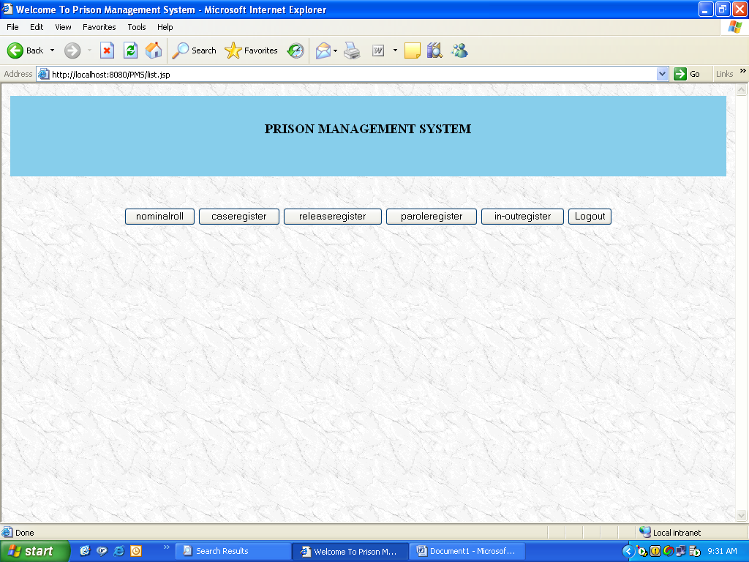

Main Functionalities of Jailor

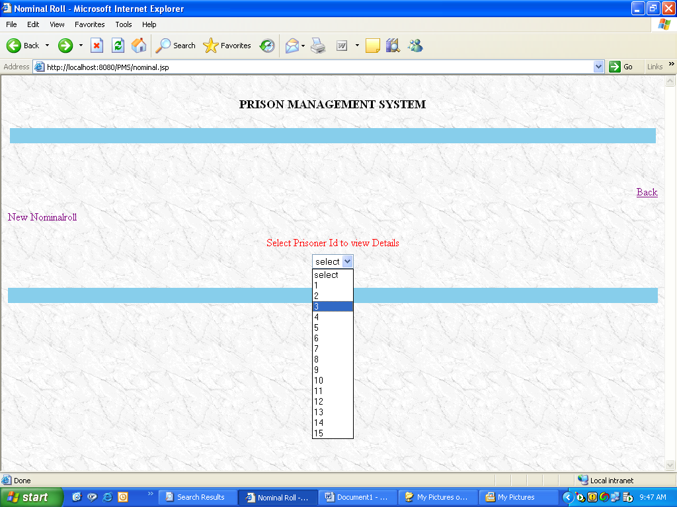

Selecting Prisoner Id’s to View Details

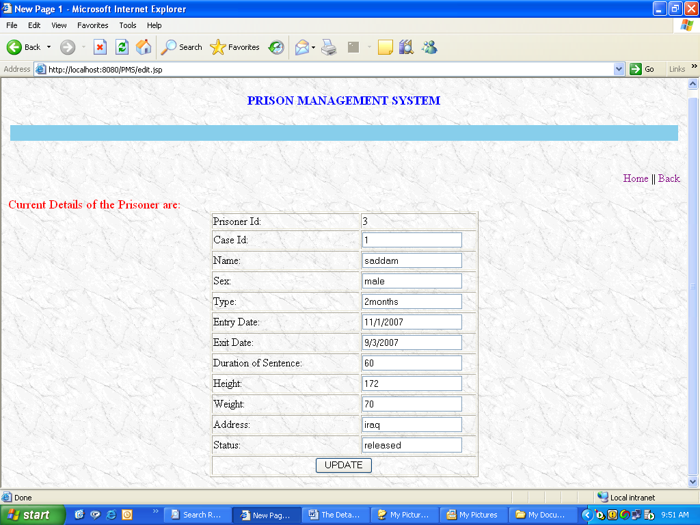

Prisoner Details with Edit Option

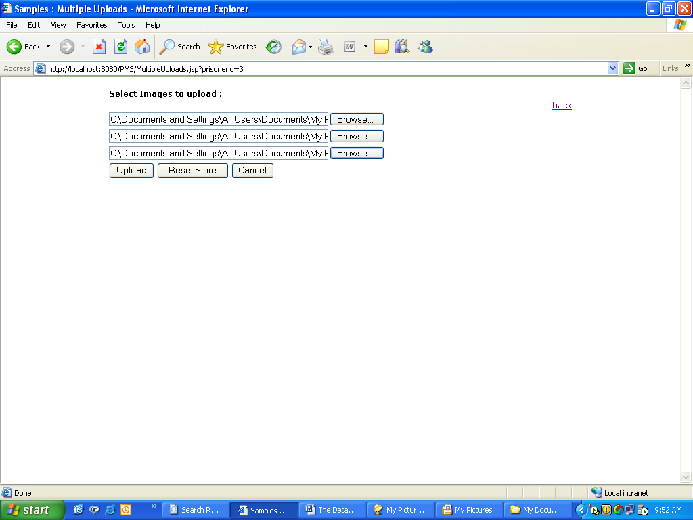

Screen to Upload Prisoner snaps

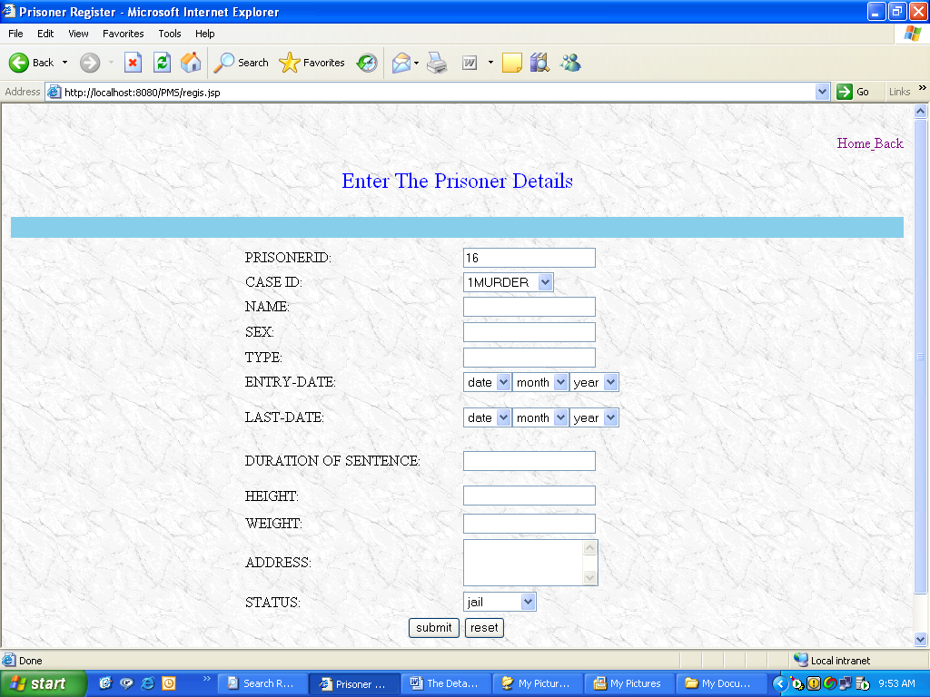

New Prisoner Registration

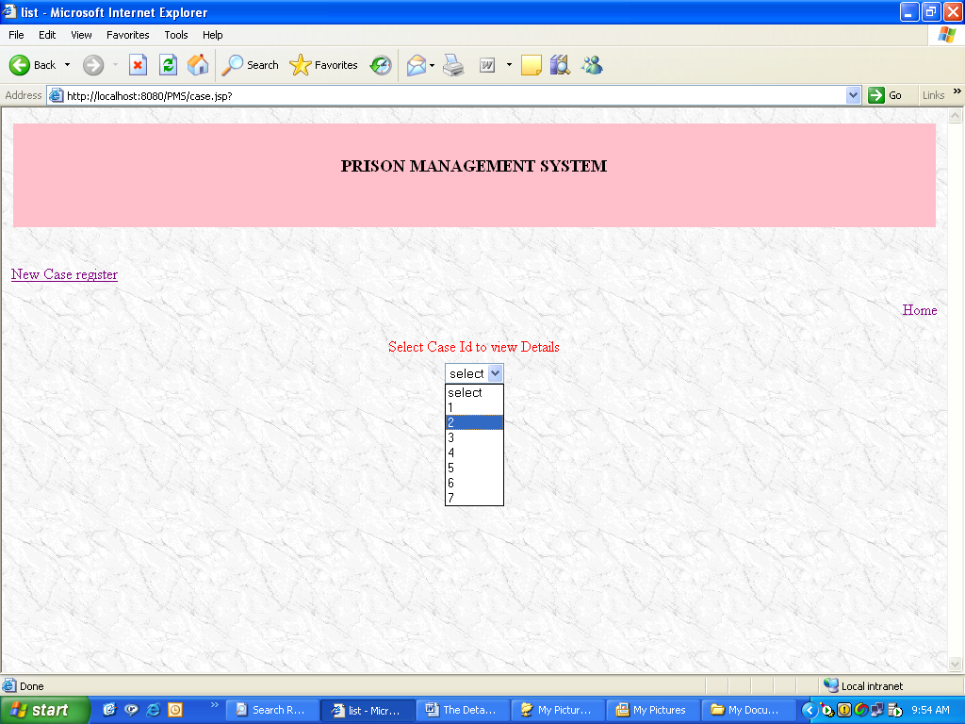

Selecting Case Id to View details

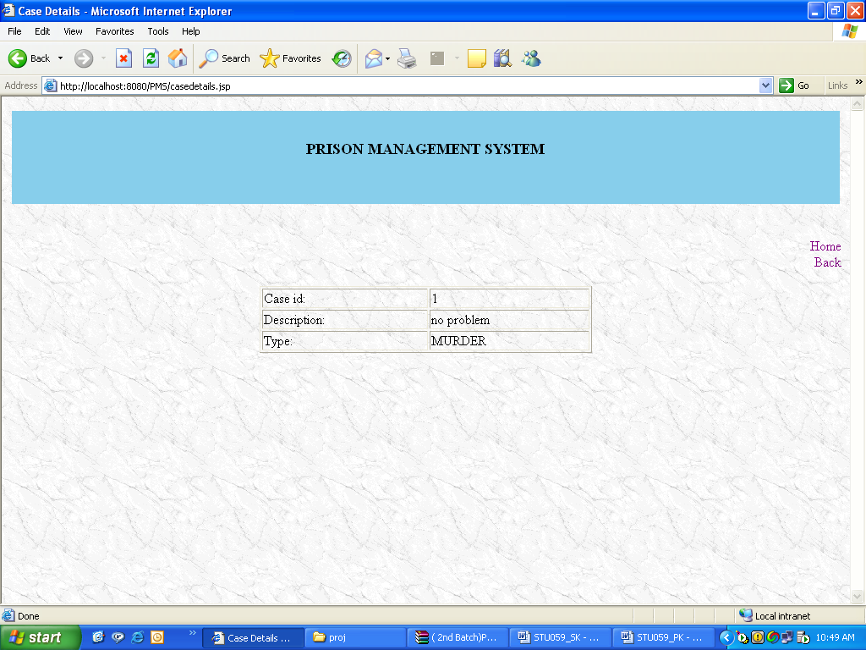

Case Details

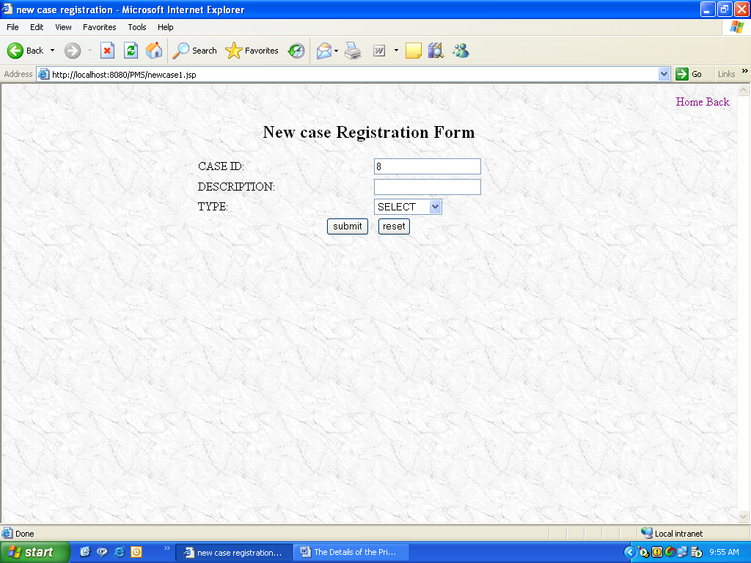

Registering New Case Details

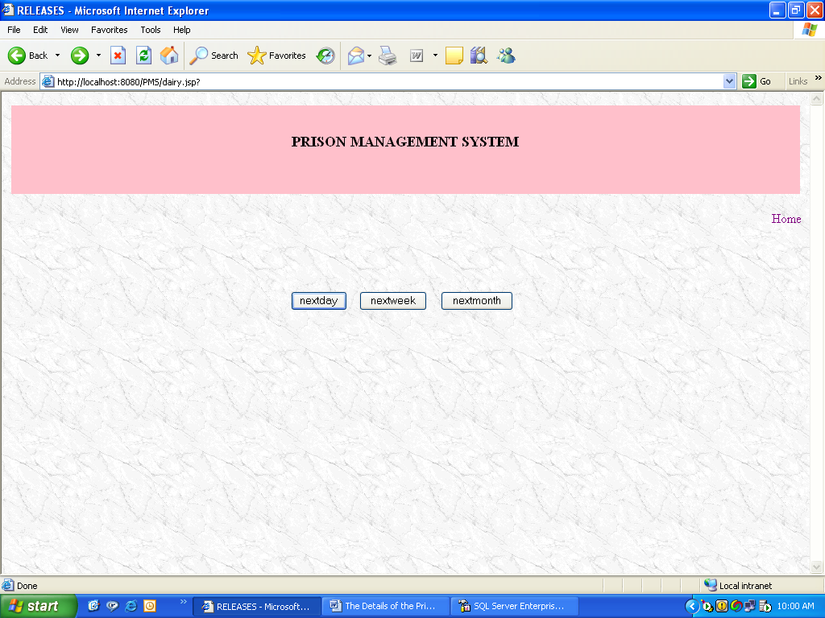

Release Dairy

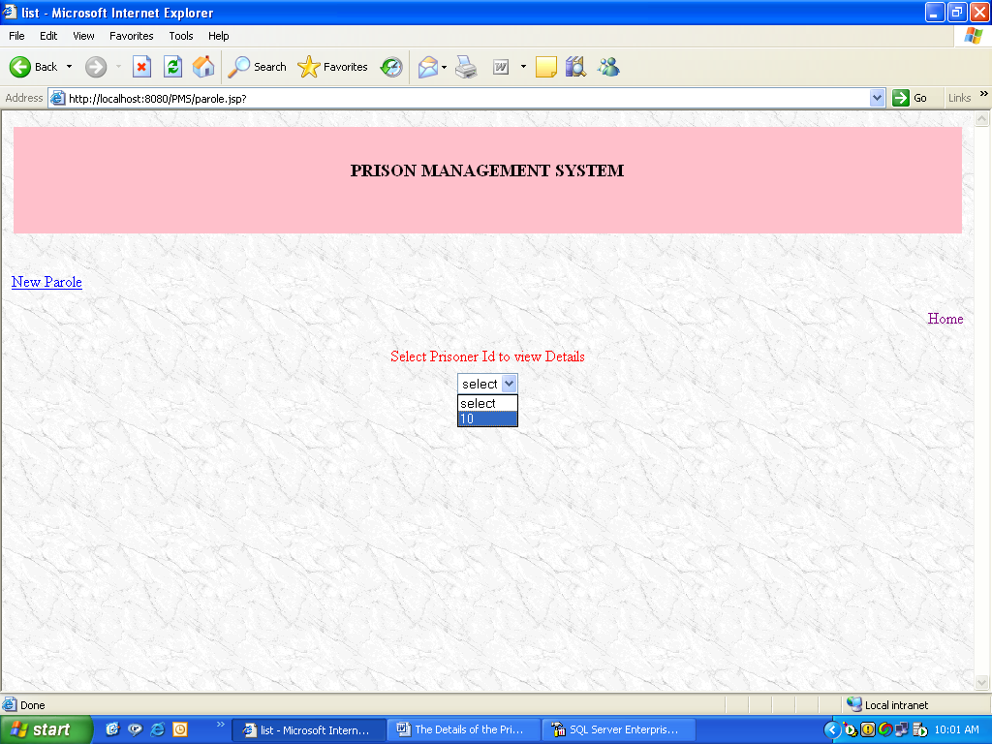

To view Parole Register

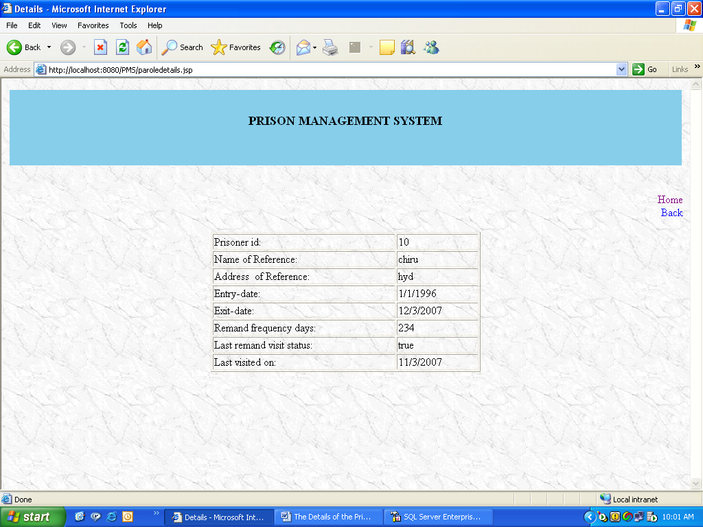

Parole Details

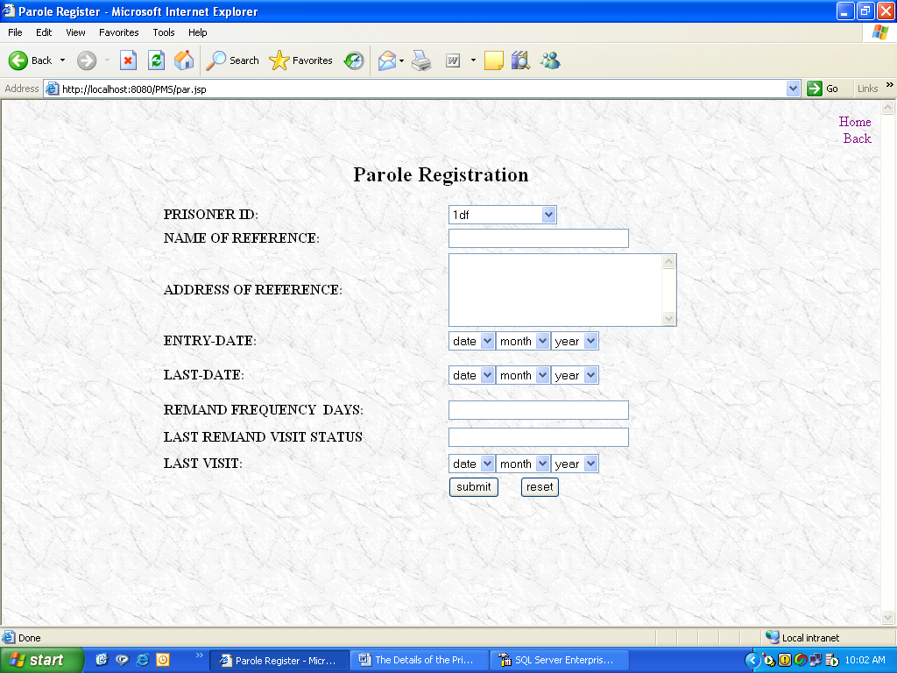

New Parole Registration

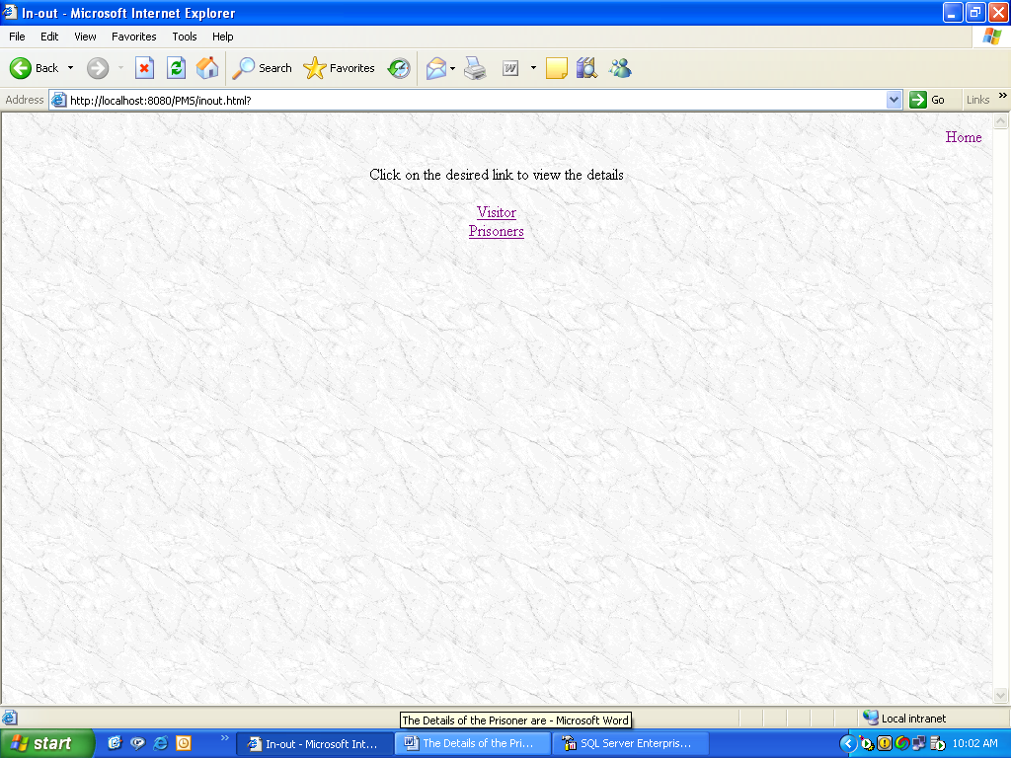

In- Out Register

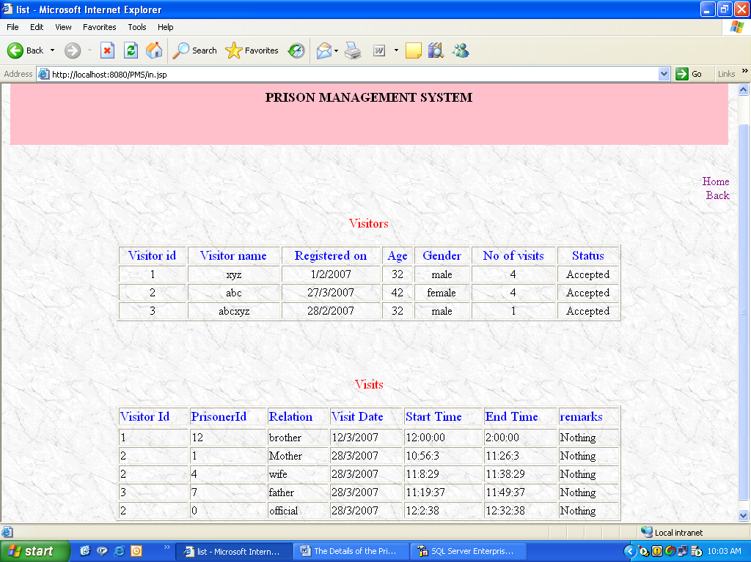

In-Out Details of Visitors

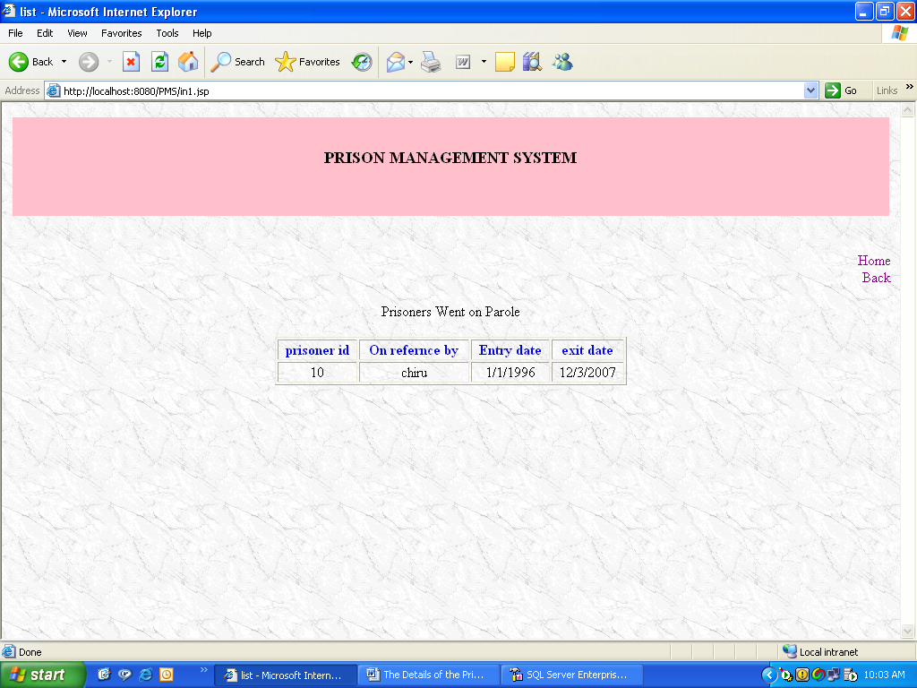

In-Out Details of Prisoners

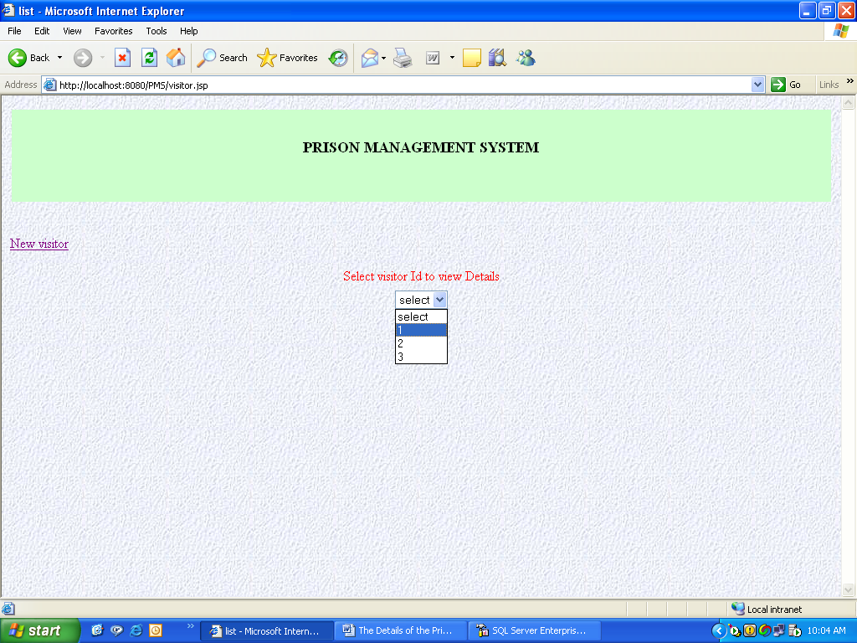

Visitor’s Screen

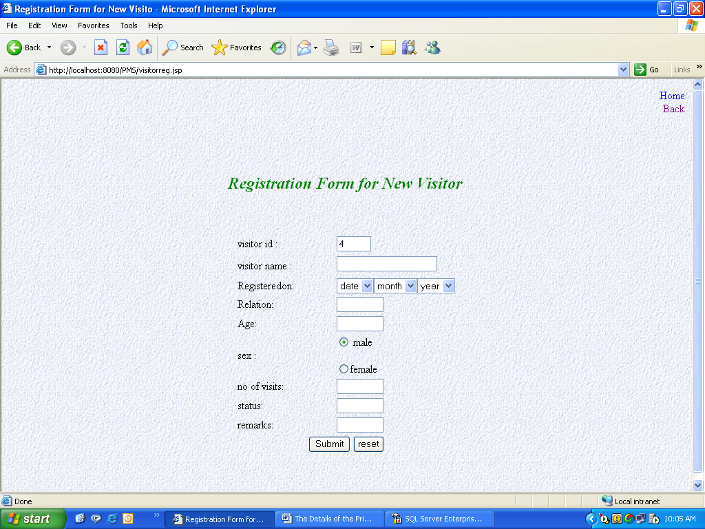

New Visitor Registration

BIBLIOGRAPHY

BIBLIOGRAPHY

THE COMPLETE REFERENCE JAVA2: PATRICK NAUGHTON

THE JAVA JSP DEVELOPER : TATA MC.GRAW –HILL

WEB SITES

HTML:

www.w3schools.com
www.htmlcodetutorial.com

JAVASCRIPT:

www.w3schools.com/js
www.javascript.com
www.javascriptkit.com

JSP:

www.java.sun.com/products/jsp/
www.jsptut.com

