Rand

1) rand:
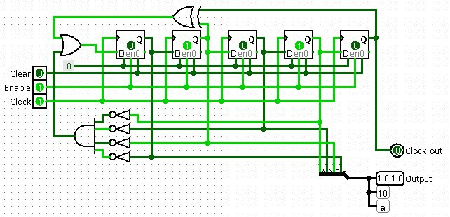
0 | 7
1 | F
2 | F
5 | E
A | C
5 | 9
B | 3
7 | 6
E | D
D | A
B | 4
6 | 9
C | 2
8 | 4
1 | 8
3 | 0

