What-A-Book

TECHNICAL DESIGN DOCUMENT

| **Author** | *Trevor McLaurine, Patrick Cuauro* |
| --- | --- |
| **Last Updated** | 7/8/2023 10:10 AM |
| **Version Number** | *1.0* |

**Version History**

| Name | Date | Reason for Change | Version |
| --- | --- | --- | --- |
| *Trevor McLaurine* | *7/8/2023* | *Initial Document* | *1.0.0* |
|  |  |  |  |
|  |  |  |  |
|  |  |  |  |
|  |  |  |  |
|  |  |  |  |
|  |  |  |  |
|  |  |  |  |
|  |  |  |  |
|  |  |  |  |

Table of Contents

SECTION 1: INTRODUCTION.. 3

1.1. Purpose. 3

1.2. Team Information. 3

1.3. User Personas. 3

1.4. User Stories. 3

1.5. Time Estimations. 3

SECTION 2: PROCESS DESIGN.. 4

2.1. Prototypes. 4

2.2. ORD (Object Relational Diagram(s) 4

2.3. NoSQL Document Diagram.. 4

2.4. NoSQL Data Structure. 4

SECTION 3: QA TESTING.. 4

3.1. QA Test Plan. 4

3.2. Unit Tests. 4

SECTION 4: REFERENCES. 5

# **SECTION 1: INTRODUCTION**

## 

## **1.1.** **Purpose**

The purpose for the What-a-book website is to provide its users with the means to find books based on the author, genre, ID, or title. This website will also allow users to create a wish list of books they want in the future and to be able to view their wish list at any time.

## **1.2.** **Team Information**

**Team Captain:** Patrick Cuauro

**Team Name:** The Fighting Lions

**Mascot:** Lion

**Why the Fighting Lions?** When we discussed coming up with a team name or a mascot, Patrick brought up that he was a big fan of cats, especially lions. Trevor is also a big fan of cats as can be seen by his bio picture. Thus, the mascot became a lion and the name ‘The Fighting Lions’ simply popped into my head.

**Team Members:**

Trevor McLaurine

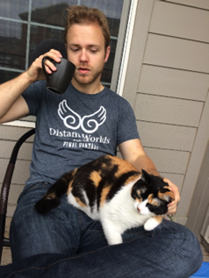

**Bio:** Hello! My name is Trevor McLaurine. I am a student at Bellevue University pursuing a degree in Web Development. I have my Associates Degree from Metropolitan Community College and I graduate to receive my Bachelor’s degree in April of 2024. I have been coding for only a couple of years now but I enjoy it greatly. It’s a very fun challenge and I enjoy learning something new every day. When I’m not coding, I’m usually spending time with my loved ones, playing a video game, or trying to find time for a nice bike ride.

Patrick Cuauro



**Bio:** Hi! I am Patrick Cuauro. I am an electrician at World Disney World, specifically at Epcot. Not only that, but I’m originally from Venezuela, my family and I fled socialism, looking for peace and freedom. I studied electronics in Venezuela and earned a degree comparable to a bachelor’s degree. Furthermore, I worked partially as a Junior Developer in a company and fell in love with coding when I started to create webpages. I’m a family man, martial artist, Presbyterian and I love technology.

Reason for the Mascot: Lion.

As a Presbyterian, I am Christ-centric and one of the symbols of Christ is the Lion of Judah. Also, I have a cat named Aslan in honor of the Narnia Chronicles character.

## **1.3.** **User Personas**

**1.** **Name:** Steve

**Distinguishing Characteristic:** Veteran

**Photo:**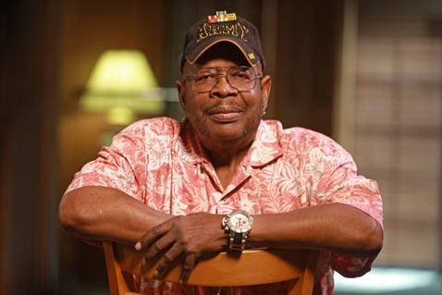

**Most Used Features:** Browsing books by his favorite author, and viewing books by his favorite genre, which is history.

**Least Used Feature:** Creating a wish list. Steve prefers to write everything down instead of relying on technology to keep track of his books.

**Needs Satisfied by Website:** What-a-book helps Steve find new and interesting titles by searching through the history section of the website. It also helps him find new authors and possibly find other interesting titles he might have never looked at before.

**Possible Problems using Website:** While Steve is an avid reader, his eyesight is not the greatest. Possible issues could arise if the font-size of the text on the website isn’t large enough or easy enough to read. Also, because of his minimal computer skills, if the interface becomes too complicated, he might not invest time looking at the website.

**2.** **Name**: Karen

**Distinguishing Characteristic**: Fanatic reader. Impatient.

Photo: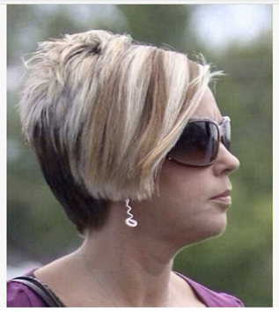

**Most Used Features:** Browsing books by title, author and genre. Creating and maintaining an extensive wish list of books.

**Least Used Feature:** None

**Needs Satisfied by Website:** Karen has an insatiable appetite for all things literature. What-a-book helps her find the latest and most interesting books that are on the market currently. She can maintain a list of the books that she wants by using the wish list feature on the website.

**Possible Problems using Website:** Karen does not like to wait, nor does she enjoy being told that a book is currently unavailable. Maintaining an up-to-date database that shows which books are in stock as opposed to out of stock is crucial for someone like Karen. She also may push the limits of the number of books that she places on her wish list. Karen is constantly looking for and searching for new books. She needs a very high limit on her wish list in the database.

**3.** **Name**: Mike

**Distinguishing Characteristic**: Farmer. Old fashioned type of person.

Photo: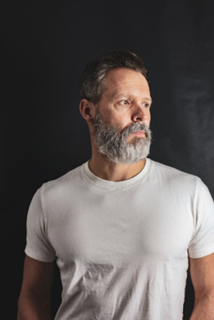

**Most Used Features:** Browsing books by author. Dabbles every now and then with the wish list, but usually makes a list and forgets about it.

**Least Used Feature:** Browsing by title, or genre. Mike has very specific tastes and generally only enjoys a few authors.

**Needs Satisfied by Website:** Mike is a simple man with simple tastes. He enjoys only a few authors, and the website will help him find the latest books by those authors. Mike usually tries to use the wish list to make a list, but generally forgets about it and resorts to writing down the books he wants.

**Possible Problems using Website:** Mike does not have a lot of computer experience. Making sure that the website is easy to read and easy to use is important. An overly complicated means of looking for books or a busy looking website with lots of stuff on the screen might put him off from using it.

## 

## **a.** **User Stories**

| **Steve User Stories** | **Priority** |
| --- | --- |
| As a user, I need to be able to search for books by genre so that I can learn more about the books I want to read. | **3** |
| As a user, I need to be able to easily read and understand the information on the page so that I can make a better decision about my book choices | **5** |
| As a user, I need an up-to-date database on books so that I know if there are any new books that have been released. | **1** |
| As a user, I need to be able to easily search for books so that I can find books without hassle. | **2** |
| As a user, I need a minimalistic user interface so that I can easily use the website. | **0** |

## 

| **Karen User Stories** | **Priority** |
| --- | --- |
| As a user, I need to be able to easily find books that I want so that I can create a wish list. | 1 |
| As a user, I need to be able to search for books by author so that I can find the books that I want | 3 |
| As a user, I need to be able to search for books by author so that I can see any new books that might be released by the author | 2 |
| As a user, I need to be able to create an account so that I can maintain a wish list of the books that I want. | 0 |
| As a user, I need to be able to organize my wish list by title or genre so that I can find the books that I have saved easier | 5 |

| **Mike User Stories** | **Priority** |
| --- | --- |
| As a user, I need to be able to create an account so that I can make a wish list. | 3 |
| As a user, I need to be able to create a wish list so that I can save the books that I might want in the future | 5 |
| As a user, I need to be able to search for books by a specific variable so that I can find the books that I want | 2 |
| As a user, I need to be able to find where things are on the web page easily so that I can interact with the website and find the books that I want | 0 |
| As a user, I need the website to have up to date information on new books so that I can always see when an author I like releases a new book. | 1 |

# **SECTION 2: PROCESS DESIGN**

## **2.1. Prototypes**

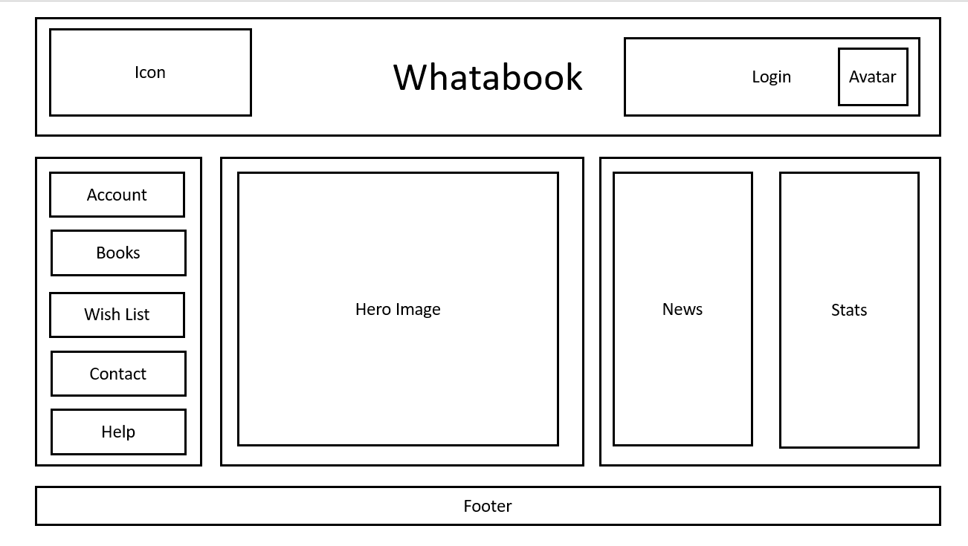

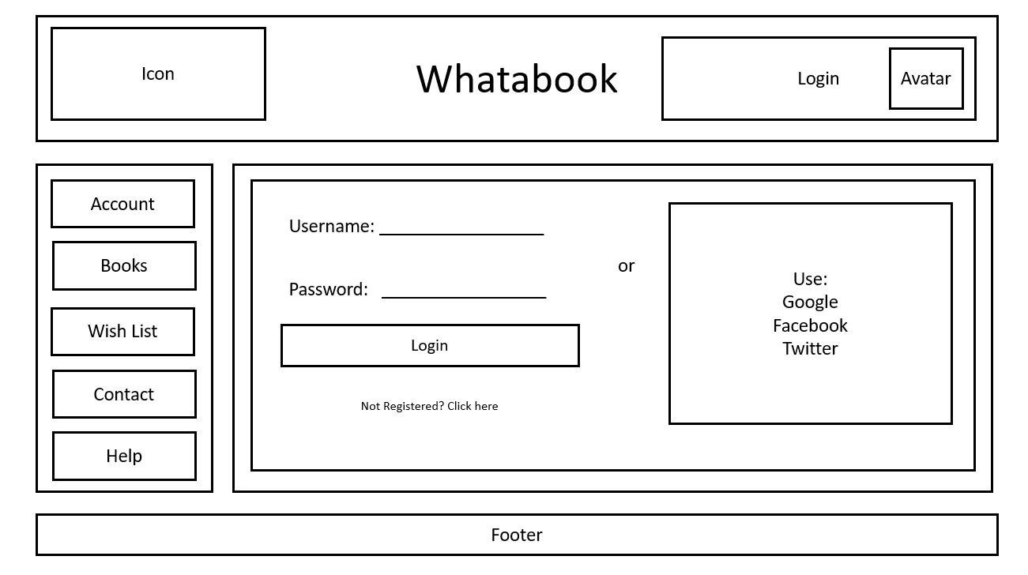

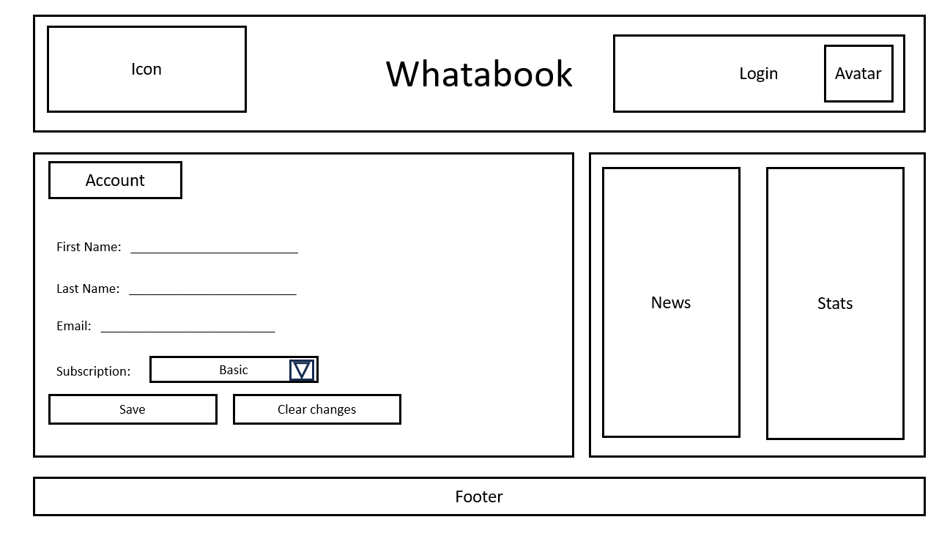

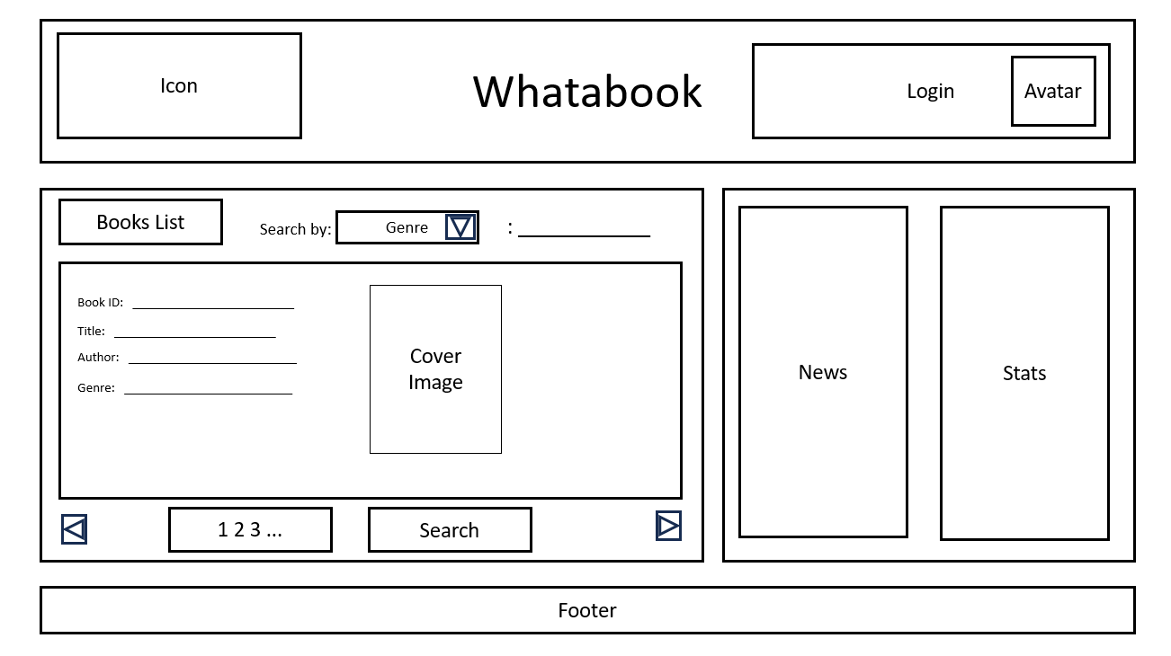

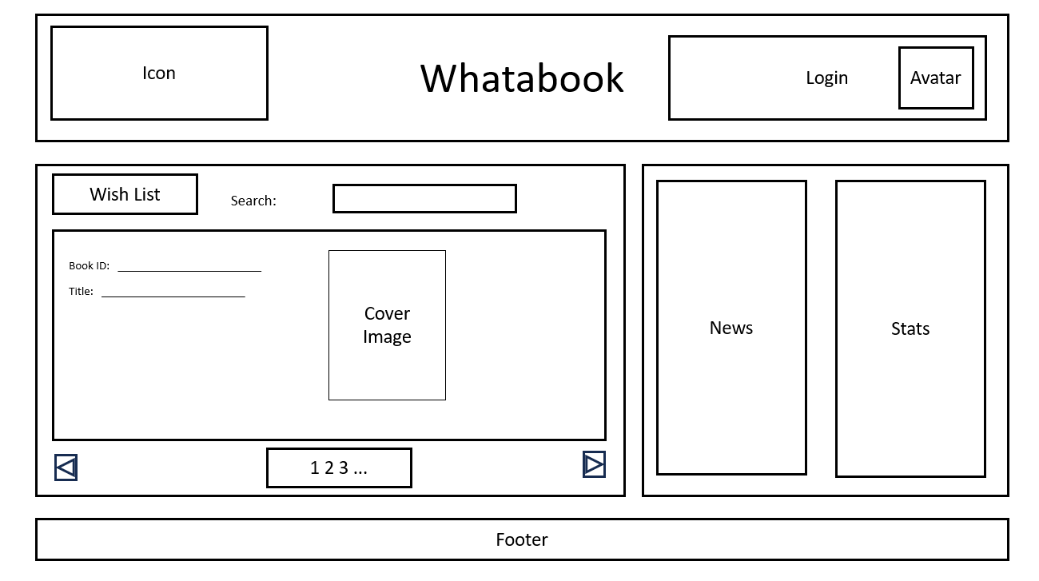

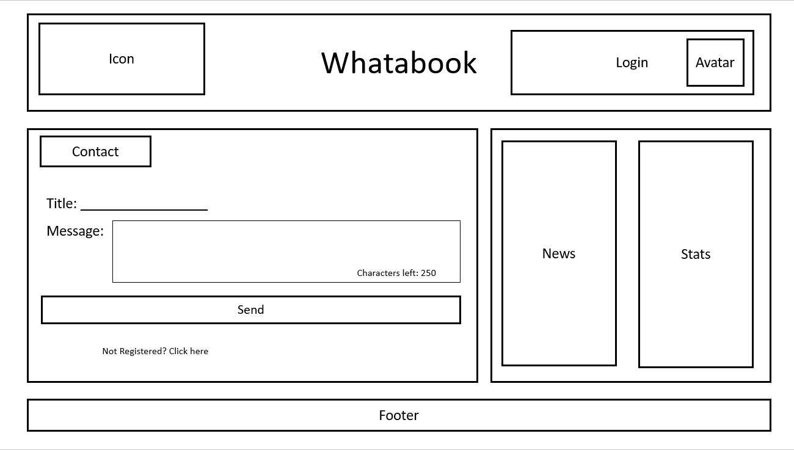

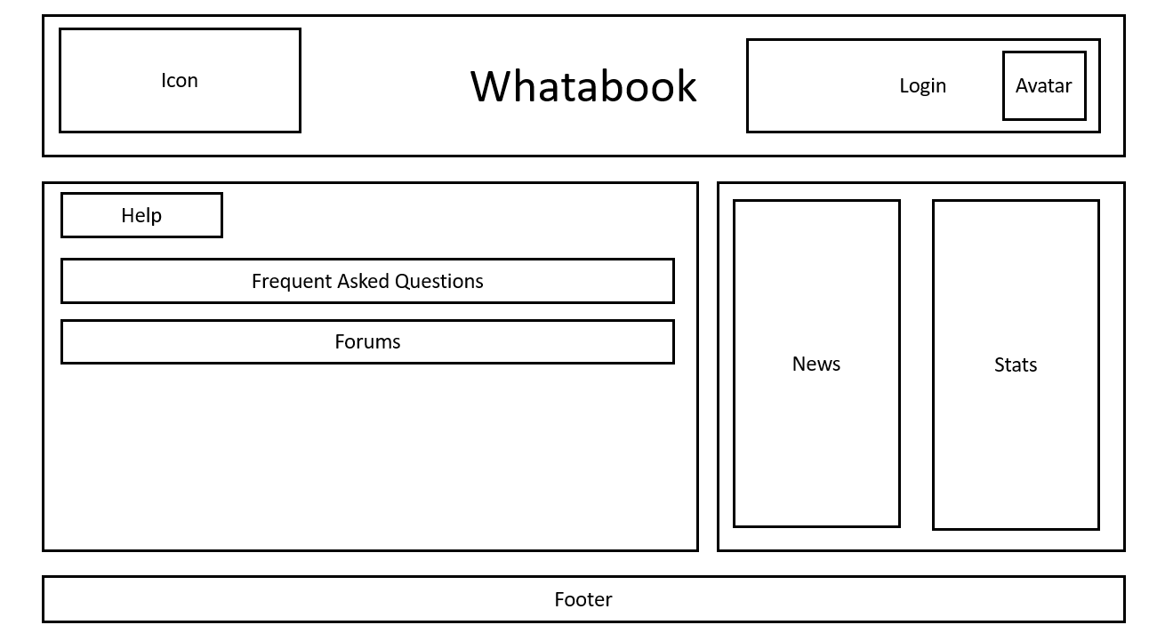

*[Make sure the prototypes cover every page/dialog/message in the proposed solution)*

## **2.2. ORD (Object Relational Diagram(s)**

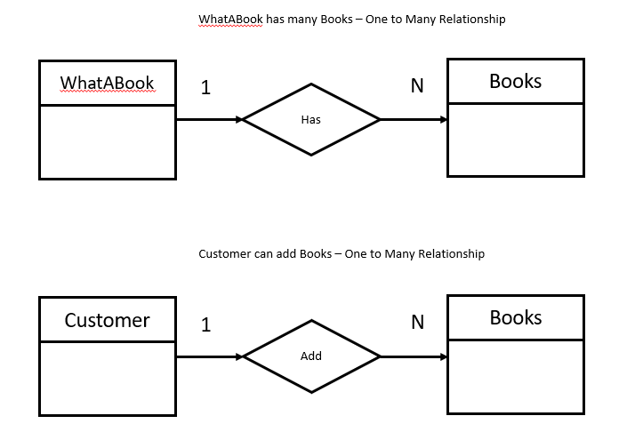

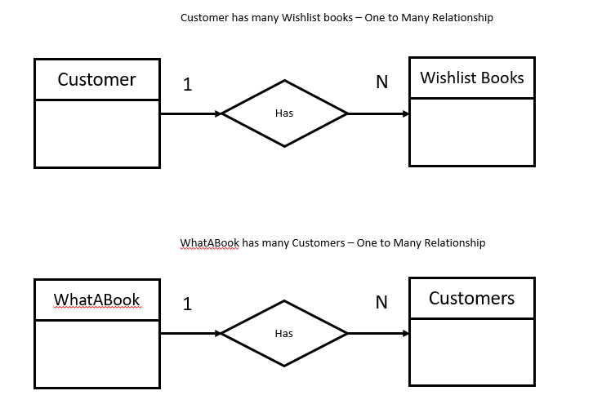

*[Create an ORD based on the proposed business rules]*

## **2.3. NoSQL Document Diagram**

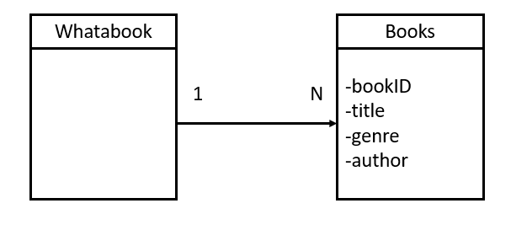

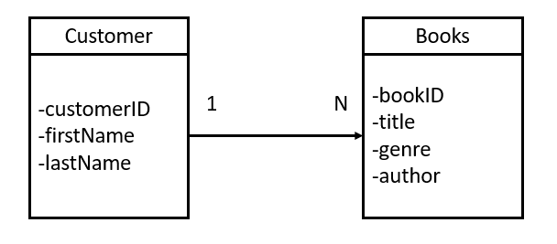

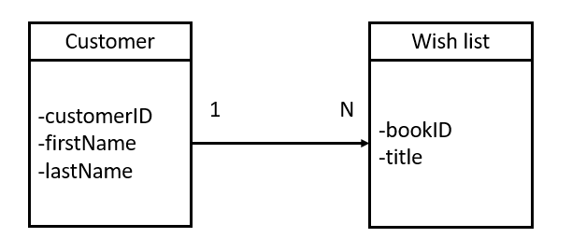

*[Covert the above ORD into a NoSQL Document Diagram]*

## **2.4. NoSQL Data Structure**

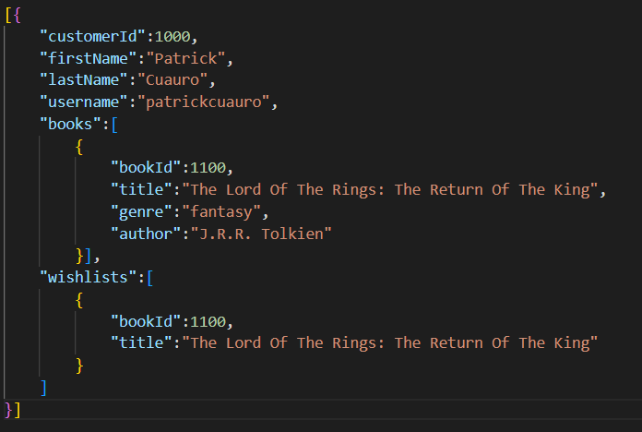

Customer Data Structure

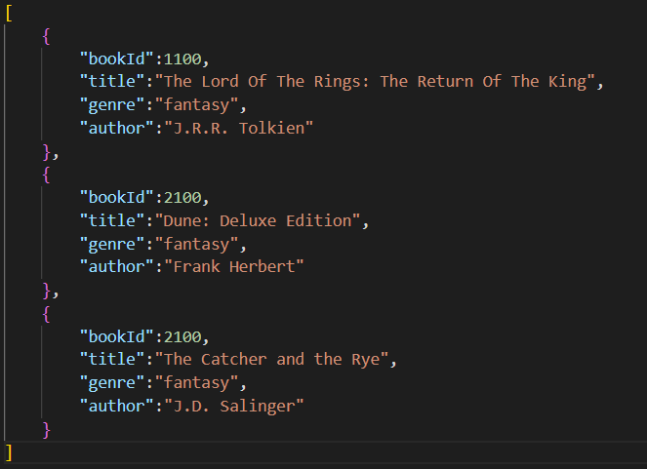

Books Data Structure

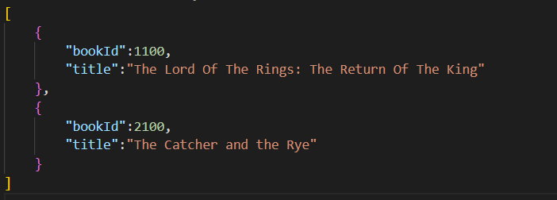

Wish List Data Structure

*[Covert the above NoSQL Document Diagram into a NoSQL Data Structure (JSON data)]*

# **SECTION 3: QA TESTING**

## **3.1. QA Test Plan**

*[Weekly Test Cases]*

## **3.2. Unit Tests**

*[Images of SoapUI Unit Tests]*

# **SECTION 4: REFERENCES**

*[APA Reference List]*