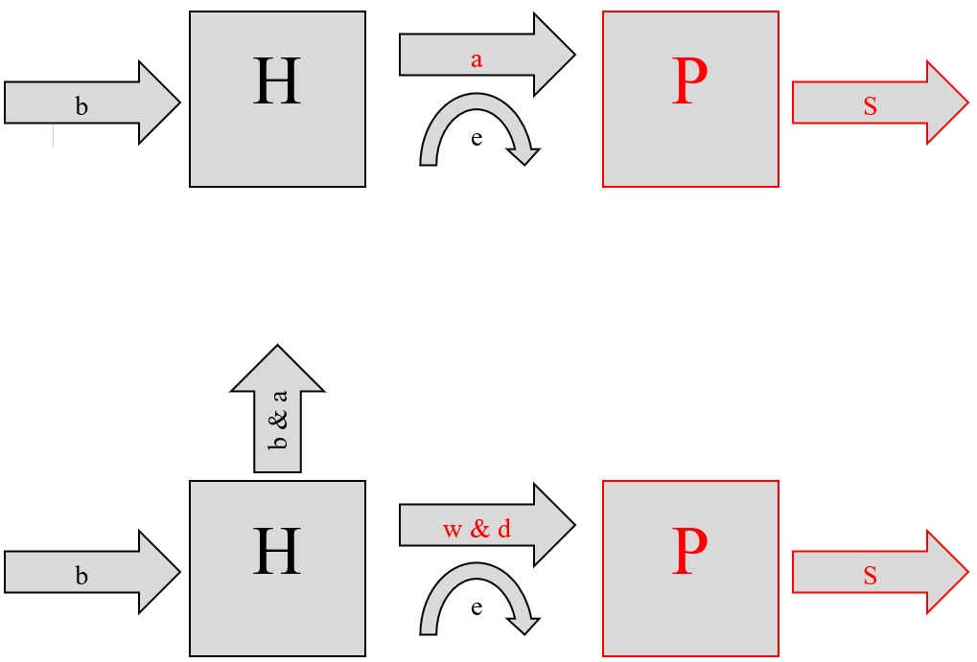Conceptual Box & Arrow Models:

b = Prey Birth Rate

H = Prey Starting Pop.

a = Alpha (1/Carrying Capacity)

w = Pred. Attack Rate

e = Conversion Efficiency

P = Pred. Starting Pop.

s = Pred. Death Rate

b = Prey Birth Rate

H = Prey Starting Pop.

a = Pred. Attack Rate

e = Conversion Efficiency

P = Pred. Starting Pop.

s = Pred. Death Rate

Lotka-Volterra Model

Rosenzweig-MacArthur Model

Rosenzweig-MacArthur Paradox of Enrichment Simulations:

In all cases, the predator population is defined by the red line and the prey population is defined by the red line.

Simulations are performed with initial conditions from previous Rosenzweig-MacArthur simulations for consistency.

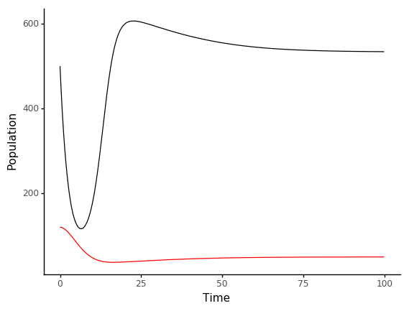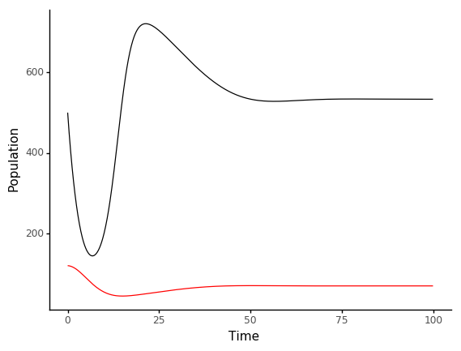

alpha = 0.00125 | carrying capacity = 800

alpha = 0.001 | carrying capacity = 1200

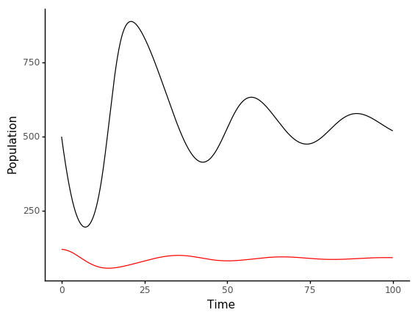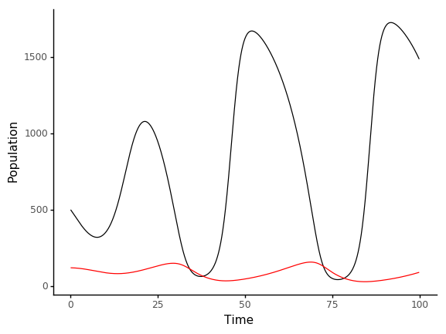

alpha = 0.0005 | carrying capacity = 2000

alpha = 0.00075 | carrying capacity = 1600

Paradox of Enrichment Questions:

1. What happens as carrying capacity increases?

As prey carrying capacity increase, there is a visible destabilization in both predator and prey populations as seen in the simulations above after a certain threshold. In all simulations, the prey and predator populations begin at 500 and 120 respectively.

When prey carrying capacity is 800, the prey population dips to ~150, spikes to ~600, and levels out at ~550, and the predator population levels out at ~50. When prey carrying capacity is 1200, the prey population dips to ~150, spikes to ~750, and levels out at ~550 once again, and the predator population levels out at ~50 once again. When prey carrying capacity is 1600, we begin to observe oscillations in the prey population, dipping initially to ~200, spiking to ~900, and oscillating until levelling out at ~500, and the predator population increases compared to previous simulations but begins to oscillate slightly as well, averaging and leveling out at ~100. When prey carrying capacity is 2000, oscillations in prey population become drastically larger, dipping initially to ~400, spiking to ~1050, then dipping to almost 0 and spiking to ~1700 in every successive cycle, with each oscillation markedly more drastic than the previous, and the predator population stays a similar level to the previous simulation of ~100, but its oscillations become notably larger as well, spiking at ~200 and dipping to almost 0 in every cycle, with each oscillation even becoming very slightly more drastic than the previous.

As evidenced by these simulations, it is very possible that given an even higher prey carrying capacity than 2000, or even simply more time at a carrying capacity of 2000, one or both of the prey and predator populations could be completely wiped out.

1. Why do you think we see the Paradox of Enrichment?

A simple and common explanation for the Paradox of Enrichment is that when presented with what is, for all intents and purposes, an unbounded carrying capacity, the prey population will grow unbounded as well. As a result of the overabundance of prey, the predator population grows drastically along with the prey population, causing the predator population to become unsustainably large, to such a degree that the number of predators consuming the prey succeeds the rate at which the prey grow even with such a high carrying capacity, causing a crash in the prey population and subsequently a crash in the predator population, which could potentially lead to the eradication of one or both of the prey and predator populations. There are many exceptions to this phenomenon observed in both many simulations and real-life scenarios though, a general explanation being that there are often factors other than the availability of prey alone that influence the growth of the predator population.