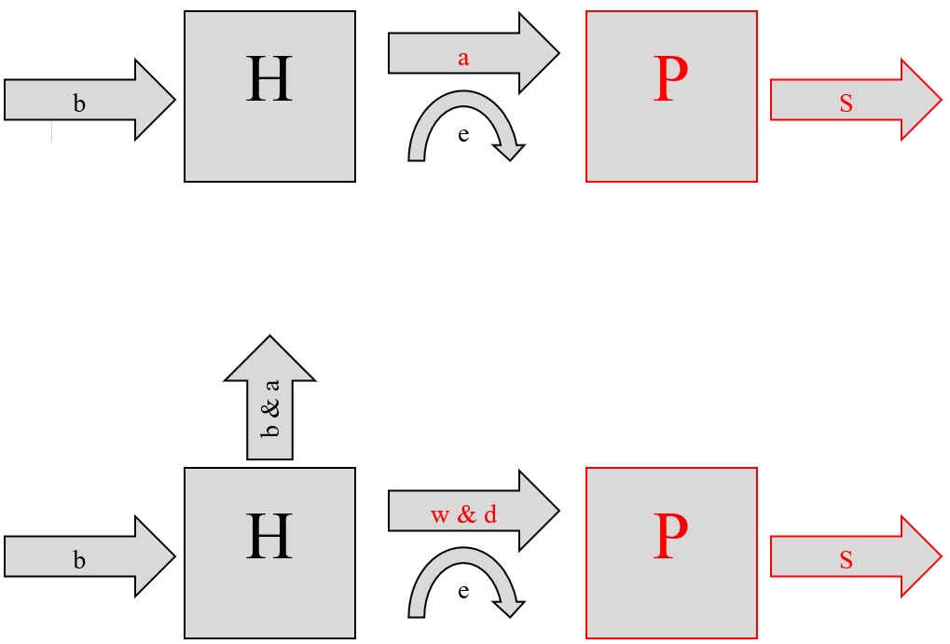Conceptual Box & Arrow Models:

Lotka-Volterra Model

Rosenzweig-MacArthur Model

b = Prey Birth Rate

H = Prey Starting Pop.

a = Pred. Attack Rate

e = Conversion Efficiency

P = Pred. Starting Pop.

s = Pred. Death Rate

b = Prey Birth Rate

H = Prey Starting Pop.

a = Alpha (1/Carrying Capacity)

w = Pred. Attack Rate

d = density of prey where predator kill rate reaches half its maximum

e = Conversion Efficiency

P = Pred. Starting Pop.

s = Pred. Death Rate

**Lotka-Volterra Plot Additional Questions**

*In all cases, the predator population is defined by the red line and the prey population is defined by the red line.*

Lotka-Volterra Plot

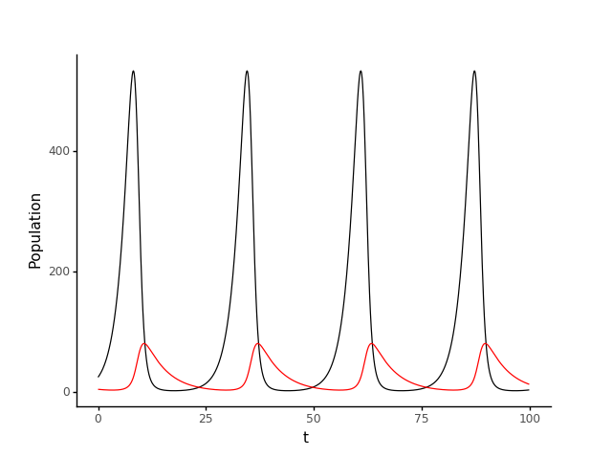

The Lotka-Volterra predator-prey model follows Equations 1 and 2

$\frac{dH}{dt}=bH-aPH$ (1)

$\frac{dP}{dt}=eaPH-sP$ (2)

where *H* represents herbivore population, *P* represents predator population, *b* represents the prey birth rate, a represents predator attack rate, *e* represents the conversion efficiency of prey to predators, and *s* represents the predator death rate. The base case for the Lotka-Volterra model is a simulation where *H­o* = 25, *Po* = 5, *b* = 0.5, *a* = 0.02, *e* = 0.1, and *s* = 0.2.

What can you say about the “role” of each of the parameters and what is the relationship between the parameters and predator-prey cycle length?

*Prey Birth Rate*

This controls how high the maximum populations of predators and prey are at each of their peaks, and how sharp each of the population increases and decreases (the peaks) are (especially those of the prey). It also controls the length of the predator-prey cycle. As the prey birth rate increases, the prey population gains and falls more rapidly, and the peak populations for predators and prey increase. There are also more cycles in a given time period with a higher prey birth rate, indicating that a high prey birth rate shortens the predator-prey cycle length.

|  |  |
| --- | --- |
| Triple the Prey Birth Rate | Half the Prey Birth Rate |
|  |  |

*Predator attack rate*

This controls the maximum and minimum populations of predator and prey in each cycle, the frequency at which the predator-prey cycle occurs, and how sharp each of the population increases and decreases are. A greater predator attack rate results in lower maximum populations and higher minimum populations for both predator and prey. It also results in more cycles of growth and decline for the two populations and more gradual growth and decline.

|  |  |
| --- | --- |
| Triple the Predator Attack Rate | Half the Predator Attack Rate |
|  |  |

*Conversion efficiency*

The conversion efficiency pretty much exclusively controls the peaks of the prey population at each cycle. Greater conversion efficiency results in a lower maximum prey population. It has only a slight effect on the predator-prey cycle length. A greater conversion efficiency translates to a slightly smaller cycle length, thus more cycles per time period

|  |  |
| --- | --- |
| Triple Conversion Efficiency of Prey to Predators | Half Conversion Efficiency of Prey to Predators |
|  |  |

*Predator death rate*

The predator death rate controls the maximum and minimum prey populations in each cycle and controls the length of each predator-prey cycle. A greater predator death rate results in greater peak prey populations, lower minimum prey populations, and more cycles in a given time period (less time per cycle).

|  |  |
| --- | --- |
| Triple the Predator Death Rate | Half the Predator Death Rate |
|  |  |

What can you say about the role of predators in the simulations?

The predator population greatly influences the prey population, and thus indirectly has a limiting effect on itself. As the predator population increases, it leads to a sharp decline in the prey population, because an increase in predator population indicates more predators are present to attack prey, reducing the prey population. The reduction in prey will lead to a subsequent decline in the predator population because the predators now lack sufficient prey to feed on, and will die. With the predator population back to its initial low state, the prey population can increase as there are few predators to feed on and attack the prey, and this increase in the prey population will allow the predator population to once again increase as the cycle repeats. The initial predator and prey populations do not have a great impact on the cycle (within reason), because the cycle will progress regardless of where in the cycle the predator and prey populations start (low predator/high prey, low predator/low prey, high predator/high prey, or high predator/low prey).

**Rosenzweig-MacArthur Plot Additional Questions**

*Questions to Answer:*

How do the dynamics differ from Lotka-Volterra?

The dynamics of the Lotka-Volterra (LV) and Rosenzweig-MacArthur (RM) models are very closely related, as the RM model is amended version of the LM model. In both models, the dynamics typically follow the dynamic response: as predator populations decrease, prey populations increase. In the LV models shown in the section above, this was always paired with dynamic response in which as prey populations increase, predator populations can increase until reaching a maximum and falling again. These cyclic, oscillatory dynamics applied for all simulations of the LV model. The RM model dynamics differ as a result of the introduction of additional terms. Namely, the RM model accounts for the predator search rate, *w*, intraspecific competition coefficient, α, and the density of prey at which the predator kill rate reaches half its maximum, *d*, but the RM does not account for the predator attack rate, *a*, that the LV model does. The introduction of these terms allows for simulations in which the dynamics are not cyclic, but rather reach a steady-state response. There are some instances of cyclic dynamics between predator and prey populations in the RM model for the cases tested, but the introduction of these terms does not only allow for these lower-order responses.

What can you say about the “role” of each parameter, especially what causes the dynamics to differ between the L-V and R-M models?

Below, simulations for the RM model are shown for a variety of parameters. To start, the base case is shown, where the simulation is run for the parameters given in the project problem statement. Then, each parameter (*b*, α, *w, d, e,* and *s*) is isolated in order to evaluate its effect on the dynamic response of the model. For each parameter, all other values are held constant while the parameter value is first tripled and then halved in order to understand how the parameter affects the predator-prey populations over time. Following the plots showing the simulations for each parameter, an analysis of the parameter’s effects on the populations of predator and prey is given, highlighting the differences of the parameters effects between the LV and RM models if applicable. In addition, the relationship between parameter values and predator abundance are given for each parameter value.

*In all cases, the predator population is defined by the red line and the prey population is defined by the black line.*

|  |  |
| --- | --- |
| Base Case for LV Model | Base Case for RM Model |
|  |  |

The populations and parameters of the LV base case can be found in the section above. The RM consumer-resource model follows Equations 3 and 4

$\frac{dH}{dt}=bH\left(1-αH\right)-w\frac{H}{d+H}P$ (3)

$\frac{dP}{dt}=ew\frac{H}{d+H}P-sP$ (4)

where *H* represents herbivore population, *P* represents predator population, *b* represents the prey birth rate, α represents the intraspecific competition coefficient (also the inverse of carrying capacity of the prey), *w* represents the predator search rate in unit area per time, *d* represents the density of prey at which the predator kill rate reaches half its maximum, *e* represents the conversion efficiency of prey to predators, and *s* represents the predator death rate. The base case for the RM model is a simulation where *H­o* = 500, *Po* = 500, *b* = 0.8, *e* = 0.07, *s* = 0.2, *w* = 5, *d* = 400, and α = 0.001.

|  |  |
| --- | --- |
| Triple the Prey Birth Rate (b) | Half the Prey Birth Rate (b) |
|  |  |

The prey birth rate has the most profound effect on the predator prey dynamics at the beginning of the simulation. When the prey birth rate is tripled, there are a lot of new prey born, which allows for higher populations of predators to be sustained. This high predator population is able to level out once the high prey birth rate is balanced out by the rate at which predators kill the prey. At this point, both populations are sustained at much higher values than in the base case. In the case that the prey birth rate is halved, the prey population immediately drops before rising again in dynamics that would suggest steady state response in the far future.

In the LV model, the prey birth rate controls how high the maximum populations of predator and prey are at each of their peaks, as well as the rate of increase or decrease approaching and following those peaks, especially for the prey. This holds true in the RM model at the beginning, as the prey population spikes sharply for the tripled birth rate. In opposition to the LV model, halving the birth rate results in an immediate reduction in prey population. This is due to additional factors *d* and *w* affecting the dynamics. In the LV case, the predator-prey populations were cyclic, but in the RM model for tripled birth rate, the dynamics are not cyclic but reach steady state again. For the halved birth rate RM model, the dynamics may still be cyclic, but at a much lower frequency than for the LV model.

Increasing the birth rate results in a higher steady state predator abundance along with a predator population change rate that is always either positive or zero. Decreasing the birth rate results in a lower steady state predator abundance than the RM base case.

|  |  |
| --- | --- |
| Triple the Intraspecific Competition Coefficient (α) | Half the Intraspecific Competition Coefficient (α) |
|  |  |

The intraspecific competition coefficient determines the degree to which the populations of each species affect the populations of their predator-prey counterpart, and is inversely related to the carrying capacity of the prey. When the competition coefficient is tripled, there is a very high affect between the populations of each species and an end result of very low steady state populations for both predator and prey due to the reduced carrying capacity. When the competition coefficient is halved, the swings in population occur with much greater magnitude than in the base case since a relatively large increase in prey population tends to not have such a large change on the prey populations ability to sustain itself. If allowed to continue further, the instability of this simulation would cause the magnitude of the oscillations of prey population to continue increasing. Both steady state populations for predator and prey are higher for this halved coefficient case than for the RM base case.

There is no direct analog between the intraspecific competition coefficient in the RM model and any parameters in the LV model, so no effective comparisons can be made between the two with respect to this parameter. Still, halving the competition coefficient for the RM model results in cyclic dynamics between predator and prey that are characteristic of the LV model.

Increasing the competition coefficient results in drastically decreased predator abundance. At a predator population < 1 individual at the end of the simulation, effectively the predators have died out, whereas in the base case the predator population reached a positive steady state value. Decreasing the competition coefficient by a factor of two resulted in more cyclic dynamics of the predator population and a higher peak value of predator abundance than in the RM base case.

|  |  |
| --- | --- |
| Triple the Predator Search Rate (w) | Half the Predator Search Rate (w) |
|  |  |

The predator search rate in unit area per time linearly affects the degree with which the predators are able to find prey, assuming a constant density of predators per unit area. When the search rate for the predators is tripled, the predators have a very easy time finding prey, and nearly wipe out the initial population of prey. After a long period of time, the prey population spikes back up, which can eventually sustain a relatively large population of very effective searching predators, killing off almost all prey again cyclically. When the predator search rate is reduced by a factor of two, the predators have a very hard time finding prey and die off very quickly, allowing the prey to asymptotically approach its carrying capacity population at steady state.

There is no direct analog between the intraspecific competition coefficient in the RM model and any parameters in the LV model, so no perfectly effective comparisons can be made between the two with respect to this parameter. The closest analog to the predator search rate would be the predator attack rate from the LV model. Increasing the predator search rate in the RM model and the predator attack rate in the LV model elicit similar cyclic dynamics where the prey populations are kept relatively low for most of the time as a result of very high frequency predator attacks/effective searches. Decreasing the predator search rate in the RM model and the predator attack rate in the LV model results in much higher maximum prey populations, but the LV model has cyclic dynamics whereas the RM model reaches steady state almost immediately partially as a result of the additional terms in the RM model.

Increasing the predator search rate results in less stable predator abundance than for the RM base case, with high but rare peaks. Decreasing the predator search rate results in a drastic decrease in predator abundance, where the predator population effectively dies out very quickly.

|  |  |
| --- | --- |
| Triple density of prey at which the predator’s kill rate reaches half its maximum (d) | Half density of prey at which the predator’s kill rate reaches half its maximum (d) |
|  |  |

The density of prey at which the predator’s kill rate reaches half its maximum (*d*) essentially accounts for the amount of time necessary to perform, eat, and digest each kill as prey population rises. Increasing *d* by triple puts the prey density of interest out of reach for the predator. Effectively, the density of prey at which the predators kill rate reaches half its maximum is not reached before the predator population has effectively died out. This is because ironically the prey population is increasing, but has to increase to a certain point to allow the predators to be able to kill the prey at a rate effective enough to maintain their population. When *d* is halved, the prey density of interest is reduced to a range such that it is reasonable for the predator kill rate to reach an appreciable magnitude before the predators all die off. Therefore, the predator kill rate reaches half its maximum almost immediately, bringing about a cyclic behavior between predator and prey populations for the remainder of the simulation.

Since *d* is a parameter not included in the LV model, it is difficult to make a direct comparison to how this parameter affects the LV model as opposed to the RM model. The dynamics of the responses between the LV and these simulations of the RM model can be compared. Tripling *d* has roughly the same effect as halving the predator search rate. Both of these cases and the cases for the LV model show results with much higher maximum prey populations, but the LV model has cyclic dynamics whereas the RM model reaches steady state almost immediately as a result of this addition of a nearly unattainable survival condition for the predators in such a high value of *d*. Decreasing *d* results in cyclic behaviors like those of the LV model simulations, but with a much lower frequency of predator-prey population cycles than the LV model simulations run.

Increasing d results in a drastic decrease in predator abundance, where the predator population effectively dies out very quickly. Decreasing *d* results in a predator abundance that follows low amplitude, low frequency cyclic dynamics for the duration of the simulation.

|  |  |
| --- | --- |
| Triple the Conversion Efficiency of Prey to Predators (e) | Half the Conversion Efficiency of Prey to Predators (e) |
|  |  |

The conversion efficiency of prey to predator *e* represents how readily increases in prey population translate into proportionally high predator populations. Increasing *e* by a factor three results in a very smooth, very cyclic predator population time series, which very closely resembled the simulations for the LV model. In this case, the predator populations can very readily increase in response to spikes in prey population without reaching debilitating lows. On the other hand, decreasing *e* by a factor of two prevents the predators from being able to capitalize on high prey populations as readily. In the beginning, predators are able to kill a little under half of the starting prey population, but beyond this the low conversion efficiency of prey to predator causes the predator population to drop off to effectively zero and the prey population to reach its carrying capacity.

In the LV model, the conversion efficiency also controls how readily the predators can increase they’re population given a prey population. Greater conversion efficiency results in a lower maximum prey population, and the RM model also closely resembles the cyclic dynamics of the LV model for increased conversion efficiency. In the LV model, reduction of conversion efficiency by a factor of two allows for higher prey populations, but the predator prey dynamics are still cyclic. In the RM model for reduced conversion efficiency, the predator population dies out and the prey population reaches steady state rather quickly due to the introduction of *d*, α and *w*.

Increasing the conversion efficiency drastically increases the peak predator abundances and results in a more cyclic time profile than for the base RM case. Decreasing conversion efficiency results in a drastic decrease in predator abundance.

|  |  |
| --- | --- |
| Triple the Predator Death Rate (s) | Half the Predator Death Rate (s) |
|  |  |

Adjusting the predator death rate has very simple and logical effects on the predator-prey population dynamics. When predator death rate is tripled, the predators die off almost instantly and the prey population is allowed to quickly reach its carrying capacity. When the predator death rate is cut in half, the predator population can rise and fall cyclically with reductions and increases in prey population.

In the RM model, the additional terms make the model more realistic such that the predator population will not rise again from virtually zero. There is no such regulation in the LV model, which is why tripling the predator death rate in the LV model still allows for predator populations to build periodically, whereas doing the same for the RM model causes the predator population to die out completely. Although the dynamics for tripling the predator death rate yield very different results for the LV and RM models, halving the predator death rate results in very similar behaviors. In both the LV and RM models, the low predator death rate result in low frequency, low amplitude oscillations on the part of the prey populations and low frequency, relatively high amplitude oscillations for the predators. This is due to the fact that the relative effects of reducing the predator death rate by this much outweighs the possible damping effects of the additional terms in the RM model.

When predator death rate is tripled, predator abundance almost immediately drops to zero. When the predator death rate is halved, predator abundance is higher than for the RM base case steady state value, but does follow a low-frequency oscillation that closely follows behind the phase of the prey oscillations.

**Rosenzweig-MacArthur Paradox of Enrichment Simulations:**

In all cases, the predator population is defined by the red line and the prey population is defined by the red line.

Simulations are performed with initial conditions from previous Rosenzweig-MacArthur simulations for consistency.

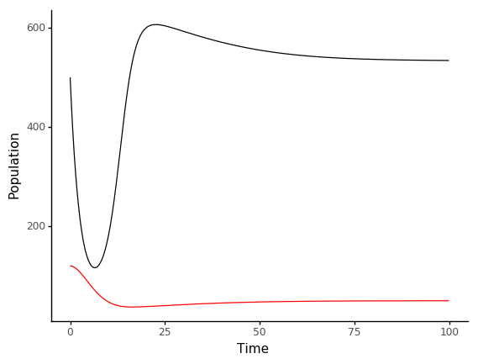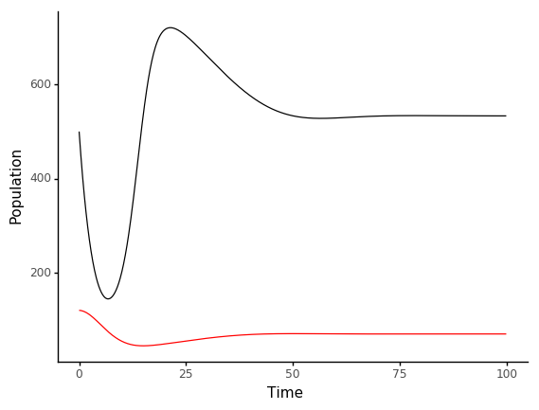

alpha = 0.00125 | carrying capacity = 800

alpha = 0.001 | carrying capacity = 1200

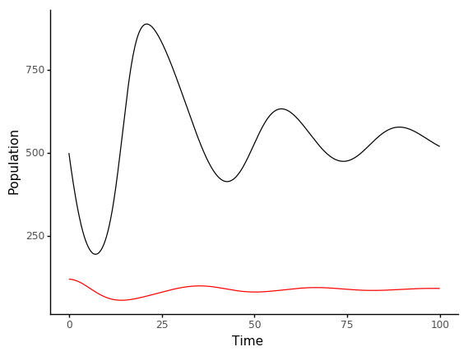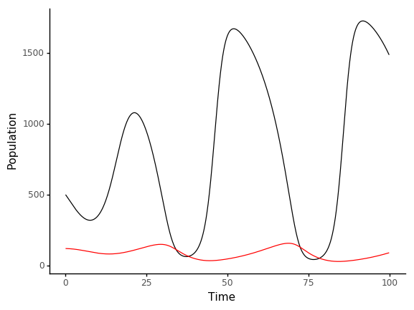

alpha = 0.0005 | carrying capacity = 2000

alpha = 0.00075 | carrying capacity = 1600

**Paradox of Enrichment Questions:**

What happens as carrying capacity increases?

As prey carrying capacity increase, there is a visible destabilization in both predator and prey populations as seen in the simulations above after a certain threshold. In all simulations, the prey and predator populations begin at 500 and 120 respectively.

When prey carrying capacity is 800, the prey population dips to ~150, spikes to ~600, and levels out at ~550, and the predator population levels out at ~50. When prey carrying capacity is 1200, the prey population dips to ~150, spikes to ~750, and levels out at ~550 once again, and the predator population levels out at ~50 once again. When prey carrying capacity is 1600, we begin to observe oscillations in the prey population, dipping initially to ~200, spiking to ~900, and oscillating until levelling out at ~500, and the predator population increases compared to previous simulations but begins to oscillate slightly as well, averaging and leveling out at ~100. When prey carrying capacity is 2000, oscillations in prey population become drastically larger, dipping initially to ~400, spiking to ~1050, then dipping to almost 0 and spiking to ~1700 in every successive cycle, with each oscillation markedly more drastic than the previous, and the predator population stays a similar level to the previous simulation of ~100, but its oscillations become notably larger as well, spiking at ~200 and dipping to almost 0 in every cycle, with each oscillation even becoming very slightly more drastic than the previous.

As evidenced by these simulations, it is very possible that given an even higher prey carrying capacity than 2000, or even simply more time at a carrying capacity of 2000, one or both of the prey and predator populations could be completely wiped out.

Why do you think we see the Paradox of Enrichment?

A simple and common explanation for the Paradox of Enrichment is that when presented with what is, for all intents and purposes, an unbounded carrying capacity, the prey population will grow unbounded as well. As a result of the overabundance of prey, the predator population grows drastically along with the prey population, causing the predator population to become unsustainably large, to such a degree that the number of predators consuming the prey succeeds the rate at which the prey grow even with such a high carrying capacity, causing a crash in the prey population and subsequently a crash in the predator population, which could potentially lead to the eradication of one or both of the prey and predator populations. There are many exceptions to this phenomenon observed in both many simulations and real-life scenarios though, a general explanation being that there are often factors other than the availability of prey alone that influence the growth of the predator population.