Rosenzweig-MacArthur Plot Additional Questions

In all cases, the predator population is defined by the red line and the prey population is defined by the red line.

Lotka-Volterra Base Case

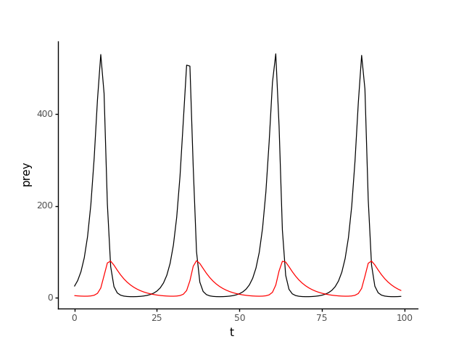

Base Case: Given Values

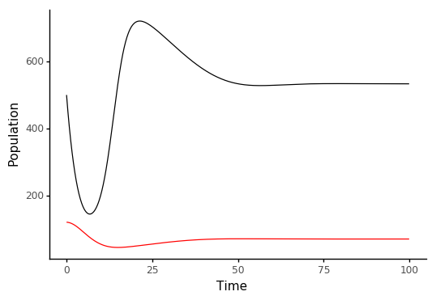

|  |  |
| --- | --- |
| Triple the Prey Birth Rate (b) | Half the Prey Birth Rate (b) |
|  |  |

|  |  |
| --- | --- |
| Triple the Intraspecific Competition Coefficient (α) | Half the Intraspecific Competition Coefficient (α) |
|  |  |

|  |  |
| --- | --- |
| Triple the Search Rate (w) | Half the Search Rate (w) |
|  |  |

|  |  |
| --- | --- |
| Triple density of prey at which the predator’s kill rate reaches half its maximum (d) | Half density of prey at which the predator’s kill rate reaches half its maximum (d) |
|  |  |

|  |  |
| --- | --- |
| Triple the Conversion Efficiency of Prey to Predators (e) | Half the Conversion Efficiency of Prey to Predators (e) |
|  |  |

|  |  |
| --- | --- |
| Triple the Predator Death Rate (s) | Half the Predator Death Rate (s) |
|  |  |