Vision and Scope Document

for

SHOW MANAGEMENT SYSTEM
Version 2.1 approved
Prepared by
Duong Pham – Van Nghia – Manh Dung – Tuan Hung – Hoang Viet
FPT UNIVERSITY
24/05/2006
Table of Contents

Table of Contents ii
Revision History ii
1. Business Requirements 1
1.1. Background 1
1.2. Business Opportunity 1
1.3. Business Objectives 1
1.4. Success Metrics 1
1.5. Vision Statement 2
1.6. Business Risks 2
1.7. Business Assumptions and Dependencies 3
2. Scope and Limitations 3
2.1. Major Features 3
2.2. Scope of Initial Release & Subsequent Releases 4
2.3. Limitations and Exclusions 5
3. Business Context 2
3.1. Stakeholder Profiles 5
3.2. Project Priorities 6
3.3. Deployment Considerations 7

Revision History

Name | Date | Reason For Changes | Version
Pham Quang Duong | 24/05/26 | 1. Business Requirement | 0.1 draft
Nguyen Vu Tuan Hung | 27/05/26 | 2. Scope and Limitations | 0.2 draft
Hoang Quoc Viet | 27/05/26 | 3. Business Context | 0.3 draft
Nguyen Vu Tuan Hung | 28/05/26 | Create tree diagram and Tagging in Scope and Limitations | 0.4 draft
Hoang Quoc Viet | 28/05/26 | Edit the Project Priorities table | 0.5 draft
Pham Quang Duong | 31/05/26 | Baseline following changes after inspection | 1.0 approved
Pham Quang Duong | 05/06/26 | Update footer and name for tree diagram | 0.6 draft
Pham Quang Duong | 08/06/26 | Fix name of diagram and tagging in 1.4 | 0.7 draft
Pham Quang Duong | 08/06/26 | Baseline following changes after inspection | 2.0 approved
Pham Quang Duong | 21/06/26 | Add new stakeholders Financial Staff | 2.1 approved

Business Requirements

Background
Nowadays, some show of water park just manual management, marketing though leaflets or poster and sell the ticket for the customer on the gateway. That’s make some problem for each segment. When the show must be update time or change the location, very difficult to conveys to the all customer and don’t have information about anybody (phone number, email). In many case 100 ticket were sold but the money manager gets is inconsistent.

Business Opportunity
The software called Show Management System to help visitors easily track and buy tickets to participate in the shows in the water park. The system also makes it easy for the manager to manage shows in the water park.

Have some application in Viet Nam also have this feature like Sun-World, but just have the combo for all the services or only stop at check the Schedule and Booking. The SMS will add some function to optimize customer experience and revenue.

Business Objectives
- BO-1: The revenue increase 30% after 6 months.
- BO-2: Increase occupancy rate for each show at least 85% on the weekends and holidays through the booking online and marketing. Reduce time sell the tickets at the gate 2 minutes/1 slot through the features booking online.
- BO-3: Reduce time sell the tickets at the gate 2 minutes/1 slot through the features booking online.
- BO-4: Save time for the manager to create, update, broadcast weekly show schedules to visistor by 50%.

Success Metrics
1.4.1 Measurable Success Criteria
- SC-1: To achieve 30% during 6 months, the data collected from the ticket sales report must be at least 5% for the 3 months since starting the operation SMS.
- SC-2: The transaction logs have to ticket sales report through the booking online at least 60% and the amount of tickets on the gate >40%.
- SC-3: The audits on the gate have to recognize the time to sales ticket for customer just 2 minutes.
- SC-4: Time to manage create, update, broadcast weekly show schedules have to audit logs and must be prove that reduced from 2 hour (manual management) to ~30 minutes (SMS).

1.4.2 External factors
- EX-1: User interface have to friendly, check and booking ticket must be successful in ~1 minutes.
- EX-2: Staff to manage SMS must to train step by step to control the Dashboard, train to handle incidents for the booking app or the broadcast weekly show schedules.
- EX-3: Marketing plan for everybody become widely known through the QR code, poster, voucher,… and many incentives for the visitors.

Vision Statement
For the visitors and management board, Who face difficulty to follow the broadcast weekly show schedules, queue to buy the ticket, waste time to report the revenue through the manual management. The Show Management System is the software control check show and booking online. That’s convenient for the customer buy ticket and easy to make report the revenue. Unlike the manual manager so hard to conveys to the customer when update the show or sales ticket in the gate have to 1-2 hour. Our product will completely digitalize the entertainment experience, eliminate some process unnecessary, optimize operational productivity and increase the revenue.

Business Risks
- BR-1: Visitor >30 years old may choose buy tickets in the gate because they do not known about the technology. That’s means system do not reach the expected user rate. (Probability = 0.5; Impact = 7).
- BR-2: The wi-fi, 4G/5G overload on the weekends and holidays, customer can not access the application to check and booking shows. (Probability = 0.6; Impact = 9).
- BR-3: System depend on the app banking like MOMO, VNPAY. If this payment gateway have some problems or maintenance, visitor can not buy the ticket online. (Probability = 0.3; Impact = 3).
- BR-4: Have some business also have software to manage the show like Sun-World very popular in Viet Nam. Customer have experienced and expect to SMS some features convenient with no room for minor errors. (Probability = 0.3; Impact = 3).

Business Assumptions and Dependencies
1.7.1 Business Assumptions
- AS-1: 90% customer use smartphone and have banking account.
- AS-2: Everybody want to buy ticket online than queue in the gateway.
1.7.2 Business Dependencies
- DE-1: Payment system like MOMO or VNPAY must be stable during the process.
- DE-2: The show have a lot of show and visitor before.

Scope and Limitations

Major Features
- FE-1: Show Scheduling:
Provides tools for the management board to quickly create, update, and broadcast weekly show schedules to visitors.
- FE-2: Online Ticket Booking:
Allow visitors to easily track show information and complete the online ticket booking process within approximately 1 minute.
- FE-3: Gate Operations (Ticketing & Verification):
Supports staff in selling and verifying tickets at the gate, optimizing the processing time to just 2 minutes per transaction.
- FE-4: Revenue Reporting:
Automates the recording of transaction logs and the extraction of ticket sales reports, resolving inconsistencies in revenue tracking.
- FE-5: Payment Integration:
Enables online payments through digital gateways and banking applications such as MOMO and VNPAY.
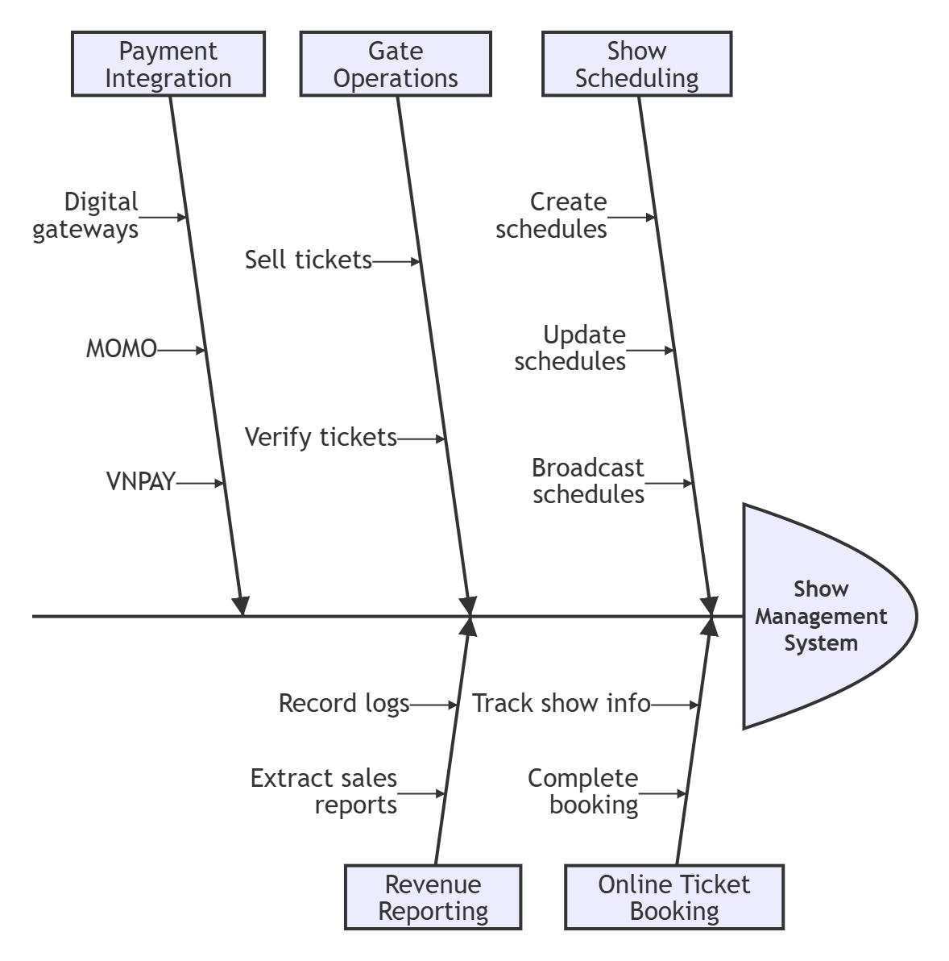
Figure 1. Feature tree for the Show Management System.

Scope of Initial Release & Subsequent Releases
Feature | Release 1 | Release 2 | Release 3
FE-1: Show Scheduling | Centralized Dashboard to create, update, and broadcast weekly show schedules. | Fully implemented
FE-2: Online Ticket Booking | Web/mobile interface to view schedules and book standard tickets online. | Integrate marketing campaign tools (QR codes, discount vouchers, special incentives). | Add combo ticket feature covering multiple services (Sun-World model).
FE-3: Gate Operations | Dedicated ticket verification interface to quickly validate digital tickets at the gates. | Fully implemented
FE-4: Revenue Reporting | Core transaction recording and basic ticket sales extraction. | Fully implemented
FE-5: Payment Integration | Integrated payment gateways: MOMO and VNPAY only. | Integrate at least 3 additional electronic payment gateways for backup. | Fully implemented

Limitations and Exclusions
- LI-1: The software system will not completely replace physical ticket counters, as the visitor segment over 30 years old may not be familiar with the technology and will still require staff support at the checkout counter.
- LI-2: The use of the online booking feature is entirely dependent on the user's Internet connection (Wi-Fi, 4G/5G). The provision and upgrading of network hardware infrastructure (such as installing additional Wi-Fi access points to prevent network overload on weekends) are outside the scope of this software development project.
- LI-3: The stability of the online ticket payment process relies completely on third-party payment gateways (MOMO, VNPAY). System maintenance or banking errors are beyond the direct control and handling capacity of the Show Management System (SMS).

Business Context

Stakeholder Profiles
Stakeholder | Major Value | Attitudes | Major Interests | Constraints
Visitors/Tourists | Convenient ticket booking, no need to queue, quick access to updated show schedule. | Positive if the system is easy to use and payments are fast. | Accurate schedules, transparent ticket prices, simple booking process. | Requires Internet connection (Wi-Fi/4G/5G).
Park Management Board | Accurate revenue control, centralized show schedule management, optimized productivity. | Highly supportive because it helps reduce losses and increase revenue. | Automatic revenue reports, intuitive dashboard. | Limited budget and implementation time.
Ticket Inspectors / Customer Service Staff | Reduced manual work, faster ticket checking process. | Positive after receiving training and usage guidance. | Simple ticket verification interface, stable operation at the entrance gates. | Limited training time
Sponsors / Investors | Increase revenue by 30% after 6 months, digitize operational processes. | Expect the product to launch on schedule to catch the peak season. | Return on investment (ROI), reliability of the payment system. | Dependence on payment partners (MOMO, VNPAY).
Accountants/  Financial Staff | Automate revenue reconciliation, eliminating errors in manual calculations (inconsistent money). | Highly recommend this system because it helps to extract reports quickly and accurately. | Transaction logs are transparent, and the sales report export feature is easy to use. | The requirement is for absolute data accuracy (100% accuracy) and the security of financial information.

Project Priorities
Dimension | Constraint | Driver | Degree of Freedom
Schedule |  | Complete version 1.0 on time so the system can operate before the peak tourism season.
Features |  |  | Secondary features (marketing, combo packages) may be postponed to later versions.
Quality | Core functions (ticket booking, payment, ticket validation) must operate with 100% accuracy.
Staff | Only the park’s existing internal IT team will be used.
Cost |  |  | Acceptable to exceed the budget by a maximum of 10% if necessary to ensure progress.

Deployment Considerations

User Access
- Visitors/Tourists: Can access the system through a web browser or mobile device to view show schedules and book tickets.
- Managers: Need access to show management, ticket management, and reporting functions.
- Staff: Need access to ticket verification and visitor support functions.
- Accountants: Need access to revenue reporting, transaction logs, and refund tracking functions.

System Availability
- The system should be available during the water park's operating hours.
- Visitors should be able to book tickets at any time.

Infrastructure Requirements
- Internet connection is required for all users.
- A central database is needed to store show schedules, ticket information, and user data.
- The system should support multiple users accessing it simultaneously.

Training and Support
- Managers and staff may require basic training before using the system.
- User guides should be provided for system operations.

