# Soft.Core.Configuration

## Descripcion

Permite la lectura del archivo config.xml y gracias a ello se puede leer datos que se colocan como parte de la inicialización

## Arquitectura

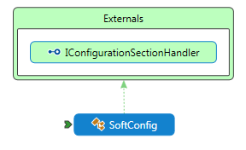

### SoftConfig

Posee la configuración para la lectura de la sección **SoftConfig**

<SoftConfig>

<DynamicDiscovery Enabled="true"/>

<Engine Type=""/>

<Themes basePath="~/Themes/"/>

<UserAgentStrings databasePath="~/App_Data/uas_20140809-02.ini"/>

</SoftConfig >

* public bool DynamicDiscovery { get; private set; }
* public string EngineType { get; private set; }
* public string ThemeBasePath { get; private set; }
* public bool IgnoreStartupTasks { get; private set; }
* public string UserAgentStringsPath { get; private set; }

Dicha sección permite cargar dinámicamente los ensamblados que estén en la carpeta \bin, además establecer el directorio de temas entre otros usos

## Especificaciones

|  |  |
| --- | --- |
| SCC1 | En la configuración debe poderse especificar la carga dinámica de los ensamblados |
| SCC2 | Permitir especificar la instancia del contexto que se va a cargar |
| SCC3 | Permitir especificar la carpeta de temas que serán cargados en el sistema |
| SCC4 | Permitir especificar si se van a ejecutar tareas antes de iniciar el sistema |
| SCC5 | Permitir el uso de base de datos de ips para geo ubicación |

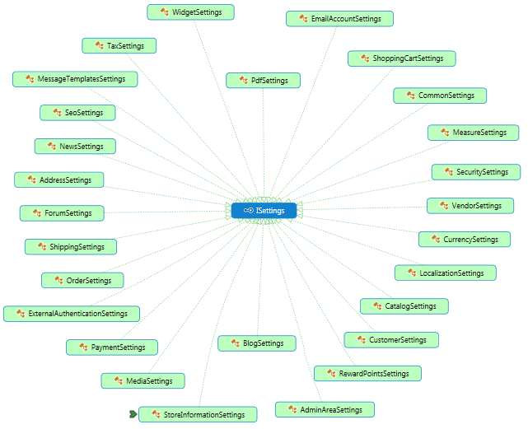

### AddressSettings

* public bool CompanyEnabled { get; set; }
* public bool CompanyRequired { get; set; }
* public bool StreetAddressEnabled { get; set; }
* public bool StreetAddressRequired { get; set; }
* public bool StreetAddress2Enabled { get; set; }
* public bool StreetAddress2Required { get; set; }
* public bool ZipPostalCodeEnabled { get; set; }
* public bool ZipPostalCodeRequired { get; set; }
* public bool CityEnabled { get; set; }
* public bool CityRequired { get; set; }
* public bool CountryEnabled { get; set; }
* public bool StateProvinceEnabled { get; set; }
* public bool PhoneEnabled { get; set; }
* public bool PhoneRequired { get; set; }
* public bool FaxEnabled { get; set; }
* public bool FaxRequired { get; set; }

### EmailAccountSettings

* public int DefaultEmailAccountId { get; set; }

### CustomerSettings

* public bool UsernamesEnabled { get; set; }
* public bool CheckUsernameAvailabilityEnabled { get; set; }
* public bool AllowUsersToChangeUsernames { get; set; }
* public PasswordFormat DefaultPasswordFormat { get; set; }
* public string HashedPasswordFormat { get; set; }
* public int PasswordMinLength { get; set; }
* public UserRegistrationType UserRegistrationType { get; set; }
* public bool AllowCustomersToUploadAvatars { get; set; }
* public int AvatarMaximumSizeBytes { get; set; }
* public bool DefaultAvatarEnabled { get; set; }
* public bool ShowCustomersLocation { get; set; }
* public bool ShowCustomersJoinDate { get; set; }
* public bool AllowViewingProfiles { get; set; }
* public bool NotifyNewCustomerRegistration { get; set; }
* public bool HideDownloadableProductsTab { get; set; }
* public bool HideBackInStockSubscriptionsTab { get; set; }
* public bool DownloadableProductsValidateUser { get; set; }
* public CustomerNameFormat CustomerNameFormat { get; set; }
* public bool NewsletterEnabled { get; set; }
* public bool NewsletterTickedByDefault { get; set; }
* public bool HideNewsletterBlock { get; set; }
* public int OnlineCustomerMinutes { get; set; }
* public bool StoreLastVisitedPage { get; set; }
* public bool SuffixDeletedCustomers { get; set; }
* public bool GenderEnabled { get; set; }
* public bool DateOfBirthEnabled { get; set; }
* public bool CompanyEnabled { get; set; }
* public bool CompanyRequired { get; set; }
* public bool StreetAddressEnabled { get; set; }
* public bool StreetAddressRequired { get; set; }
* public bool StreetAddress2Enabled { get; set; }
* public bool StreetAddress2Required { get; set; }
* public bool ZipPostalCodeEnabled { get; set; }
* public bool ZipPostalCodeRequired { get; set; }
* public bool CityEnabled { get; set; }
* public bool CityRequired { get; set; }
* public bool CountryEnabled { get; set; }
* public bool StateProvinceEnabled { get; set; }
* public bool PhoneEnabled { get; set; }
* public bool PhoneRequired { get; set; }
* public bool FaxEnabled { get; set; }
* public bool FaxRequired { get; set; }
* public bool AcceptPrivacyPolicyEnabled { get; set; }

### SecuritySettings

* public bool ForceSslForAllPages { get; set; }
* public string EncryptionKey { get; set; }
* public List<string> AdminAreaAllowedIpAddresses { get; set; }