## Setup Keycloak Roles

Ensure role is setup under Springback client

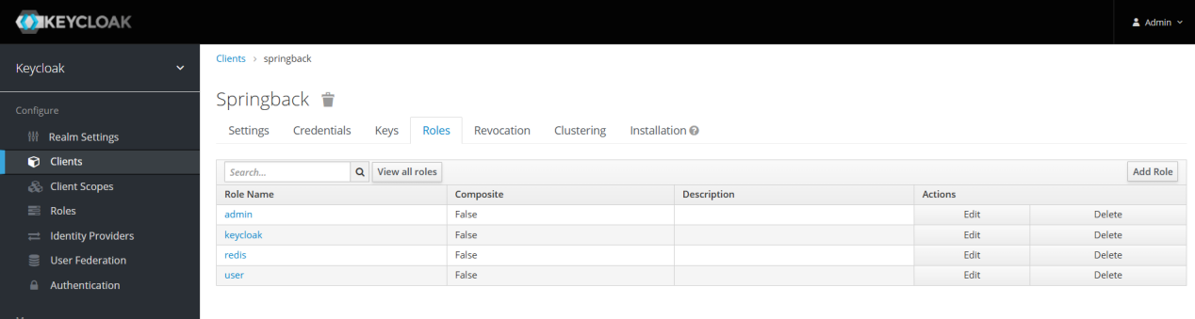

Add keycloak and redis role if not exist

## Setup Users

Create both user and keycloak then assign under role mapping.

Redis user should have both keycloak and redis role

Keycloak user should have only keycloak role

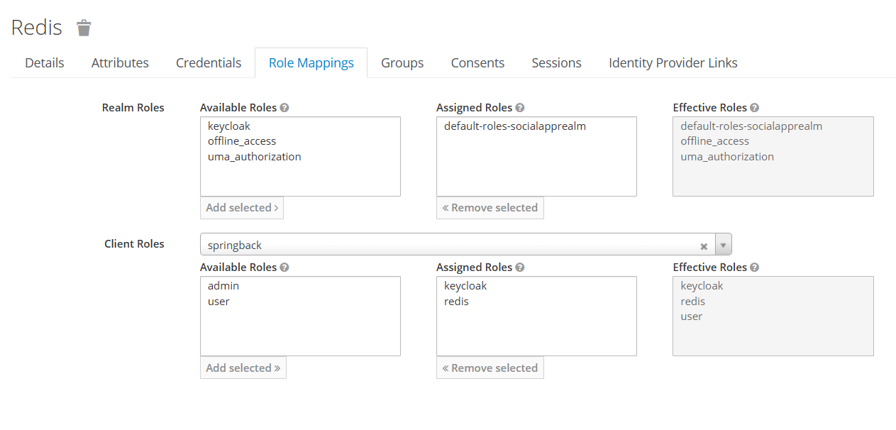

## Spring Boot

Prerequisite: Java 17 setup

run java -jar backend\App_api-0.0.1-SNAPSHOT.jar

## Start Keycloak and MYSQL as docker service

run docker compose up

