Basic User Guide

Start Keycloak and MYSQL as docker service 1

Start Spring Boot 3

Start Angular 3

Finish setup and test the app 4

## Start Keycloak and MYSQL as docker service

Run this command

[spring-boot-keycloak-mysql-demo]$ sudo docker compose up

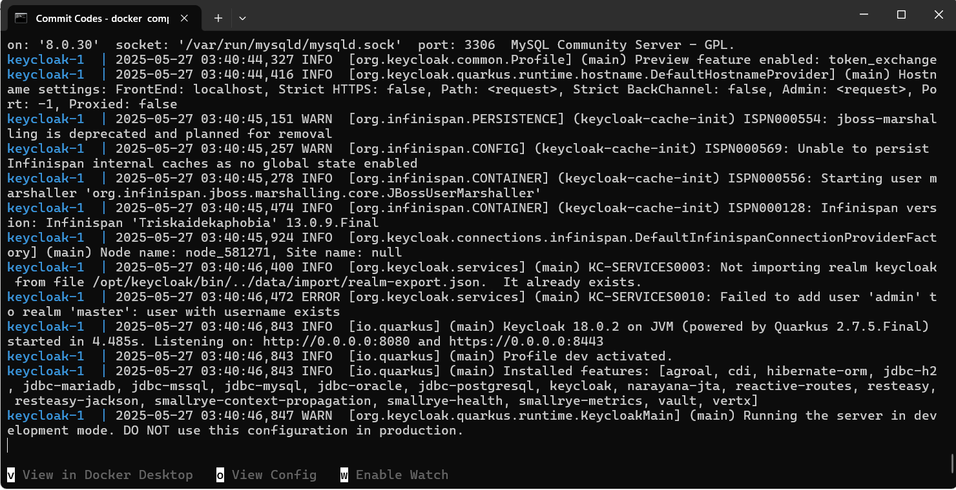

**Login to keycloak on http://localhost:7080/**

Username: admin , Password: adminpass

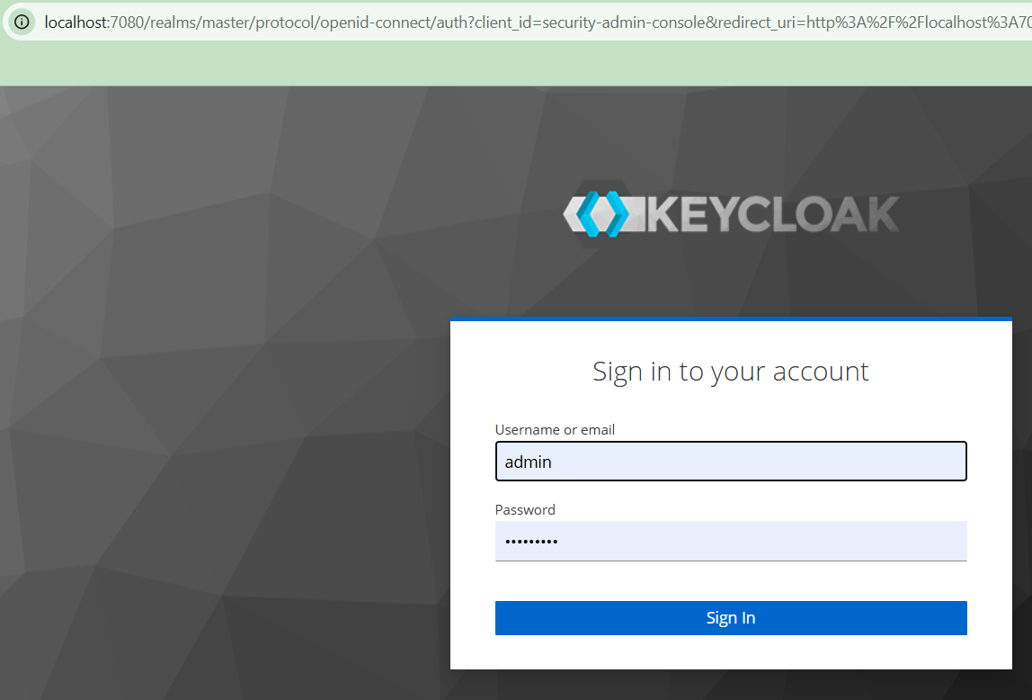**Setup Keycloak Roles**

Ensure role is setup under Springback client

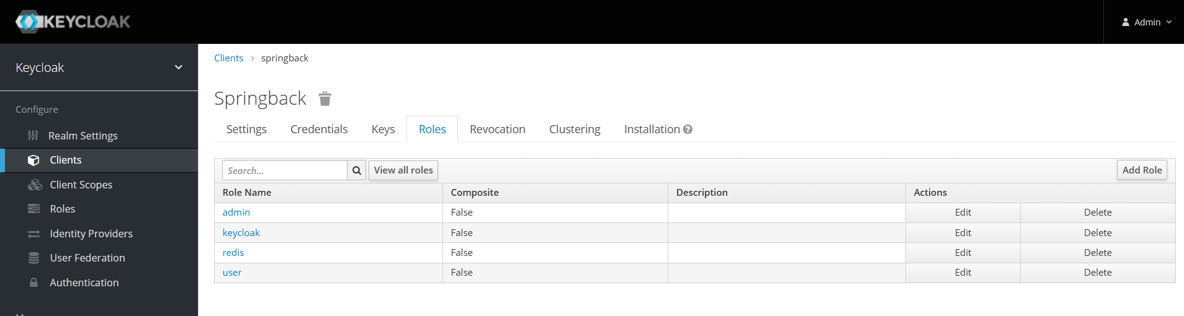

Add keycloak and redis role if not exist

**Setup Users**

Create both user and keycloak then assign under role mapping.

Redis user should have both keycloak and redis role

Keycloak user should have only keycloak role

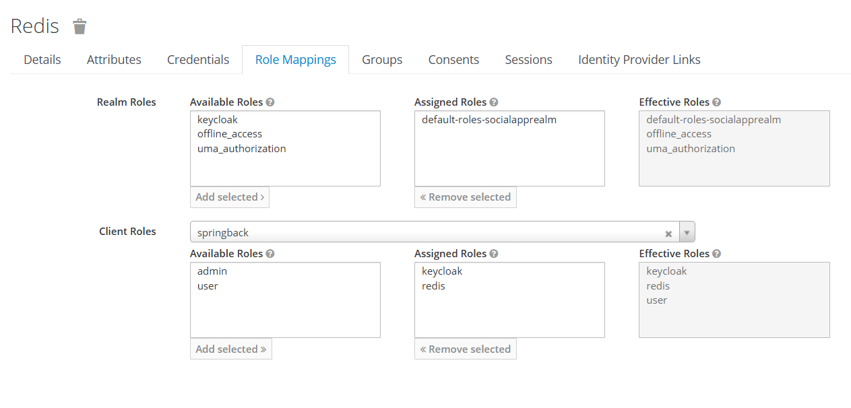

## Start Spring Boot

**Prerequisite**: Java 17 JRE setup

Run the command below

[spring-boot-keycloak-mysql-demo]$ java -jar Backend/App_api-0.0.1-SNAPSHOT.jar

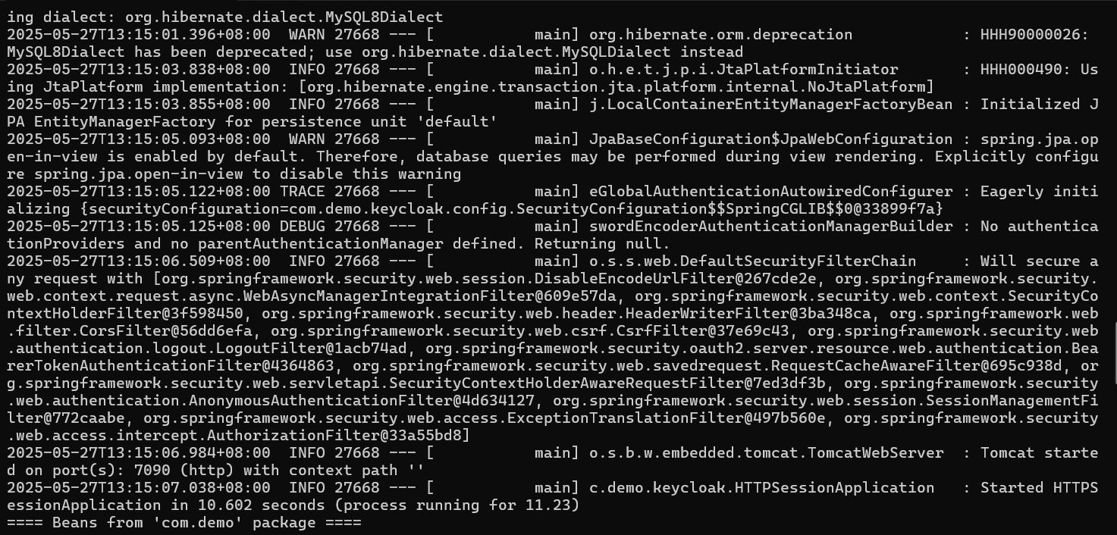

## Start Angular

Go to Frontend folder then run the command below

[Frontend]$ **nvm install v18.19**

v18.19.1 is already installed.

Now using node v18.19.1 (npm v10.2.4)

[Frontend]$ **npm i**

added 135 packages, removed 155 packages, changed 201 packages, and audited 1286 packages in 36s

[Frontend]$ **npm start**

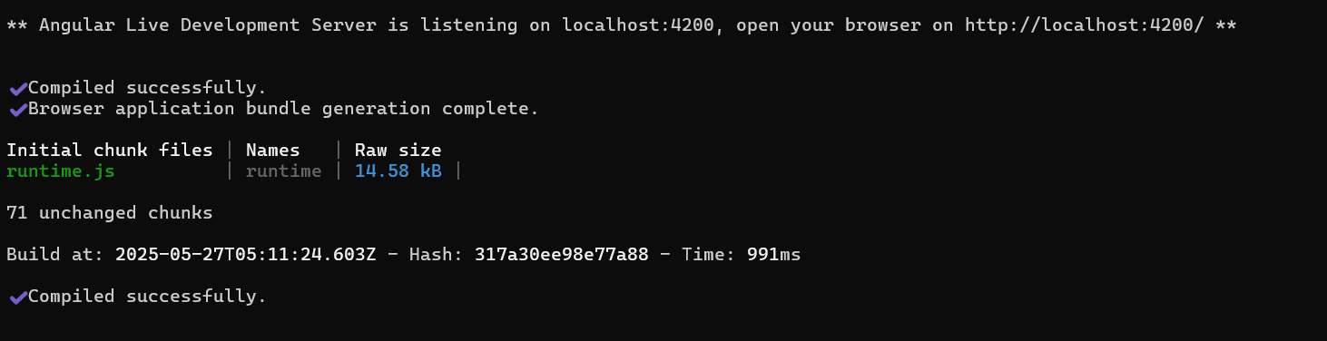

## Finish setup and test the app

Go to http://localhost:4200/

