

Course Name: Making Sense of Disease Pathways

Title of Assessment:

Sulfur amino acid metabolism

Examination Number:

B081462

Roll Number:

134

Word count (excluding references):

2677

**Sulfur amino acid metabolism**

**Abstract**

Usually associated with hot springs, skunks and the stench of rotten eggs, sulfur is more than just a smelly chemical. It is the 10th most abundant element in the universe and 8th most abundant in the human body1. Sulfur containing compounds have a central role in many key metabolic processes within the body, such as cellular redox regulation and protein synthesis. Recently, hydrogen sulfide has been gaining a lot of attention as the 3rd endogenous gasotransmitter (after NO and CO) with suggested roles in cardiovascular health, neuronal tissues and the immune system2. Many disease states, such as atherosclerosis, are characterized by a dysregulation of sulfur compounds3 (including H2S), thus a sophisticated understanding of the underlying metabolic pathways is crucial for understanding the pathophysiology and future treatments. This pathway model represents the major destinations of the sulfur amino acids and their metabolites, starting from ingestion and ending with various biochemical roles.

**Introduction**

Sulfur, a chemical element essential for all types of life, forms a part of many biomolecules that act in fields as varied as DNA methylation, detoxification and protein synthesis3. It is introduced into the human body in the form of sulfate or sulfur-containing biomolecules through protein, especially seafood, meat and eggs.

In humans, the two amino acids methionine and cysteine are the main players in sulfur metabolism4. Methionine, the initiating amino acid in all eukaryotic protein synthesis, is taken up by diet as it cannot be made *de novo* in mammalian cells5. All of the body’s sulfur requirements can be met by methionine, with the exception of sulfur-containing vitamins thiamine (B1) and biotin (B7)1.

The other sulfur-containing proteinogenic amino acid – cysteine – is important in the production of coenzyme A and glutathione among other metabolites. In addition, two other non-proteinogenic amino acids – homocysteine and taurine – have important roles in hydrogen sulfide production and bile acid synthesis.

When it comes to human disease, changes to sulfur containing compounds have been implicated in many complex, multifactorial disorders, such as cardiovascular disease, diabetes and neurodegenerative disorders4. Thus, it is vital to further the understanding of sulfur biology further in order to pave the way towards potential pharmacological interventions.

**Sources of information**

I started building my pathway by consulting the “[Cysteine and methionine metabolism](https://www.genome.jp/kegg/pathway/map/hsa00270.html)” KEGG pathway. Although a good starting point, I found that many of the reactions represented here only occur in bacteria. The pathway also had many dead ends, where produced biochemicals were not linked to any other pathways or reactions. In addition, almost none of the reactions had references provided and sometimes it was hard to find any information on a reaction from other sources, making me doubt the very existence of it. That said, KEGG pathways were reasonably up-to-date, including proteins only recently discovered to participate in a reaction.

Later on I used other KEGG pathways, such as the “[Sulfur metabolism](https://www.genome.jp/kegg-bin/show_pathway?hsa00920)” and “[Glutathione metabolism](https://www.genome.jp/kegg-bin/show_pathway?org_name=hsa&mapno=00480&mapscale=&show_description=hide)”, which presented similar problems but were still useful.

I also used the “[Sulfur amino acid metabolism](https://reactome.org/PathwayBrowser/#/R-HSA-1614635)” Reactome pathway. This was nowhere near as complete as the KEGG source, missing several important reactions and even pathways. The only reference provided with this pathway was a review by Brosnan et al5, which I had already used in the production of my pathway.

There are also several pathways on the [Small Molecule Pathway Database (SMPDB)](http://smpdb.ca/) that I found useful. Out of the diagrams I’ve looked at over this semester, these were the most visually appealing, and I especially liked the included chemical structures and precise enzyme representations (quaternary structure and cofactors). In addition to having the same issues as the KEGG pathways, I found their representation of some reactions misleading. For example, in the “[Glutathione metabolism](http://smpdb.ca/view/SMP0000015)” pathway, instead of showing that there are tens of different glutathione S-transferases that can catalyse hundreds of different reactions, this pathway only shows one enzyme and one reaction, not mentioning anywhere that this is just an example.

Furthermore, all the above-mentioned pathways individually only include a portion of the pathway I have tried to put together. There were multiple overlaps and connections between them, that I discovered only upon reading the literature. Also, all these pathways included related reactions that did not involve sulfur-containing compounds, which I have almost fully avoided in my pathway.

Notably, none of the pathways showed the full picture of hydrogen sulfide production and degradation, some even not including it at all.

Aside from the available pathway diagrams, most of the information that I gathered about my pathway came from reviews and primary research papers from PubMed. In addition, I found the [Human Metabolome Database](http://www.hmdb.ca/) and [UniProt](https://www.uniprot.org/) websites very useful as starting material for biochemicals and proteins, respectively.

**Simplified overview diagram of the whole pathway**

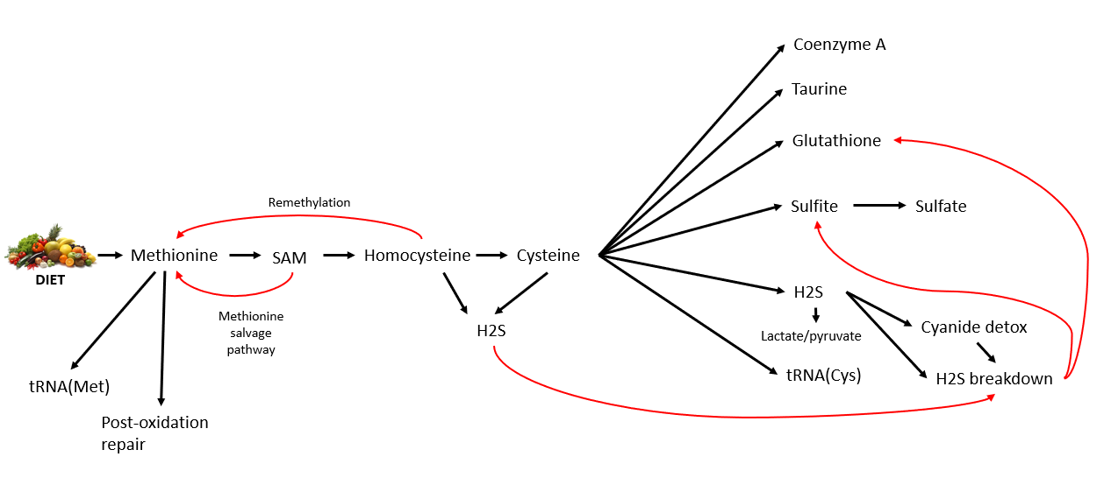

***Figure 1.*** Simplified overview of the sulfur amino acid metabolism pathway

**Description of parts**

*Met to Cys pathway*

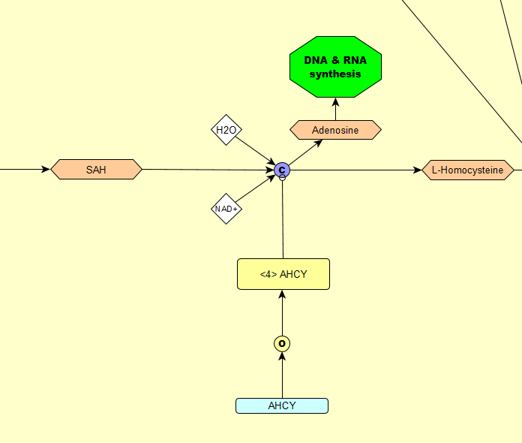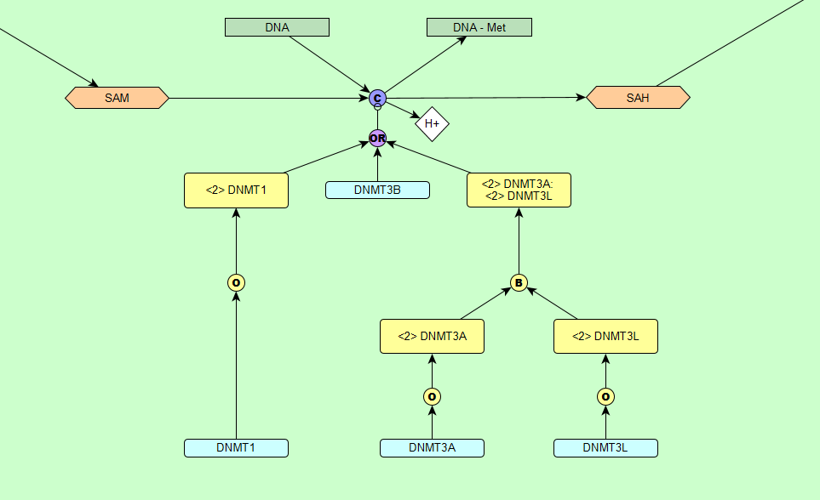Although it is difficult to choose a starting point for a biochemical pathway, I’ve selected the ingestion of methionine, an essential amino acid. It plays a central role and is where I started building my pathway from, in particular its conversion to cysteine. Firstly, in the form of S-adenosylmethionine (SAM) it is a very important methylating agent (methyl group donor), responsible for gene regulation in the nucleus6 (see Fig. 2). After that, it is hydrolysed to adenosine and homocysteine (see Fig. 3). Then homocysteine can enter two pathways – the remethylation cycle or transsulfuration2 (see Fig. 4). The remethylation cycle is an important way of replenishing the cell’s methionine pool, whereas transsulfuration leads to cysteine synthesis2. In addition, homocysteine can be a substrate for transsulfuration enzymes to produce hydrogen sulfide7.

***Figure 2.*** SAM is converted to SAH by DNA methyltransferases 1, 3A and 3B by transferring the methyl group in SAM to DNA.

***Figure 3.*** SAH and water is converted to L-Homocysteine and adenosine by S-adenosyl-L-homocysteine hydrolase, using NAD+ as a cofactor.

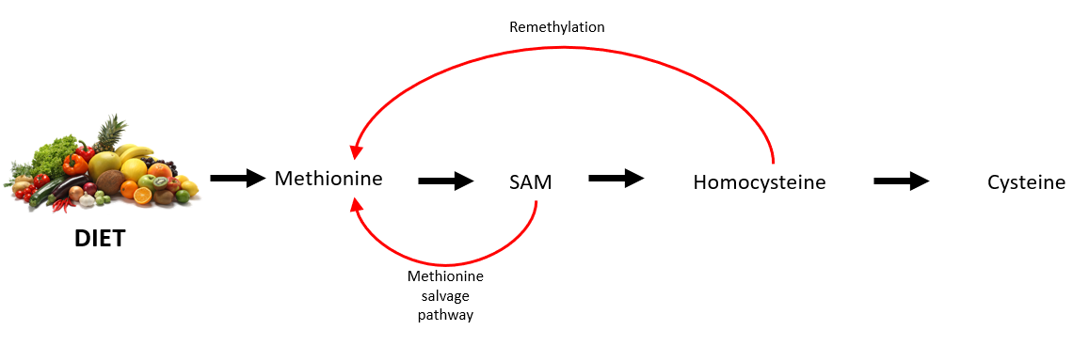

***Figure 4.*** Simplified diagram of the methionine to cysteine pathway. Methionine is taken up by diet and converted first to SAM, then to homocysteine and finally to cysteine. Homocysteine can enter the remethylation cycle and SAM can enter the methionine salvage pathway, both resulting in methionine recycling.

*Transsulfuration and hydrogen sulfide production*

Cystathione beta-synthase and cystathione gamma-lyase can produce hydrogen sulfide through a number of reactions by utilising homocysteine and cysteine8 (see reactions 3-9 in Fig. 5) . The dynamics of how and when these reactions are favoured over the transsulfuration reactions (see reactions 1 and 2 in Fig. 5) is unclear, and a matter of debate7.

Hydrogen sulfide goes on to function as a gasotransmitter, that is thought to signal via sulfhydration, also known as persulfidation9. Its functions and importance are discussed later in this essay.

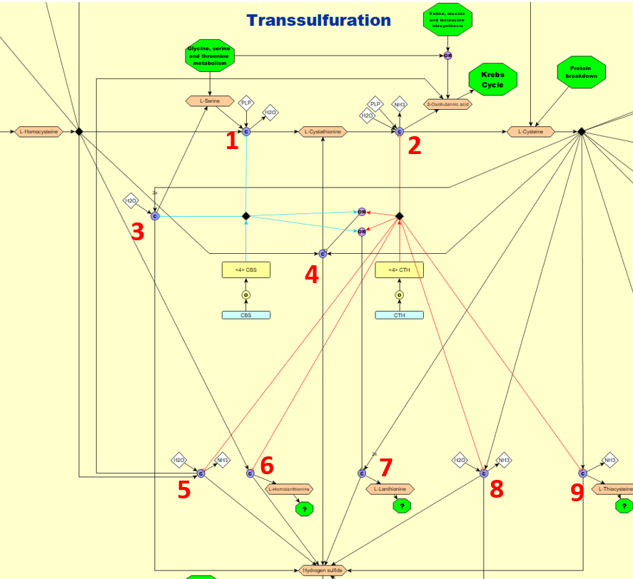The importance of the transsulfuration reactions is exemplified by the fact that an estimated 50% of cysteine used for hepatic glutathione production comes from this pathway7. Cystathione beta-synthase deficiency manifests with a range of symptoms, from neurological to connective tissue problems, with an associated homocystinuria (increased levels of homocysteine in blood and urine)10.

***Figure 5.*** The two transsulfuration pathway enzymes cystathione beta-synthase and cystathione gamma-lyase catalyse several reactions to produce hydrogen sulfide.

*Methionine salvage pathway*

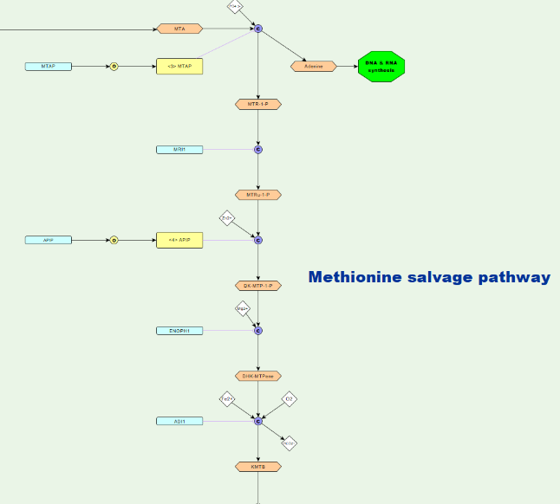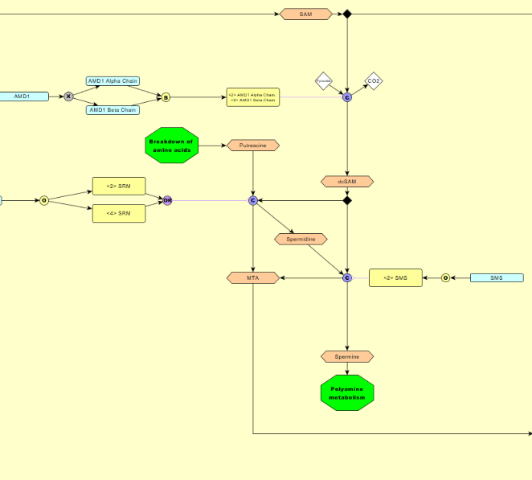The methionine salvage pathway, also called the MTA pathway, is a pathway present in most organisms for recycling the sulfur in 5′‐methylthioadenosine (MTA), a by-product of polyamine synthesis, back to methionine11 (see Fig. 6 and 7). In some cancers this pathway is dysregulated, with a malfunctioning MTAP, thus methionine depletion has been considered as treatment11.

***Figure 6.*** Decarboxylated SAM and putrescine form spermine (a polyamine) and MTA (a by-product, that enters the methionine salvage pathway).

***Figure 7.*** The methionine salvage pathway. In the nucleus, MTA undergoes a number of steps to form KMTB, going on to form methionine in the cytoplasm.

*Glutathione redox cycle*

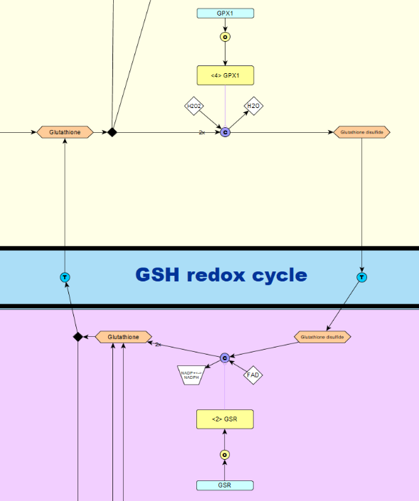

***Figure 8.*** Reduced glutathione (glutathione) reacts with reactive oxygen species, such as H2O2 and form oxidised glutathione (glutathione disulfide). In the mitochondria, it is recycled back to reduced glutathione.

*Mercapturic acid pathway*

Glutathione can also enter the mercapturic acid. (mercapturate) pathway (see Fig. 9). First, glutathione reacts with an endogenous (e.g. leukotriene) or an exogenous (e.g. many drugs) electrophile, to form R-S-Glutathione, where R is the conjugate from the electrophile12. Next, the compound is converted to R-S-cysteinylglycine, then R-S-cysteine, which is transferred back into the cytoplasm13. In the final step, R-S-cysteine is converted to R-S-N-acetylcysteine, also called a mercapturic acid or mercapturate, which is excreted in urine or bile13. This pathway results in a mercapturate that is more polar and water soluble than the original electrophile, making it much easier to excrete from the body13.

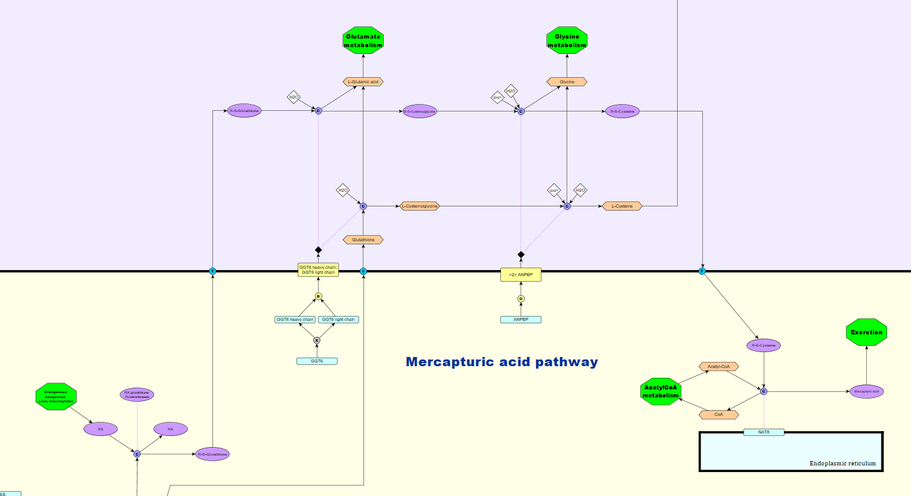Disbalances in glutathione metabolism are associated with a number of conditions, such as cancer, aging, metabolic and cardiovascular diseases14. Cancer cells generally have increased levels of glutathione, thus making them resistant to oxidative stress and better at metabolising anti-cancer drugs through the mercapturic acid pathway14.

***Figure 9.*** The mercapturic acid pathway. Glutathione reacts with a toxic electrophile and via several reactions forms a mercapturic acid, which is easily excreted from the body.

*H2S breakdown:*

Hydrogen sulfide breakdown takes place in the mitochondrion. Although several pathways have been proposed, I have presented what is currently the consensus view. First, sulfide : quinone oxidoreductase (SQOR) converts hydrogen sulfide to a protein-bound persulfide2. The acceptor of this persulfide group is controversial, but is most likely to be glutathione2. Glutathione persulfide is then metabolised in two ways, either to thiosulfate via TST or to sulfite via ETHE17 (see Fig. 10 and 11). Both products are readily excreted from the body2. Sulfite can also be further metabolised via SUOX, to yield sulfate2.

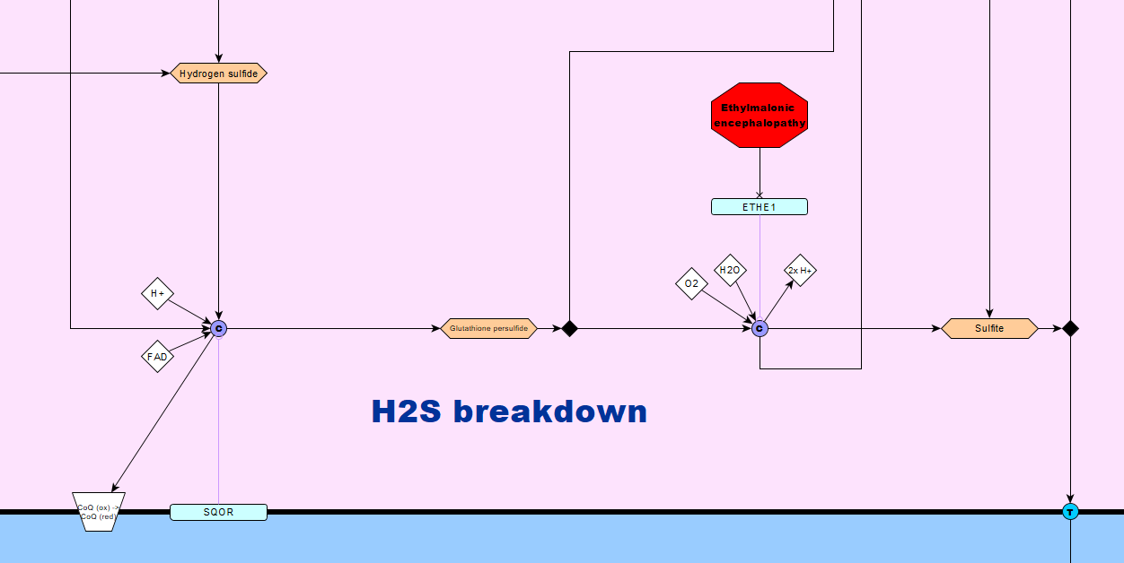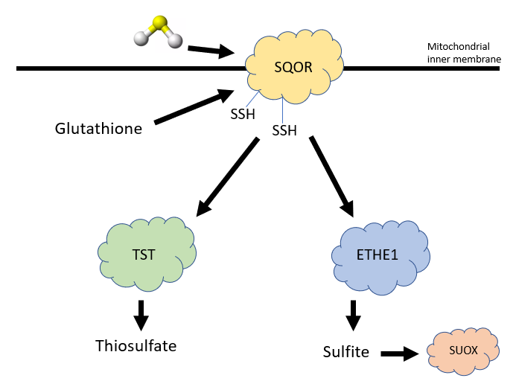While much attention has been given to H2S biological function and its synthesis, its breakdown pathway has been largely ignored15. Nevertheless, there has been some research in this area, looking at mouse knock-outs of the enzymes involved. ETHE1 K/O mice die from sulfide toxicity after 4 weeks, showing the importance of this pathway in H2S breakdown16. Ongoing work at Prof Morton’s lab in the Edinburgh University Centre for Cardiovascular Science is looking at the effects of a TST K/O in mice17, which so far show an increased level of sulfide without toxicity and possible vasoprotective effects (unpublished results).

***Figure 11.*** Hydrogen sulfide breakdown pathway. Hydrogen sulfide is transformed to sulfite and thiosulfate, via SQOR, ETHE1 and TST enzymes.

***Figure 10.*** Simplified diagram of the hydrogen sulfide breakdown pathways. H2S, represented in ball and stick format, reacts with SQOR and forms SSH residues on it. These are removed by glutathione, which then forms either thiosulfate or sulfite via TST and ETHE1 enzymes. Sulfite can be further metabolised by the action of SUOX.

**Overview of other parts of the pathway**

Majority of the remaining pathway can be broken down to the following 7 areas:

1. tRNA synthesis
2. Taurine production
3. Coenzyme A production
4. H2S production by GOT1/GOT2/MPST
5. Sulfite production by GOT1/GOT2
6. Cyanide detoxification
7. Sulfate metabolism

**tRNA synthesis** is important for the two proteinogenic amino acids – cysteine and methionine. Cysteine as part of protein, plays a very important role in forming disulfide bonds with other cysteine residues18. This is what makes structures with a high cysteine content, such as hair, so strong. On the other hand, methionine is the initiating amino acid in all eukaryotic protein synthesis and one of the most hydrophobic amino acids5.

Even though it is nonproteinogenic, **taurine** is one of the most abundant amino acids within the brain and other parts of the body19. It is implicated in a variety of functions such as bile acid formation, antioxidation, anti-inflammatory effects and modulation of the central nervous system2. Taurine deficiency is linked to conditions such as cardiomyopathy, renal dysfunction and developmental abnormalities19.

The discovery of **coenzyme A** by F. Lipmann in 1947 was so influential that it earned him a Nobel Prize 6 years later20. Since then CoA and its derivatives have been shown to act in a variety of different pathways within cells. Biosynthesis of fatty acids, cholesterol and acetylcholine, acetylation of histones and the Krebs cycle are only a few examples of this20. Changes in the level of CoA in the body have been reported in a number of conditions, such as diabetes, cancer and cardiac hypertrophy20.

The **GOT1/GOT2/MPST** pathways represent an alternative path for H2S production, yet much less important than the CTH/CBS one7. This pathway might be used more in cells with higher cysteine levels, such as the kidney or where CTH/CBS expression is lower7.

**Sulfite** forms mainly as a breakdown product of sulfur-containing compounds and needs to be immediately oxidized by an enzyme called sulfite oxidase (SUOX) to prevent cellular damage2. Deficiency of SUOX in humans results in a condition called isolated sulfite oxidase deficiency (ISOD) which results in neurological symptoms and premature death, due to sulfite toxicity21.

**Cyanide** is found in nature and comes from sources as varied as cigarette smoke to spinach22. The human body has developed a way how to neutralise and excrete this very toxic compound, when it comes into contact with small quantities22. The two sulfurtransferases: TST and MPST can utilise sulfur compounds to form thiocyanate which is easily excreted in the urine23. The substrate for these enzymes – thiosulfate – has been used as an antidote for cyanide poisoning in the clinic24.

**Sulfate** is produced from metabolism of sulfur-containing compounds, and plays an important role in many biochemical processes within cells25. It is converted into 3′-phosphoadenosine 5′-phosphosulfate (PAPS) which is considered to be the main sulfonate donor for all sulfonation reactions25. Sulfonation, in most cases, leads to inactivation of steroids, thyroid hormone and neurotransmitters; glycosaminoglycan sulfonation is required for the maintenance of structure and function of tissues25.

**Hydrogen sulfide – the third endogenous gasotransmitter**

For decades, hydrogen sulfide was thought to be a toxic by-product of sulfur amino acid metabolism, due to its cytotoxicity at high concentrations9. Only over the last 10 years have we come to realise the function and effects of hydrogen sulfide as a gasotransmitter, following the discovery of H2S as a regulator of blood pressure and vascular tone in mice26. In fact, H2S has been shown to have cytoprotective effects at low concentrations, similar to nitric oxide - another gasotransmitter9. In addition to previously mentioned roles, H2S is an important modulator of neurotransmission, angiogenesis, nociception, cardiac function, leukocyte function, penile erectile function and many more, as the list keeps growing27. Various studies have shown decreased H2S levels in several conditions (diabetes, aging related diseases, ischaemic disease) and increased in others (inflammation, cancer)27.

Therefore, interest has turned to development of pharmacological manipulations to increase or decrease hydrogen sulfide levels in patients. An important step towards developing drugs is in understanding the underlying biology, which this diagram contributes to. It will be exciting to follow future developments as hydrogen sulfide biology enters an “exponential exploration era”28.

**Conclusion**

Over the course of this semester, I have produced a pathway diagram that depicts the most important destinations of sulfur amino acids within the human body. This diagram combines the best qualities of already existing diagrams and builds on them, to produce a more detailed, fully referenced and up-to-date view of sulfur amino acid metabolism. Whilst there are several areas not covered, such as the formation of sulfur-iron clusters and melanin production, I believe that the most important areas are covered. This diagram will hopefully be useful as a reference point to anyone researching sulfur biology, and perhaps as a computational model.

**References**

1. Nimni ME, Han B, Cordoba F. Are we getting enough sulfur in our diet? *Nutr Metab (Lond)*. 2007;4(1):24. doi:10.1186/1743-7075-4-24

2. Kohl JB, Mellis AT, Schwarz G. Homeostatic impact of sulfite and hydrogen sulfide on cysteine catabolism. *British Journal of Pharmacology*. 2018.

3. Palego L, Betti L, Giannaccini G. Sulfur Metabolism and Sulfur-Containing Amino Acids: I- Molecular Effectors. *Biochem Pharmacol*. 2015;04(01):1-8. doi:10.4172/2167-0501.1000158

4. Palego L, Betti L, Giannaccini G. Sulfur Metabolism and Sulfur-Containing Amino Acids Derivatives – II: Autism Spectrum Disorders, Schizophrenia and Fibromyalgia. *Biochem Pharmacol*. 2015;4(1). doi:10.4172/2167-0501.1000159

5. Brosnan JT, Brosnan ME, Bertolo RFP, Brunton JA. Methionine: A metabolically unique amino acid. *Livest Sci*. 2007;112(1-2):2-7. doi:10.1016/J.LIVSCI.2007.07.005

6. Fellinger K, Rothbauer U, Felle M, Längst G, Leonhardt H. Dimerization of DNA methyltransferase 1 is mediated by its regulatory domain. *J Cell Biochem*. 2009;106(4):521-528. doi:10.1002/jcb.22071

7. Kabil O, Banerjee R. Enzymology of H2S biogenesis, decay and signaling. *Antioxid Redox Signal*. 2014;20(5):770-782. doi:10.1089/ars.2013.5339

8. Chiku T, Padovani D, Zhu W, Singh S, Vitvitsky V, Banerjee R. H2S Biogenesis by Human Cystathionine γ-Lyase Leads to the Novel Sulfur Metabolites Lanthionine and Homolanthionine and Is Responsive to the Grade of Hyperhomocysteinemia. *J Biol Chem*. 2009;284(17):11601-11612. doi:10.1074/jbc.M808026200

9. Paul BD, Snyder SH. H2S: A Novel Gasotransmitter that Signals by Sulfhydration. *Trends Biochem Sci*. 2015;40(11):687-700. doi:10.1016/j.tibs.2015.08.007

10. Kozich V, Sokolová J, Klatovská V, et al. Cystathionine beta-synthase mutations: effect of mutation topology on folding and activity. *Hum Mutat*. 2010;31(7):809-819. doi:10.1002/humu.21273

11. Albers E. Metabolic characteristics and importance of the universal methionine salvage pathway recycling methionine from 5methylthioadenosine. *IUBMB Life*. 2009;61(12):1132-1142. doi:10.1002/iub.278

12. Whalen R, Boyer T. Human Glutathione S-Transferases. *Semin Liver Dis*. 1998;18(04):345-358. doi:10.1055/s-2007-1007169

13. Cooper AJL, Krasnikov BF, Niatsetskaya Z V, et al. Cysteine S-conjugate β-lyases: important roles in the metabolism of naturally occurring sulfur and selenium-containing compounds, xenobiotics and anticancer agents. *Amino Acids*. 2011;41(1):7-27. doi:10.1007/s00726-010-0552-0

14. Ballatori N, Krance SM, Notenboom S, Shi S, Tieu K, Hammond CL. Glutathione dysregulation and the etiology and progression of human diseases. *Biol Chem*. 2009;390(3):191-214. doi:10.1515/BC.2009.033

15. Rose P, Moore PK, Zhu YZ. H2S biosynthesis and catabolism: new insights from molecular studies. *Cell Mol Life Sci*. 2017;74(8):1391-1412. doi:10.1007/s00018-016-2406-8

16. Tiranti V, Viscomi C, Hildebrandt T, et al. Loss of ETHE1, a mitochondrial dioxygenase, causes fatal sulfide toxicity in ethylmalonic encephalopathy. *Nat Med*. 2009;15(2):200-205. doi:10.1038/nm.1907

17. Morton NM, Beltram J, Carter RN, et al. Genetic identification of thiosulfate sulfurtransferase as an adipocyte-expressed antidiabetic target in mice selected for leanness. *Nat Med*. 2016;22(7):771-779. doi:10.1038/nm.4115

18. Brosnan JT, Brosnan ME. The Sulfur-Containing Amino Acids: An Overview. *J Nutr*. 2006;136:1636-1640. https://academic.oup.com/jn/article-abstract/136/6/1636S/4664439.

19. Ripps H, Shen W. Review: Taurine: a very essential amino acid. *Mol Vis*. 2012;18:2673-2686. http://www.ncbi.nlm.nih.gov/pubmed/23170060. Accessed December 12, 2018.

20. Martinez DL, Tsuchiya Y, Gout I. Coenzyme A biosynthetic machinery in mammalian cells. *Biochem Soc Trans*. 2014;42(4):1112-1117. doi:10.1042/BST20140124

21. Brumaru D, Guerin E, Voegeli A-C, Eyer D, Maitre M. A compound heterozygote case of isolated sulfite oxidase deficiency. *Mol Genet Metab Reports*. 2017;12:99-102. doi:10.1016/j.ymgmr.2017.06.009

22. Schnepp R. Cyanide: Sources, Perceptions, and Risks. *J Emerg Nurs*. 2006;32(4):S3-S7. doi:10.1016/j.jen.2006.05.008

23. Nakajima T. Roles of Sulfur Metabolism and Rhodanese in Detoxification and Anti-Oxidative Stress Functions in the Liver: Responses to Radiation Exposure. *Med Sci Monit*. 2015;21:1721-1725. doi:10.12659/MSM.893234

24. Hall AH, Saiers J, Baud F. Which cyanide antidote? *Crit Rev Toxicol*. 2009;39(7):541-552. doi:10.1080/10408440802304944

25. Langford R, Hurrion E, Dawson PA. Genetics and pathophysiology of mammalian sulfate biology. *J Genet Genomics*. 2017;44(1):7-20. doi:10.1016/J.JGG.2016.08.001

26. Yang G, Wu L, Jiang B, et al. H2S as a physiologic vasorelaxant: hypertension in mice with deletion of cystathionine gamma-lyase. *Science (80- )*. 2008;322(5901):587-590. doi:10.1126/science.1162667

27. Szabo C, Papapetropoulos A. International Union of Basic and Clinical Pharmacology. CII: Pharmacological Modulation of H2S Levels: H2S Donors and H2S Biosynthesis Inhibitors. Ohlstein EH, ed. *Pharmacol Rev*. 2017;69(4):497-564. doi:10.1124/pr.117.014050

28. Wang R. Physiological Implications of Hydrogen Sulfide: A Whiff Exploration That Blossomed. *Physiol Rev*. 2012;92:791-896. doi:10.1152/physrev.00017.2011

29. Blankenberg S, Rupprecht HJ, Bickel C, et al. Glutathione Peroxidase 1 Activity and Cardiovascular Events in Patients with Coronary Artery Disease. *N Engl J Med*. 2003;349(17):1605-1613. doi:10.1056/NEJMoa030535

30. Deponte M. Glutathione catalysis and the reaction mechanisms of glutathione-dependent enzymes. *Biochim Biophys Acta*. 2013;1830(5):3217-3266. doi:10.1016/j.bbagen.2012.09.018

31. Sharma A, Yuen D, Huet O, et al. Lack of glutathione peroxidase-1 facilitates a pro-inflammatory and activated vascular endothelium. *Vascul Pharmacol*. 2016;79:32-42. doi:10.1016/j.vph.2015.11.001