**Methionine tRNA synthesis**

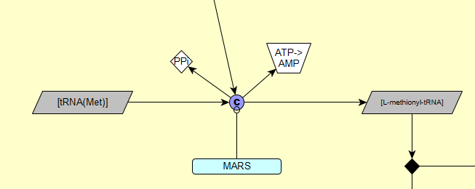

Methionine binds to tRNA(Met) to form L-methionyl-tRNA and PPi, which is catalysed by MARS. ATP in converted to AMP in the process: [PMID: 11714285](https://www.ncbi.nlm.nih.gov/pubmed/11714285)

**Met to Cys pathway**

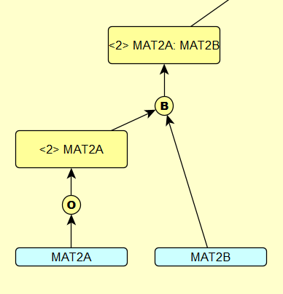

S-adenosylmethionine synthetase 2 is composed of a MAT2A homodimer and MAT2B: [PMID: 10644686](https://www.ncbi.nlm.nih.gov/pubmed/10644686)

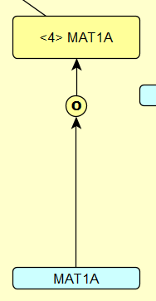

S-adenosylmethionine synthase 1 is composed of a MAT1A homotetramer: [PMID: 9175157](https://www.ncbi.nlm.nih.gov/pubmed/?term=9175157)

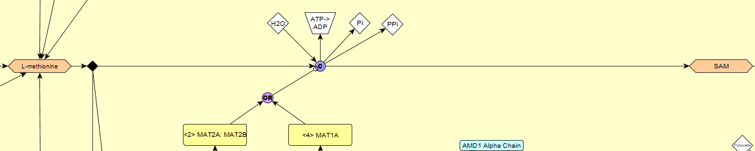

L-Methionine and water form SAM, Pi and PPi, converting ATP to ADP. The reaction can be catalysed by S-adenosylmethionine synthase 1 or 2: [PMID: 13416303](https://www.ncbi.nlm.nih.gov/pubmed/?term=13416303)

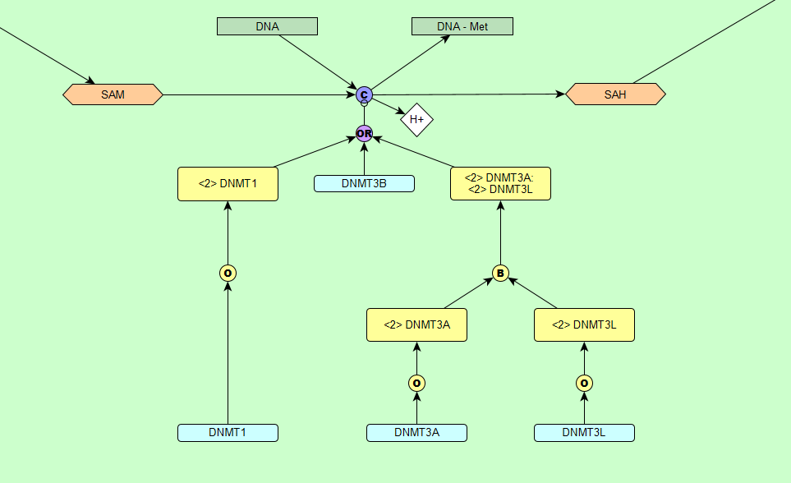

Within the nucleus, SAM is converted to SAH by DNA methyltransferases 1, 3A and 3B by transferring the methyl group in SAM to DNA: [PMID: 19173286](https://www.ncbi.nlm.nih.gov/pubmed/?term=19173286) DNA methyltransferase 1 exists as a homodimer: [PMID: 19173286](https://www.ncbi.nlm.nih.gov/pubmed/?term=19173286) DNA methyltransferase 3B exists as a monomer: [PMID: 11735126](https://www.ncbi.nlm.nih.gov/pubmed/?term=11735126) DNA methyltransferase 3A exists as a heterotetramer composed of a DNMT3A dimer and a DNMT3L dimer: [PMID: 17713477](https://www.ncbi.nlm.nih.gov/pubmed/17713477)

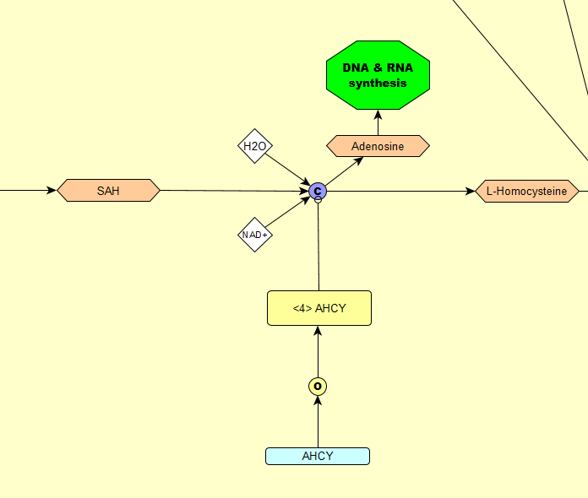

SAH and water is converted to L-Homocysteine and adenosine by S-adenosyl-L-homocysteine hydrolase, using NAD+ as a cofactor: [PMID: 762125](https://www.ncbi.nlm.nih.gov/pubmed/?term=762125). S-adenosyl-L-homocysteine hydrolase exists as a homotetramer: [PMID: 9586999](https://www.ncbi.nlm.nih.gov/pubmed/?term=9586999).

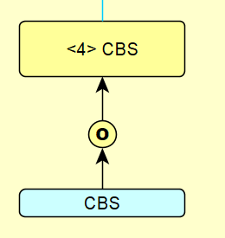 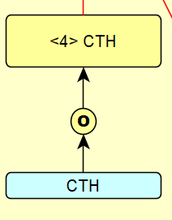

Cystathionine beta-synthase and Cystathionine gamma-lyase both exist as homotetramers: [PMID: 11483494](https://www.ncbi.nlm.nih.gov/pubmed/?term=11483494) and [PMID: 23600844](https://www.ncbi.nlm.nih.gov/pubmed/?term=23600844).

**Transsulfuration and H2S production**

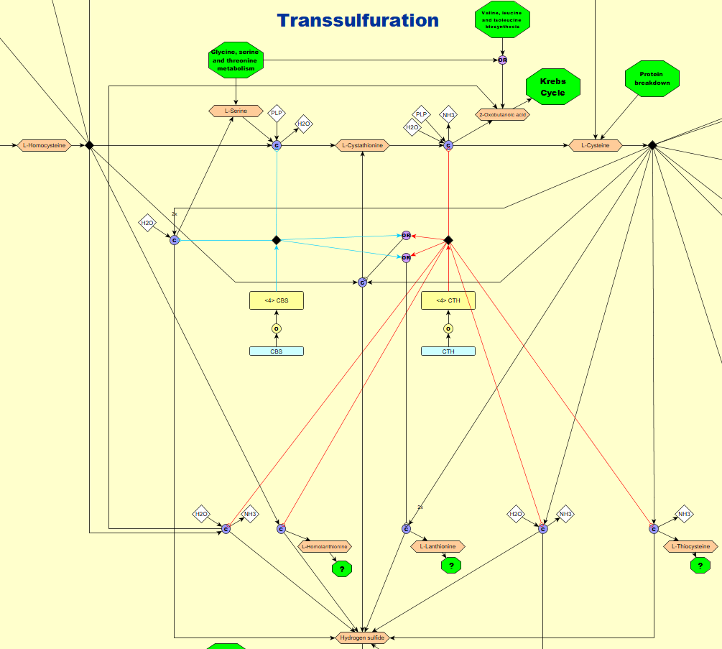

**9**

**8**

**7**

**6**

**5**

**4**

**3**

**1**

**2**

1. L-Homocysteine and L-serine combine to form L-cystathione and water. The reaction is catalysed by cystathione beta-synthase, requiring PLP as a cofactor.
2. L-Cystathione and water form L-cysteine, 2-oxobutanoic acid and NH3. The reaction is catalysed by cystathione gamma-lyase, requiring PLP as a cofactor.
3. 2 molecules of L-cysteine and water combine to form L-serine and hydrogen sulfide. The reaction is catalysed by cystathione beta-synthase, requiring PLP as a cofactor.
4. L-homocysteine and L-cysteine combine to form L-cystathionine and hydrogen sulfide. The reaction is catalysed by either cystathione beta-synthase or cystathione gamma-lyase, requiring PLP as a cofactor.
5. L-Homocysteine and water combine to form 2-oxobutanoic acid, hydrogen sulfide and NH3. The reaction is catalysed by cystathione gamma-lyase, requiring PLP as a cofactor.
6. 2 molecules of L-homocysteine form hydrogen sulfide and L-homolanthionine. The reaction is catalysed by cystathione gamma-lyase, requiring PLP as a cofactor. It is unclear what happens to L-homolanthionine, it might be degraded.
7. 2 molecules of L-cysteine combine to form L-lanthionine and hydrogen sulfide. The reaction is catalysed by either cystathione beta-synthase or cystathione gamma-lyase, requiring PLP as a cofactor. It is unclear what happens to L-lanthionine, it might be degraded.
8. L-Cysteine and water combine to form hydrogen sulfide, pyruvate and NH3. The reaction is catalysed by cystathione gamma-lyase, requiring PLP as a cofactor.
9. L-Cysteine forms L-thiocysteine, hydrogen sulfide and NH3. The reaction is catalysed by cystathione gamma-lyase, requiring PLP as a cofactor. L-thiocysteine might be an intermediate product in this reaction and it is unclear where it is used.

All cystathione beta-synthase catalysed reactions – [PMID: 23600844](https://www.ncbi.nlm.nih.gov/pubmed/?term=23600844)

All cystathione gamma-lyase catalysed reactions – [PMID: 19261609](https://www.ncbi.nlm.nih.gov/pubmed/?term=19261609)

**Cysteine tRNA synthesis**

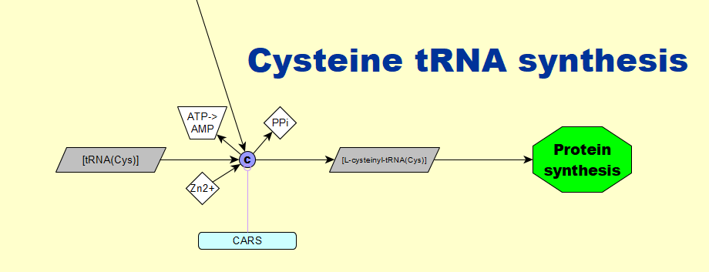

Cysteine binds to tRNA(Cys) to form L-cysteinyl-tRNA(Cys) and PPi. The reaction is catalysed by cysteine tRNA ligase and requires Zn2+ as a cofactor. ATP is converted to AMP in the process: [PMID: 7987009](https://www.ncbi.nlm.nih.gov/pubmed/?term=7987009).

**Methionine salvage pathway**

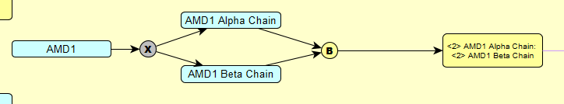

S-adenosylmethionine decarboxylase 1 is synthesised as a proenzyme that undergoes an autocatalytic cleavage to form the alpha and beta subunits, which together form the active enzyme: [PMID: 10574985](https://www.ncbi.nlm.nih.gov/pubmed/?term=10574985)

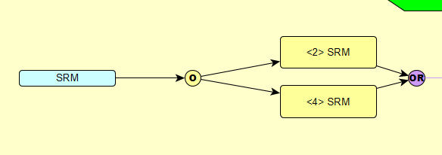

Spermidine synthase exists both as a homodimer and a homotetramer: [PMID: 17585781](https://www.ncbi.nlm.nih.gov/pubmed/?term=17585781)

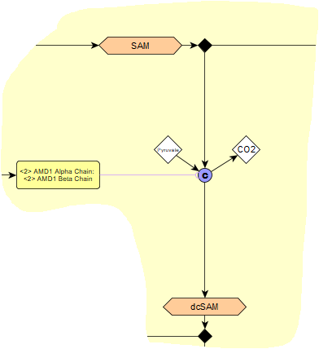

SAM forms dcSAM and CO2. The reaction is catalysed by S-adenosylmethionine decarboxylase 1, using pyruvate as a co-factor/prosthetic group: [PMID: 17585781](https://www.ncbi.nlm.nih.gov/pubmed/?term=17585781)

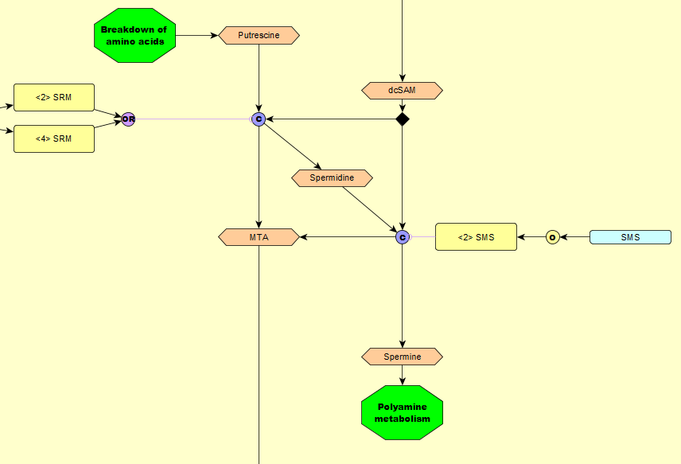

**3**

**2**

**1**

1. dcSAM and putrescine combine to form MTA and spermidine. The reaction is catalysed by spermidine synthase: [PMID: 17585781](https://www.ncbi.nlm.nih.gov/pubmed/?term=17585781)
2. Spermine synthase exists as a homodimer: [PMID:18367445](https://www.ncbi.nlm.nih.gov/pubmed/?term=18367445)
3. Spermidine and dcSAM form MTA and spermine. The reaction is catalysed by spermine synthase: [PMID:18367445](https://www.ncbi.nlm.nih.gov/pubmed/?term=18367445)

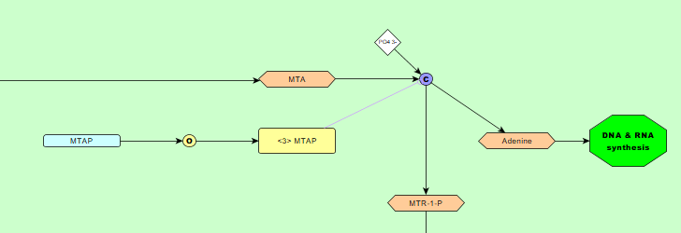

In the nucleus, MTA and a phosphate form adenine and MTR-1-P. The reaction is catalysed by a homotrimeric enzyme called S-methyl-5'-thioadenosine phosphorylase: [PMID: 3091600](https://www.ncbi.nlm.nih.gov/pubmed/?term=3091600)

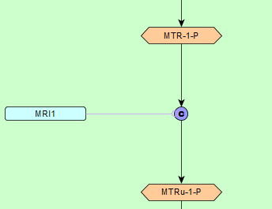

MTR-1-P forms MTRu-1-P. The reaction is catalysed by a monomeric enzyme called methylthioribose-1-phosphate isomerase: [PMID:19620624](https://www.ncbi.nlm.nih.gov/pubmed/?term=19620624)

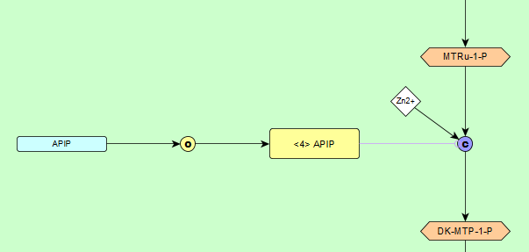

MTRu-1-P forms DK-MTP-1-P. The reaction is catalysed by a homotetrameric enzyme called methylthioribulose-1-phosphate dehydratase, requiring Zn2+ as a cofactor: [PMID: 24367089](https://www.ncbi.nlm.nih.gov/pubmed/?term=24367089)

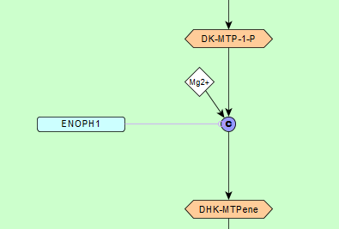

DK-MTP-1-P forms DHK-MTPene. The reaction is catalysed by a monomeric enzyme called enolase-phosphatase E1, requiring Mg2+ as a cofactor: [PMID:15843022](https://www.ncbi.nlm.nih.gov/pubmed/?term=15843022)

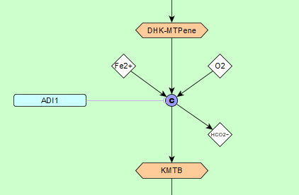

DHK-MTPene and oxygen form KMTB and HCO2-. The reaction is catalysed by a monomeric enzyme called 1,2-dihydroxy-3-keto-5-methylthiopentene dioxygenase, requiring Fe2+ as a cofactor: [PMID:15938715](https://www.ncbi.nlm.nih.gov/pubmed/?term=15938715)

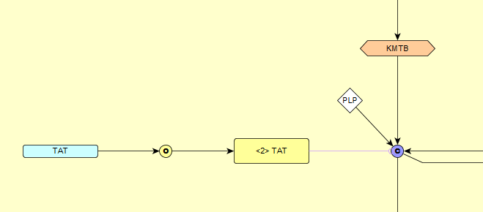

In the cytoplasm, KMTB and L-glutamic acid form L-methionine and oxoglutaric acid. The reaction is catalysed by a homodimeric enzyme called tyrosine aminotransferase, requiring PLP as a cofactor: [PMID:16640556](https://www.ncbi.nlm.nih.gov/pubmed/?term=16640556)

**Remethylation cycle**

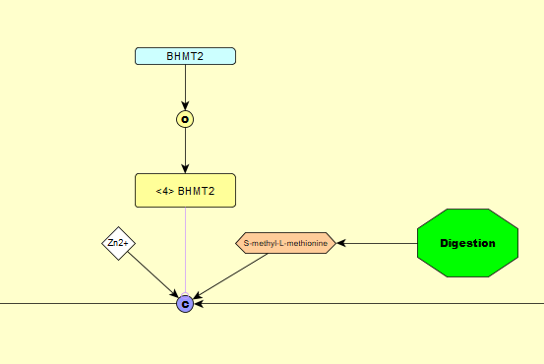

L-homocysteine and S-methyl-L-methionine form 2 molecules of L-methionine. The reaction is catalysed by a homotetrameric enzyme called S-methylmethionine--homocysteine S-methyltransferase, requiring Zn2+ as a cofactor: [PMID:18230605](https://www.ncbi.nlm.nih.gov/pubmed/?term=18230605)

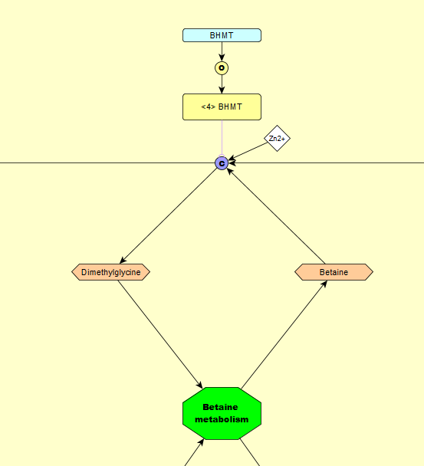

L-homocysteine and betaine form L-methionine and dimethylglycine. The reaction is catalysed by a homotetrameric enzyme called betaine--homocysteine S-methyltransferase 1, requiring Zn2+ as a cofactor: [PMID:12220488](https://www.ncbi.nlm.nih.gov/pubmed/?term=12220488) [PMID:14456704](https://www.ncbi.nlm.nih.gov/pubmed/?term=14456704)

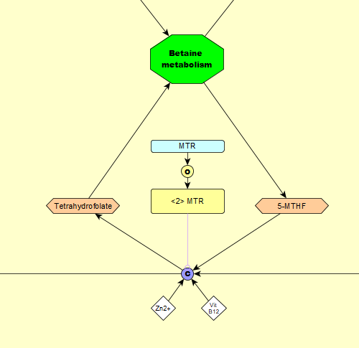

L-homocysteine and 5-MTHF form L-methionine and tetrahydrofolate. The reaction is catalysed by a homodimeric enzyme called methionine synthase, requiring Zn2+ and vitamin B12 as cofactors: [PMID:17288554](https://www.ncbi.nlm.nih.gov/pubmed/?term=17288554) [PMID:2407589](https://www.ncbi.nlm.nih.gov/pubmed/?term=2407589).

**Taurine production**

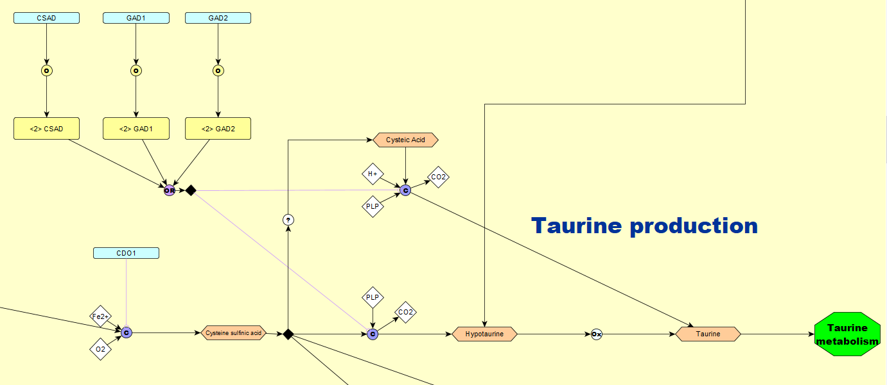

**2**

**6**

**4**

**5**

**3**

**1**

1. L-cysteine and oxygen form cysteine sulfinic acid. The reaction is catalysed by a monomeric enzyme called cysteine dioxygenase type 1, requiring Fe2+ as a cofactor: [PMID:17135237](https://www.ncbi.nlm.nih.gov/pubmed/?term=17135237)
2. Cysteine sulfinic acid decarboxylase, glutamate decarboxylase 1 and glutamate decarboxylase 2 all exist as homodimers: [PMID: 26327310](https://www.ncbi.nlm.nih.gov/pubmed/?term=26327310) [PMID:17384644](https://www.ncbi.nlm.nih.gov/pubmed/?term=17384644)
3. Cysteic acid and H+ form taurine and CO2. This reaction is catalysed by either cysteine sulfinic acid decarboxylase or glutamate decarboxylase 1 or glutamate decarboxylase 2, requiring PLP as a cofactor: [PMID:26327310](https://www.ncbi.nlm.nih.gov/pubmed/?term=26327310)
4. Cysteine sulfinic acid forms hypotaurine and CO2. This reaction is catalysed by either cysteine sulfinic acid decarboxylase or glutamate decarboxylase 1 or glutamate decarboxylase 2, requiring PLP as a cofactor: [PMID:26327310](https://www.ncbi.nlm.nih.gov/pubmed/?term=26327310)
5. Cysteine sulfinic acid is very similar to cysteic acid in terms of chemical structure, but it is unclear how the former is formed.
6. Hypotaurine is thought to form taurine through a non-enzymatic oxidation reaction, it is possible that there is an enzyme involved but it has not been purified yet: [PMID: 21778230](https://www.ncbi.nlm.nih.gov/pmc/articles/PMC3173217/)

**H2S production by GOT1/MPST**

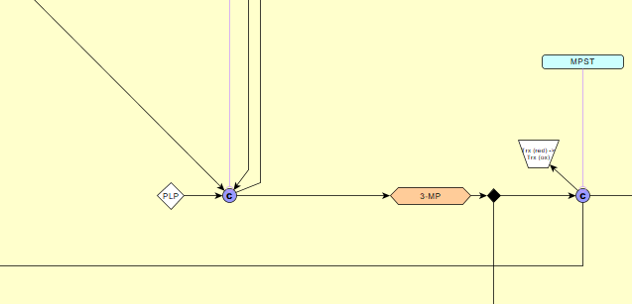

**2**

**1**

1. L-cysteine and oxoglutaric acid form L-glutamic acid and 3-MP. The reaction is catalysed by a homodimeric enzyme called cytoplasmic aspartate aminotransferase, requiring PLP as a cofactor: [PMID:7426616](https://www.ncbi.nlm.nih.gov/pubmed/?term=7426616) [PMID: 2225456](https://www.ncbi.nlm.nih.gov/pubmed/2225456)
2. 3-MP is broken down to pyruvate and hydrogen sulfide. The reaction is catalysed by a monomeric enzyme called 3-mercaptopyruvate sulfurtransferase, transforming thioredoxin from a reduced to an oxidized state in the process: [PMID: 21543637](https://www.ncbi.nlm.nih.gov/pubmed/?term=21543637)

**Sulfite production by GOT1**

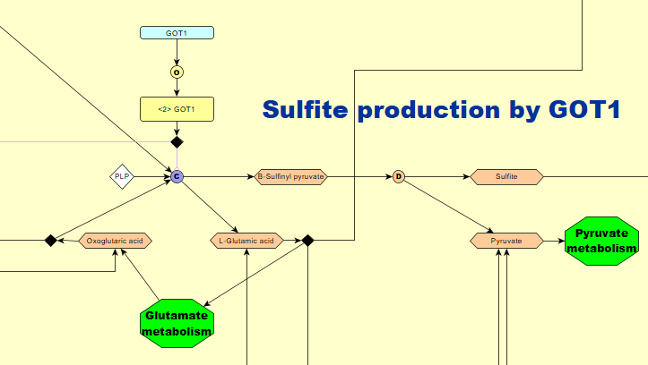

Cysteine sulfinic acid and oxoglutaric acid form L-glutamic acid and β-Sulfinyl pyruvate. The reaction is catalysed by a homodimeric enzyme called cytoplasmic aspartate aminotransferase, requiring PLP as a cofactor. β-Sulfinyl pyruvate is unstable and breaks down to form sulfite and pyruvate: [PMID: 2225456](https://www.ncbi.nlm.nih.gov/pubmed/2225456) [PMID: 7771805](https://www.ncbi.nlm.nih.gov/pubmed/7771805)

**Lactate/pyruvate conversion**

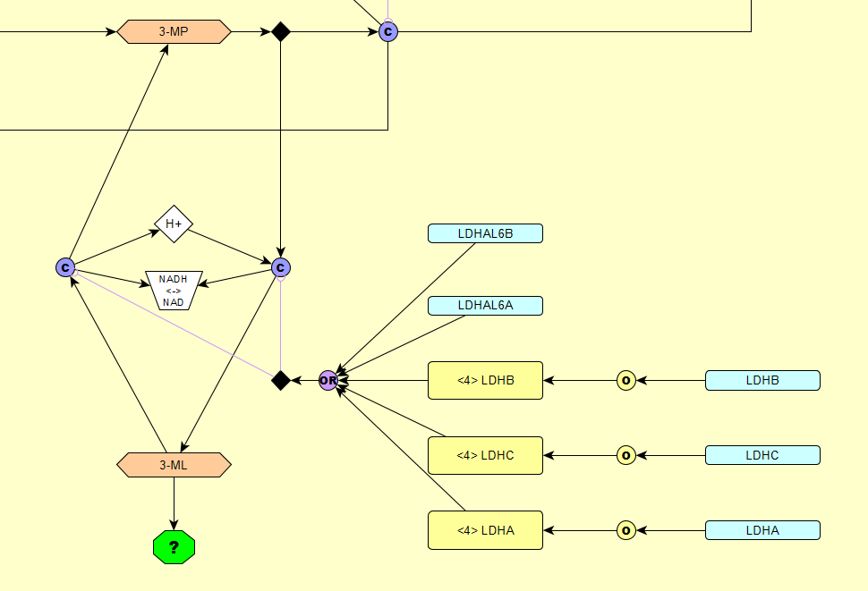

In a reversible reaction, 3-MP and H+ forms 3-ML, transforming NADH to NAD in the process. The reaction is catalysed by L-lactate dehydrogenase A, B, C, A-like 6A or A-like 6B. L-lactate dehydrogenases A,B and C exist as homotetramers and the A-like 6A and A-like 6B are monomeric: [PMID:11276087](https://www.ncbi.nlm.nih.gov/pubmed/?term=11276087)

**CoA synthesis**

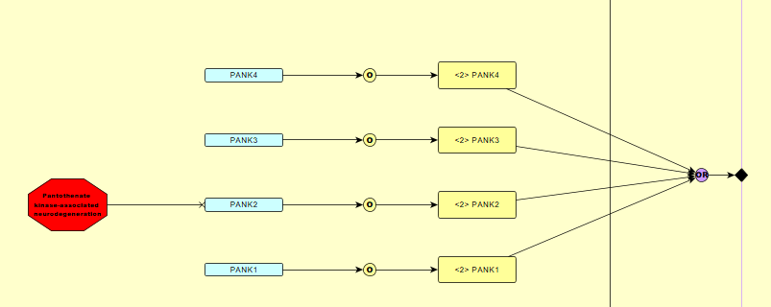

Pantothenate kinase 1,2,3 and 4 all exist as homodimers: [PMID: 25110011](https://www.ncbi.nlm.nih.gov/pubmed/?term=25110011)

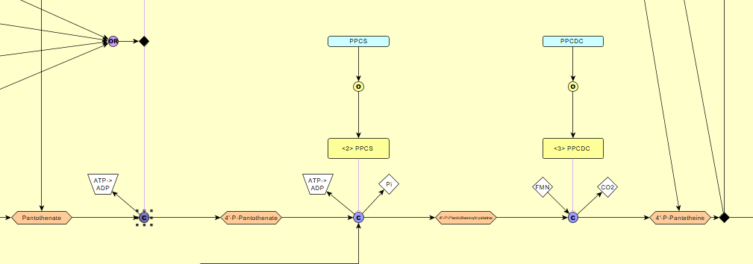

**1**

**2**

**3**

1. Pantothenate forms 4′-P-Pantothenate, transforming ATP to ADP in the process. The reaction is catalysed by either pantothenate kinase 1,2,3 or 4: [PMID: 25110011](https://www.ncbi.nlm.nih.gov/pubmed/?term=25110011)

2. 4′-P-Pantothenate and L-cysteine form 4′-P-Pantothenoylcysteine and Pi, transforming ATP to ADP in the process. The reaction is catalysed by a homodimeric enzyme called phosphopantothenate--cysteine ligase: [PMID: 25110011](https://www.ncbi.nlm.nih.gov/pubmed/?term=25110011)

3. 4′-P-Pantothenoylcysteine forms 4′-P-Pantetheine and CO2 . The reaction is catalysed by a homotrimeric enzyme called phosphopantothenoylcysteine decarboxylase, requiring a flavin mononucleotide as a cofactor: [PMID: 25110011](https://www.ncbi.nlm.nih.gov/pubmed/?term=25110011)

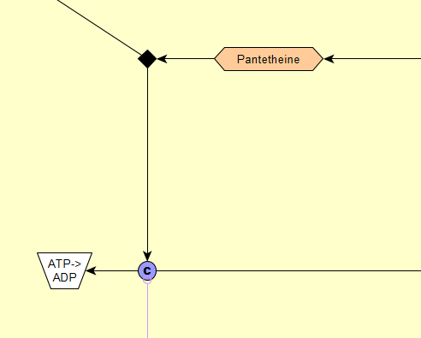

Pantetheine forms 4′-P-Pantetheine, transforming ATP to ADP in the process. The reaction is catalysed by either pantothenate kinase 1,2,3 or 4: [PMID: 25110011](https://www.ncbi.nlm.nih.gov/pubmed/?term=25110011)

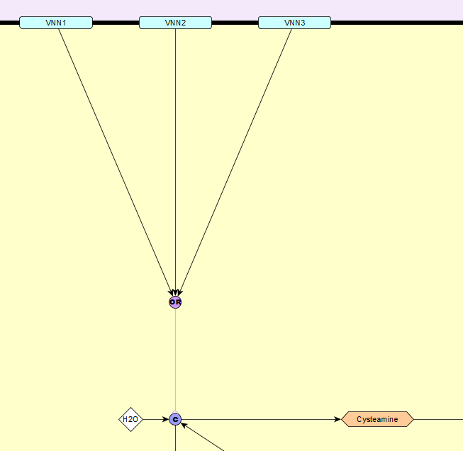

Pantetheine and water form cysteamine and pantothenate. The reaction is catalysed by either one of plasma membrane bound monomeric enzymes called vascular non-inflammatory molecule 1,2 and 3: [PMID: 25478849](https://www.ncbi.nlm.nih.gov/pubmed/?term=25478849)

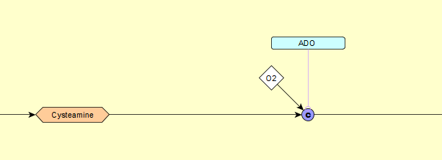

Cysteamine and oxygen form hypotaurine. The reaction is catalysed by a monomeric enzyme called 2-aminoethanethiol dioxygenase: [PMID: 17581819](https://www.ncbi.nlm.nih.gov/pubmed/?term=17581819)

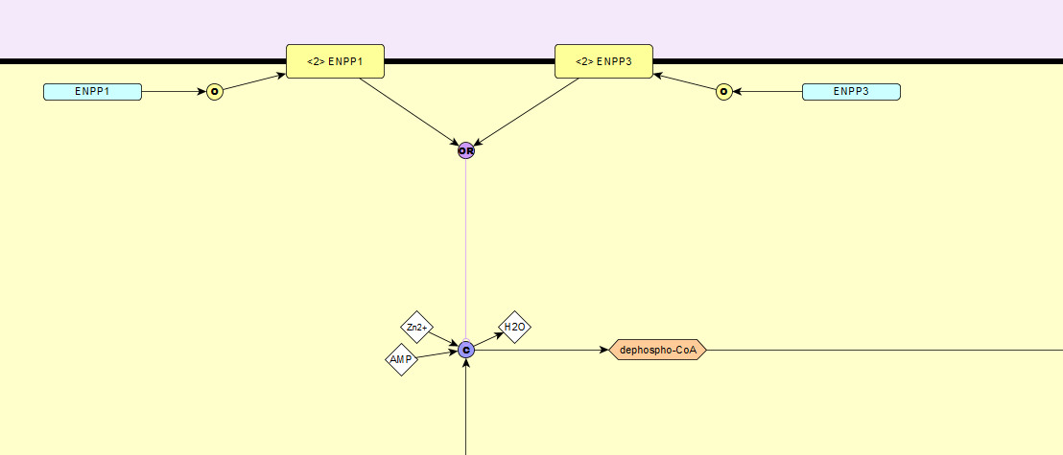

4′-P-Pantetheine and AMP forms dephospho-CoA and water. The reaction is catalysed by either one of two homodimeric, cell membrane bound enzymes called ectonucleotide pyrophosphatase/phosphodiesterase family member 1 and 3 (both requiring Zn2+ as a cofactor): [PMID: 8001561](https://www.ncbi.nlm.nih.gov/pubmed/8001561)

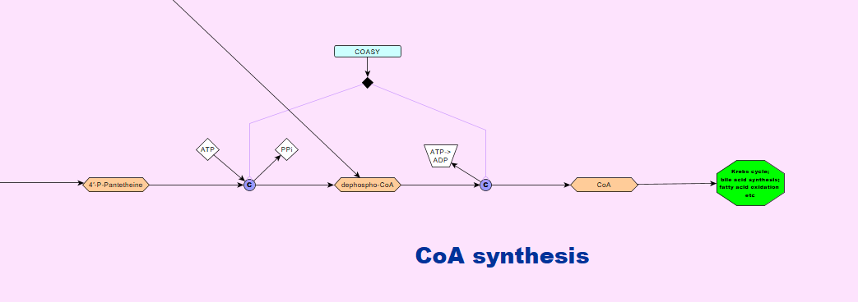

**2**

**1**

1. In the mitochondrial matrix, 4′-P-Pantetheine and ATP form dephospho-CoA and PPi. The reaction is catalysed by a monomeric enzyme called bifunctional coenzyme A synthase: [PMID: 25110011](https://www.ncbi.nlm.nih.gov/pubmed/?term=25110011)
2. Dephospho-CoA forms CoA, transforming ATP to ADP in the process. The reaction is catalysed by a monomeric enzyme called bifunctional coenzyme A synthase: [PMID: 25110011](https://www.ncbi.nlm.nih.gov/pubmed/?term=25110011)

**Glutathione production**

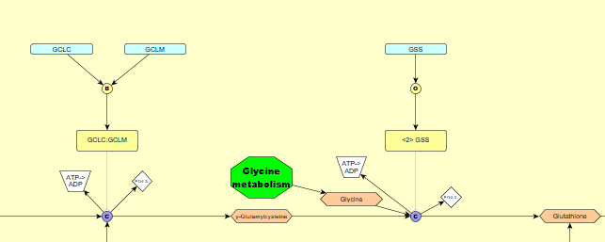

**1**

**2**

1. L-cysteine and L-glutamic acid form y-glutamylcysteine and phosphate, transforming ATP to ADP in the process. The reaction is catalysed by an enzyme called cytosolic glutamate-cysteine ligase, that is composed of a catalytic and a regulatory subunit: [PMID: 16137247](https://www.ncbi.nlm.nih.gov/pmc/articles/PMC1383676/)
2. y-glutamylcysteine and glycine form glutathione and phosphate, transforming ATP to ADP in the process. The reaction is catalysed by a homodimeric enzyme called glutathione synthetase: [PMID: 10369661](https://www.ncbi.nlm.nih.gov/pubmed/10369661)

**Glutathione redox cycle**

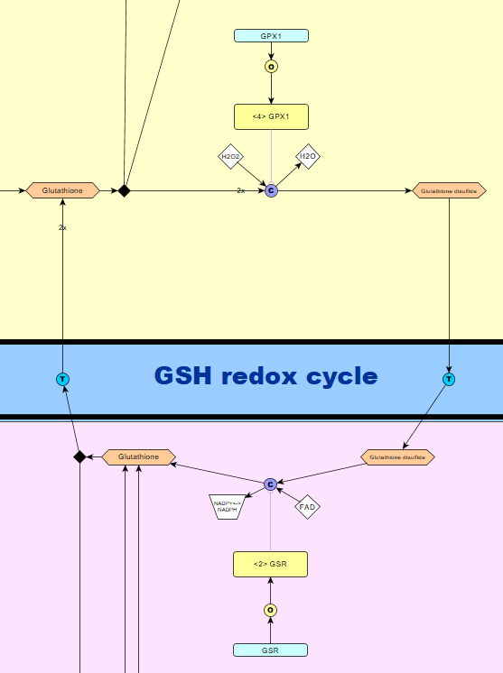

**1**

**2**

1. 2 molecules of glutathione and H2O2 form glutathione disulfide and water. The reaction is catalysed by a homotetrameric enzyme, called glutathione peroxidase 1: [PMID:14573732](https://www.ncbi.nlm.nih.gov/pubmed/14573732)
2. In the mitochondria, glutathione disulfide forms 2 molecules of glutathione, transforming NADP+ to NADPH in the process. The reaction is catalysed by a homodimeric enzyme called glutathione reductase, that requires FAD as a cofactor: [PMID: 23036594](https://www.ncbi.nlm.nih.gov/pubmed/?term=23036594)

**Mercapturic acid pathway**

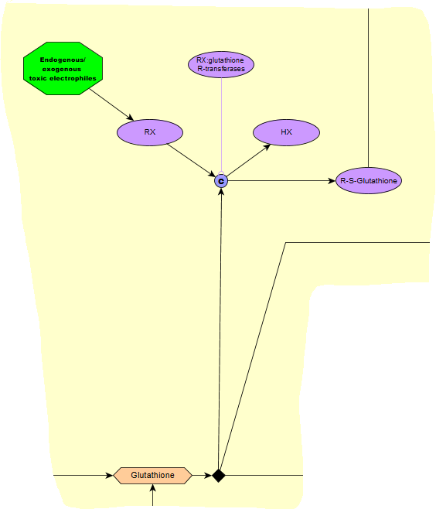

Glutathione reacts with a generic compound RX (a toxic electrophile) and forms R-S-glutathione and HX. The reaction is catalysed by a number of enzymes belonging to the group RX:glutathione R-transferases (also called glutathione S-transferases) : [PMID: 9875553](https://www.ncbi.nlm.nih.gov/pubmed/9875553)

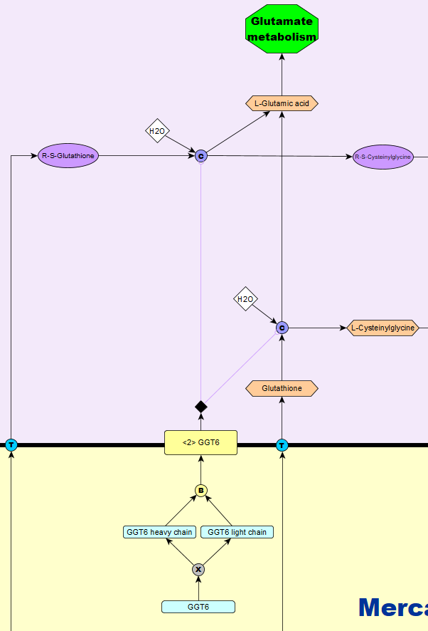

In the extracellular space, R-S-glutathione and water form R-S-cysteinylglycine and L-glutamic acid. Glutathione and water forms L-cysteinylglycine and L-glutamic acid. Both reactions are catalysed by a cell membrane bound enzyme called glutathione hydrolase 6. It is a heterodimer, composed of a GGT6 heavy chain and a GGT6 light chain: [PMID: 18357469](https://www.ncbi.nlm.nih.gov/pubmed/?term=18357469)

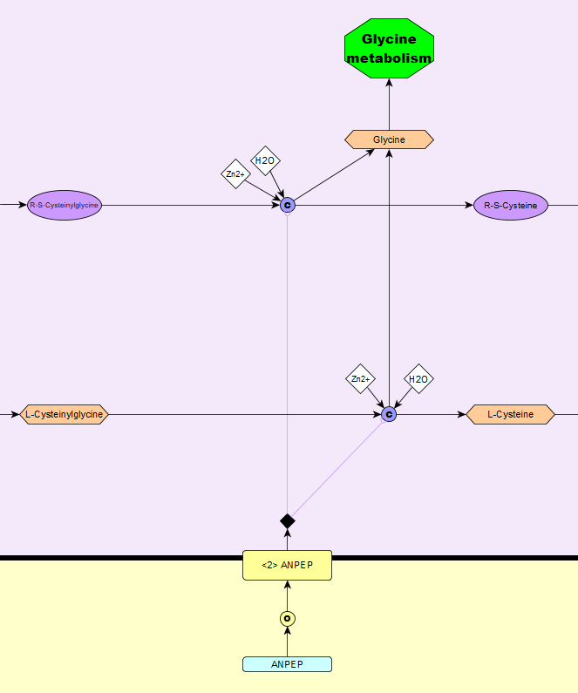

R-S-Cysteinylglycine and water form R-S-cysteine and glycine. L-cysteinylglycine and water form L-cysteine and glycine. Both reactions are catalysed by a cell membrane bound enzyme called Aminopeptidase N. It requires Zn2+ as a cofactor: [PMID: 11746430](https://www.ncbi.nlm.nih.gov/pubmed/11746430)

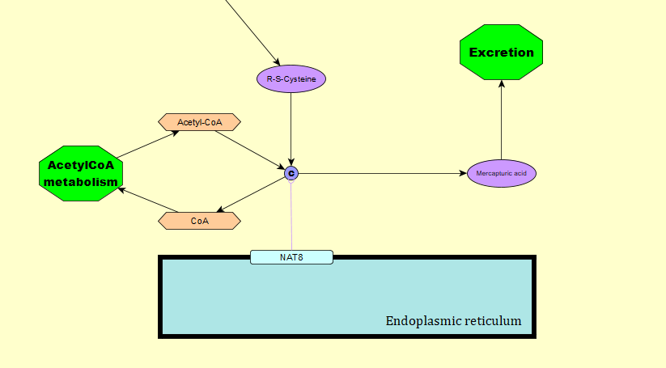

In the cytoplasm, R-S-cysteine and acetyl-CoA forms a mercapturic acid and CoA. The reaction is catalysed by a monomeric endoplasmic reticulum membrane bound enzyme called N-acetyltransferase 8: [PMID: 20392701](https://www.ncbi.nlm.nih.gov/pubmed/20392701)

**N-Formylmethionyl tRNA synthesis**

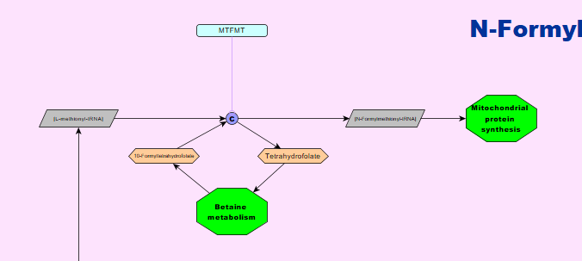

In the mitochondrial matrix, L-methionyl-tRNA and 10-formyltetrahydrofolate form N-formylmethionyl-tRNA and tetrahydrofolate. The reaction is catalysed by a monomeric enzyme called methionyl-tRNA formyltransferase: [PMID: 21907147](https://www.ncbi.nlm.nih.gov/pubmed/21907147)

**Mitochondrial cysteine tRNA synthesis**

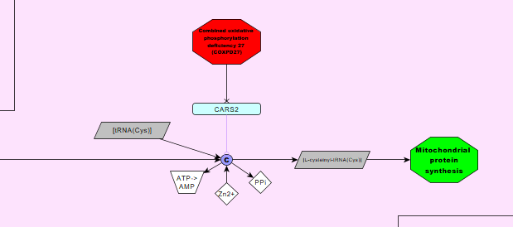

L-Cysteine binds to tRNA(Cys) to form L-cysteinyl-tRNA(Cys) and PPi, transforming ATP to AMP in the process. The reaction is catalysed by a monomeric enzyme called mitochondrial cysteine--tRNA ligase, requiring Zn2+ as a cofactor: [PMID: 25787132](https://www.ncbi.nlm.nih.gov/pubmed/?term=25787132)

**H2S production by GOT2/MPST and Sulfite production by GOT2**

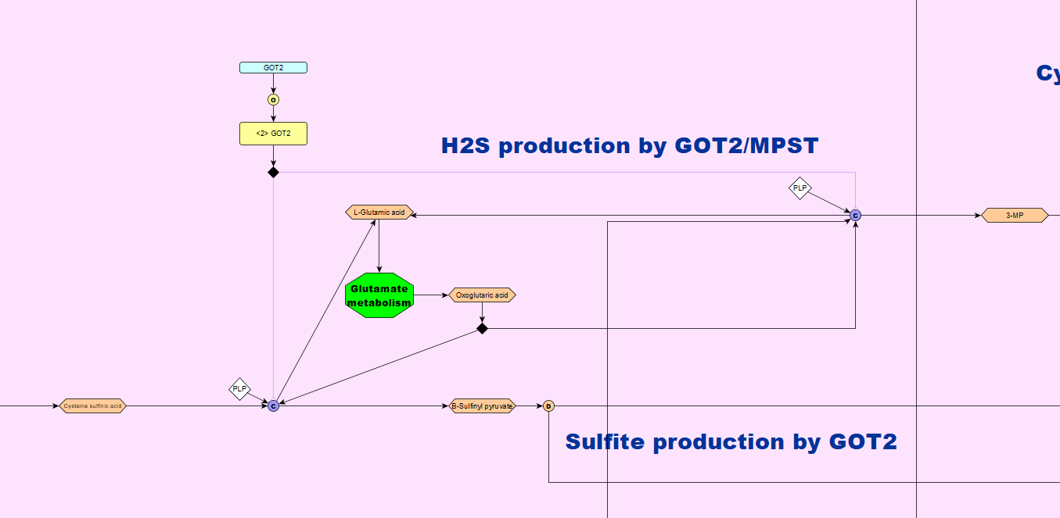

**1**

**3**

**2**

1. Cysteine sulfinic acid and oxoglutaric acid form L-glutamic acid and β-Sulfinyl pyruvate. The reaction is catalysed by a homodimeric enzyme called mitochondrial aspartate aminotransferase, requiring PLP as a cofactor: [PMID:12137566](https://www.ncbi.nlm.nih.gov/pubmed/?term=12137566)
2. L-cysteine and oxoglutaric acid form L-glutamic acid and 3-MP. The reaction is catalysed by a homodimeric enzyme called mitochondrial aspartate aminotransferase, requiring PLP as a cofactor: [PMID:12137566](https://www.ncbi.nlm.nih.gov/pubmed/?term=12137566) [PMID:7426616](https://www.ncbi.nlm.nih.gov/pubmed/?term=7426616)
3. β-Sulfinyl pyruvate is unstable and breaks down to form sulfite and pyruvate: [PMID:12137566](https://www.ncbi.nlm.nih.gov/pubmed/?term=12137566)

**Cyanide detoxification**

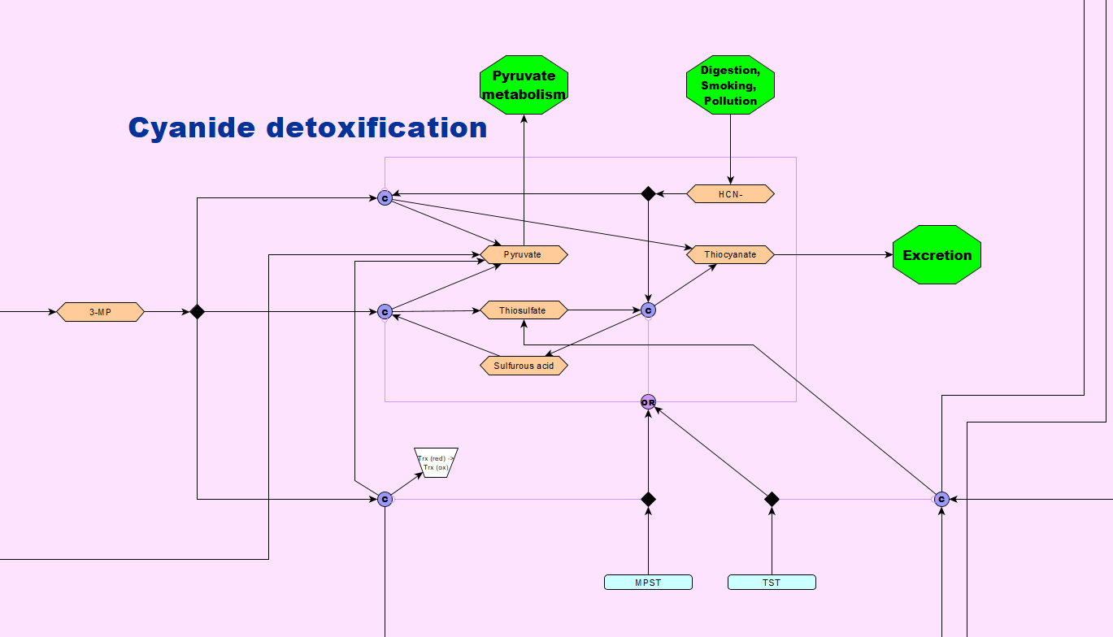

**1**

**2**

**3**

**4**

**5**

1. 3-MP and HCN- form thiocyanate and pyruvate. The reaction is catalysed by either of two monomeric enzymes called 3-mercaptopyruvate sulfurtransferase and thiosulfate sulfurtransferase: [PMID: 29156095](https://www.ncbi.nlm.nih.gov/pubmed/29156095) [PMID: 26071878](https://www.ncbi.nlm.nih.gov/pmc/articles/PMC4471854/)
2. 3-MP and sulfurous acid forms pyruvate and thiosulfate. The reaction is catalysed by either of two monomeric enzymes called 3-mercaptopyruvate sulfurtransferase and thiosulfate sulfurtransferase: [PMID: 29156095](https://www.ncbi.nlm.nih.gov/pubmed/29156095) [PMID: 26071878](https://www.ncbi.nlm.nih.gov/pmc/articles/PMC4471854/)
3. 3-MP is broken down to pyruvate and hydrogen sulfide. The reaction is catalysed by a monomeric enzyme called 3-mercaptopyruvate sulfurtransferase, transforming thioredoxin from a reduced to an oxidized state in the process: [PMID: 29156095](https://www.ncbi.nlm.nih.gov/pubmed/29156095) [PMID: 26071878](https://www.ncbi.nlm.nih.gov/pmc/articles/PMC4471854/)
4. Thiosulfate and HCN- form thiocyanate and sulfurous acid. The reaction is catalysed by either of two monomeric enzymes called 3-mercaptopyruvate sulfurtransferase and thiosulfate sulfurtransferase: [PMID: 29156095](https://www.ncbi.nlm.nih.gov/pubmed/29156095) [PMID: 26071878](https://www.ncbi.nlm.nih.gov/pmc/articles/PMC4471854/)
5. Glutathione persulfide and sulfite form glutathione and thiosulfate. The reaction is catalysed by a monomeric enzyme called thiosulfate sulfurtransferase: [PMID: 26071878](https://www.ncbi.nlm.nih.gov/pmc/articles/PMC4471854/)

**H2S breakdown**

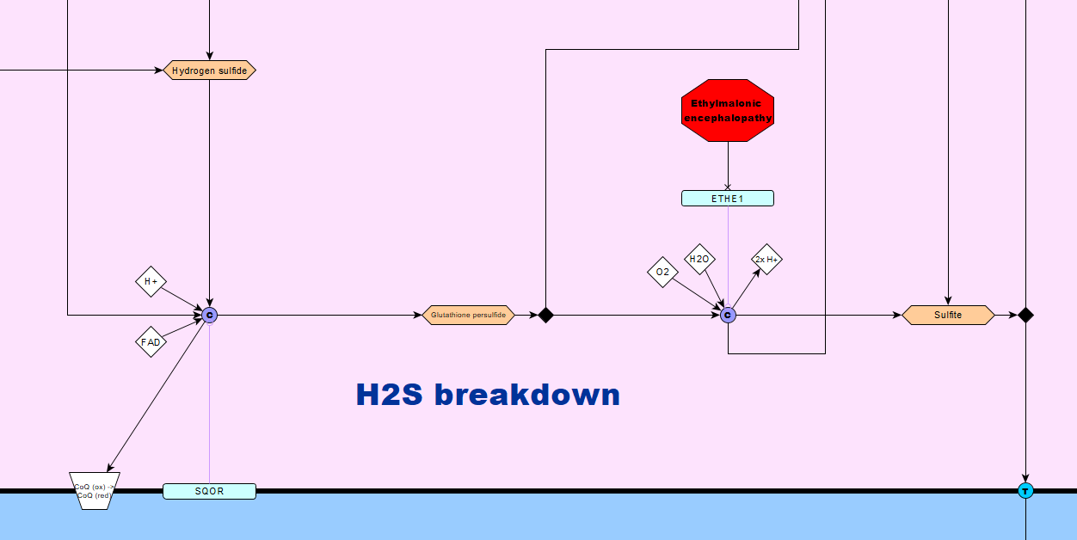

**2**

**1**

1. Hydrogen sulfide, glutathione and H+ form glutathione persulfide, transforming CoQ from an oxidized to a reduced state in the process. The reaction is catalysed by a mitochondrial inner membrane bound, monomeric enzyme called mitochondrial sulfide:quinone oxidoreductase, requiring FAD as a cofactor: [PMID: 25725526](https://www.ncbi.nlm.nih.gov/pubmed/?term=25725526) [PMID:30088670](https://www.ncbi.nlm.nih.gov/pubmed/?term=30088670)
2. Glutathione persulfide, water and oxygen form sulfite, glutathione and 2 H+. The reaction is catalysed by a monomeric enzyme called mitochondrial persulfide dioxygenase ETHE1: [PMID:30088670](https://www.ncbi.nlm.nih.gov/pubmed/?term=30088670)

**SUOX**

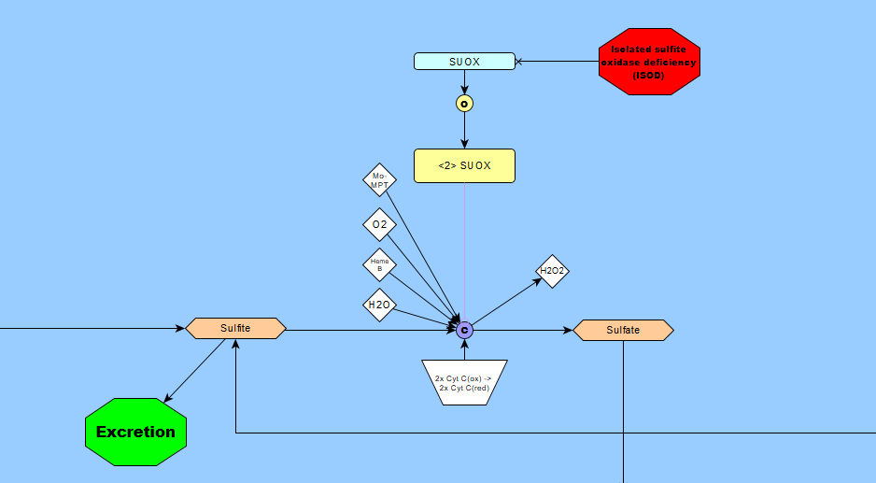

In the mitochondrial intermembrane space, sulfite, oxygen and water form sulfate and H2O2, transforming two CytC from an oxidized to a reduced state in the process. The reaction is catalysed by a homodimeric enzyme called sulfite oxidase, requiring Mo-MPT and heme B as cofactors: [PMID: 28725568](https://www.ncbi.nlm.nih.gov/pubmed/28725568)

**Sulfate activation**

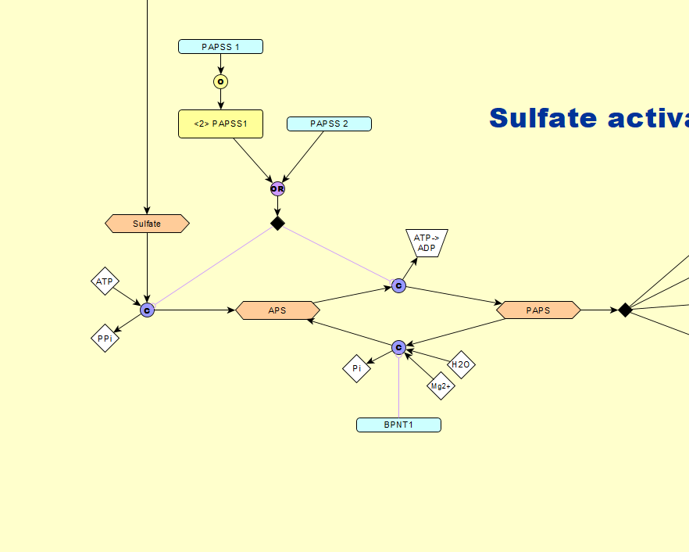

**1**

**3**

**2**

1. Sulfate and ATP form APS and PPi. The reaction is catalysed by either a homodimeric enzyme called bifunctional 3'-phosphoadenosine 5'-phosphosulfate synthase 1 or a monomeric enzyme called bifunctional 3'-phosphoadenosine 5'-phosphosulfate synthase 2: [PMID:12716056](https://www.ncbi.nlm.nih.gov/pubmed/?term=12716056)
2. APS forms PAPS, transforming ATP to ADP in the process. The reaction is catalysed by either a homodimeric enzyme called bifunctional 3'-phosphoadenosine 5'-phosphosulfate synthase 1 or a monomeric enzyme called bifunctional 3'-phosphoadenosine 5'-phosphosulfate synthase 2: [PMID:12716056](https://www.ncbi.nlm.nih.gov/pubmed/?term=12716056)
3. PAPS and water form APS and Pi. The reaction is catalysed by a monomeric enzyme called 3'(2'),5'-bisphosphate nucleotidase 1, requiring a Mg2+ as a cofactor: [PMID: 10224133](https://www.ncbi.nlm.nih.gov/pubmed/10224133)

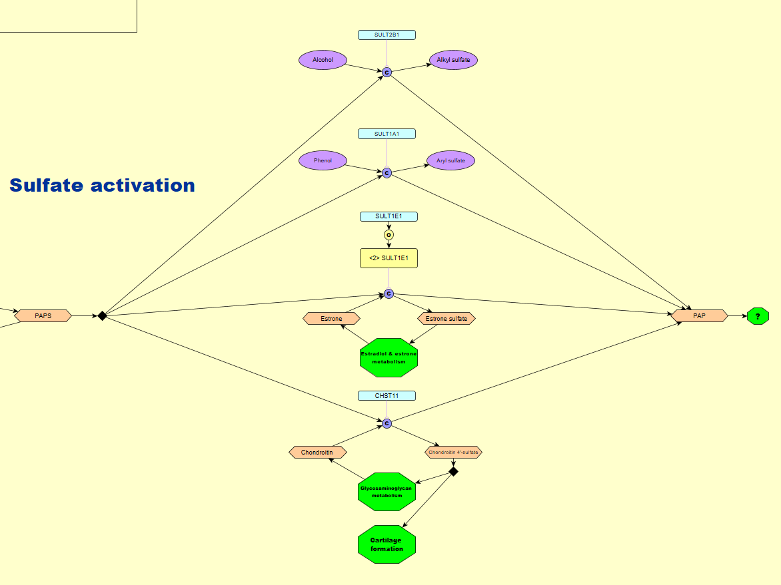

**3**

**1**

**2**

**4**

1. PAPS and an alcohol form PAP and a alkyl sulfate. The reaction is catalysed by a monomeric enzyme called sulfotransferase family cytosolic 2B member 1: [PMID: 9799594](https://www.ncbi.nlm.nih.gov/pubmed/9799594)
2. PAPS and a phenol form PAP and a aryl sulfate. The reaction is catalysed by a monomeric enzyme called phenol sulfotransferase 1: [PMID: 12471039](https://www.ncbi.nlm.nih.gov/pubmed/?term=12471039)
3. PAPS and estrone form PAP and estrone sulfate. The reaction is catalysed by a homodimeric enzyme called estrogen sulfotransferase: [PMID: 11884392](https://www.ncbi.nlm.nih.gov/pubmed/?term=11884392)
4. PAPS and chondroitin form PAP and chondroitin 4'-sulfate. The reaction is catalysed by a monomeric enzyme called carbohydrate sulfotransferase 11: [PMID: 15628971](https://www.ncbi.nlm.nih.gov/pubmed/15628971)

**Post-oxidation protein repair**

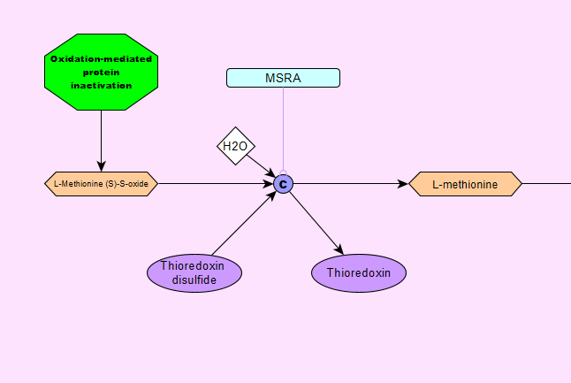

L-methionine (S)-S-oxide, water and a thioredoxin disulfide form L-methionine and a thioredoxin. Th reaction is catalysed by a monomeric enzyme called mitochondrial peptide methionine sulfoxide reductase: [PMID:12039877](https://www.ncbi.nlm.nih.gov/pubmed/?term=12039877)