CASE STUDY

Lead-Source Cohort Performance Assessment

Vahan sources candidate leads and calls them to assess which lead sources (cohorts) convert best into FT (full-time hires). The raw data is candidate-level: one row per candidate per lead_source, with funnel flags (Attempted, Connected, Interested, Onboarded, FT) and timing metrics. This document answers the three assigned questions.

Q1. Which 3 cohorts are best, and on what metric?
Metric used: FT Conversion % = FT after Upload ÷ Uploaded Leads, calculated per lead_source. This is the right metric because the business goal stated in the brief is finding which lead sources drive more conversion (FT) — not just call activity. Using a rate (not raw FT count) makes cohorts of different sizes comparable, and anchoring the denominator to Uploaded Leads (not Attempted) captures leakage from leads that were never even dialed, which is itself a sourcing/ops quality signal.

Ranked cohorts (highest FT Conversion % first), top 3 highlighted:
Rank | Lead Source | Uploaded Leads | FT after Upload | FT Conversion %
1 | Single Referral > 7 days- 24th Jul | 1500 | 14 | 0.93%
2 | Khanna- 2W 26th Jul | 1546 | 14 | 0.91%
3 | PreOb-Ob Fees Paid 29th Jul (set 1) | 1483 | 7 | 0.47%
4 | PreOb-Ob Fees Paid 29th Jul (set 2) | 1558 | 7 | 0.45%
5 | AI Connected but not Connected by TC- Set 1 | 1480 | 5 | 0.34%
6 | AI Connected but not Connected by TC- Set 2 | 1193 | 2 | 0.17%
7 | Khanna AI | 886 | 1 | 0.11%
8 | OLX - Ashwin - 2W - 17 Jul | 5182 | 4 | 0.08%
9 | 50K 2W5 - Khanna - 2W - 17 Jul | 1 | 0 | 0.00%
10 | AI Connected band Not Interested | 2137 | 0 | 0.00%
11 | 2W3W - 3WEV - Khanna - 3W - 17 Jul | 201 | 0 | 0.00%
12 | 50K 2W4 - Khanna - 2W - 17 Jul | 1 | 0 | 0.00%
13 | 2W3W - 3WCNG - Khanna - 3W - 17 Jul | 530 | 0 | 0.00%
14 | 2W3W - 3WAHD - Khanna - 3W - 17 Jul | 495 | 0 | 0.00%
15 | JobHai - Khanna - Riders - 16 Jul | 2 | 0 | 0.00%
16 | JobHai - Khanna - Riders - 17 Jul | 3 | 0 | 0.00%

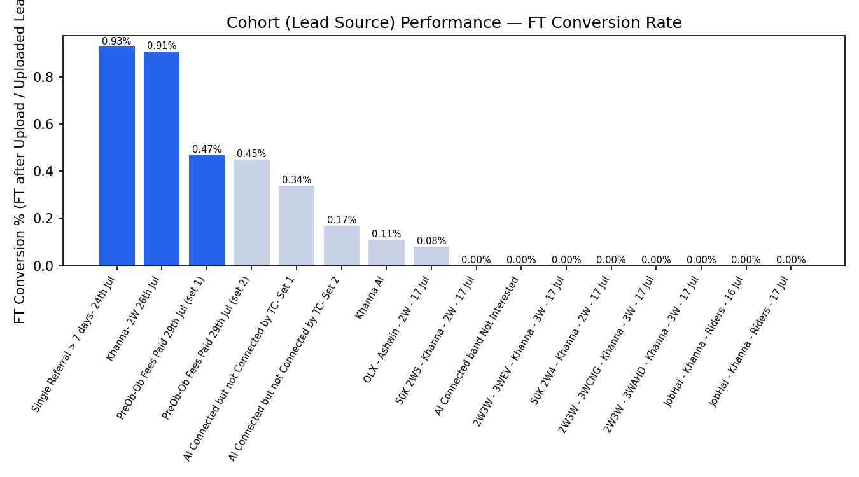

Answer
- 1st — Single Referral > 7 days- 24th Jul (0.93% FT conversion, 14 FTs from 1,500 leads)
- 2nd — Khanna- 2W 26th Jul (0.91% FT conversion, 14 FTs from 1,546 leads)
- 3rd — PreOb-Ob Fees Paid 29th Jul (set 1) (0.47% FT conversion, 7 FTs from 1,483 leads) — narrowly ahead of "set 2" at 0.45%

Caveat: several cohorts (e.g. "50K 2W4", "50K 2W5", the two JobHai cohorts) have only 1–3 leads each. Their 0% rate is not statistically meaningful and they were excluded from being read as "worst" cohorts — they simply have too little volume to judge. Ranking is only reliable for cohorts with a reasonable lead count (roughly 200+).

Q2. SQL query + aggregated output
Aggregation level: lead_source (the cohort grain the business asked about). Each cohort in this dataset already corresponds to a single sourcing batch/date, so lead_source is the natural grain — it answers "which cohort performs best" directly without needing a second dimension. (If cohorts were reused across multiple upload dates, I would aggregate by lead_source + upload_date instead, to track a cohort's performance batch by batch.)

Query (raw_leads → cohort-level aggregate)

SELECT

lead_source,

SUM(uploaded_leads) AS uploaded_leads,

SUM(attempted) AS attempted,

SUM(CAST(connected AS INT)) AS connected,

SUM(CAST(interested AS INT)) AS interested,

SUM(ob_after_upload) AS ob_after_upload,

SUM(ft_after_upload) AS ft_after_upload,

SUM(ft_after_first_attempt) AS ft_after_first_attempt,

ROUND(100.0 * SUM(attempted) / NULLIF(SUM(uploaded_leads), 0), 1) AS attempted_pct,

ROUND(100.0 * SUM(CAST(connected AS INT)) / NULLIF(SUM(attempted), 0), 1) AS connect_rate_pct,

ROUND(100.0 * SUM(CAST(interested AS INT)) / NULLIF(SUM(CAST(connected AS INT)), 0), 1) AS interested_rate_pct,

ROUND(100.0 * SUM(ft_after_upload) / NULLIF(SUM(uploaded_leads), 0), 2) AS ft_conversion_pct

FROM raw_leads

GROUP BY lead_source

ORDER BY ft_conversion_pct DESC;

Aggregated output (query result)

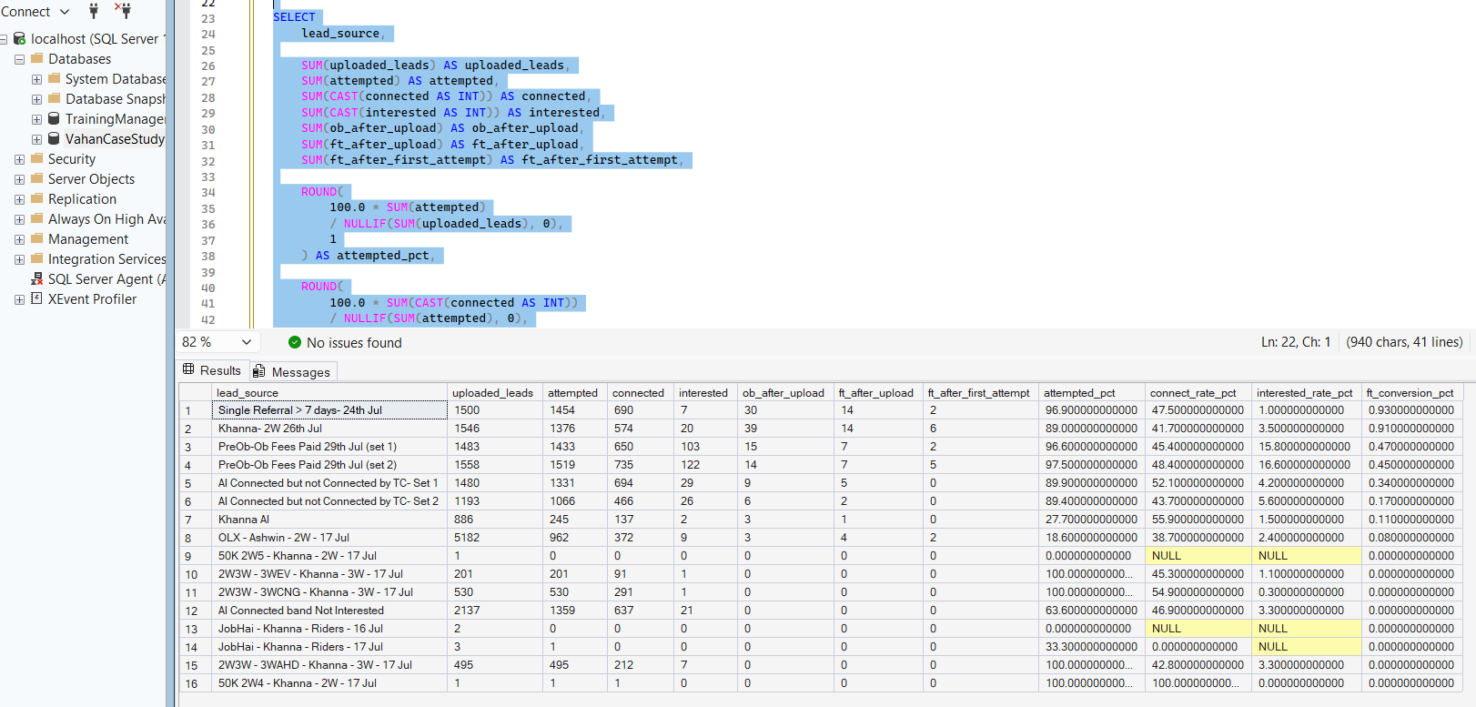

Q3. ML model — factors influencing chances of FT

Setup
- Target: FT_after_upload (1 = candidate converted to FT, 0 = did not). Positive rate in the data is very low: 54 of 18,198 candidates (0.30%) — a strongly imbalanced classification problem.
- Features used: Attempted, Connected, Interested, OB_after_upload, tag_filled, Attempt per Lead, upload_to_first_attempt_P50 (hrs), lead_source (one-hot encoded), and upload day-of-week.
- Deliberately excluded: FT_after_first_attempt and the pre-computed "→ %" columns. These are row-level restatements of the same funnel event as the target (e.g. a % column that is just 0/100 per row) and would leak the answer into the model rather than explain it.
- Model: Random Forest Classifier (300 trees, max depth 6, class_weight="balanced" to counter the 0.3% positive rate), 75/25 stratified train/test split.

Confusion matrix (test set, n = 4,550)
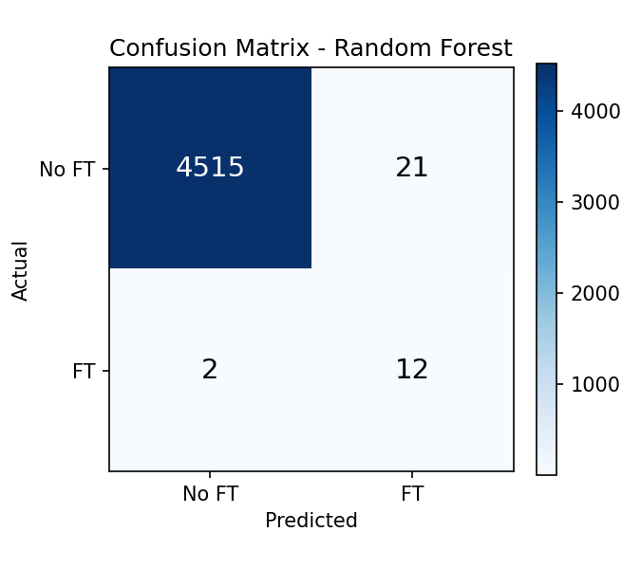
Precision (FT class): 36.4% | Recall (FT class): 85.7% | ROC-AUC: 0.934
Given the huge class imbalance, the model is deliberately tuned to prioritize recall (catching most true FT conversions) over precision — appropriate for a business use case where the cost of missing a genuine FT candidate is higher than the cost of a few extra follow-ups on false positives.

Top factors driving FT conversion
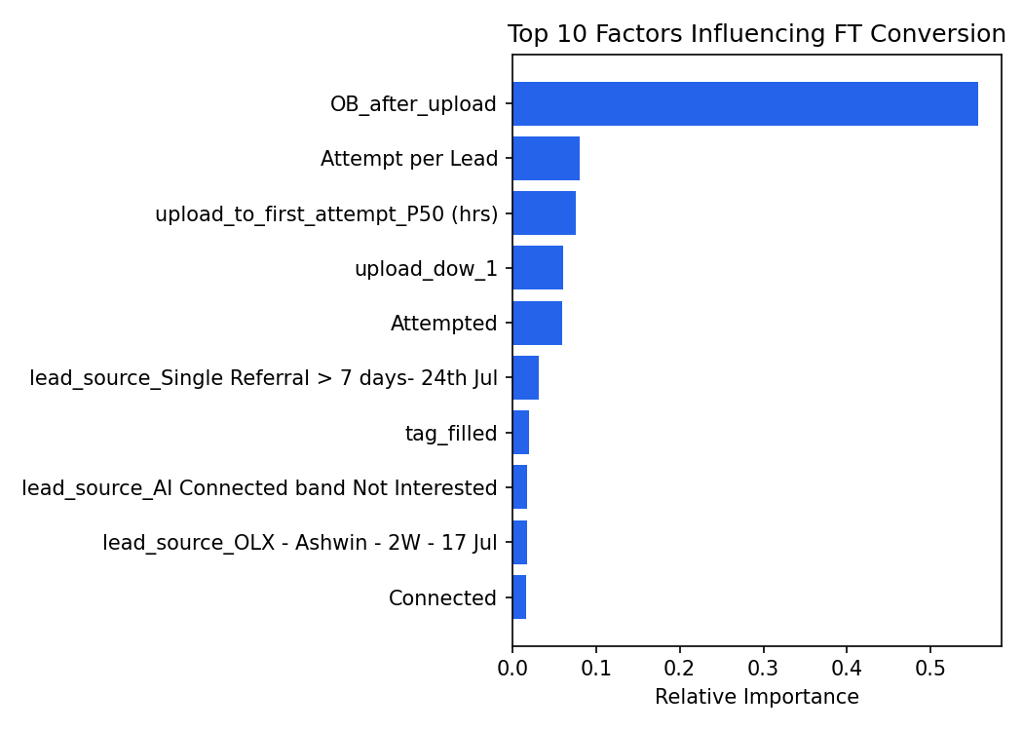
- OB_after_upload (was the candidate onboarded) dominates — unsurprising, since onboarding is the step immediately before FT in the funnel, but it confirms OB is the real bottleneck to focus ops effort on.
- Attempt per Lead and upload_to_first_attempt_P50 (speed of first outreach) are the next strongest — candidates called faster, and called more persistently, convert more.
- Day of upload (upload_dow) and Attempted also matter — some days source better-intent leads than others.
- Lead source itself shows up further down (Single Referral, Khanna 2W) — confirming Q1's finding that these cohorts are structurally better, even after controlling for funnel activity.

Business takeaway
The single highest-leverage lever is getting candidates through onboarding — and getting to them fast with more attempts. Cohort/source selection matters (Q1), but operational speed and follow-through inside the funnel matter even more.

