Project Proposal
RC-Gate
Reliability-Conditioned Gated Fusion for LLM Hallucination Detection
A claim-type and model-aware mixture-of-experts approach to combining cross-model consistency and evidence-retrieval signals
Submitted for Faculty Guide Review
Department of Computer Science and Engineering
SRM Institute of Science and Technology, Chennai
B.Tech Computer Science and Engineering — Third Year
August 2026

1. What Is This Project About?
Large Language Models (LLMs) like GPT, Claude, and Llama generate text by predicting the most statistically plausible next word based on patterns learned during training — they are not, by default, looking anything up. Most of the time this produces accurate text, but sometimes it produces a “hallucination”: a statement that is fluent, confident, and completely wrong — a fabricated fact, a made-up citation, a wrong date, or a plausible-sounding but false claim.
What makes hallucinations dangerous is that they don’t look uncertain. A model is often exactly as confident when it is wrong as when it is right. For example, if asked “When was the Eiffel Tower completed, and who was the chief engineer?”, a model might correctly answer 1889 but confidently name the wrong engineer — one true claim and one false claim, stated in the same tone, in the same sentence.
This project is about building a system that can automatically catch these errors at the level of individual claims — not just judge a whole answer as “good” or “bad”, but flag exactly which statement inside it is unsupported.

2. Why This Matters
Hallucination remains one of the biggest blockers to deploying LLMs in high-stakes settings — medicine, law, finance, and enterprise decision-making. Industry benchmarking in 2026 reports hallucination rates ranging from roughly 15% to 52% across evaluated models on structured analysis tasks, and considerably higher in specialised domains without mitigation (medical case summaries have been reported as high as 64% without mitigation prompts). Retrieval-augmented generation reduces — but does not eliminate — the problem, and simple ensembling of detection signals has been shown to give only modest gains (roughly 10–15%) over single-signal approaches.
In other words: every individual technique helps a little, but none of them solves the problem, and (as the literature review below shows) simply combining techniques the obvious way doesn’t reliably help either. That is the opening this project is aimed at.

3. Literature Review — What Existing Research Has Done
Before proposing anything new, it’s important to be precise about what already exists so the contribution is genuinely additive rather than a re-implementation. The table below summarises the closest prior work and, crucially, the specific limitation each one leaves open.
Prior Work | What It Does | Its Limitation (the gap it leaves open)
BEACON (2026) | Cross-model behavioral entropy + gradient boosting ensemble; black-box, works on any API-accessible LLM. | Uses cross-model consistency only — no evidence retrieval, no claim-type awareness.
Medico (2024) | Multi-source evidence fusion + an ensemble classifier built on retrieved-evidence likelihoods. | Uses evidence signals only — no cross-model consistency, no conditional weighting.
Evidence Graph Consistency – EGC (2026) | Shows that structural consistency signals are diagnostic of hallucination for Llama-2 but reverse direction for GPT-4, GPT-3.5 and Mistral-7B. | Proves no single global signal is model-independent — but offers no mechanism to adapt to this.
Pooled 9-signal detector (ACL 2026 Findings collection) | Combines nine signals (NLI entailment, entity checks, novelty, etc.) via one pooled logistic regression. | Near-perfect AUC on QA/TruthfulQA but falls below chance on DROP and FinanceBench — flat fusion breaks on specific claim types.
Rowen (2024) | Combines cross-language and cross-model consistency into one hybrid score using a fixed weight (alpha) before triggering retrieval. | The weighting is static and hand-set, not learned or conditioned on the claim; does not fuse in evidence-support features.
Temporal Multi-Signal Fusion (2026) | Fuses NLI, entropy and surprisal features for token-level detection; tested across RNN, Mamba and attention architectures. | Performance plateaus around 0.845 AUC regardless of which architecture is used — shows the bottleneck is the feature/fusion design, not the classifier.
Naive LLM-judge ensembling study (2025) | Ensembles multiple LLMs as judges of hallucination. | The ensemble fails to beat the single best individual model — proof that combining signals “flatly” isn’t automatically better.
FLaG (2026, KDD) | Mixture-of-experts-style latent grouping over a single model’s internal representation and token-level signals. | Requires white-box access to internal activations; operates on one model, not a multi-LLM + evidence-retrieval pipeline.

Reading across these eight lines of work, a pattern emerges: every fusion method combines its signals in a single, fixed way — either concatenated into one flat vector (BEACON, Medico, the pooled 9-signal detector) or combined with a hand-set static weight (Rowen). Meanwhile, three separate papers independently document that this flat/static approach breaks down in specific, predictable circumstances: it reverses sign across model families (EGC), it fails below chance on specific claim types (the pooled 9-signal detector on DROP/FinanceBench), and naively ensembling models doesn’t even beat the best single model. Nobody has connected these three findings into a fix.

4. The Research Gap
The gap is this: existing hallucination-detection fusion methods assume that a signal’s reliability is constant — that “cross-model agreement” or “evidence support” means the same thing regardless of what kind of claim is being checked or which model produced it. The evidence above shows this assumption is false. Signal reliability is conditional, not global — and no existing architecture has a mechanism to detect and adapt to that.
Put simply: current systems (including the version of this project’s architecture proposed at the start) throw every clue into one basket and hope the classifier sorts it out. The gap is a mechanism that decides, per claim, which basket of clues to trust in the first place.

5. Proposed Solution: RC-Gate
RC-Gate (Reliability-Conditioned Gated Fusion) keeps the same two signal families as the original design — cross-model consistency (agreement, contradiction, semantic distance) and evidence retrieval (support, source quality, conflict) — but changes how they are combined.
Instead of concatenating both signal families into one flat vector and handing it to a single classifier, RC-Gate adds two cheap, easy-to-compute pieces of context for every claim:
- Claim type — is this a numeric/extractive claim, an entity/fact-lookup claim, or an abstractive/causal claim?
- Generator fingerprint — which model or model family originally produced this claim?
A small learned gating network looks only at these two pieces of context and decides, for this specific claim, how much to trust the cross-model signals versus the evidence signals — before they are combined. This turns the RC-Gate system into a two-expert mixture-of-experts: a Cross-Model Expert, an Evidence Expert, and a gate that decides how much each expert’s opinion should count for the claim currently being checked. Their weighted outputs are then combined by a final stacked meta-learner into one hallucination probability.

Hypotheses to Test
- H1 — Signal reliability is conditional on claim type and generator identity, not stationary across the dataset.
- H2 — A learned conditional gate outperforms both flat-concatenation fusion and naive model-judge voting, especially on claim types where flat fusion is documented to fail.
- H3 — The gate’s learned weights are interpretable — they can show, after training, which signal family was trusted and why for a given claim, turning a previously silent failure mode into a visible, explainable one.

6. System Architecture
The diagram below shows the full pipeline, from the original user question down to the final claim-level report.
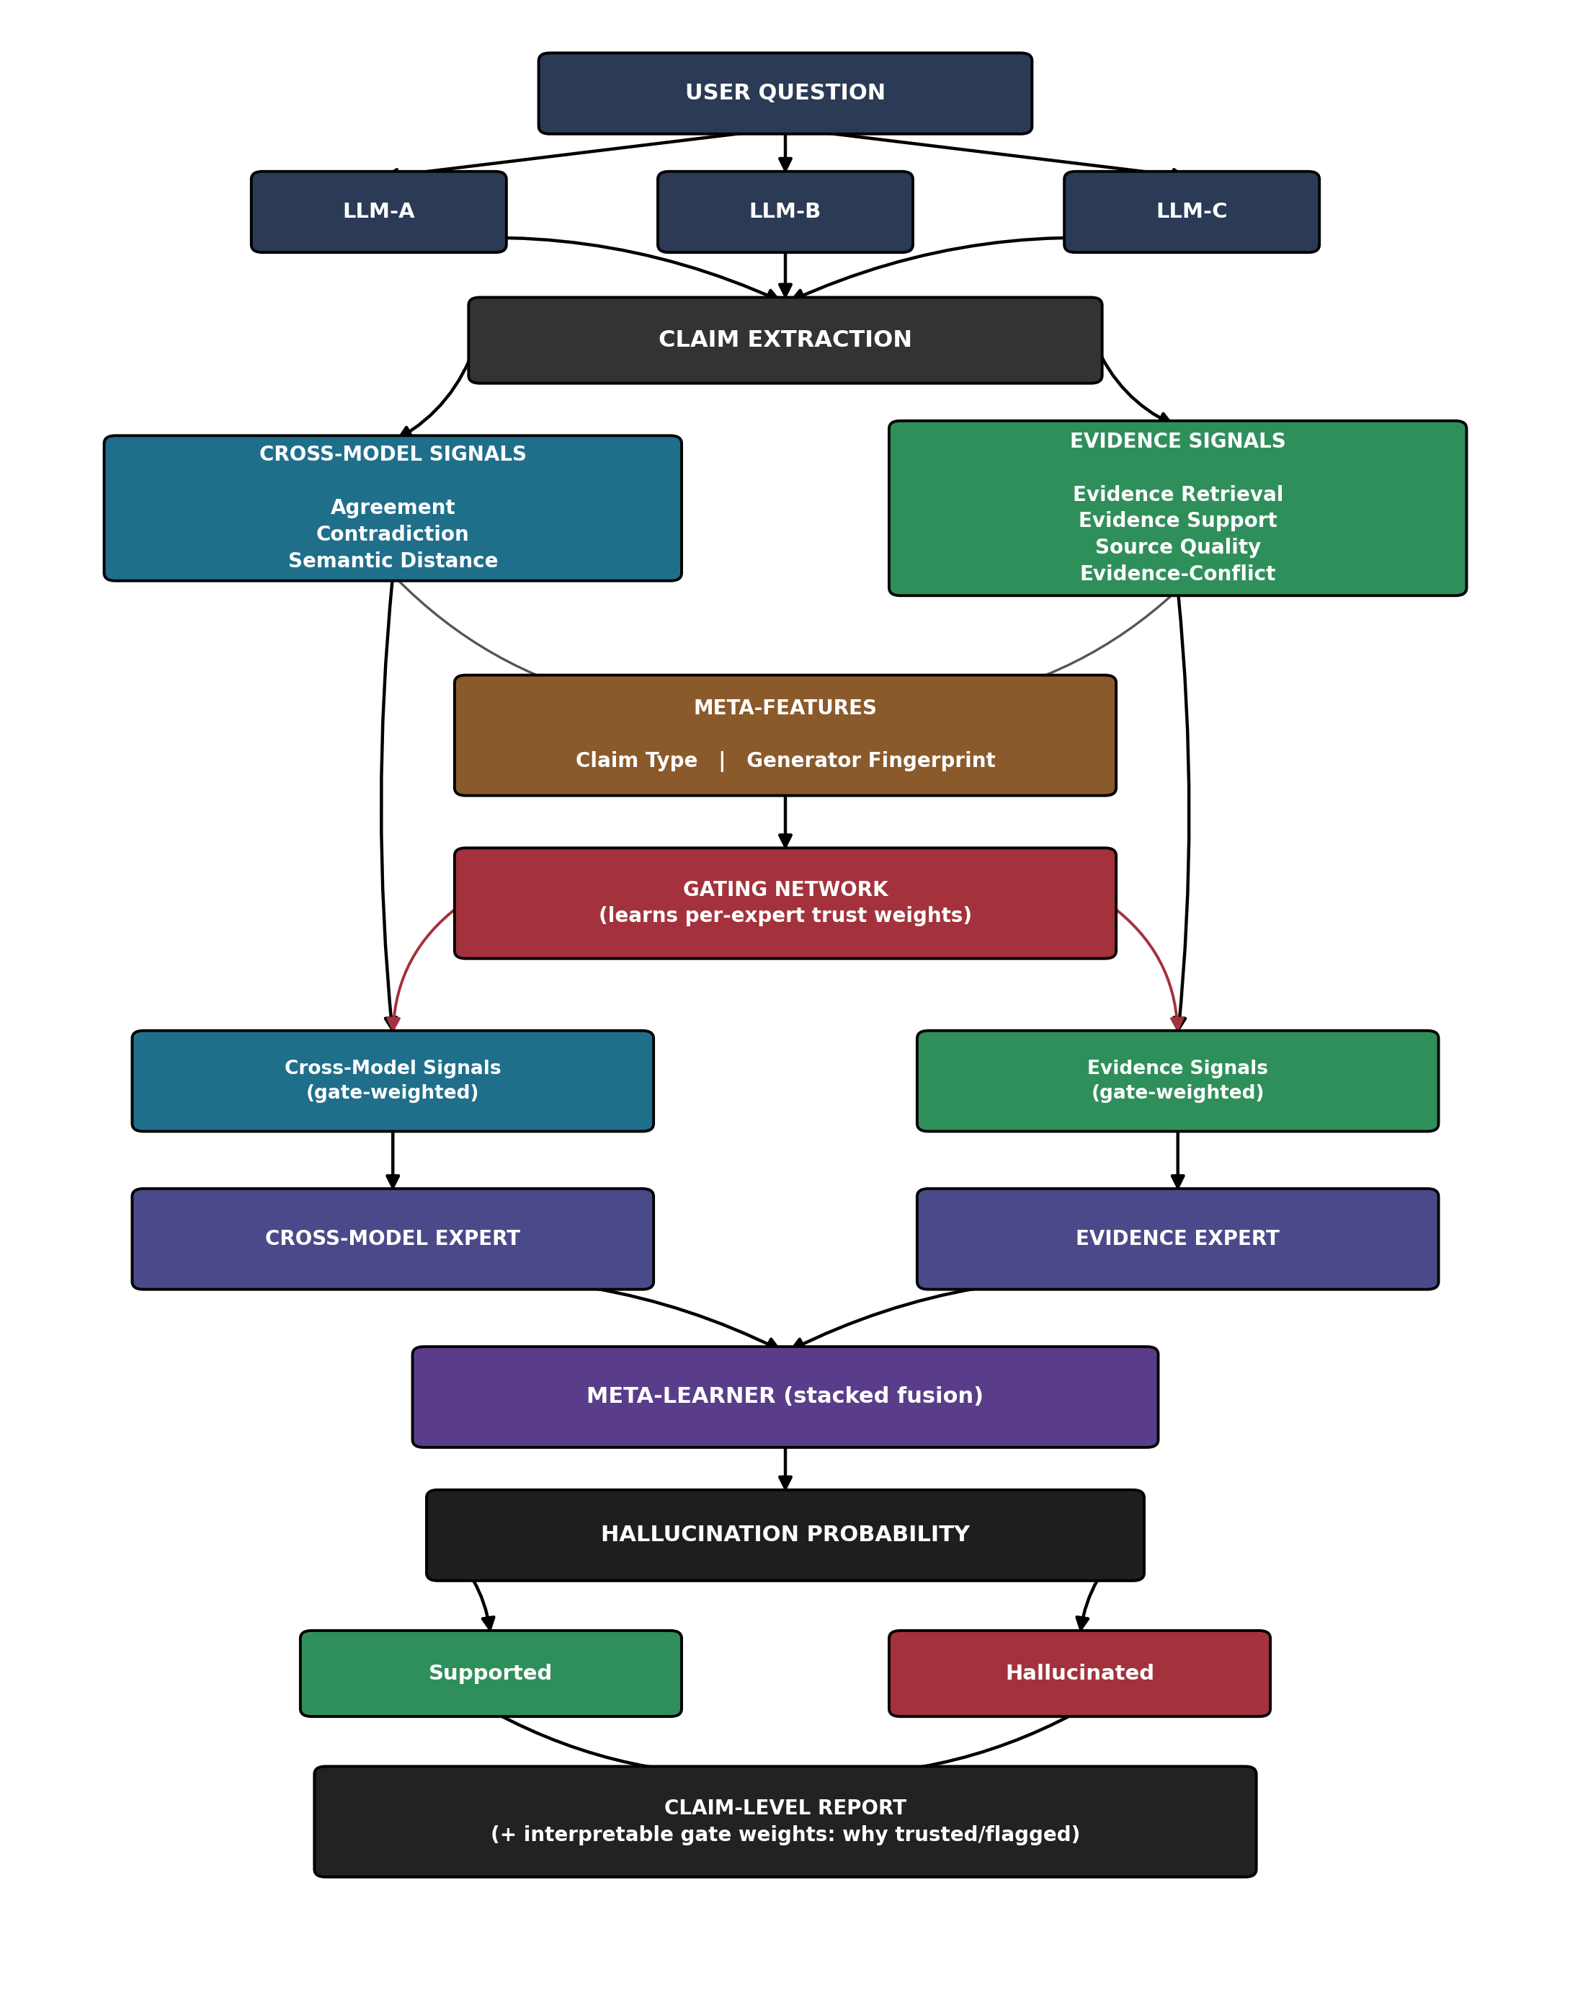
Figure 1. RC-Gate system architecture.

Walking Through the Pipeline
Consider the claim: “Marie Curie won the Nobel Prize in Chemistry in 1911.”
- Steps 1–2 — Generation and extraction: the original question is sent to several LLMs, and each answer is broken down into small, checkable, atomic claims. Our example claim is one of them.
- Step 3 — Cross-model signals: do the other LLMs also say 1911/Chemistry (agreement)? Does any of them contradict it? How semantically far apart are their answers?
- Step 4 — Evidence signals: retrieve real documents about Marie Curie — do they confirm 1911/Chemistry (support)? How reliable is the source? Do multiple sources disagree (conflict)?
- Step 5 — Meta-features: this is tagged as a factual entity-lookup claim, and its generator fingerprint is recorded.
- Step 6 — The gate: for a factual entity-lookup claim, both evidence and cross-model signals are historically reliable, so the gate weights both meaningfully. For a claim like “what is 847 × 12”, the gate instead learns to almost ignore cross-model agreement (models can agree and still both be wrong on arithmetic) and lean on evidence/verification instead.
- Steps 7–9 — Experts, fusion, and output: each expert scores the claim using its gate-weighted signals; a meta-learner stacks both expert outputs into a final hallucination probability; and the claim-level report shows the verdict plus the gate’s reasoning — which signal family it trusted and why.

7. Project Methodology
To keep this project academically rigorous, the work is organised into the same six phases expected of any transparent ML pipeline — adapted from regression-project conventions to this classification/detection setting.
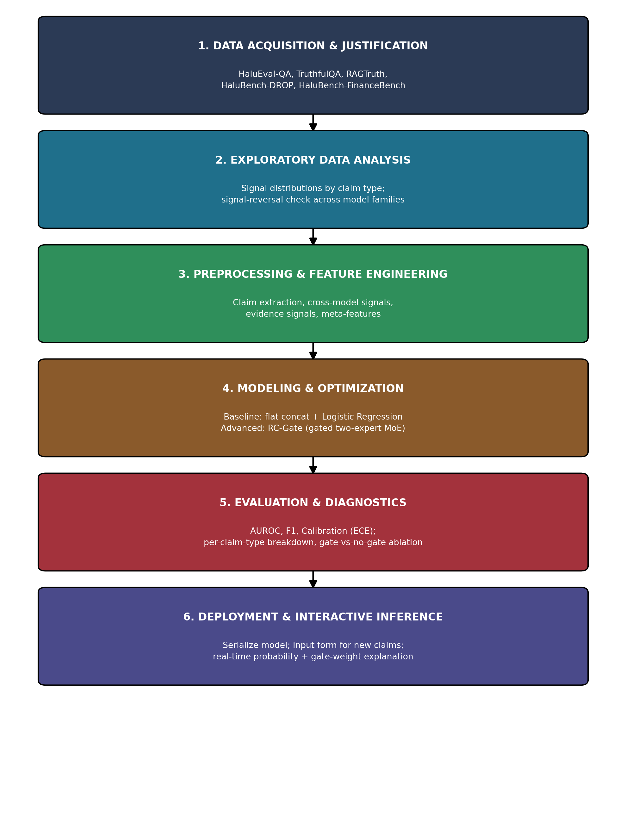
Figure 2. End-to-end project methodology, phase by phase.

Phase 1 — Data Acquisition & Justification
Data comes from established, peer-reviewed hallucination-detection benchmarks rather than a scraped or ad-hoc dataset — see the benchmark table in Section 8. Each benchmark’s labelling methodology (human-annotated vs. synthetic) is documented, and a data dictionary defines every signal (agreement, contradiction, semantic distance, evidence support, source quality, evidence-conflict, claim type, generator fingerprint), its type, and how it is computed.

Phase 2 — Exploratory Data Analysis
Instead of standard scatter plots of numeric features, EDA here focuses on: the distribution of claim types across each benchmark; how agreement/contradiction/evidence scores differ between hallucinated and non-hallucinated claims; and — specifically motivated by the EGC finding — whether signal direction flips across model families in our own data. A correlation matrix across the six core signals checks for redundancy before fusion.

Phase 3 — Preprocessing & Feature Engineering
This phase is the heart of the project: implementing claim extraction from multi-LLM outputs, computing the cross-model and evidence signal families, and engineering the two meta-features (claim type classifier, generator fingerprint tagging) that the gate depends on.

Phase 4 — Modeling & Optimization
Following a progressive approach: start with a simple baseline (flat concatenation of all six signals into one Logistic Regression classifier — this doubles as the “naive fusion” baseline the project is trying to beat), then build up to the full RC-Gate architecture (gating network + two experts + stacked meta-learner), with hyperparameter tuning (grid/random search) on the gate size, expert learners, and meta-learner choice.

Phase 5 — Evaluation & Diagnostics
Because this is a classification task, not a regression task, the metrics are AUROC, F1, precision/recall, and calibration error (ECE) rather than MAE/RMSE/R². The equivalent of a residual plot here is a confusion matrix broken down by claim type, plus a direct gate-vs-no-gate ablation on HaluBench-DROP and HaluBench-FinanceBench — the exact benchmarks where flat fusion is documented to fail.

Phase 6 — Deployment & Interactive Inference
The trained model is serialized (Pickle/Joblib equivalent) and wrapped in a simple input form: paste a claim and its context, and get back a real-time hallucination probability along with the gate’s learned trust weights — giving a transparent, “glass-box” explanation for every prediction, not just a bare number.

8. Evaluation Plan

Datasets
Benchmark | Role in This Study
HaluEval-QA / TruthfulQA | General-purpose factual QA hallucination benchmarks — sanity-check baseline performance.
RAGTruth | Retrieval-augmented generation benchmark with span-level hallucination labels across multiple model families.
HaluBench-DROP | Extractive-span reasoning — one of the two benchmarks where flat fusion is documented to fail below chance.
HaluBench-FinanceBench | Numeric / arithmetic claims — the other documented flat-fusion failure case; key test for the gating mechanism.

Baselines to Compare Against
- Flat-concatenation ensemble (RF + XGBoost + SVM on all six signals together) — this is the original, pre-gate design.
- BEACON-style cross-model-only detector.
- Medico-style evidence-only detector.
- Naive majority-vote across LLM judges.

Metrics
- AUROC and F1 per benchmark.
- Expected Calibration Error (ECE), since a probability output should also be trustworthy, not just rank-accurate.
- Per-claim-type breakdown, to directly test whether the gate rescues performance on numeric/extractive claims.

9. Expected Contribution — Why This Is Publishable
- It is directly falsifiable against named, existing baselines (BEACON, Medico, flat ensembles, naive voting) rather than only against itself.
- It is tested precisely on the benchmarks where prior work has already documented failure (DROP, FinanceBench), turning a known problem into a targeted experiment rather than a vague improvement claim.
- It produces an interpretable artifact (the gate’s learned weights) that explains its own decisions — a genuine, demonstrable answer to “why did existing methods fail here, and why does this one not?”
- The core idea — conditioning signal fusion on claim-type and generator identity — has not been proposed in this form in the reviewed literature as of August 2026.

10. Proposed Paper Title
Primary: “RC-Gate: Reliability-Conditioned Gated Mixture-of-Experts for Claim-Type and Model-Aware Hallucination Detection”
Alternative: “Conditional Gating for Cross-Model and Evidence-Based Hallucination Detection”

11. References
BEACON: Behavioral Entropy Aggregation for Cross-Model Hallucination Detection in Large Language Models (2026). arXiv:2606.07528.
Medico: Towards Hallucination Detection and Correction with Multi-source Evidence Fusion (2024). arXiv:2410.10408.
Evidence Graph Consistency in Retrieval-Augmented Generation: A Model-Dependent Analysis of Hallucination Detection (2026). arXiv:2606.06748.
A Survey on Hallucination in Large Language Models: Principles, Taxonomy, Challenges, and Open Questions — pooled 9-signal detector entry (ACL 2026 Findings), as catalogued in the EdinburghNLP awesome-hallucination-detection collection.
Rowen: Adaptive Retrieval-Augmented Generation for Hallucination Mitigation in LLMs (2024). arXiv:2402.10612.
Temporal Multi-Signal Fusion for Token-Level Hallucination Detection (2026). Research Square preprint.
Detecting Hallucinations in Authentic LLM-Human Interactions (2025). arXiv:2510.10539.
FLaG: Fine-Grained Latent Grouping for Hallucination Detection (2026). arXiv:2606.00301. ACM SIGKDD (KDD’26).

