set hive.support.concurrency = true;

set hive.enforce.bucketing = true;

set hive.exec.dynamic.partition.mode = nonstrict;

set hive.txn.manager = org.apache.hadoop.hive.ql.lockmgr.DbTxnManager;

set hive.compactor.worker.threads = a positive number on at least one instance of the Thrift metastore service;

CREATE TABLE passenger(pass_id int, name string, age int, coach string, berth string) clustered by (pass_id) into 5 buckets stored as orc TBLPROPERTIES('transactional'='true');

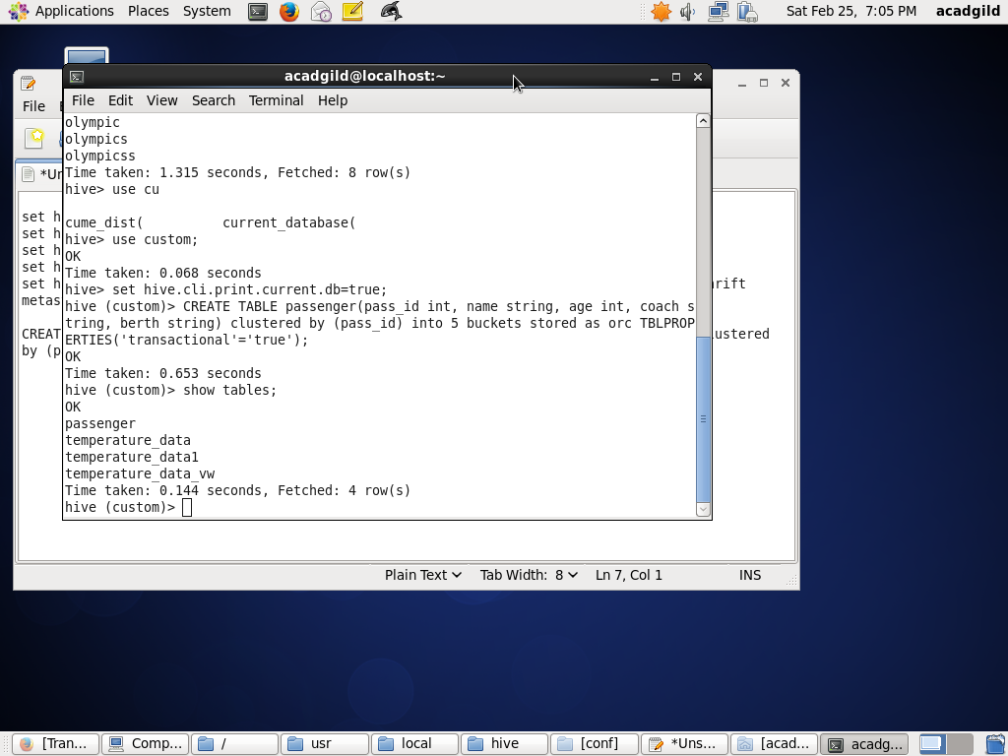

INSERT INTO table passenger values(1,'Nitin','24','A1','LB'),(2,'Megha','34','B1','UB'),(3,'Suraj','28','S11','MB'),(4,'Shobha','21','A2','UB'),(5,'Bhaskar','18','A2','LB'),(6,'Hari','31','B2','UB');

select * from passenger;

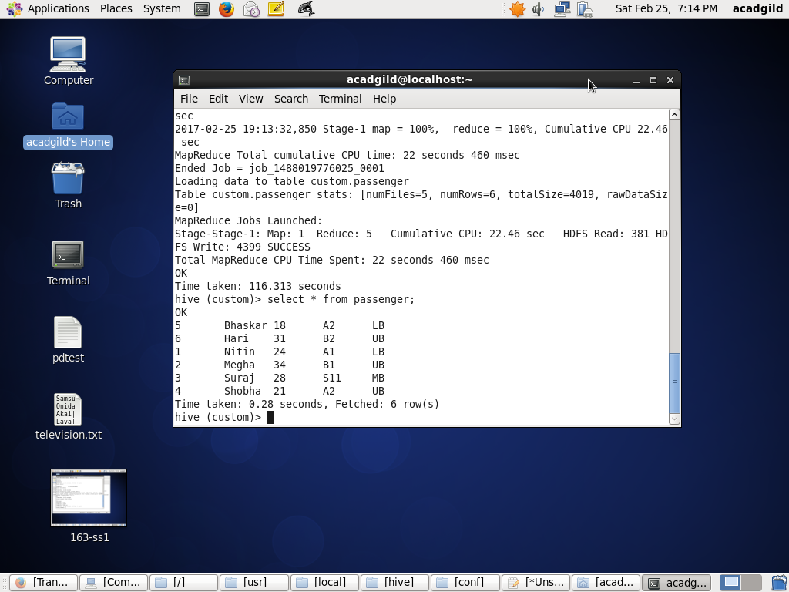

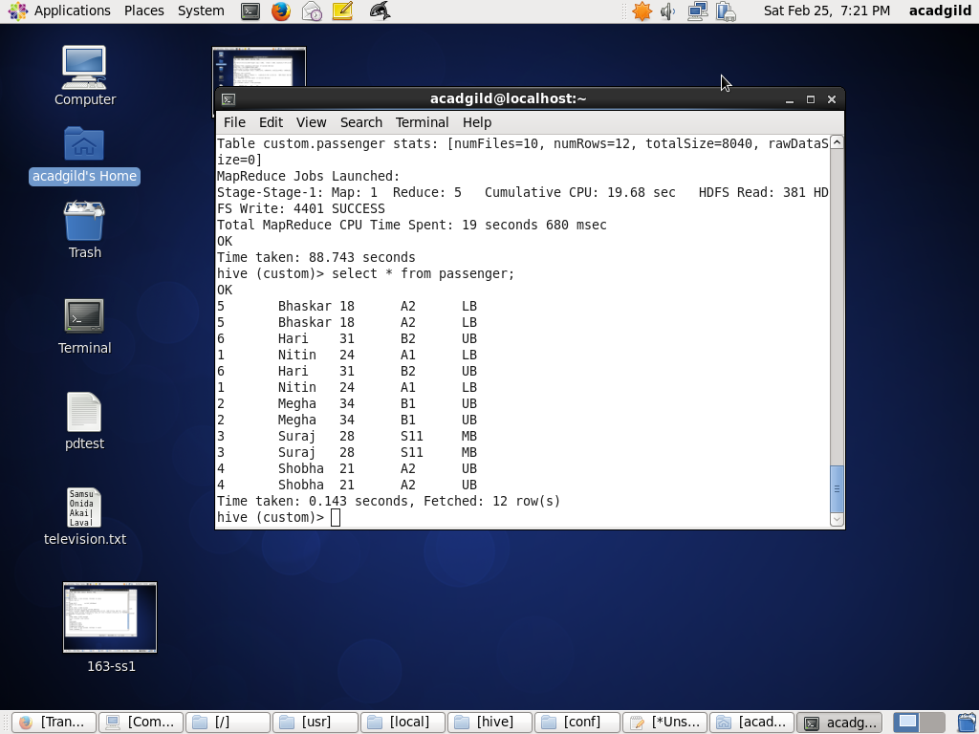

UPDATE passenger set berth = 'LB' where coach = 'S11' and name = 'Suraj';

select * from passenger;

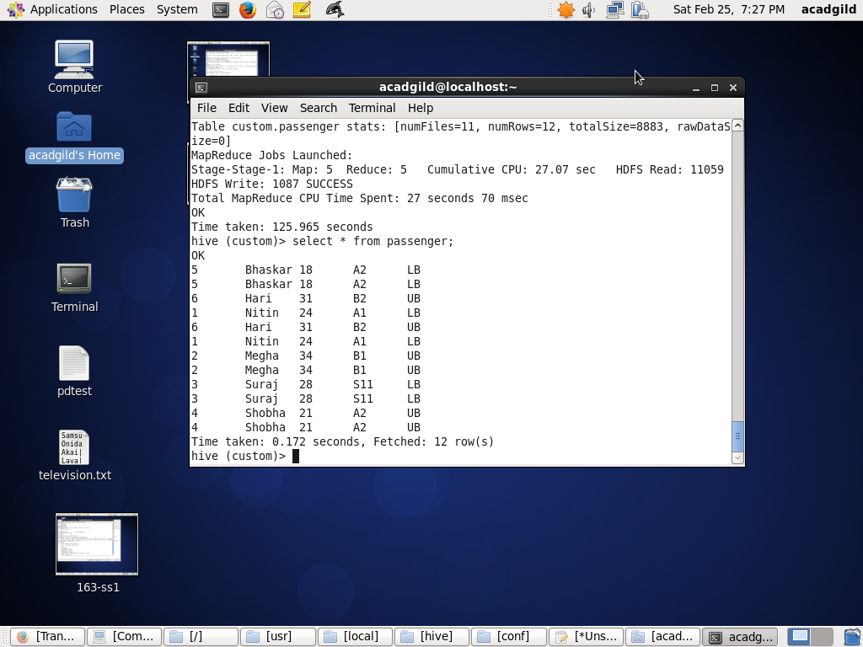

delete from passenger where pass_id=6;

select * from passenger;

