No. 1  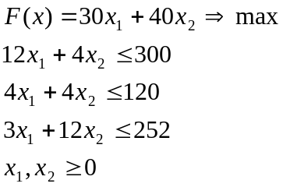 | No. 2  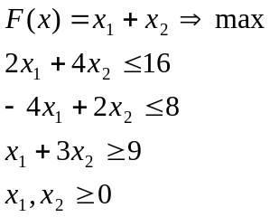
No. 3  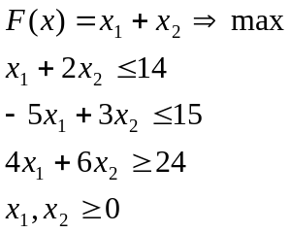 | No. 4  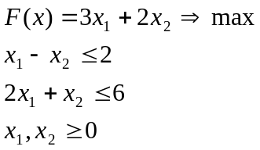
No. 5  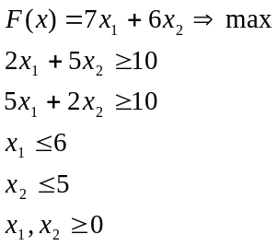 | No. 6  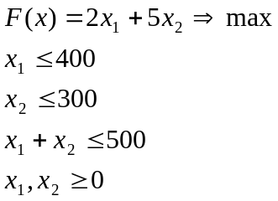
No. 7  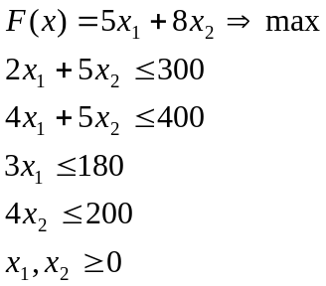 | No. 8  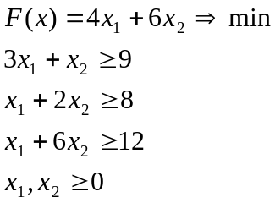
No. 9  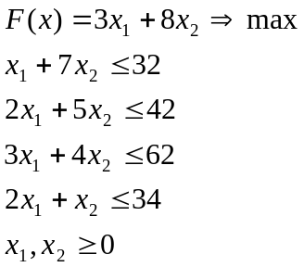 | No. 10  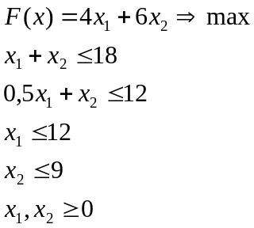

No. 11  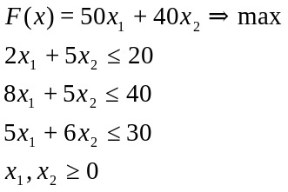 | No. 12  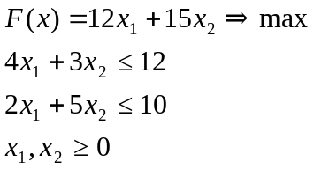
No. 13  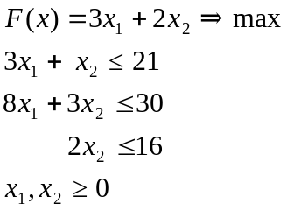 | No. 14  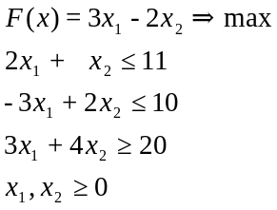
No. 15 | No. 16
No. 17 | No. 18
No. 19 | No. 20
No. 21 | No. 22
No. 23 | No. 24

No. 25 | No. 26
No. 27 | No. 28
No. 29 | No. 30

  No. 31 | No. 32
  No. 33 | No. 34
  No. 32 | No. 32
  No. 34

No. 35 | No. 36
No. 37 | No. 38
No. 39 | No. 40
No. 41 | No. 42

No. 43 | No. 44

