The use of the Boldur's method (Roy, 1972) provides another way of the normalization. In particular, we can assign "values" or "utilities" 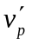 and 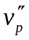 to 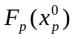 and 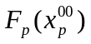, respectively, if 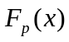 is to be minimized or to and , respectively, if is to be maximized. Then, accepting linear interpolation, it is possible to construct the following aggregation:

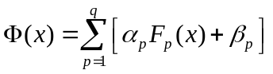 (4.11)

where the coefficients 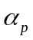 and 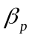 can be obtained by solving the following system of equations:

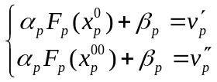 (4.12)

if is to be minimized or by solving the following system of equations:

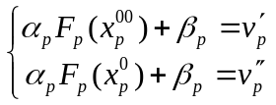 (4.13)

if is to be maximized.

It is not difficult to verify that if the "values" or "utilities" 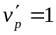 and =0, the convolution (4.11) is reduced to (4.4).

