.
The simplest convolution is the following:

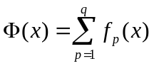 (4.4)

where 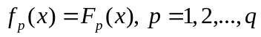 if all objective functions 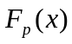 are of a homogeneous character or exhibit the same semantics. However, if the objective functions have different meaning, it becomes impossible, as it was indicated above, to compare the quality of obtained solutions with respect to different objective functions.

It is possible to identify several requirements related to the normalization of objective functions. However, the most important of them (Pedrycz, Ekel, and Parreiras, 2011) is the necessity to assign equal values to 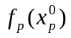 or 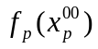 where 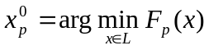 for minimized objective functions and 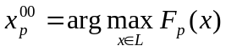 for maximized objective functions. The inclusion of this requirement permits one to compare objective functions on the basis of their numerical values.

The indicated requirement is satisfied by using the following normalization:

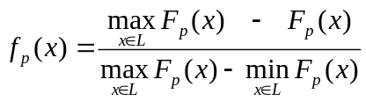 (4.5)

if the objective function is to be minimized. If the objective function is to be maximized, then it is possible to utilize

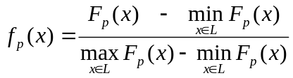 (4.6)

To construct (4.5) or (4.6) for any objective function, it is necessary to solve the following monocriteria problems:

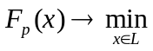 (4.7)

and

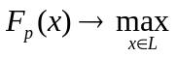 (4.8)

Considering this, it is possible to apply another type of normalization

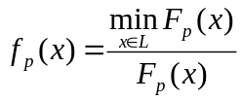 (4.9)

if the corresponding is to be minimized or use the normalization

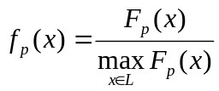 (4.10)

if the corresponding is to be maximized.

The construction of (4.9) requires determining only the solution to the problem (4.7) while the construction of (4.10) requires obtaining the solution to the problem (4.8). However, although the construction of (4.9) and (4.10) is more rational from the computational point of view, the quality of normalized functions (4.9) and (4.10) may not be always acceptable. This is illustrated by the following example (Pedrycz, Ekel, and Parreiras, 2011).

Example 4.1. Let us construct the normalization functions (4.5), (4.6), (4.9), and (4.10), when 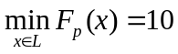 and 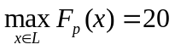. The levels of as well as the values of different 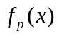 are shown in Table 4.1.

Table 4.1 Normalization of the objective function
 | 10 | 11 | 12 | 13 | 14 | 15 | 16 | 17 | 18 | 19 | 20
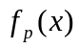 (4.5) | 1 | 0.9 | 0.8 | 0.7 | 0.6 | 0.5 | 0.4 | 0.3 | 0.2 | 0.1 | 0
(4.6) | 0 | 0.1 | 0.2 | 0.3 | 0.4 | 0.5 | 0.6 | 0.7 | 0.8 | 0.9 | 1
(4.7) | 1 | 0.91 | 0.83 | 0.77 | 0.71 | 0.67 | 0.63 | 0.59 | 0.56 | 0.53 | 0.50
(4.8) | 0.50 | 0.55 | 0.60 | 0.65 | 0.70 | 0.75 | 0.80 | 0.85 | 0.90 | 0.95 | 1

The results presented in Table 4.1 demonstrate that the use of (4.5) and (4.6) provides 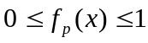 and does not modify a character of . At the same time, the application of (4.9) and (4.10) leads to 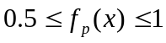. Besides, the use of (4.9) does not permit one to keep a character of .

The use of the Boldur's method (Roy, 1972) provides another way of the normalization. In particular, we can assign "values" or "utilities" 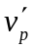 and 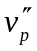 to 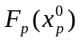 and 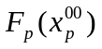, respectively, if is to be minimized or to and , respectively, if is to be maximized. Then, accepting linear interpolation, it is possible to construct the following aggregation:

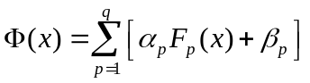 (4.11)

where the coefficients 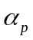 and 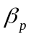 can be obtained by solving the following system of equations:

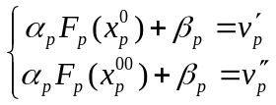 (4.12)

if is to be minimized or by solving the following system of equations:

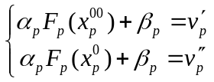 (4.13)

if is to be maximized.

It is not difficult to verify that if the "values" or "utilities" 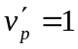 and =0, the convolution (4.11) is reduced to (4.4).

If we have to differentiate the importance of different objective functions, it is possible to transform (4.4) into

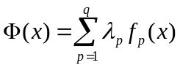 (4.14)

where 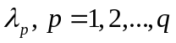 are weighting factors or importance factors which reflect a relative importance of objective functions, which are to satisfy the following conditions:

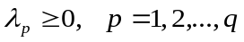 (4.15)

and

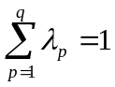 (4.16)

In (Lu et al., 2008), the maximization of the convolution (4.14) is called the weighting function method.

The application of the convolutions (4.4) and (4.14), which have found wide practical applications, corresponds to the principle of uniform optimality (Lyapunov, 1972). At the same time, the application of convolutions of the type

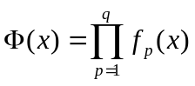 (4.17)

as well as

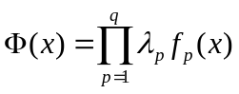 (4.18)

or

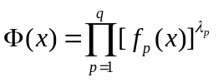 (4.19)

which have found some applications, corresponds to the principle of just compromise (Lyapunov, 1972).

