Data Wrangling

Data source:
The data was retrieved from the US Department of Labor from the following link:
https://www.foreignlaborcert.doleta.gov/performancedata.cfm
For this explanation only data from 2017 was taken into account.

Process:
The data being an excel file, it was loaded using Pandas’ ExcelFile() method. After examination of its containing sheets, the proper one was parsed into a Pandas data frame:

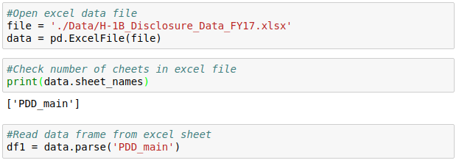
The data frame has several unnecessary columns for our project, so only the following columns were considered to create a clean data frame:

- EMPLOYER_NAME: Name of employer submitting labor condition application.
- JOB_TITLE: Title of the job.
- SOC_NAME: Occupational name associated with the SOC_CODE.
- FULL_TIME_POSITION: Y = Full Time Position; N = Part Time Position.
- PREVAILING_WAGE: Prevailing Wage for the job being requested for temporary labor condition.
- PW_UNIT_OF_PAY: Unit of Pay. Valid values include “Daily (DAI),” “Hourly (HR),” “Bi-weekly (BI),” “Weekly (WK),” “Monthly (MTH),” and “Yearly (YR)”.
- WORKSITE_CITY :City information of the foreign worker's intended area of employment.
- WORKSITE_COUNTY: County information of the foreign worker's intended area of employment.
- WORKSITE_STATE: State information of the foreign worker's intended area of employment.
- WORKSITE_POSTAL_CODE: Zip Code information of the foreign worker's intended area of employment.

The columns above were renamed for better clarity respectively as:
'employer', 'job_title', 'occupational_name', 'full_time', 'prevailing_wage', 'wage_period', 'city', 'county', 'state', 'postal_code'.

Around 0.21% of the rows contained NULL values. The amount being insignificant, it was decided to eliminate them:

Columns ‘full_time’ and ‘wage_period’ were checked for their unique possible values to check consistency with data set documentation:

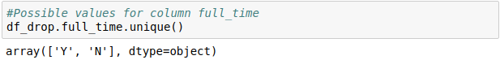
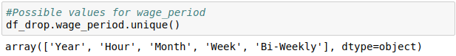
The results agreed with the documentation, so we proceeded to check the ‘wage_period’ distribution for rows without full time employment. Only 14 rows showed a yearly wage period which is contradictory with part-time employment. Part-time employment is associated with hourly pay, so those 14 rows were dropped from the data frame:

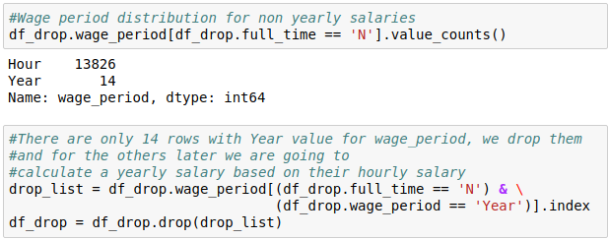
To reduce memory usage, the columns 'job_title', 'occupational_name', 'full_time', 'wage_period', 'state' and 'postal_code' were turned to ‘category’ type.

10 rows were found to have a value of zero for the prevailing wage, so they were filtered out from the data frame:

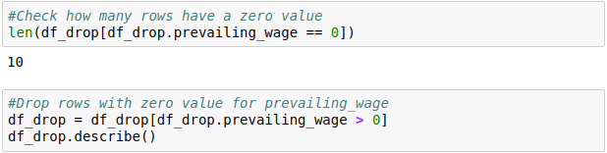

To make the wage data consistent, all fields from column ‘prevailing_wage’ were turned into yearly salaries with the information provided by the column ‘wage_period’ . This was achieved by creating a helper function called ‘annual_salary’ and then by applying it to the data frame:

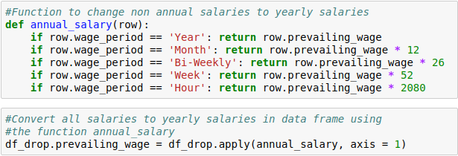
Given that the salaries were now expressed in a yearly format and assuming full time employment, the columns ‘full_time’ and ‘wage_period’ were eliminated:

Finally annual salaries bigger than $5 million (127 of them) and smaller than $15 000 (only 1) being considered outliers, their rows were filtered out from the data frame.

Finally, the indexes in the data frame are reset and the obtained clean data frame saved into a csv file:
