We have the min and max temperatures in a city In India for each months of the year.

We would like to find a function to describe this and show it graphically, the dataset

given below.

Data

Max = 39, 41, 43, 47, 49, 51, 45, 38, 37, 29, 27, 25

Min = 21, 23, 27, 28, 32, 35, 31, 28, 21, 19, 17, 18

Task 1:

fitting it to the periodic function

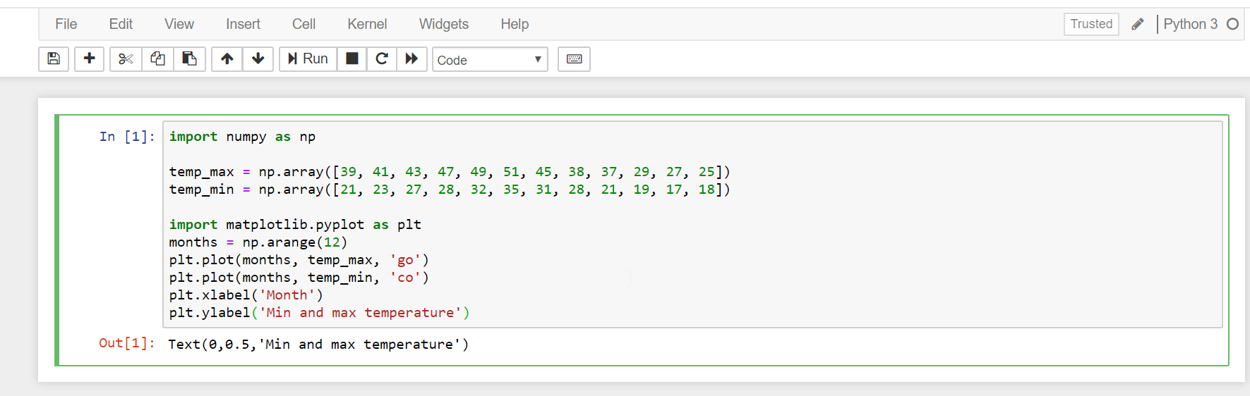

Task 2:

fitting it to the periodic function

