Session_4_Assignments

Write a Python Program(with class concepts) to find the area of the triangle using the below

formula.

area = (s*(s-a)*(s-b)*(s-c)) ** 0.5

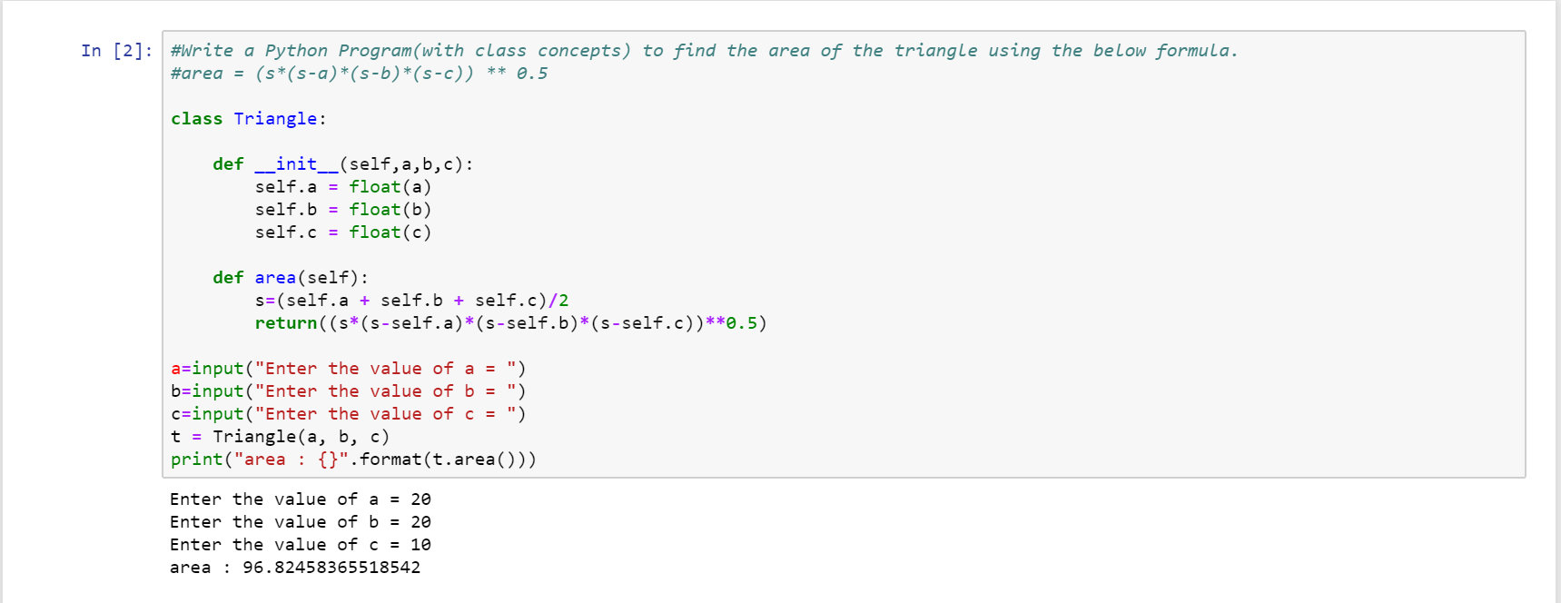

Write a function filter_long_words() that takes a list of words and an integer n and returns

the list of words that are longer than n.

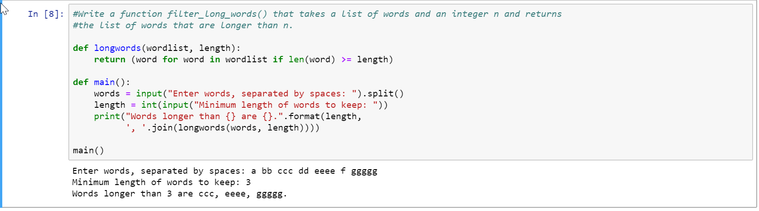

Write a Python program using function concept that maps list of words into a list of integers

representing the lengths of the corresponding words .

**Hint:** If a list [ ab,cde,erty] is passed on to the python function output should come as [2,3,4]

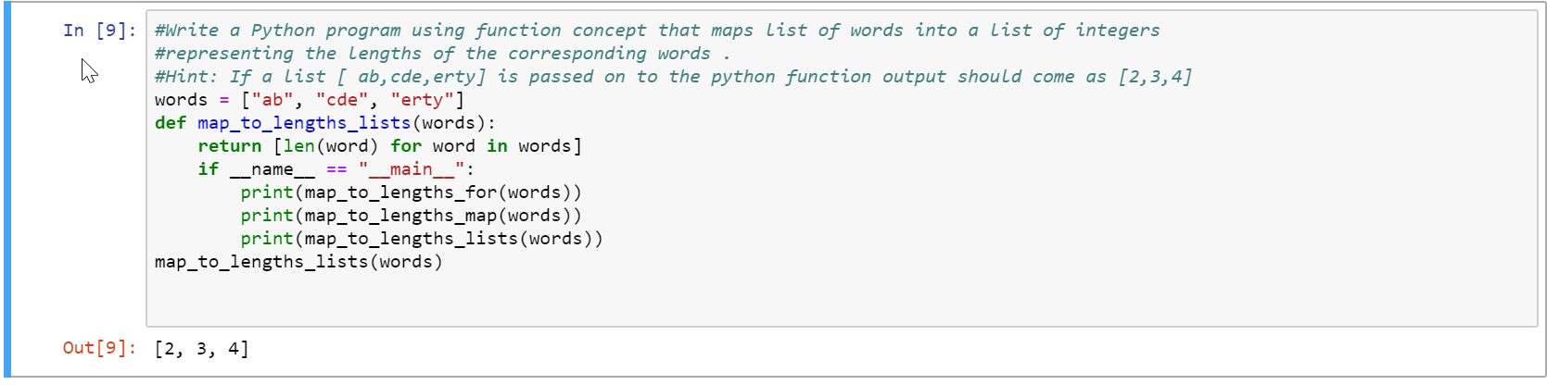

Write a Python function which takes a character (i.e. a string of length 1) and returns True if

it is a vowel, False otherwise

