E=100;
Rload=0:12.5:500;
Rint1=50; Rint2=75; Rint3=100;
I1=E./(Rint1+Rload); I2=E./(Rint2+Rload); I3=E./(Rint3+Rload);
P1=I1.^2.*Rload; P2=I2.^2.*Rload; P3=I3.^2.*Rload;
%Find Maximums & store in variables
HRint1=find(P1==max(P1)); HRint2=find(P2==max(P2)); HRint3=find(P3==max(P3));
HRint1=HRint1(1); HRint2=HRint2(1); HRint3=HRint3(1);%Display only one point in case of multiples
Xmax1=Rload(HRint1); Xmax2=Rload(HRint2); Xmax3=Rload(HRint3); Ymax1=P1(HRint1); Ymax2=P2(HRint2); Ymax3=P3(HRint3);
%Set grid scale [xmin xmax ymin ymax]
axis([0 500 0 60])
hold all;
%Plot lines and [points at maximums]
plot(Rload,P1,'-*r')
Max1=plot(Xmax1,Ymax1,':^g','LineWidth',2,'MarkerEdgeColor','g','MarkerFaceColor',[.7 .7 .7],'MarkerSize',7);
plot(Rload,P2,'-.ob');
Max2=plot(Xmax2,Ymax2,':og','LineWidth',2,'MarkerEdgeColor','g','MarkerFaceColor',[.7 .7 .7],'MarkerSize',7);
plot(Rload,P3,':p', 'Color',[0 0.5 0]);
Max3=plot(Xmax3,Ymax3,':vg','LineWidth',2,'MarkerEdgeColor','g','MarkerFaceColor',[.7 .7 .7],'MarkerSize',7);
%Draw lines to maximums from x axis
P1max=line([Xmax1 Xmax1],[0 Ymax1],'LineStyle',':','Color','r','LineWidth',1);
P2max=line([Xmax2 Xmax2],[0 Ymax2],'LineStyle',':','Color','b','LineWidth',1);
P3max=line([Xmax3 Xmax3],[0 Ymax3],'LineStyle',':','Color',[0 0.5 0],'LineWidth',1);
%Display maximum values at corresponding points
text(Rload(HRint1)-30,P1(HRint1)+4,sprintf('%dW',round(P1(HRint1))),'Color',[1 0 0],'BackgroundColor',[.9 1 .9]);
text(Rload(HRint2)-10,P2(HRint2)+3,sprintf('%dW',round(P2(HRint2))),'Color',[0 0 1],'BackgroundColor',[.9 1 .9]);
text(Rload(HRint3)+10,P3(HRint3)-5,sprintf('%dW',round(P3(HRint3))),'Color',[0 0.5 0],'BackgroundColor',[.9 1 .9]);
%Exclude lines from legend
PmaxLines=[P1max P2max P3max];
hA = get(PmaxLines,'Annotation');
hLL = get([hA{:}],'LegendInformation');
set([hLL{:}],{'IconDisplayStyle'},{'off','off','off'}');
%Exclude maximum point markers from legend
PmaxMarkers=[Max1 Max2 Max3];
hAb = get(PmaxMarkers,'Annotation');
hLLb = get([hAb{:}],'LegendInformation');
set([hLLb{:}],{'IconDisplayStyle'},{'off','off','off'}');
%Display legend and other graph information
legend('50 \Omega Int.','75 \Omega Int.','100 \Omega Int.',[330 250 0 0]);
xlabel({'Rload','( \Omega )'});
ylabel({'Pload','( W )'});
title('PROJ13 MAXIMUM POWER TRANSFER (trial & error)');
grid on;
set(gca,'GridLineStyle','-');
%Set grid lines to gray
set(gca,'Xcolor',[0.8 0.8 0.8]);
set(gca,'Ycolor',[0.8 0.8 0.8]);
%Set graph ticks back to black
Caxes = copyobj(gca,gcf);
set(Caxes, 'color', 'none', 'xcolor', 'k', 'xgrid', 'off', 'ycolor','k', 'ygrid','off');

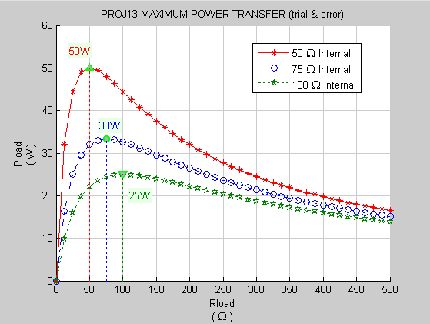

Q1. What is the relationship between R_{load} and R_{internal} that produces P_{load} max?
A1. The relationship between R_{load} and R_{internal} that produces P_{load} max is when R_{load} and R_{internal} are equal (R_{load} = R_{internal}).

Q2. What is the percentage of power that reaches the load when P_{load} is maximum?
A1. (P_{load}max / P_{input} ) * 100 = ((V_{L}*I_{T}) / (V_{RB}*I_{T})) * 100 = ((50V*1A) / (50V*1A)) * 100 = 50
((I²max*R_{load}) / (I²max*(R_{internal} + R_{load}))) * 100 = ((1A * 50Ω) / (1A * (50Ω + 50Ω))) * 100 = (50Ω / 100Ω) * 100 = 0.5 * 100 = 50%
The percentage of power that reaches the load when P_{load} is maximum is Fifty Percent (50%)

