MBFD Workgroup Summary — Mid-Mount Ladder Equipment Evaluation Report
Save as PDF
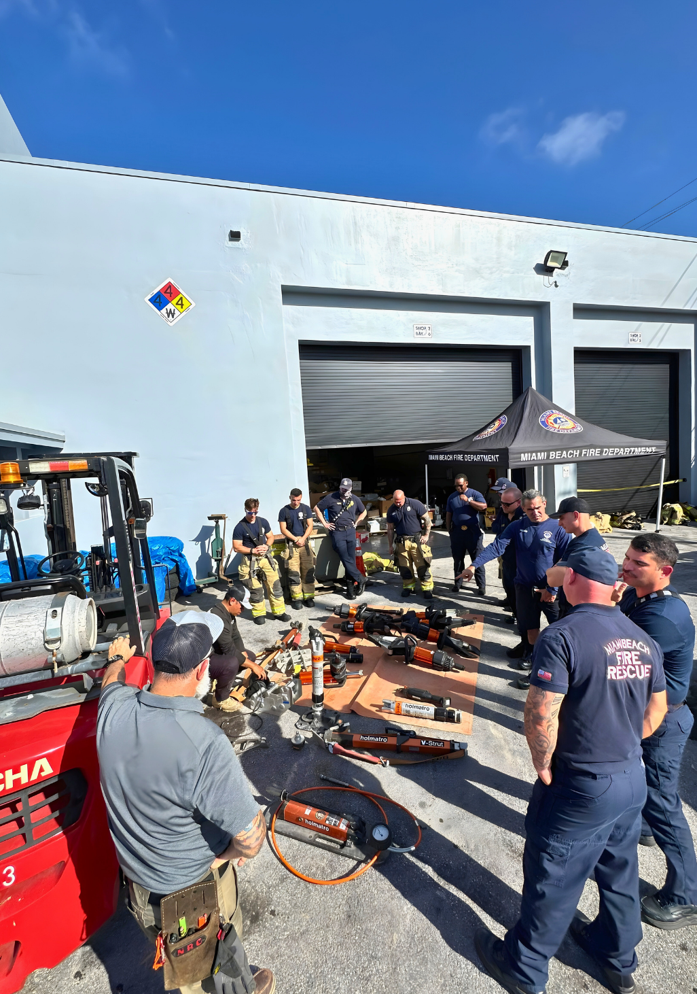

Mid-Mount Ladder Workgroup
Equipment Evaluation, Procurement Analysis, and Final Selection Report — Q1 2026
Prepared By: MBFD Support Services
Prepared For: Fire Chief Digna Abello · Health & Safety Committee
Reviewing Authority: Miami Beach Fire Department Command Staff
Report Designation: MBFD-WG-EVAL-2026-001
Date: March 2026
Approved for Internal Department Release

Table of Contents
- 1Executive Summary
- 2Workgroup Background and Purpose
- 3Operational Context
- 4Evaluation Framework and Methodology
- 5Finalist Evaluation Results
- 6Specialty Tool Considerations
- 7Final Workgroup Determinations and Purchasing Recommendations
- 8Apparatus Deployment and Implementation Strategy
- 9Training and In-Service Plan
- 10Strategic Conclusion
- AAppendix A — Product Evaluation Data Summary
- BAppendix B — Data Source Notes
- CAppendix C — Scoring Key

1. Executive Summary
In February 2026, the Miami Beach Fire Department convened a specialized workgroup to evaluate, rank, and select loose equipment for integration into a new Pierce Velocity 100-foot Ascendant mid-mount aerial tower. The workgroup conducted structured, multi-day hands-on evaluations of battery-operated extrication tools, rotary cut-off saws, vehicle stabilization systems, and specialty breaching tools from six manufacturers across fourteen product lines.
The evaluation dataset was forensically reconstructed to remove cost-based scoring influences. The original five-pillar model—which included an "Affordability" dimension—was corrected to a four-pillar framework reflecting pure operational performance: Capability, Usability, Maintainability, and Deployability. All scores reported in this document reflect the corrected methodology.

Key Findings
- Holmatro (Pentheon Series) achieved the highest corrected brand average among extrication manufacturers at 90.72, leading all four scoring dimensions. The Holmatro PSP40 spreader earned the single highest corrected tool score in the evaluation at 92.02.
- Hurst (eDRAULIC E3 Series) ranked second with a corrected brand average of 86.53, demonstrating competitive Capability scores (87.56) and superior saltwater protection (IP58).
- The DeWalt 12-inch POWERSHIFT cut-off saw dominated the rotary saw category with a corrected score of 91.25, outperforming 14-inch competitors by more than 26 points.
- Holmatro V-Struts led vehicle stabilization at 87.28 with 15-second auto-lock deployment.

Final Workgroup Determination
Despite Holmatro's evaluation leadership, the workgroup selected the Hurst E3 CAPTIUM platform (SP 777 E3 spreader, S 789 E3 cutter, CR 522 E3 ram) as the primary frontline extrication system. This determination reflects operational factors beyond pure score ranking—including IP58 saltwater certification critical for Miami Beach's coastal environment, ecosystem compatibility with the Hurst M40 heavy spreader assigned to the battalion chief's vehicle, and Captium cloud-based fleet management integration.
The complete recommended equipment package includes the Hurst E3 extrication suite, DeWalt 12-inch cut-off saw, DeWalt 18-inch chainsaw, four Holmatro V-Struts, the Holmatro T1 on trial basis as a rabbit tool replacement, and the Hurst M40 as a supplemental heavy extrication asset on the 300 vehicle.

2. Workgroup Background and Purpose

2.1 Origin and Command Directive
The Mid-Mount Ladder Workgroup was established by MBFD command to address a fundamental operational challenge: the department's acquisition of a new Pierce Velocity 100-foot Ascendant aerial tower with a mid-mount configuration required a complete reassessment of loose equipment stowage, tool selection, and deployment doctrine.
Unlike rear-mount aerial platforms, a mid-mount configuration introduces asymmetrical compartment geometry that precludes direct transfer of existing equipment layouts. The workgroup was tasked with evaluating the commercial market, conducting structured hands-on testing, and delivering a consensus-driven "Top 3" finalist list for procurement authorization.

2.2 Command Structure
- Consensus-driven model: All configuration decisions were driven by workgroup vote
- 12 active workgroup members serving as tactical decision-makers
- Support Services provided logistics, intelligence, and data analysis
- Health & Safety Committee held final procurement authorization
- Fire Chief Digna Abello served as reviewing authority

2.3 Day 1 Objectives
- Evaluate, rank, and select loose equipment across all frontline operational categories
- Deliver a finalized procurement recommendation to the Health & Safety Committee
- Assess platform ecosystem strategy—specifically whether to commit exclusively to the DeWalt battery platform to match the truck's existing charging infrastructure
- Optimize for narrow-profile tools compatible with asymmetrical compartment constraints
- Address the saltwater/coastal exposure factor in tool selection criteria
The workgroup identified four primary evaluation criteria from the outset: Cost, Interoperability, Serviceability, and Lifecycle—which were later refined into the structured four-dimension scoring framework.

3. Operational Context

3.1 The Mid-Mount Platform
The subject apparatus—Pierce Velocity 100-foot Ascendant aerial tower, Job #41559AD—presents specific engineering constraints that shaped the workgroup's evaluation priorities:
- TAK-4 independent suspension with 24,880 lb rating and low center of gravity
- 2,000 GPM water output pump supporting high-flow aerial and handline operations
- Overall length of 528.50 inches (44 feet, 0.5 inches)
- Mid-mount turntable placement displacing traditional compartment volumes

3.2 The Compartment Challenge: Asymmetrical Storage
The most consequential platform constraint identified on Day 1 was the asymmetrical compartment architecture inherent to the mid-mount design:
Side | Configuration | Implication
Driver Side (L Zones) | Full height, full depth | Primary bulk storage for fans, saws, rescue kits
Officer Side (R Zones) | Full height, reduced depth | Torque box intrusion limits stowage depth
The workgroup characterized this as "asymmetrical warfare"—the officer-side compartments cannot accommodate the same tool profiles as the driver side. This constraint eliminated the possibility of copying equipment layouts from existing apparatus and mandated optimization for narrow-profile tools across multiple categories.
Strategic implication: The department could not simply replicate existing configurations. Every tool selection required evaluation against the physical geometry of both compartment zones.

3.3 Coastal and Environmental Factors
Miami Beach's barrier-island geography imposes environmental requirements on rescue equipment that inland departments do not face:
- Saltwater exposure: Proximity to the Atlantic Ocean and Biscayne Bay subjects equipment to persistent salt air and potential submersion scenarios
- IP rating significance: Ingress Protection ratings became a differentiating evaluation factor, with IP58 (saltwater-rated) tools receiving operational preference over IP54/IP57 alternatives
- Corrosion lifecycle: Equipment lifecycle projections must account for accelerated metallic degradation in marine environments

3.4 Platform Ecosystem Strategy
A foundational strategic question raised on Day 1 was whether MBFD should commit exclusively to the DeWalt battery platform to match the truck's integrated charging infrastructure. The workgroup identified this as a decision point across three categories:
- Extrication tools: Proprietary battery ecosystems (Hurst eDRAULIC, Holmatro Pentheon) vs. COTS platforms (Amkus on DeWalt 60V)
- Forcible entry tools: Battery-powered vs. manual hydraulic options
- Saws: Multiple competing battery architectures (DeWalt POWERSHIFT, Makita XGT, Husqvarna 94V)
The workgroup ultimately adopted a hybrid ecosystem strategy—selecting brand-specific proprietary batteries for primary extrication tools (where performance requirements dictate the power platform) while adopting COTS DeWalt batteries for secondary tools including saws and chainsaws.

4. Evaluation Framework and Methodology

4.1 Original Scoring Model
The workgroup's initial evaluation framework employed a five-dimension scoring model applied across all candidate products during hands-on testing sessions. Each dimension was scored on a 0–100 scale:
- Capability — Raw performance: force output, cutting capacity, spreading distance, operational power
- Usability — Ergonomic design, control interface, operator comfort, learning curve
- Maintainability — Service requirements, durability, component accessibility, field-repairability
- Deployability — Storage footprint, activation speed, weight, cordless readiness, compartment fit
- Affordability — Cost-based considerations

4.2 Analytical Correction: Removal of Affordability
During post-evaluation data analysis, the Affordability dimension was identified as analytically problematic. Cost-based scoring introduced variability that did not reflect the pure operational performance of the tools under evaluation.
Corrected Overall Score = f(Capability, Usability, Maintainability, Deployability)
All scores presented in this report—brand averages, individual tool scores, and category rankings—reflect this corrected methodology with Affordability permanently removed.

4.3 Extrication Brand Scoring Standardization
Brand-level averages for extrication manufacturers were computed exclusively from the performance of the mandatory frontline tactical triad: the 32-inch spreader, cutter, and ram platforms. This standardization ensured that:
- The Hurst M40 (40-inch heavy spreader) was excluded from the Hurst baseline brand average
- The Holmatro T1 (forcible entry tool) was excluded from the Holmatro baseline brand average
- Both tools were isolated into standalone specialty analysis

4.4 Scoring Classification
90+ Elite
80–89 Highly Capable
70–79 Acceptable
< 70 Deficient

5. Finalist Evaluation Results

5.1 Extrication Brand Overall Performance (Corrected)
Four extrication manufacturers advanced to the final evaluation. Brand averages are derived strictly from the frontline triad (32-inch spreader, cutter, ram):
Rank | Brand | Corrected Avg | Capability | Usability | Maintainability | Deployability
#1 | Holmatro | 90.72 | 89.41 | 93.99 | 89.82 | 89.69
#2 | Hurst | 86.53 | 87.56 | 85.76 | 82.58 | 82.74
#3 | TNT | 75.12 | 74.67 | 78.38 | 65.78 | 81.67
#4 | Amkus | 73.56 | 84.21 | 66.98 | 69.14 | 73.89
Holmatro achieved Elite classification (90+) while Hurst achieved Highly Capable (80–89). The most significant dimension gap between the top two brands occurred in Usability (+8.23 points favoring Holmatro). The narrowest gap appeared in Capability (+1.85), confirming that both platforms deliver competitive raw performance.

5.2 Frontline Extrication Tools: Individual Corrected Scores
Tool Category | Product Model | Manufacturer | Corrected Score
Spreader | PSP40 (32-inch) | Holmatro | 92.02
Ram | PRA40 | Holmatro | 91.29
Spreader | SP 777 E3 (32-inch) | Hurst | 90.99
Cutter | PCU30CL | Holmatro | 88.86
Ram | CR 522 E3 | Hurst | 86.02
Cutter | S 789 E3 | Hurst | 82.57

Spreader Comparison
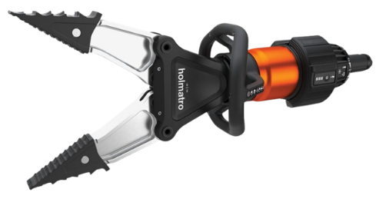
Holmatro PSP40 — 92.02 (Elite)
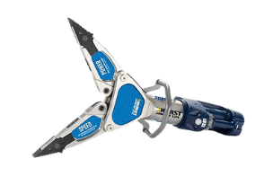
Hurst SP 777 E3 — 90.99 (Elite)
The Holmatro PSP40 achieved the highest individual score in the entire evaluation at 92.02, leading the Hurst SP 777 E3 (90.99) by 1.03 points. Both earned Elite classification. The PSP40's advantage derived primarily from its 360-degree inline control handle and Extreme Grip Spreader Tips, while the Hurst SP 777 E3 countered with substantially higher maximum spreading force (600 kN vs. 280 kN), wider 32-inch spreading distance (vs. 28.5 inches), and IP58 watertight design rated for saltwater operations.

Cutter Comparison
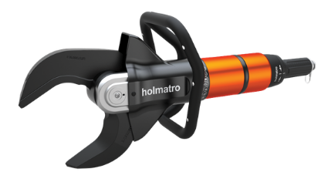

Holmatro PCU30CL vs. Hurst S 789 E3
Cutter Category — Largest performance gap among frontline tools
The Holmatro PCU30CL led by 6.29 points (88.86 vs. 82.57). The PCU30CL's 30-degree inclined jaw design maximizes working space between the tool and the vehicle, enabling safer and faster cutting without repositioning. The i-Bolt construction eliminates retightening the central bolt after each use.
Δ 6.29 pts

Ram Comparison
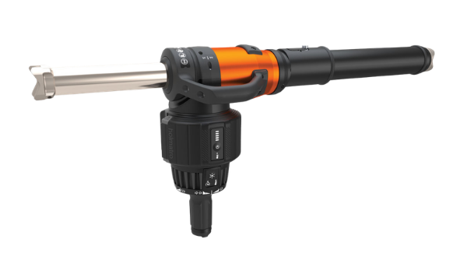

Holmatro PRA40 vs. Hurst CR 522 E3
Ram Category — 91.29 vs. 86.02
The PRA40 dominated ram evaluations with 91.29 versus 86.02 (Δ = 5.27). Its integrated laser pointer provides first-time-right positioning, and at 31.1 lbs with a retracted length of only 15.2 inches, it is particularly suited to mid-mount compartment constraints.
91.29 Elite

5.3 Rotary Cut-Off Saws
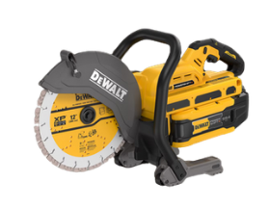

DeWalt 12" POWERSHIFT (DCPS612AG2)
Rotary Saw Category Winner — Categorical Dominance
Established categorical dominance with a 91.25 corrected score—outperforming the Makita by 26.42 points and the Husqvarna by 29.47 points. Gear-driven power delivery (not belt-driven), 3-second electric brake, and superior ergonomics rendered the 14-inch competitors operationally inferior.
91.25 Elite
Rank | Product | Manufacturer | Score
#1 | 12-inch (DCPS612AG2) | DeWalt | 91.25
#2 | 14-inch (GEC01PL4) | Makita | 64.83
#3 | 14-inch (K1 Pace) | Husqvarna | 61.78

5.4 Vehicle Stabilization
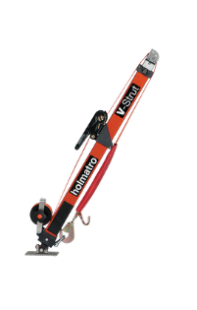
Holmatro V-Strut — 87.28
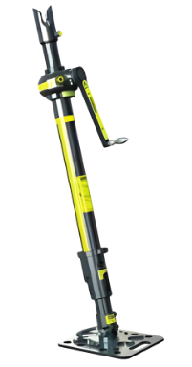
Paratech StrutDriver — 76.13
Rank | System | Manufacturer | Score
#1 | V-Strut (Auto-locking) | Holmatro | 87.28
#2 | OmniShore (Pneumatic) | Holmatro | 85.87
#3 | Strut Driver (Mechanical) | Paratech | 76.13
The Holmatro V-Strut's auto-lock mechanism enables deployment in approximately 15 seconds—a single pull-and-lock movement with no separate locking operation required. At 15.87 lbs (7.2 kg), it is the lightest system evaluated.

6. Specialty Tool Considerations
The workgroup isolated two tools for standalone analysis. Due to their unique engineering, dimensions, and tactical deployment profiles, including them in standard frontline brand averages would produce mathematically inaccurate capability assessments.

6.1 Holmatro T1 — Multi-Purpose Forcible Entry Tool
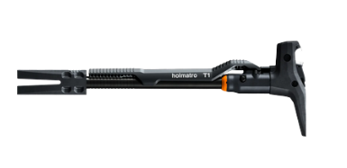

Holmatro T1
Six-function-in-one tool — Cut, Wedge, Ram, Spread, Hammer, Lift
82.23 Highly Capable
Specification | Value
Weight | 17.0 lbs (7.7 kg)
Spreading Force | 33.0 kN (7,419 lbf)
Cutting Force | 139.0 kN (31,248 lbf)
Max Spreading Distance | 5.0 in (128 mm)
Cutting Opening | 1.1 in (29 mm)
Power Source | Manual hydraulic (2-stage hand pump)
The T1 operates as a fully self-contained device—no batteries, no external pump, no hoses. Application of 30 kg (66 lbs) of manual force on the pump rod generates up to 14.2 tons of hydraulic cutting force and 3.4 tons of spreading force. The workgroup evaluated the T1 specifically as a potential replacement for the traditional rabbit tool. The T1's detachable wedge enables single-operator door breaching.
Workgroup consensus strongly recommends the T1 for rapid entry teams. The tool has been authorized for trial deployment rather than immediate full adoption.

6.2 Hurst M40 — 40-Inch Heavy Spreader
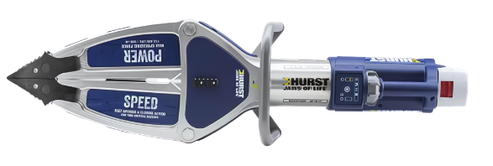

Hurst M40
40-inch heavy rescue spreader — Supplemental command-level asset
Provides 40-inch spreading distance for heavy rescue operations. Capability score of 83.39 demonstrates substantial raw power, but its Usability score of 79.29—the lowest in the entire dataset—reflects the immense physical footprint.
78.80 Acceptable
The M40 is intended for heavy rescue apparatus and should not be deployed as a primary tool on standard frontline engines. Within MBFD's fleet strategy, the M40 is selected as a supplemental asset for the 300 (battalion chief's vehicle).

7. Final Workgroup Determinations and Purchasing Recommendations

7.1 The Selection–Score Divergence
The most significant analytical finding in this report is the divergence between evaluation scoring leadership and the final workgroup selection for the primary extrication platform.
Holmatro (Pentheon Series) led every frontline scoring dimension and achieved the highest brand average (90.72), the highest individual tool score (PSP40 at 92.02), and Elite classification across the board.
The workgroup selected Hurst (eDRAULIC E3 CAPTIUM) as the primary extrication platform. This determination was not an error. The workgroup exercised its consensus-driven authority to weigh operational factors:
- Saltwater certification (IP58): The Hurst E3 platform carries IP58 watertight certification rated for saltwater operations. For a barrier-island department, this represents a measurable operational advantage.
- Ecosystem interoperability with the M40: Selecting Hurst for both the frontline triad and the supplemental heavy spreader consolidates battery platform, maintenance pipeline, vendor relationship, and training requirements.
- Captium cloud integration: The E3 Connect platform with Wi-Fi data transfer provides fleet-management capabilities—tool usage tracking, battery health monitoring, and maintenance scheduling.
- Capability parity: The Capability dimension gap between Holmatro (89.41) and Hurst (87.56) is only 1.85 points—effectively at parity.

7.2 Final Selected Equipment Package
Category | Selected Equipment | Platform Assignment
Cut-Off Saw | DeWalt 12" Battery Cut-Off Saw (DCPS612AG2) | Frontline (L1/L3)
Chainsaw | DeWalt 18" Chainsaw (bullet chain + depth markings) | Frontline (L1/L3)
Stabilization | 4 × Holmatro V-Struts | Frontline (L1/L3)
Spreader | Hurst SP 777 E3 Connect | Frontline — CAPTIUM Platform
Cutter | Hurst S 789 E3 Connect | Frontline — CAPTIUM Platform
Ram | Hurst CR 522 E3 Connect | Frontline — CAPTIUM Platform
Specialty Tool | Holmatro T1 (Trial Authorization) | Rabbit Tool Replacement Candidate
Heavy Extrication | Hurst M40 + 2 batteries + charging station | 300 (Battalion Chief Vehicle)
Future Addition | Lifting Struts (pending evaluation) | 300 / Captain 5
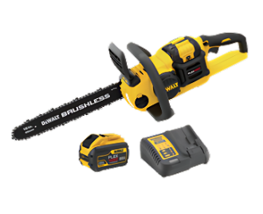
DeWalt 18" Chainsaw — Selected for Ventilation Ops

DeWalt 12" POWERSHIFT — 91.25 Elite

8. Apparatus Deployment and Implementation Strategy

8.1 Tiered Deployment Model
The workgroup established a tiered deployment architecture ensuring full operational independence across all rescue scenarios without dependency on mutual aid.

Frontline Apparatus (L1 / L3)
Equipment | Deployment Role
Hurst SP 777 E3 Connect Spreader | Primary extrication spreading
Hurst S 789 E3 Connect Cutter | Primary extrication cutting
Hurst CR 522 E3 Connect Ram | Extension / displacement operations
4 × Holmatro V-Struts | Rapid vehicle stabilization
DeWalt 12" Battery Cut-Off Saw | Rapid entry / concrete-steel cutting
DeWalt 18" Chainsaw | Ventilation operations
Holmatro T1 (trial) | Multi-function access / forcible entry

Command Level (300 / Captain 5)
Equipment | Deployment Role
Hurst M40 40" Spreader | Heavy extrication beyond standard parameters
2 × CAPTIUM Batteries | Extended power supply
Charging Station | Field recharging capability
Lifting Struts (future) | Vehicle lifting operations

Heavy Rescue (E2 / Box Truck)
High-capacity rescue systems for extreme lifting and technical rescue scenarios. Strategic goal: Full operational independence across all rescue levels—ensuring MBFD units can handle any vehicle extrication scenario without dependency on mutual aid resources.

9. Training and In-Service Plan

9.1 Train-the-Trainer Model
Workgroup members who participated in the evaluation process will serve as subject matter experts (SMEs) and lead departmental training through a phased implementation.

Phase 1 — Vendor Training
Workgroup members receive comprehensive manufacturer-led training on all selected equipment systems. Members achieve proficiency qualification on each platform before conducting internal training.

Phase 2 — Department-Wide Rollout
Department personnel are divided across shift groups. Each workgroup SME trains their assigned shift. No overtime is required—training is integrated into existing shift schedules, minimizing budget impact while ensuring complete departmental coverage.

Phase 3 — Deep Familiarization
All personnel complete training covering:
- Tool operation and safety protocols for each selected system
- Tactical application in vehicle extrication scenarios specific to the mid-mount platform
- Battery management and field charging procedures across both Hurst CAPTIUM and DeWalt ecosystems
- V-Strut stabilization deployment procedures
- Integration of the T1 trial tool into existing forcible entry protocols
- M40 heavy spreader operation for personnel assigned to the 300

9.2 Ladder Truck In-Service Requirements
Training Component | Requirement
Driving Operations | Full certification on mid-mount ladder configuration
Pumping Operations | Operational proficiency on all pump functions
Tactical Deployment | Extrication tool deployment from mid-mount compartments
Equipment Integration | Familiarization with all selected equipment as installed
All training components must be completed before the apparatus enters service.

10. Strategic Conclusion
The MBFD Mid-Mount Ladder Workgroup has completed a rigorous, data-driven evaluation of rescue equipment spanning six manufacturers, fourteen products, and four operational categories. The corrected four-pillar scoring framework—with Affordability permanently removed—provides command staff with an unambiguous performance baseline for current and future procurement decisions.
The final equipment package reflects a deliberate balance of quantitative evaluation data and operational judgment. Where the scoring data pointed clearly to a single solution (DeWalt for saws, Holmatro for stabilization), the workgroup followed the data directly. Where the top two extrication platforms demonstrated competitive performance with differentiated operational advantages, the workgroup exercised its consensus authority to select the platform best aligned with MBFD's coastal operating environment, fleet integration strategy, and heavy-rescue interoperability requirements.
The workgroup remains active through full implementation of the selected equipment. Ongoing responsibilities include procurement tracking, delivery coordination, installation oversight, dashboard monitoring, and leadership of the scheduled follow-on evaluation session for lifting struts.

A. Appendix A — Product Evaluation Data Summary
Product | Category | Manufacturer | Corrected Score
Holmatro PSP40 (32" Spreader) | Hydraulic Tool | Holmatro | 92.02
Holmatro PRA40 (Ram) | Hydraulic Tool | Holmatro | 91.29
DeWalt DCPS612AG2 (12" Saw) | Rescue Saw | DeWalt | 91.25
Hurst SP 777 E3 (32" Spreader) | Hydraulic Tool | Hurst | 90.99
Holmatro PCU30CL (Cutter) | Hydraulic Tool | Holmatro | 88.86
Holmatro V-Strut | Stabilization | Holmatro | 87.28
Hurst CR 522 E3 (Ram) | Hydraulic Tool | Hurst | 86.02
Holmatro OmniShore | Stabilization | Holmatro | 85.87
Hurst S 789 E3 (Cutter) | Hydraulic Tool | Hurst | 82.57
Holmatro T1 | Specialty | Holmatro | 82.23
Hurst M40 (40" Spreader) | Specialty | Hurst | 78.80
Paratech StrutDriver | Stabilization | Paratech | 76.13
Makita GEC01PL4 (14" Saw) | Rescue Saw | Makita | 64.83
Husqvarna K1 Pace (14" Saw) | Rescue Saw | Husqvarna | 61.78

B. Appendix B — Data Source Notes
All numerical evaluation scores are sourced from the forensically reconstructed Executive Procurement Dashboard. Dashboard scores are designated TIER 1 authority—where any conflict exists between dashboard values and PDF-extracted text, the dashboard values govern.
Product specifications are sourced from manufacturer catalogs processed through the Docling document intelligence pipeline, cross-referenced against original vendor PDFs.
The corrected scoring methodology removes the Affordability dimension from all composite calculations. Original uncorrected scores are retained in archival records but are not presented in this report.

C. Appendix C — Scoring Key
90+ — Elite — Exceeds all operational requirements with distinction
80–89 — Highly Capable — Meets or exceeds operational requirements
70–79 — Acceptable — Meets minimum operational requirements
< 70 — Deficient — Falls below operational requirements
MBFD-WG-EVAL-2026-001 · Miami Beach Fire Department · Support Services Division
Approved for Internal Department Release · March 2026

