Tuturial:

<https://www.youtube.com/watch?v=59duINoc8GM>

Conda create –name tensorflow python=3.6

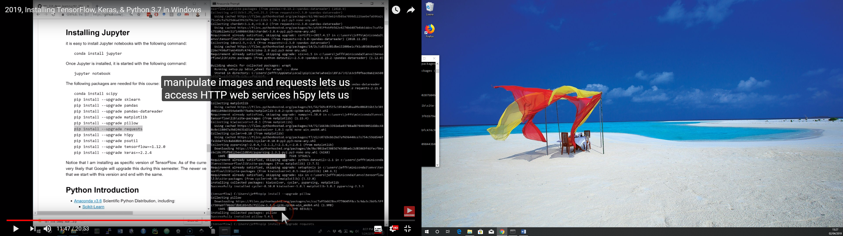

Python

import tensorflow as tf

print(tf.__version__)

python -m ipykernel install --user --name tensorflow --display-name "Python 3.6 (tensorflow)"

activate tensorflow

import numpy as np

(train_data, train_labels), (test_data, test_labels) = reuters.load_data(num_words=10000)

print(len(train_data), 'train sequences')

print(len(test_data), 'test sequences')

print(train_data[10])

word_index=reuters.get_word_index()

reverse_word_index=dict([(value,key) for(key,value) in word_index.items()])

decoder_newswire=' '.join([reverse_word_index.get(i-3,'?') for i in train_data[0]])

print(decoder_newswire)

num_classes = np.max(train_labels)+1

print(num_classes, 'classes')

from keras.preprocessing.text import Tokenizer

tokenizer = Tokenizer(num_words=10000)

train_data=tokenizer.sequences_to_matrix(train_data,mode='binary')

test_data=tokenizer.sequences_to_matrix(test_data,mode='binary')

from keras.utils.np_utils import to_categorical

one_hot_train_labels = to_categorical(train_labels, num_classes)

one_hot_test_labels = to_categorical(test_labels, num_classes)

>>> from keras import models

>>> from keras import layers

>>> model = models.Sequential()

>>> model.add(layers.Dense(64, activation='relu', input_shape=(10000,)))

model.add(layers.Dense(64, activation='relu'))

model.add(layers.Dense(46, activation='softmax'))

model.compile(optimizer='rmsprop', loss='categorical_crossentropy', metrics=['accuracy'])

history = model.fit(train_data, train_labels, batch_size=512, epochs=20, verbose=1, validation_split=0.1)