EE463 Hardware Project

Simulation Report

4 December, 2019

Team “Blue Smoke”

Paul Brown – 2463461

İbrahim Duru – 2166304

Mustafa Şahin

# Table of contents will be added

# Formula Sheet

# Vt = Ea + Ia x Ra (1)

# Ea = Laf x If x wm (2)

# T = Laf x If x Ia (3) Ea = Vt - Ia x Ra (4)

# Ea x = (5)

# T = P/ωm (6)

# Introduction

This report presents the designing a rectifier circuit that will be used to operate a DC motor in three possible alternatives ways such that single or three phase thyristor rectifier or diode rectifier with buck convertor.

# Simulations

Simulations were performed for various topologies under consideration to better understand the advantages and disadvantages among them and to show some of the component ratings that would be needed for those topologies to be applied. The topologies simulated were a three-phase thyristor rectifier, a three-phase diode rectifier with buck converter, and a TRIAC-based AC chopper to diode bridge rectifier. The simulation models and results will be shown in following subsections, however, some common assumptions and calculations will be shown first.

## Voltage Source Model

The converter designed in this project will be fed from a variable transformer (variac) adjusted to give the desired output voltage. It is assumed that the variac output voltage will be adjusted to a desired setpoint prior to connecting load to the output of our converter. For the three-phase rectifier and buck converter models, a variac output voltage of 120 Vrms,l-n was selected. This voltage level allows the converters to be in the middle of their regulating range while providing 175 VDC output.

For the triac-based model, since it is fed from single-phase voltage source and because the diac circuit needs a substantial voltage headroom over the motor back EMF in order to charge, the variac is simulated as set to 220 Vrms,l-n. Based on simulations, this voltage allows the circuit to achieve 175 VDC (average) output to the motor.

The source impedance of the lab AC power supply and variac is not known, but for modeling purposes, it was represented with an resistance of 50 mΩ and an inductance of 180 μH. This works out to an available short-circuit current at 120 V of 1590 A.

## Motor Calculations and Modeling

In this project, the DC motor load to be driven by the electronic power converter should be represented in the simulations. In Simulink, it is possible to represent the DC motor load as a motor with a torque load or using the Ea, Ra, La equivalent circuit elements. Both representations were developed for our Simulink model, but for the simulation results, the Ea, Ra, La equivalent circuit elements were used.

The parameters for the DC motor model were calculated based on the nameplate data of the motor and parameters provided with the project assignment.

The nameplate is shown in Figure 1 below.

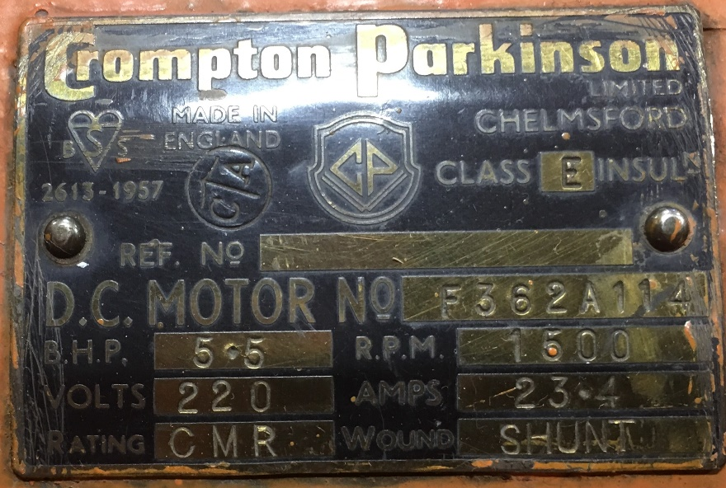

Figure 1: DC Motor Nameplate

Additional motor parameters were provided with the project assignment. The motor data taken from this information is summarized in Table 1.

Table 1: DC Motor Provided Parameters

| Parameter | Value |
| --- | --- |
| Pmec | 5.5 HP |
| RPM | 1500 |
| VS | 220 V |
| IS | 23.4 A |
| Armature Winding | 0.8 Ω, 12.5 mH |
| Shunt Winding | 210 Ω, 23 H |
| Interpoles Winding | 0.27 Ω, 12 mH |

The DC motor model in Simulink takes some additional parameters that were not provided, but which can be calculated from the available information.

Rated speed (rad/s) = = 157 rad/s

Rated field current (A) = = 1.06 A

Simulink also takes parameters for armature-field mutual inductance Laf as well as a friction coefficient. These can be calculated from the provided values for motor operation at rated speed, power, voltage, and current, as is shown in the following subsection.

### Motor Operation at Rated Load

The equivalent circuit parameters for a DC motor are the following:

Vt = Ea + Ia x Ra (1)   
Ea = Laf x If x wm (2)   
T = Laf x If x Ia (3)

(In many formulations, Ka*Φ is used instead of Laf*If, but since Simulink will use Laf, it is convenient that we use this formulation.)

Prated = (5.5 HP) x (746 ) = 4103 W. This power is mechanical output.

At rated speed of 157 rad/s, rated mechanical torque is   
(4103 W)/(157 rad/s) = 26.12 N-m.

Since the motor is rated for a shunt configuration,  
If = = 1.05 A

Rated electrical input is (220 V) x (23.4 A) = 5148 W (neglecting any reactive power). So rated efficiency is approximately 0.80.

Resistive losses in armature = (22.4 A)2 x (0.8 Ω) = 401 W. Remaining losses are in the field resistance and friction.

At full load Vt = 220 V and Ea = Vt - Ia x Ra = 220 V - (0.8 Ω)*(22.4 A) = 202 V. (4)

Laf = = = 1.23 H

Laf*If = 1.05 A * 1.23 H = 1.29

The electrical torque can be calculated as  
Ea x = = 28.76 N-m. (5)

Since the rated output mechanical torque is 26.1 N-m, apparently there are additional mechanical torque losses. The simplest is to model them as Coulomb friction losses (i.e. constant torque):  
Te - T = 28.76 N-m - 26.12 N-m = 2.64 N-m

At rated speed, this works out to friction loss of  
2.64 N-m * 157 rad/s = 415 W.

### Simulink Parameters

When modeled as a DC motor in Simulink, the parameters entered are as shown in Figure 2.

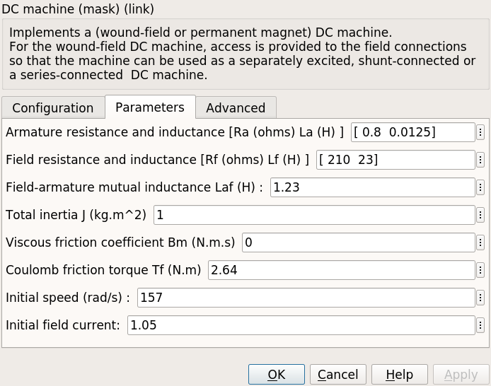

Figure 2: DC Motor Simulink Parameters

When modeled using Ea, Ra, and La, Ra and La are entered directly as shown in the datasheet, but back EMF Ea should be calculated based on the operating speed. Ea was calculated for rated load above, and is calculated for other load conditions in the following subsections, the results of which are summarized in Table 1. A terminal voltage of 175 V is chosen since the problem specifies that Vmax < 180 V, but lower voltages require higher current to get the same power output.

Table 2: Equivalent Ea for Various Load Conditions

| Load Condition | Vt (V) | Ea (V) | ωm (rad/s) | External  T (N-m) |
| --- | --- | --- | --- | --- |
| Starting | 175 | 0 | 0 | 283 |
| No Load | 175 | 171 | 133 | 2.6 |
| Kettle Load (1600 W) | 175 | 164 | 127 | 15.4 |
| Rated Load | 220 | 202 | 157 | 26.1 |

### Startup

At startup, ωm = 0, so Ea = 0.

Torque and current at startup will depend on how much voltage is applied. If full rated voltage were applied, startup current would be  
Ia = = 219 A  
T = 219 * 1.29 = 283 N-m

This is too much current and torque, so the applied voltage must be reduced for starting the motor. Either soft start algorithms can be developed or one can increase voltage gradually by controlling variac.

### No Load

The motor running at no load has only to output mechanical power equal to the friction of the running motor and coupled AC synchronous machine.

Neglecting voltage drop on the armature winding such that Ea = Vt, speed can be estimated as  
= = 136 rad/s

Based on the coefficient of friction calculated in the full load section above, the mechanical power at this speed can be estimated as  
2.65 N-m x 136 rad/s = 360 W

Estimating additionally that the connected synchronous maching has a similar amount of friction, the total "no load" load is estimated as 700 W.

At no-load, this friction loss will have the following circuit values:

Vt = 175 V  
Ia x Ea = 700 W ⇒ Ea =

= 175 V - Ia x (0.8 Ω)

700 W = (175 V) x Ia - Ia2 x (0.8 Ω)

0 = 0.8 x Ia2 – 175 x Ia + 700

Ia = = 4.1 A.

Ea = = 171 V

No-load speed can be calculated as

ωm = = = 133 rad/s.

This is 133/157 = 85% of rated speed.

The external torque to account for the synchronous generator friction is estimated as  
350 W / 133 rad/s = 2.6 N-m

### Kettle Load

For the “Robust Design” bonus, the motor must be run such that it supplies power to a 1600-W water kettle connected to the output of the synchronous machine coupled to the DC motor. Based on the additional friction load calculated for “no-load” operation, the total mechanical power for the kettle load is 2300 W.

The kettle load is calculated to have the following circuit values:

Vt = 175 V  
Ia x Ea = 2300 W ⇒ Ea =

= 175 V - Ia x (0.8 Ω)

2300 W = (175 V) x Ia – Ia2 x (0.8 Ω)

0 = 0.8 x Ia2 - 175 x Ia + 2300

Ia = = 14.0 A.

Ea = = 164 V

Speed can be calculated as

ωm = = = 127 rad/s.

This is = 81% of rated speed.

At ωm = 127 rad/s, the estimated 1950 W external mechanical load will have a torque of  
T = P/ωm = = 15.4 N-m. (6)

## Three-Phase Thryristor Rectifier Simulation

The three-phase thyristor rectifier was simulated in Simulink using the built-in thyristor blocks. The firing signal was provided by the power toolbox pulse generator. Since in some cases the load current is discontinuous, the double firing option had to be selected in the pulse generator in order to ensure that each thyristor was able to conduct through both pulses in its sequence.

In each load scenario, the firing angle α was adjusted to give an average output voltage of 175 V for the no-load and kettle load scenarios and 220 V for the full load scenario. For the load scenario of motor starting, a firing angle close to 90° was selected such that the motor current was around rated current or less.

Thyristors were modeled with typical data rather than as ideal switches. Thyristors were modeled with a forward voltage drop of 1.5 V and on-state resistance of 0.001 Ω.

Although there were several load scenarios simulated, a single Simulink model was created, and the parameters were adjusted by a script for each load condition. The common model for the three-phase thyristor rectifier simulations is shown in Figure 3.

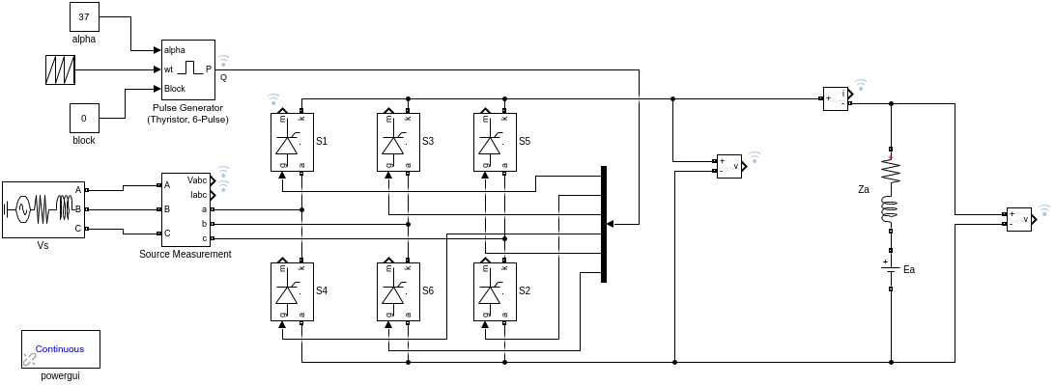

Figure 3: Three-Phase Thyristor Rectifier Simulink Model

Summary values of the simulation results are shown in Table 3 and Table 4.

Table 3: Three-Phase Thyristor Rectifier Simulation Summary (Input Side)

| Load | α | VIN (VRMS) | IIN (ARMS) | PIN  (W) | QIN  (var) | SIN  (VA) | PF | **IIN**  **THD (%)** |
| --- | --- | --- | --- | --- | --- | --- | --- | --- |
| Starting | 87 | 119.6 | 9.99 | 62.43 | 1193 | 1194 | 0.05 | 37.2 |
| No Load | 53 | 119.8 | 3.79 | 242.6 | 383.2 | 453.6 | 0.53 | 59.71 |
| Kettle Load | 50 | 119.3 | 11.39 | 823.2 | 1082 | 1360 | 0.61 | 33.02 |
| Rated Load | 36 | 118.9 | 18.53 | 1688 | 1416 | 2203 | 0.77 | 30.72 |

Table 4: Three-Phase Thyristor Rectifier Simulation Summary (Output Side)

| Load | VOUT (VAVG) | VOUT Ripple | IOUT (AAVG) | IOUT Ripple | POUT  (W) | **Efficiency (%)** |
| --- | --- | --- | --- | --- | --- | --- |
| Starting | 10.16 | 284.9 | 11.89 | 10.41 | 124.4 | 66.45 |
| No Load | 174.3 | 207.9 | 4.08 | 6.62 | 715 | 98.23 |
| Kettle Load | 175.5 | 218.5 | 13.72 | 8.27 | 2414 | 97.73 |
| Rated Load | 220.8 | 167.6 | 22.54 | 6.84 | 4978 | 98.31 |

Table 5 shows some key values that would be needed to select/size the thyristor for this circuit if more detailed design were to be carried out. Note that the power is conduction loss in each thyristor based on the typical forward voltage drop of 1.5 V and Ron of 1 mΩ that was used. If this topology were selected, for a more accurate simulation, the simulation could be repeated with parameters of the selected thyristor devices.

Table 5: Thyristor Key Values

| Load | Iavg  (A) | IRMS  (A) | Vmax Rev. | Vmax Fwd. | Ploss  (W) |
| --- | --- | --- | --- | --- | --- |
| Starting | 3.98 | 7.09 | 290.1 | 293.3 | 6.02 |
| No Load | 1.36 | 2.68 | 292.6 | 221.3 | 2.05 |
| Kettle Load | 4.56 | 8.00 | 292.1 | 225.4 | 6.9 |
| Rated Load | 7.48 | 12.98 | 292.5 | 173.8 | 11.38 |

The output voltage and current waveforms for the various load scenarios are shown in Figure 4.

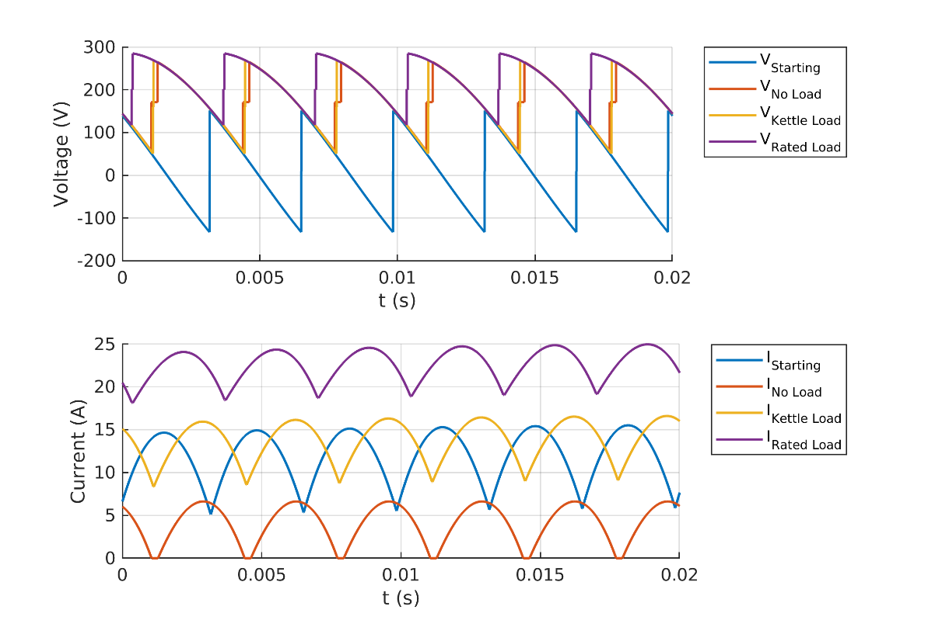

Figure 4: Three-Phase Thyristor Rectifier Simulated Waveforms

## Three-Phase Diode Rectifier + Buck Converter Simulation

The second circuit type that was simulated was a three-phase diode rectifier with buck converter on the DC side. The converter was modeled with a switching speed of 10 kHz. A DC-side filter capacitor of 1000 μF was included. The buck converter L was selected as 0.1 mH and C was selected as 100 μF. These values were chosen to give reasonably good ripple on the DC bus and the output. If this topology were selected, these values would require further investigation and refinement.

Diodes were modeled with typical voltage drop of 0.8 V while the MOSFET was modeled with typical on-state resistance of 0.1 Ω. Equivalent series resistance was neglected for capacitors and the inductor in the circuit.

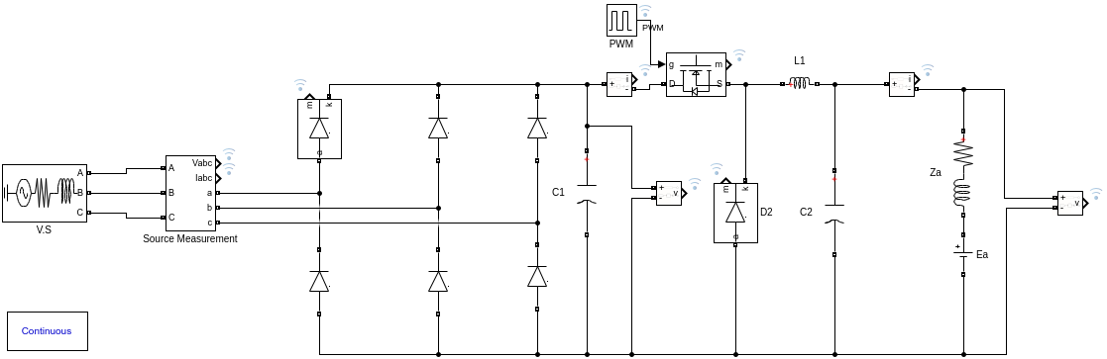

Figure 5: Buck Converter Simulink Model

For each load condition, the MOSFET duty cycle was adjusted to give an average output voltage appropriate to the load condition. For the motor start, this was set to a small duty cycle to obtain current near or less than the rated current of the motor. For no load and kettle load conditions, the output voltage was adjusted to 175 V, and for the rated load case, the output voltage was adjusted to 220 V.

Summary values of the simulation results are shown in Tables 6, 7, and 8.

Table 6: Buck Converter Simulation Summary (Input Side)

| Load | D | VIN (VRMS) | IIN (ARMS) | PIN  (W) | QIN  (var) | SIN  (VA) | PF | **IIN**  **THD (%)** |
| --- | --- | --- | --- | --- | --- | --- | --- | --- |
| Starting | 4 | 120 | 0.88 | 51.25 | 91.86 | 105.2 | 0.49 | 178.4 |
| No Load | 25 | 119.9 | 4.7 | 339.8 | 449.6 | 563.6 | 0.6 | 130.8 |
| Kettle Load | 41 | 119.6 | 11.14 | 887.1 | 994.5 | 1333 | 0.67 | 110.2 |
| Rated Load | 75 | 119.3 | 19.78 | 1673 | 1664 | 2360 | 0.71 | 96.94 |

Table 7: Buck Converter Simulation Summary (DC Bus)

| Load | VD  (VAVG) | VD Ripple | ID,OUT (AAVG) | ID,OUT Ripple | PD,OUT  (W) |
| --- | --- | --- | --- | --- | --- |
| Starting | 290.5 | 1.32 | 0.53 | 19.68 | 153 |
| No Load | 288.2 | 7.07 | 3.52 | 28.87 | 1013 |
| Kettle Load | 285.9 | 15.73 | 9.25 | 47.58 | 2645 |
| Rated Load | 283.3 | 24.51 | 17.59 | 51.91 | 4991 |

Table 8: Buck Converter Simulation Summary (Output Side)

| Load | VOUT  (VAVG) | VOUT Ripple | IOUT (AAVG) | IOUT Ripple | POUT  (W) | **Efficiency (%)** |
| --- | --- | --- | --- | --- | --- | --- |
| Starting | 10.79 | 2.31 | 13.17 | 0.41 | 142.1 | 92.43 |
| No Load | 175.6 | 3.18 | 5.72 | 0.08 | 1005 | 98.57 |
| Kettle Load | 175.9 | 10.12 | 14.86 | 0.29 | 2613 | 98.18 |
| Rated Load | 219.9 | 21.35 | 22.42 | 0.78 | 4932 | 98.24 |

If we were designing the buck converter in detail, the key simulation values for each component could be examined, but as there are several components in the model and the purpose of these simulations was general comparison of the topologies, the detailed tabulation of component voltages & currents is not presented in this report.

The output voltage and current waveforms for the various load scenarios are shown in Figure 4.

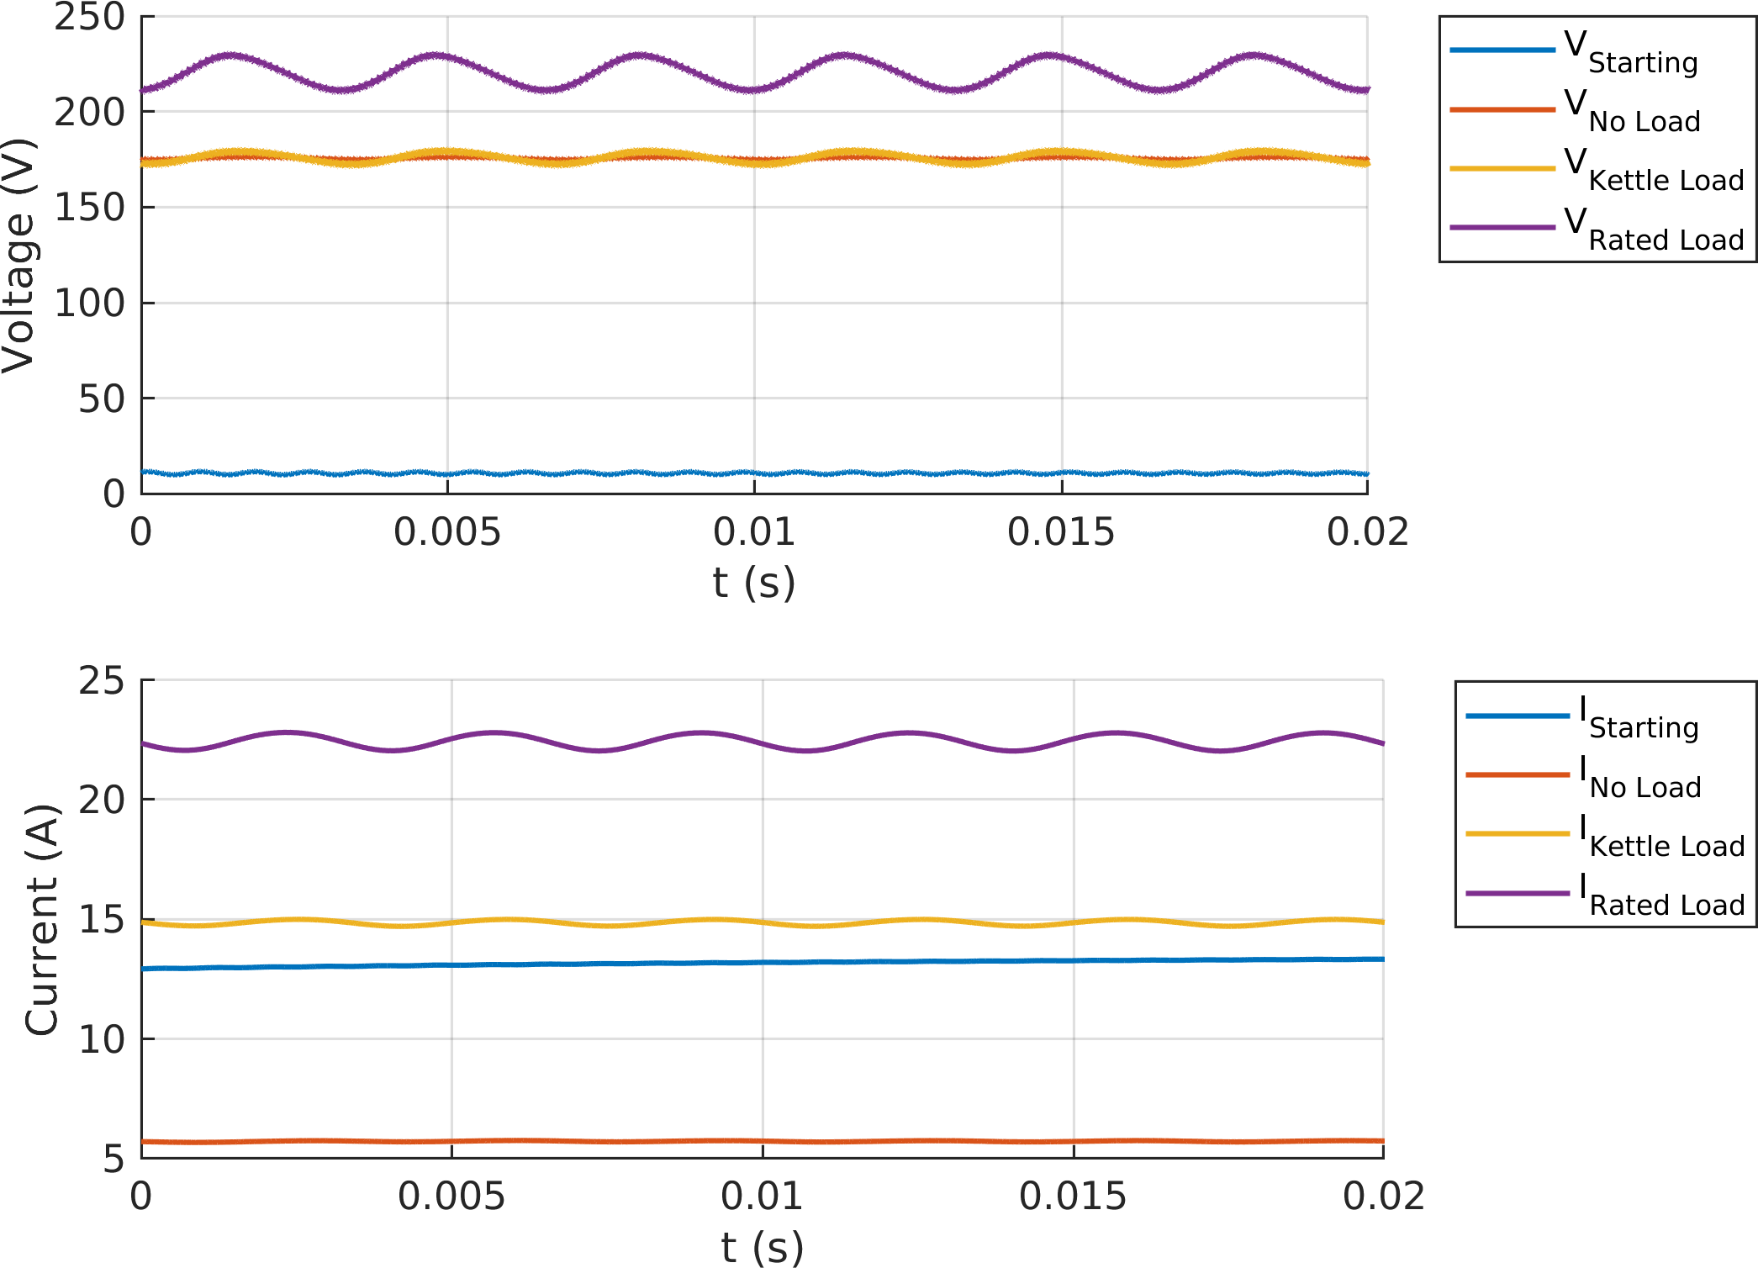

Figure 6: Buck Converter Simulated Waveforms

In Figure 6, we can see how the ripple on the DC bus shows up in the output voltage even though the MOSFET is switching at a much higher speed. This is because the model is using a fixed duty cycle, without any feedback or feedforward to regulate the output voltage. With an adaptive duty cycle control, the output voltage could be regulated much closer to a desired setpoint even though the intermediate DC bus has significant ripple, especially at high load currents.

## TRIAC AC Chopper + Diode Bridge Rectifier

The last topology that was considered is a simple triac AC chopper circuit connected to the DC motor through a diode bridge. This topology was not presented in class, but when asked about how to generate the gate signals for a thyristor rectifier, he suggested that we could use triac and diac components and recommended basic driver circuits. After some research on possible thyristor driver circuits, we found a circuit in the Littlefuse “Phase Control Using Thyristors” Application Note AN1003 that we thought could possibly work for this project. The circuit as shown in the application note is reproduced in Figure 7.

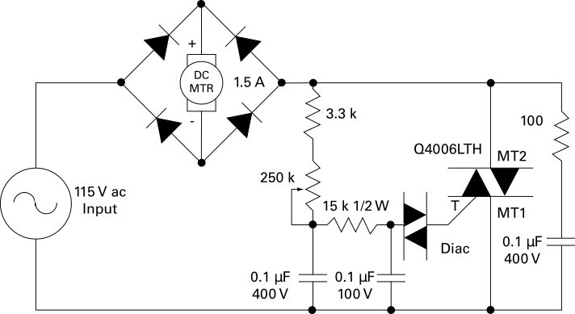

Figure 7: TRIAC DC Motor Control Circuit

Simulating this circuit is complicated in Simulink by the fact that Simulink does not have any triac or diac models in the toolbox. In order to implement the circuit in Simulink, a triac model was developed by placing two thyristors in parallel but with opposite polarity and connecting the firing signals together. The input resistance of the triac gate was modeled with a resistance of 1 kΩ since that gives a gate current pulse of 10-20 mA when the diac fires and seems to be in the right order of magnitude.

A Simulink diac model was created by making the same counter-parallel connection as was done for the triac and then creating logic in the firing circuit such that the diac fires when the voltage across the device exceeds its characteristic turn-on voltage.

Figure 8 shows the full triac-based Simulink model.

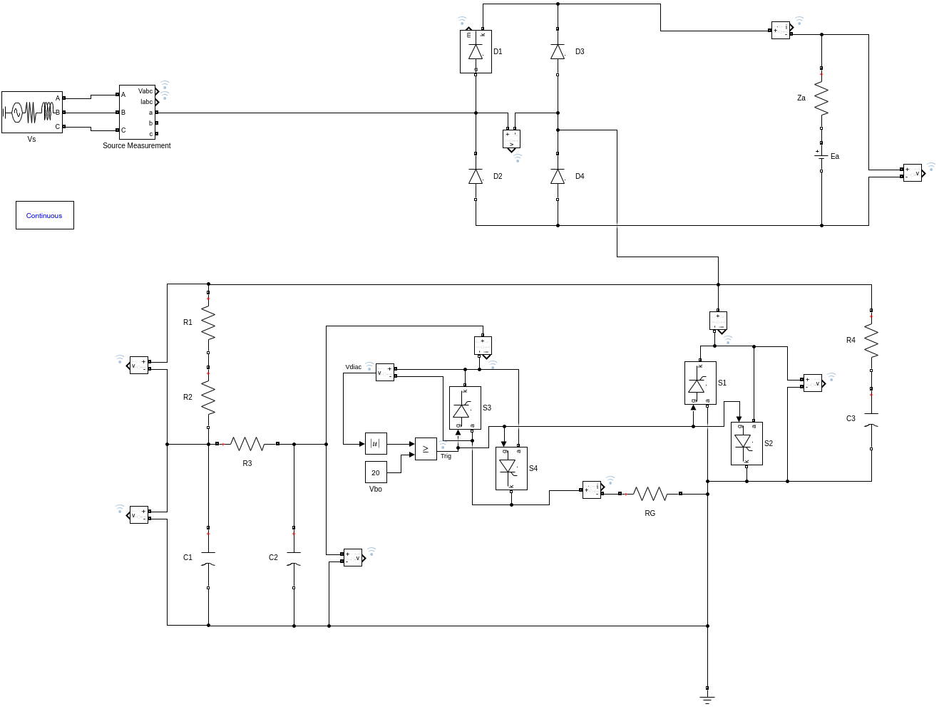

Figure 8: Triac-Diac Simulink Model

### Small Resistive Load

In order to test that the circuit works as expected and see the range of control of the triac, the model was first tested using relatively small resistive load of 100 Ω on the rectifier output. The resistance of R2, representing the control potentiometer, was varied and the output voltage and current waveforms recorded. Results of these simulations are shown in Figure 9.

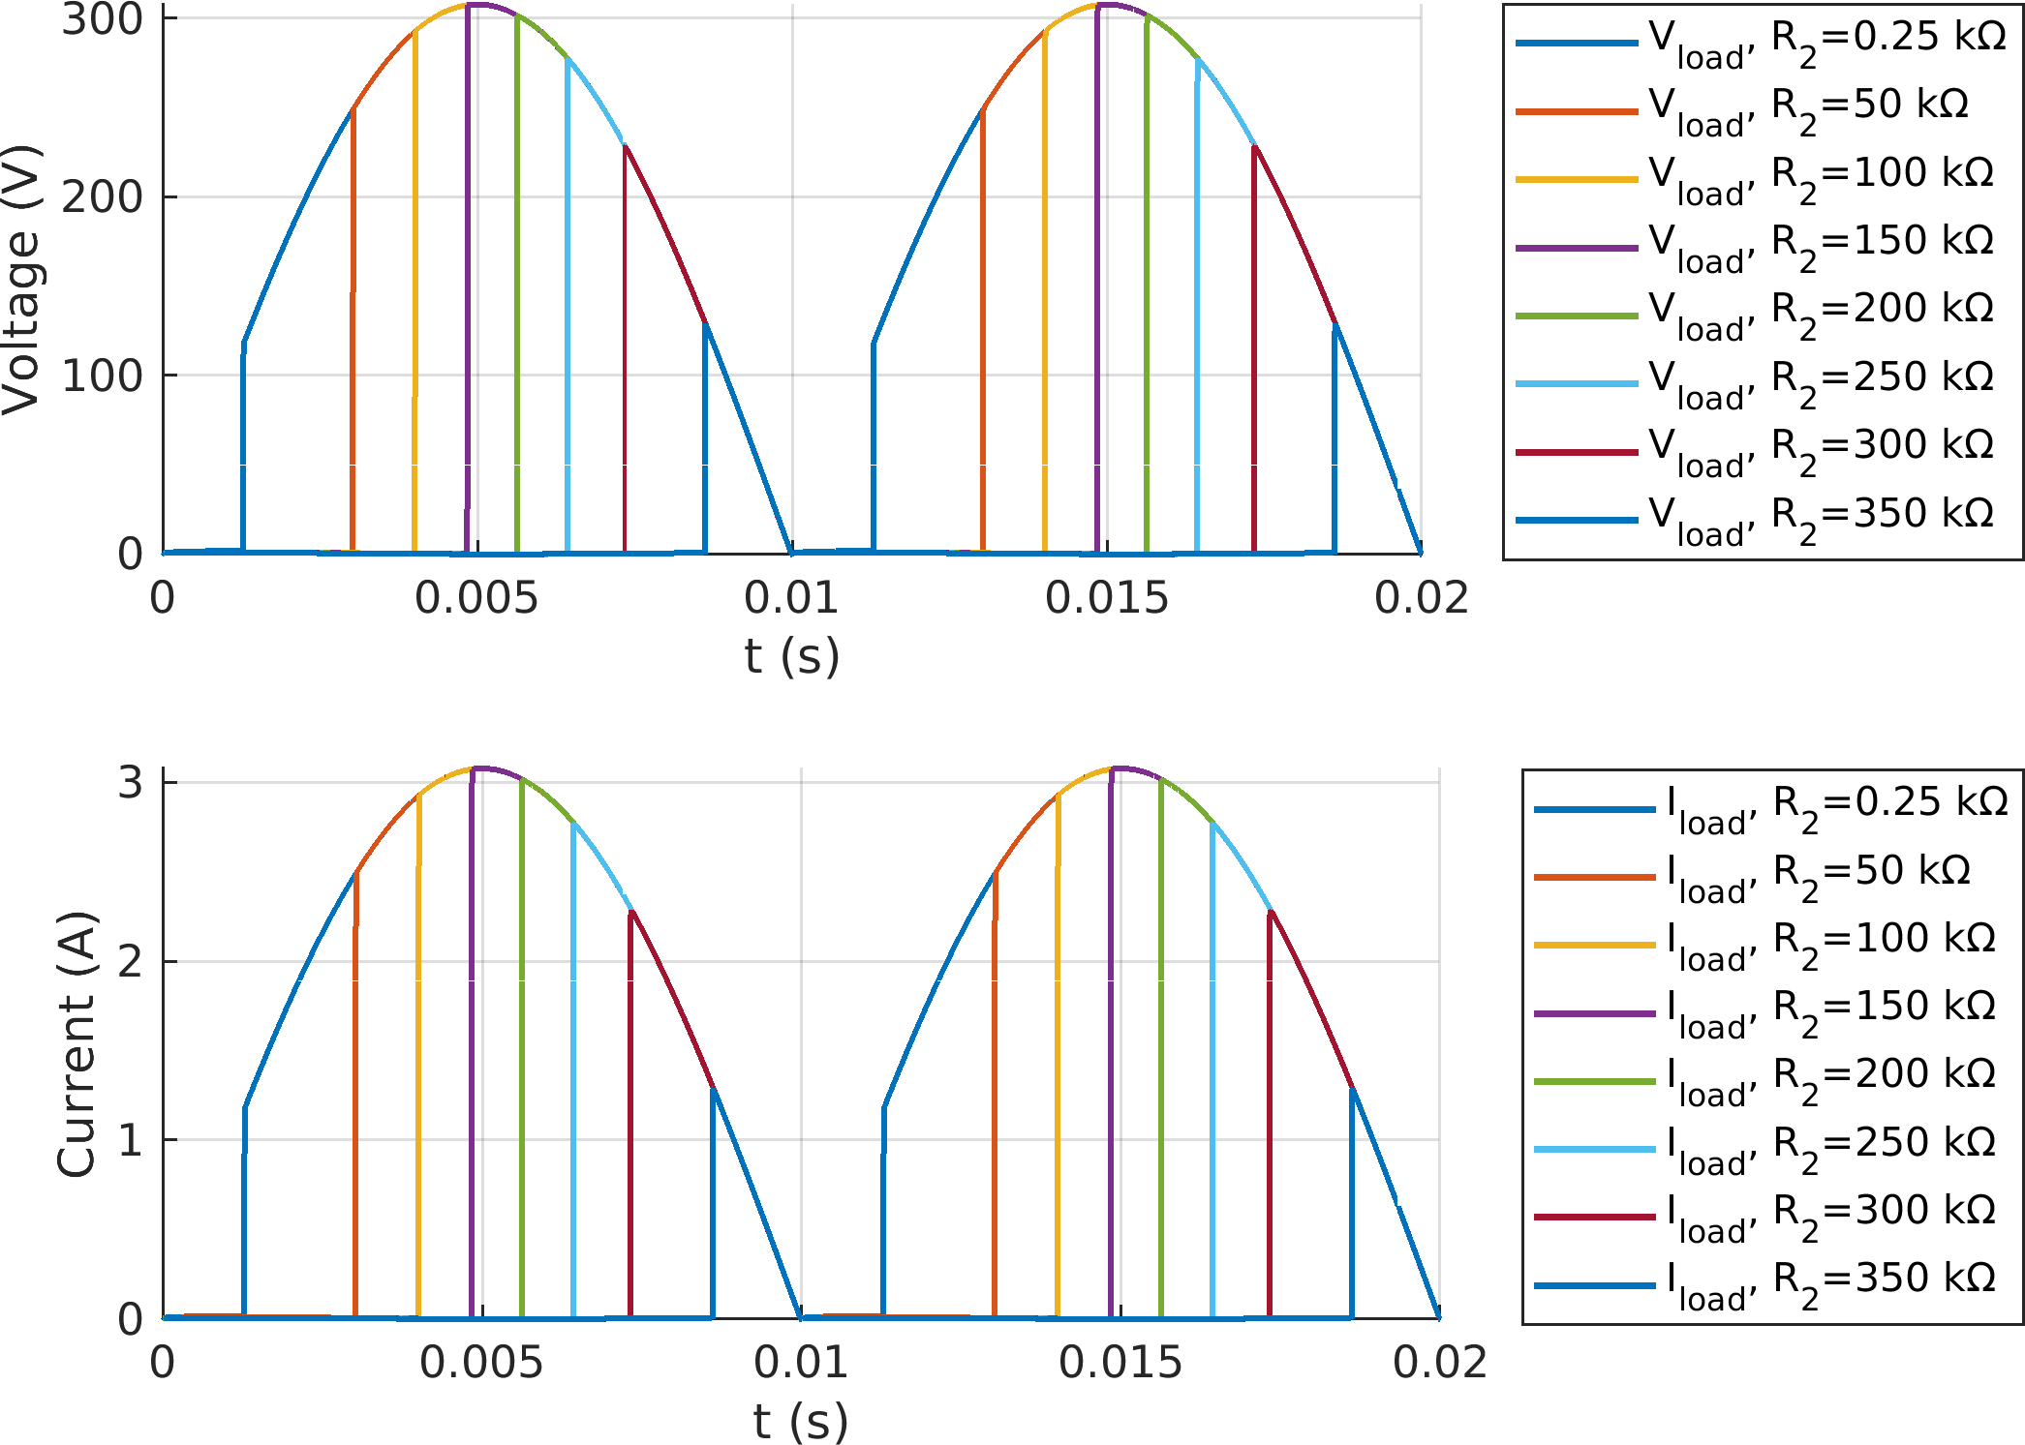

Figure 9: Triac-Diac Simulink Results with Small Resistive Load

As can be seen from Figure 9, the diac firing circuit is limited in its ability to fire at angles near 0° and near 90°. We think that this is probably owing to the inclusion of series resistor R1 that prevents the capacitors from being short-circuited if the potentiometer is adjusted to its minimum position.

### DC Motor Load

Once the circuit was simulated using the small resistive load and was giving reasonable results, we passed to simulations using the equivalent circuit for the DC motor as we did for the other topologies. For each load condition, the R2 resistance was adjusted to give an average output voltage appropriate to the load condition. For the motor start, this was set to obtain current near or less than the rated current of the motor. For no load and kettle load conditions, the output voltage was adjusted to 175 V. In this case, the rated motor load was not simulated since a phase-to-neutral supply voltage of 220 V was not sufficient to obtain an output voltage of 220 VDC. Since the problem statement restricts the output voltage to less than 180 VDC anyway, the rated load simulation is not essential to the project.

Figure 10 shows the output voltage and current waveforms for the simulations of the triac-based control model.

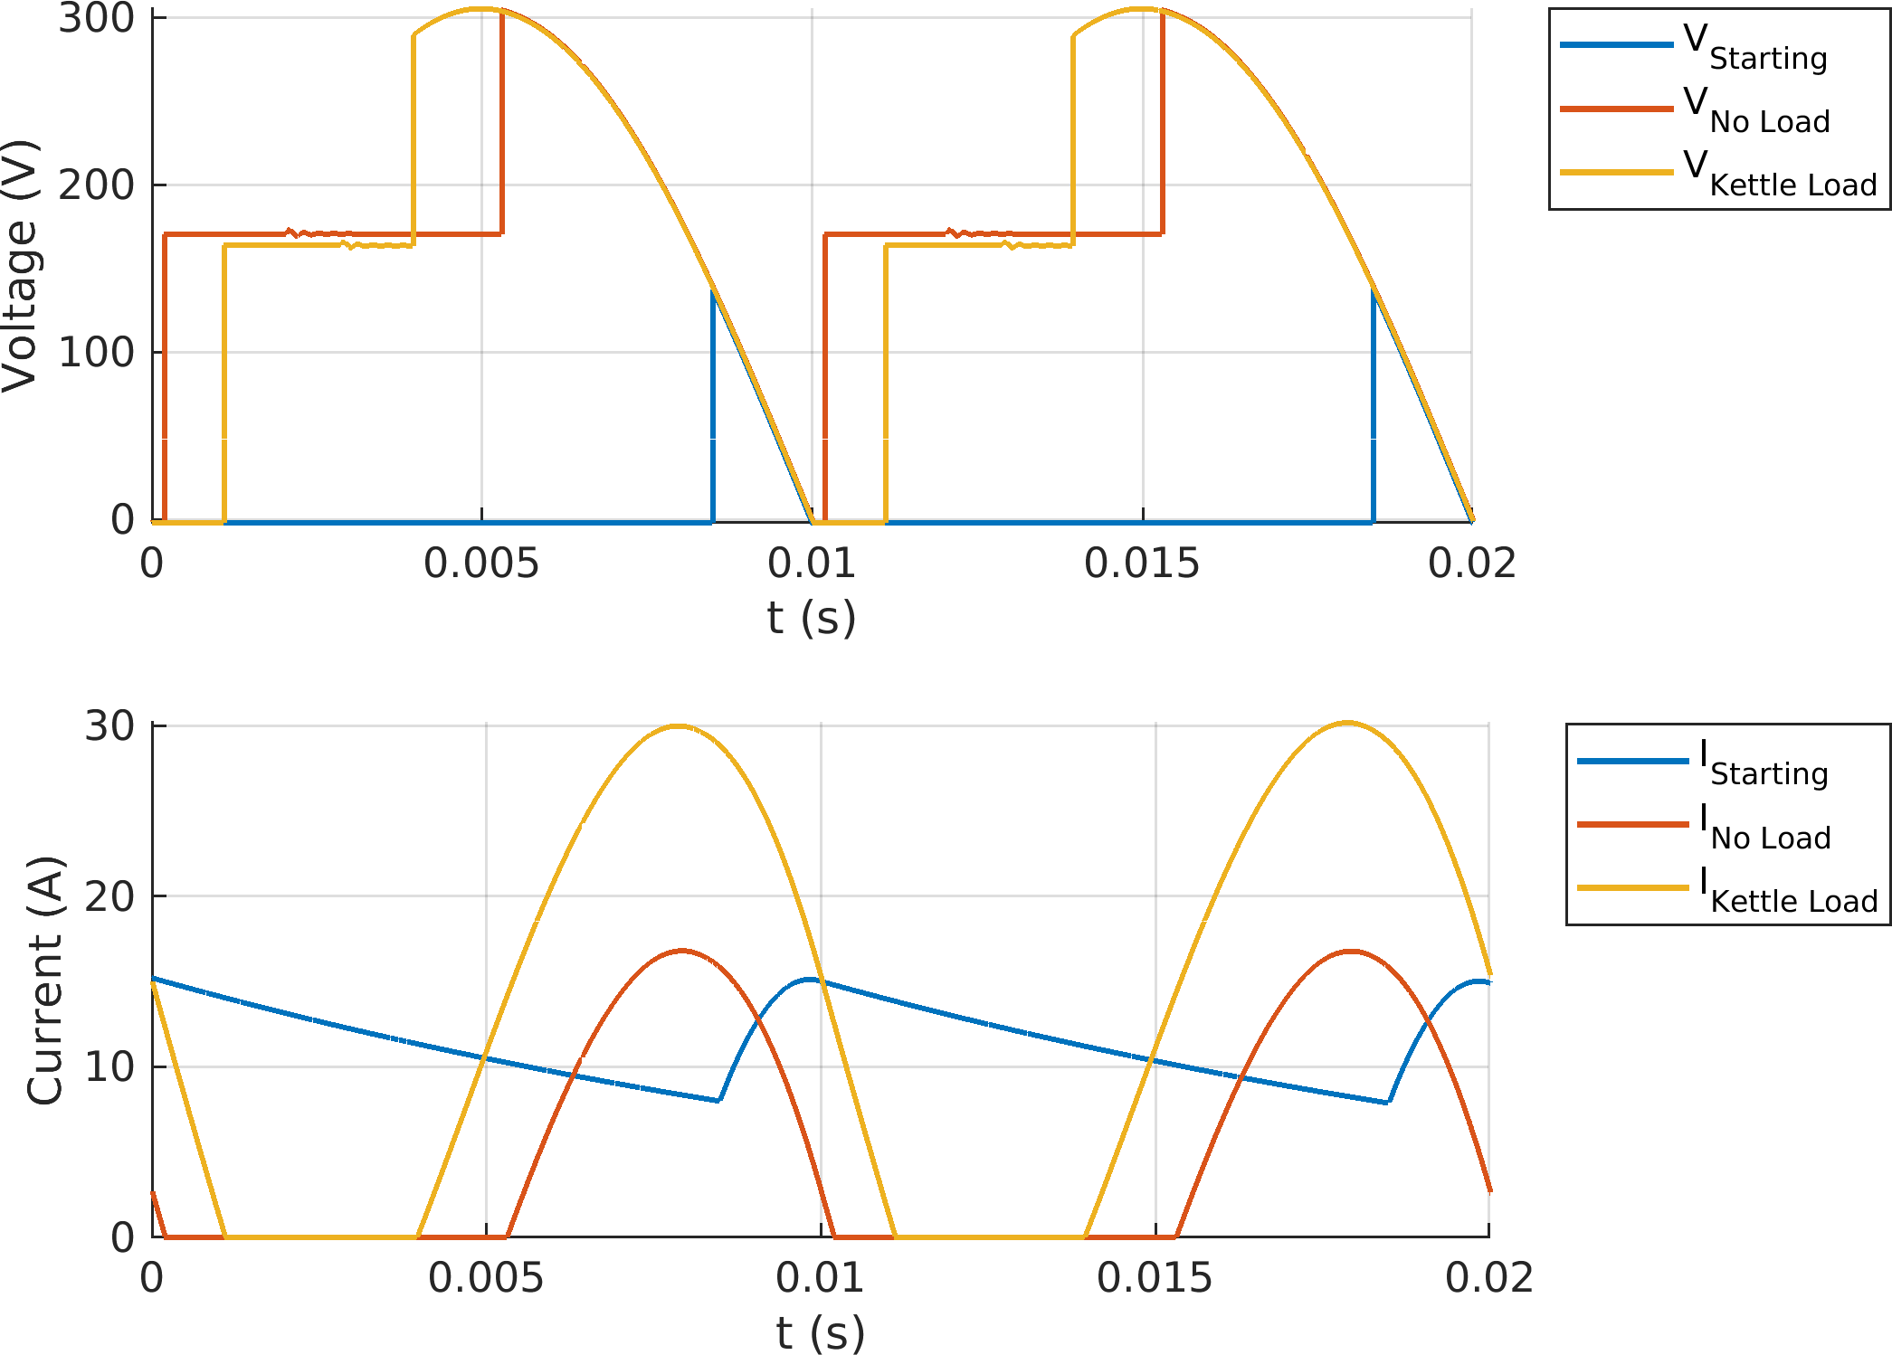

Figure 10: Triac-Diac Simulation Output Waveforms

In Figure 10, we can see that the output current is continuous only for the starting case. In the other two load cases, current was discontinuous. This is largely due to the use of a single-phase AC voltage source rather than three-phase.

Add tables with input, output, and important device values.

# Topology Comparison and Selection

1. Each of the topologies considered will be discussed briefly.

## Three-Phase Thyristor Rectifier

1. This circuit offers us higher output average voltage and less ripple compared to the other alternatives without using parallel output capacitor. However, it requires six thyristor and required gate signal driver circuits. As we can see from the table 3, in order to arrange the feedback and behavior of circuit, we need to change the firing angle of thyristor. In addition, number of thyristor is more than our chosen topology. This effects the size and cost of the project. As a result, in order to work toward compactness and simplicity bonuses, this topology was judged as not appropriate.

## Rectifier + Buck Converter

1. This circuit offers us a simpler way to finish the project compared to the three-phase thyristor rectifier. However, it requires six diodes and a buck convertor part. Similar to our opinion for the three-phase thyristor rectifier, in order to work toward compactness and simplicity bonuses, this topology was judged as not appropriate.

## Single-Phase Thyristor Rectifier

1. This circuit offers us more simple way compared to the three-phase thyristor rectifier. However, it has less output voltage and more ripple comparing to a three-phase rectifier. Again, in this topology, we need to drive four thyristor in synchronism with each other. The gains in eliminating two thyristor to drive still did not achieve the level of simplicity that we desired.

## Chosen Topology: Single-Phase Diac-Controlled Triac rectifer

1. 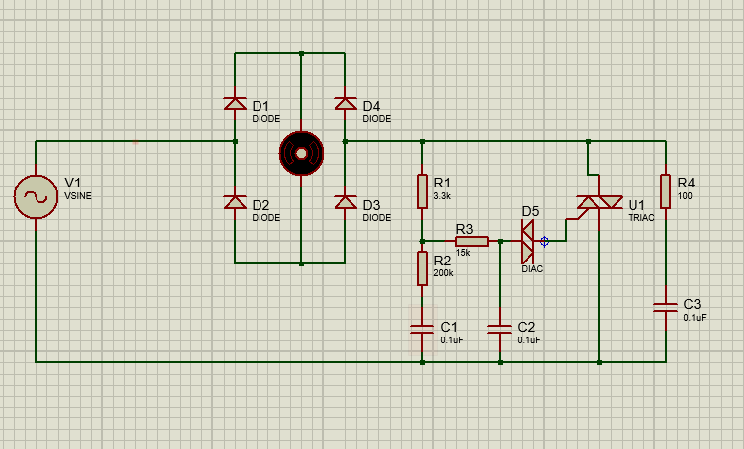
2. Figure X. Circuit Schematic of Triac- Diac circuit

The single-phase diac-controlled triac rectifier has several advantages for which we selected it. The primary advantage is its simplicity. There is a single controlled element, the triac, for which a gate signal is required. The diac can be used to control the triac by adjusting the value of the variable resistor in the circuit. Because the control circuit is powered from the mains voltage, no additional power supply or regulation is needed for the control circuit as it would be in other configurations.

One disadvantage of this topology is that it is not easily adapted to any type of feedback control. It is also limited to single-quadrant operation by the diode bridge that supplies the DC motor load.

If we are successful in implementing a working circuit using the diac for controlling the triac, we could explore other, more flexible methods for control that would allow feedback control, especially to limit current during motor start-up.

# Component Selection

# Project Planning

# Conclusions