Introduction

This report presents the designing a rectifier circuit that will be used to operate a DC motor in 3 possible alternatives ways such that single or three phase thyristor rectifier or diode rectifier with buck convertor.

Design Alternatives

3- phase Thyristor Rectifier

This circuit offers us a more output average voltage and less ripple comparing to the other alternatives. However, it requires 6 thyristors and required gate signal driver circuit. Due to achive compactness and simplicity bonus, this topology is not apprapiate.

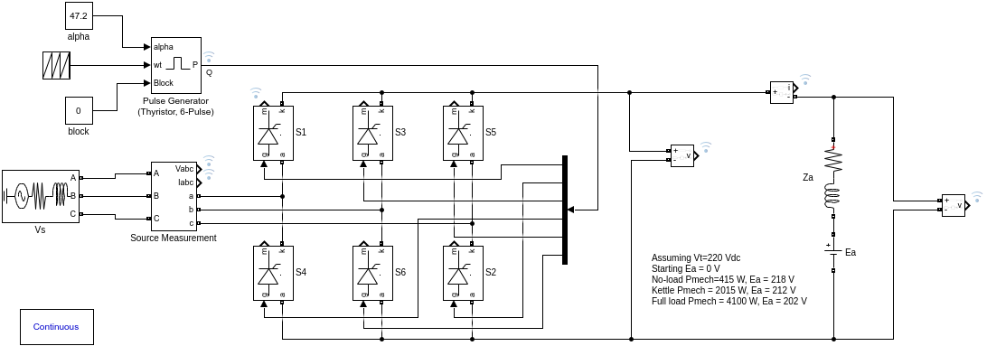

Diode Rectifier + Buck Convertor

This circuit offers us a more simple way to finish the project. However, it requires 6 diode and a buck convertor part. Due to achieve, compactness bonus and this topology is not apporiapiate.

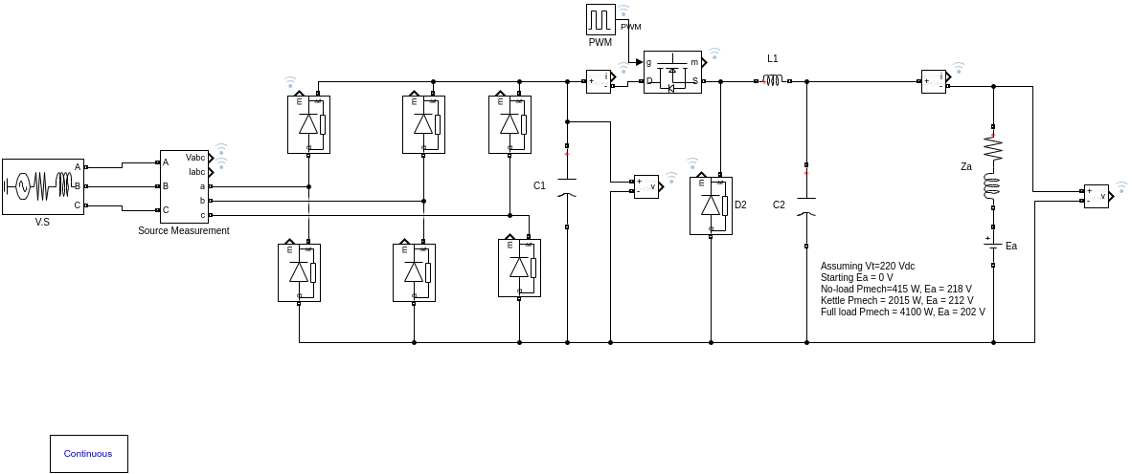

1-phase Thyristor Rectifier

This circuit offers us more simple way comparing to 3 phase thyristor rectifier . However, it has less output voltage and more ripple comparing to first one. Again, it this topology, we need to drive 4 thyristor in syncnyrhous wtih each other. Due to simplicity and compacnett bonus, this topology is not apporiapate.

Chosen Topology

1 phase Diac –triac controlled diode rectifer

