Data Analysis Portfolio

EXPLANATORY DATA ANALYSIS OF E-Commerce

1. Change Over Time Trends
- How have monthly sales revenue and order volume changed over the past year?
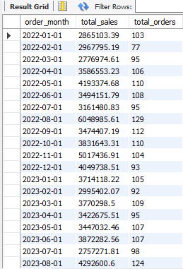

- How has the number of new customer registrations changed each month?
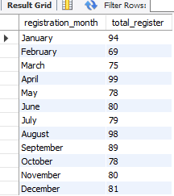
- How has the monthly return rate changed over time?

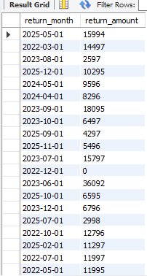

- How have shipping delays trended by month?
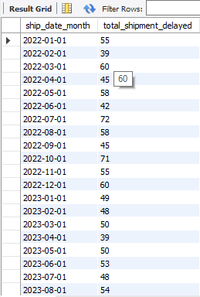

- How has the average order value changed each quarter?

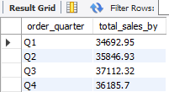

2. Cumulative Analysis
- What is the cumulative sales revenue over time?

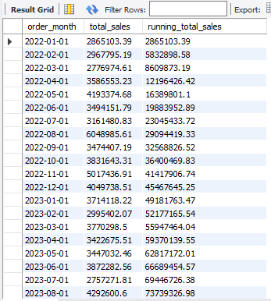

- How many customers have registered cumulatively each month?
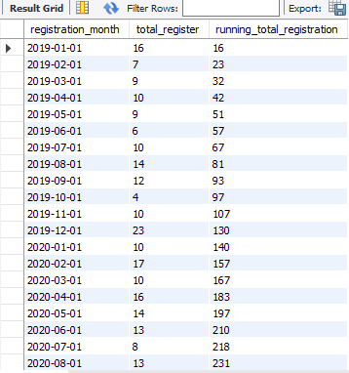

- What is the cumulative number of orders processed throughout the year?
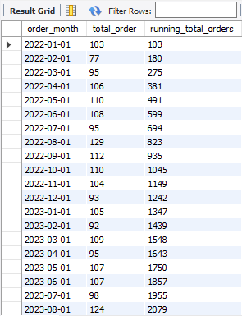
- What is the cumulative refund amount due to returned products?
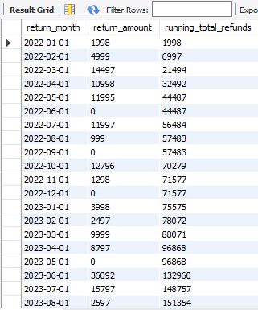

- How has cumulative shipping cost increased over time?
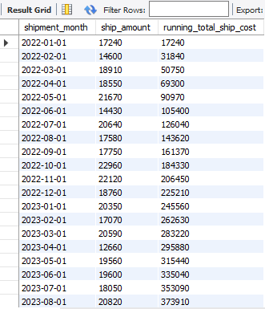

3. Performance Analysis
- Which products generate the highest sales and profit?

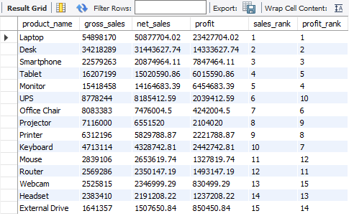

- Which employees process the most orders and generate the highest revenue?

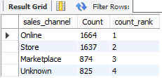

- Which sales channels (Online, Store, etc.) perform best?

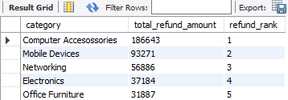

- Which shipping carriers have the best on-time delivery performance?
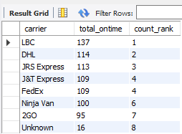

4. Part-to-Whole Analysis
- What percentage of total revenue comes from each product category?

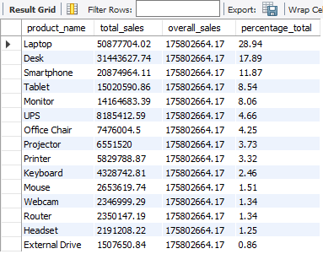

- What share of total orders comes from each sales channel?
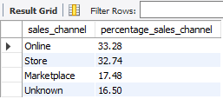

- What proportion of refunds comes from each return reason?

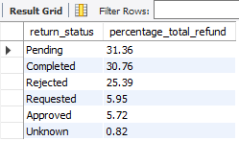
- What percentage of total shipping cost is contributed by each carrier?

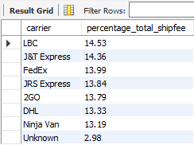

5. Data Segmentation
- Segment customers by customer type and compare their spending behavior.
- Segment customers by region to identify high-performing locations.
- Segment products by category to compare sales and return rates.
- Segment employees by department to compare sales performance.
- Segment orders by payment method to identify purchasing patterns.

