Data Analysis Portfolio

EXPLANATORY DATA ANALYSIS OF HEALTHCARE

# | Category | Analysis Question
1 | Change Over Time | How has monthly patient visit volume changed?  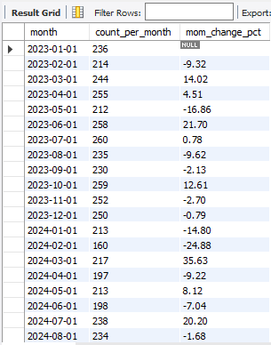
2 | Change Over Time | How has monthly healthcare revenue changed?  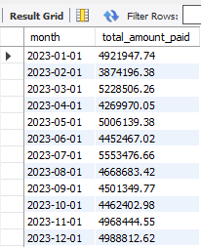
3 | Change Over Time | How have diagnoses changed over time?  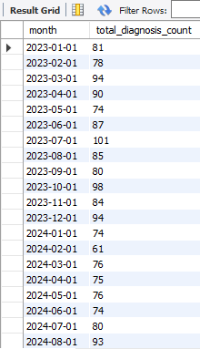
4 | Change Over Time | How has prescription activity changed?  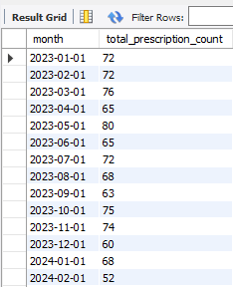
5 | Change Over Time | How have visit statuses changed over time?  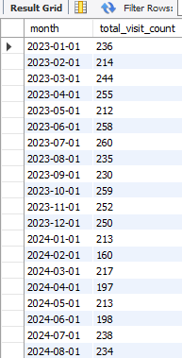
6 | Cumulative | What is the cumulative healthcare revenue?  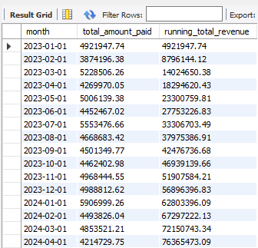
7 | Cumulative | What is the cumulative amount collected?  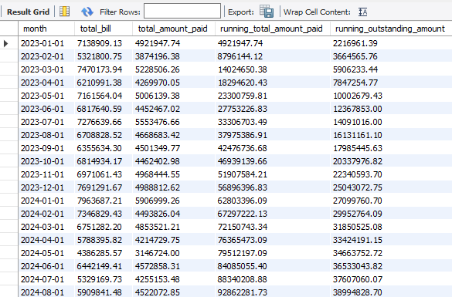
8 | Cumulative | What is the cumulative number of patient visits?  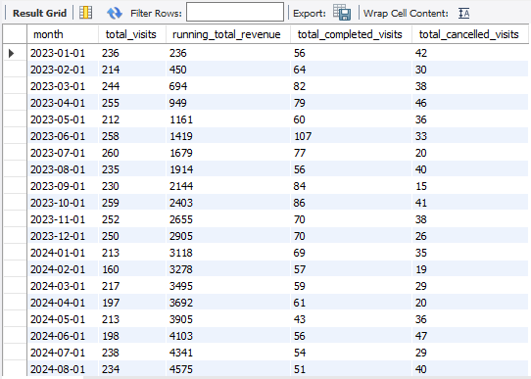
9 | Cumulative | What is the cumulative number of diagnoses?  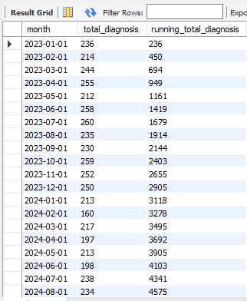
10 | Cumulative | What is the cumulative number of prescriptions?  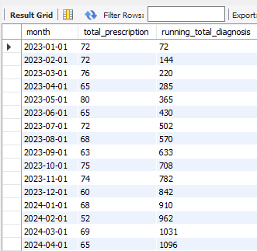
11 | Performance | How does physician performance compare?  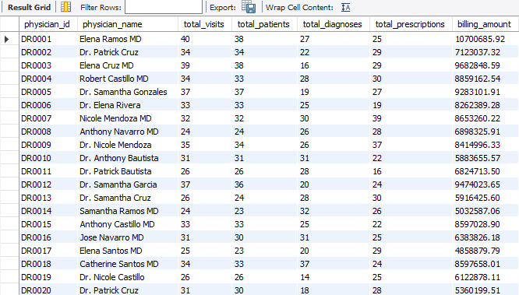
12 | Performance | How does department performance compare?  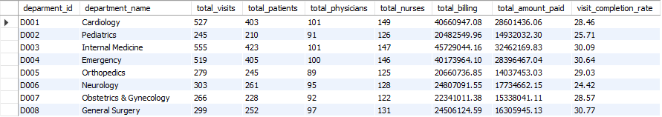
13 | Performance | How is nurse workload distributed?  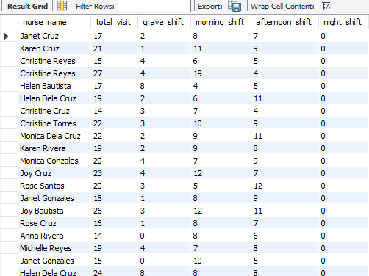
14 | Performance | How effective is payment collection?  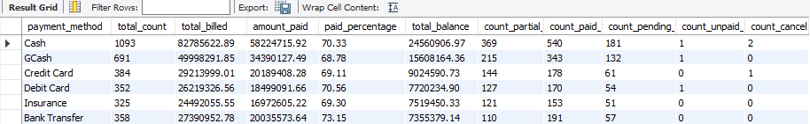
15 | Part-to-Whole | What is each department's revenue contribution?  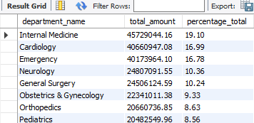
16 | Part-to-Whole | What is each department's visit contribution?  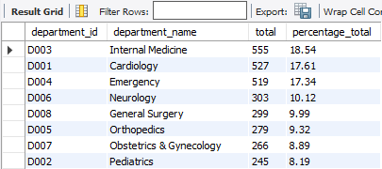
17 | Part-to-Whole | What is each charge type's revenue contribution?  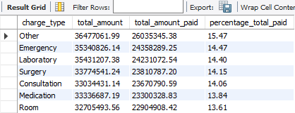
18 | Part-to-Whole | What is the distribution of diagnosis severity?  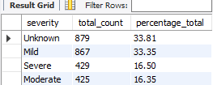
19 | Part-to-Whole | What is each medication's prescription contribution?  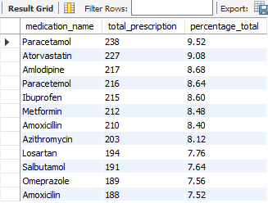
20 | Segmentation | How do patients differ by age group?  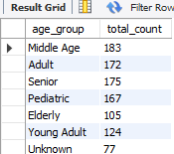
21 | Segmentation | How do patients differ by visit frequency?  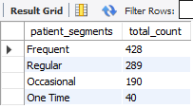
22 | Segmentation | How do patients differ by healthcare spending?  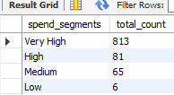
23 | Segmentation | How can physicians be segmented by workload?  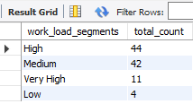
24 | Segmentation | How does patient traffic differ by time of day?  