Creating a Hugging Face Account

Here are simplified steps to create an account on Hugging Face and access your tokens:

Step 1: Go to the Hugging Face website by typing huggingface in your web browser's search bar or directly entering https://huggingface.co/

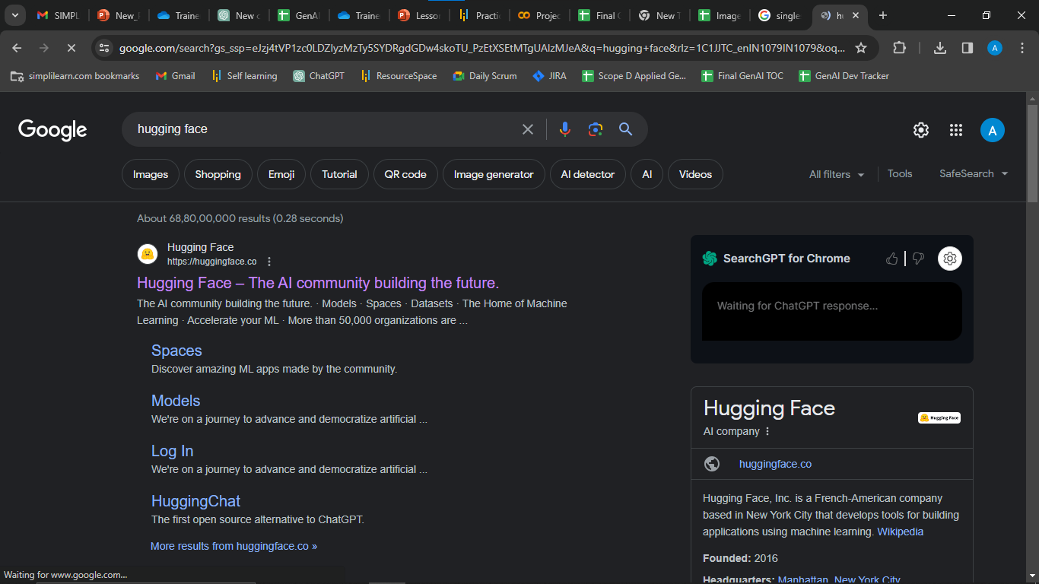

Step 2: Look for a Sign Up button on the website's homepage and click on it

Step 3: You'll be prompted to enter your details. This usually includes your email address, username, and password. Fill in the required fields.

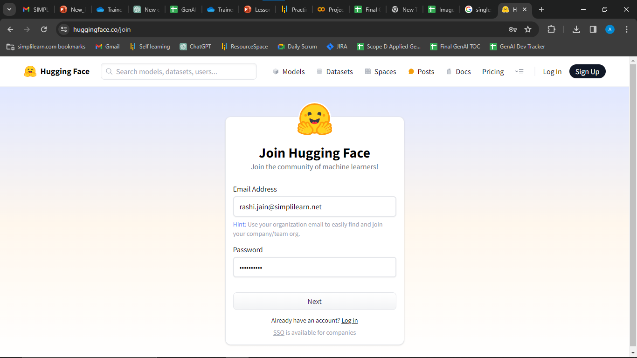

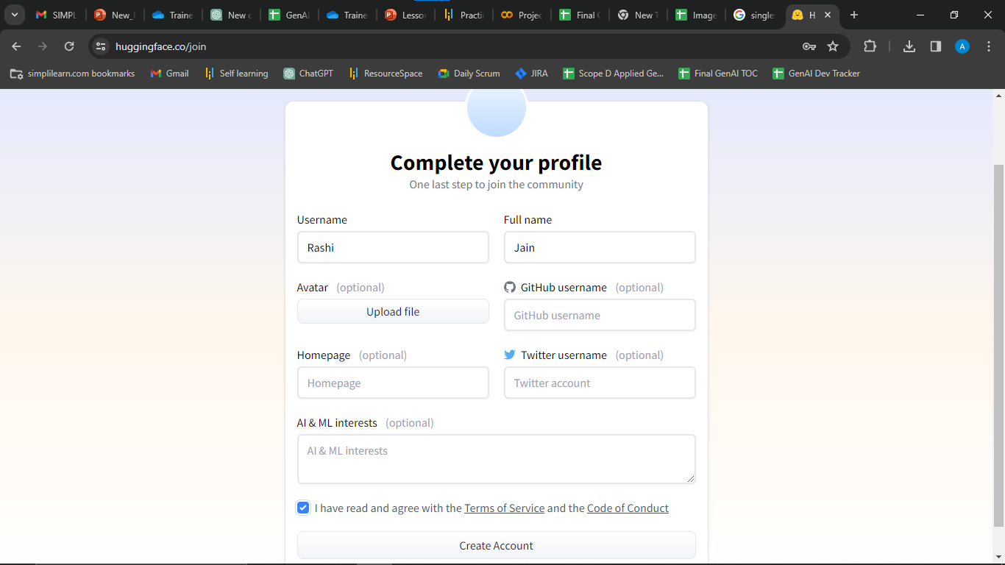

Step 4: After submitting your information, you may need to verify your email address. Check your email for a verification message from Hugging Face and follow the instructions.
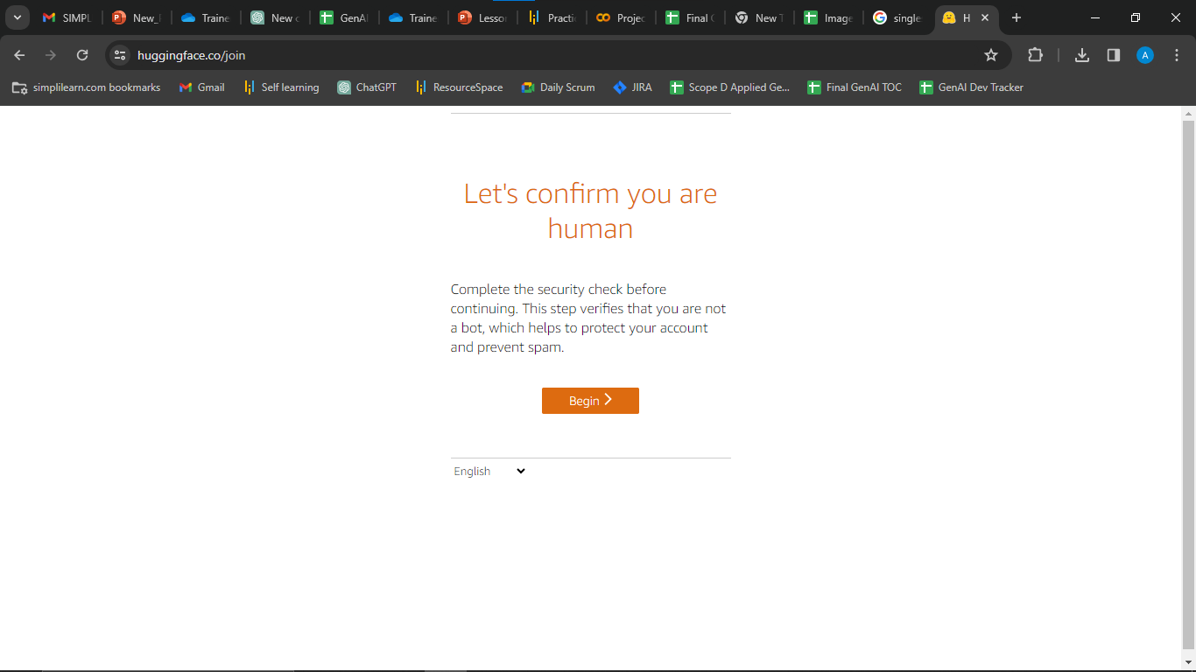

Once your email is verified, go back to the Hugging Face website and log in using your newly created username and password.

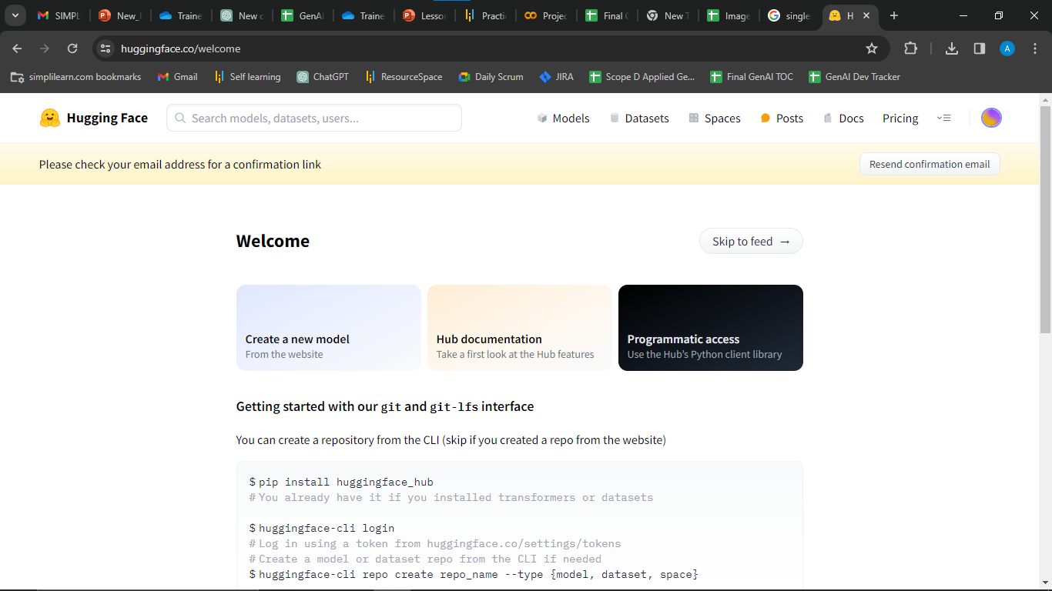

Step 5: After logging in, you should be directed to your Hugging Face dashboard. If not, find a Dashboard or Settings section on the website.
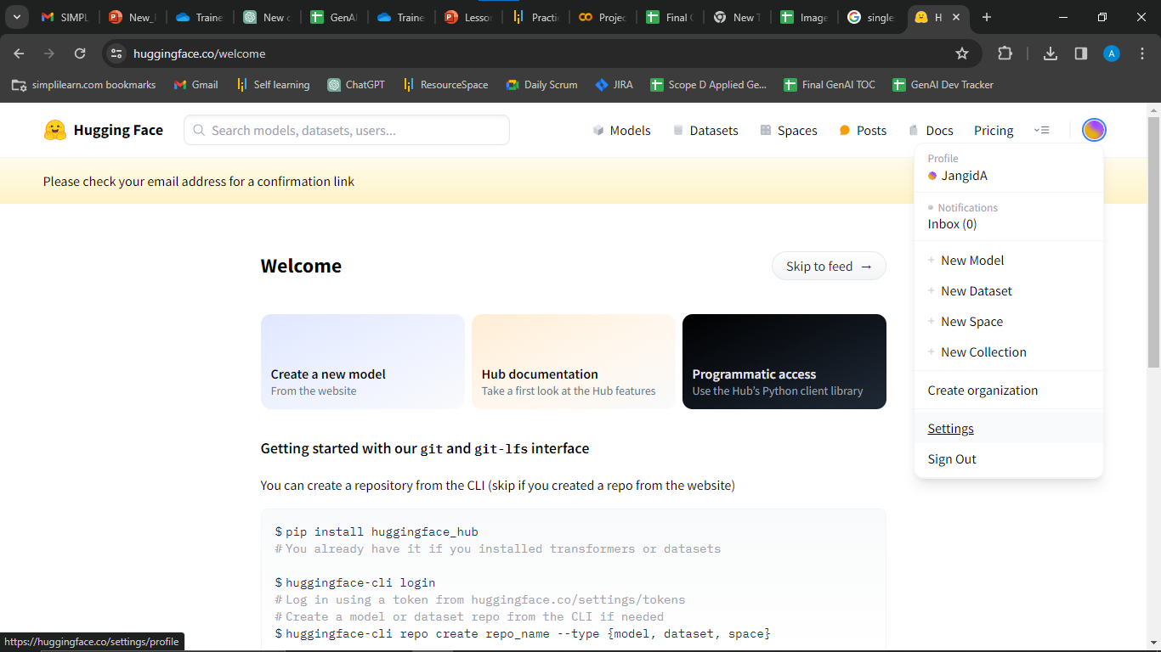

Step 6: Look for a section related to Access Tokens or Account Settings. This is where you can manage your access tokens.
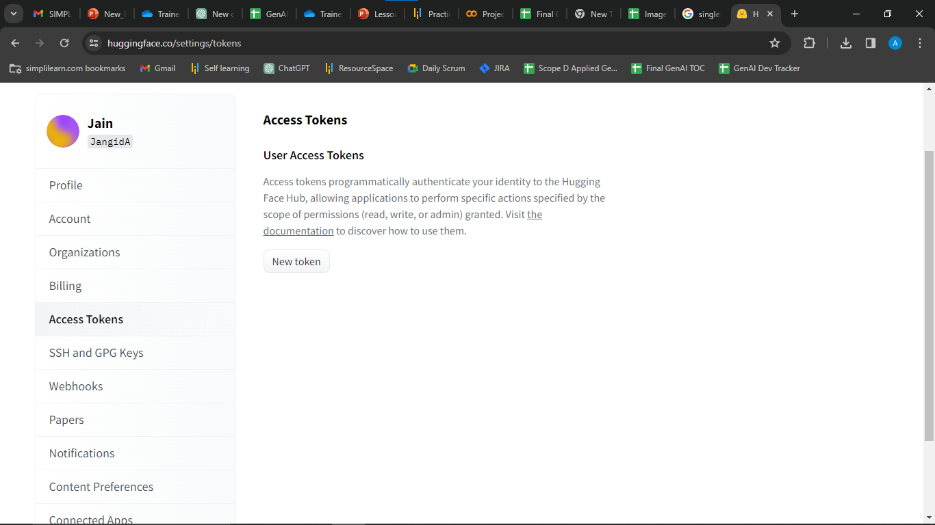

Step 7: There should be an option to create a new access token. Click on it. You may need to provide some additional information or confirm your identity. You can set the Role as read or write as required.
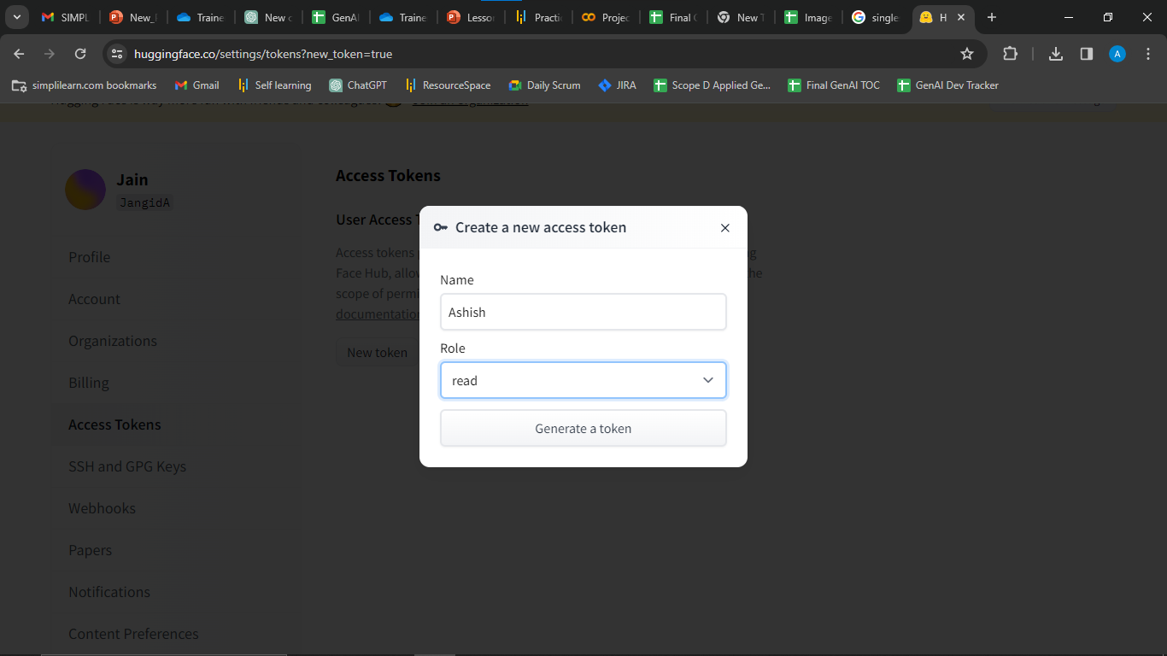

Step 8: Once the token is generated, you'll likely see it displayed on your screen. Copy the token to your clipboard.
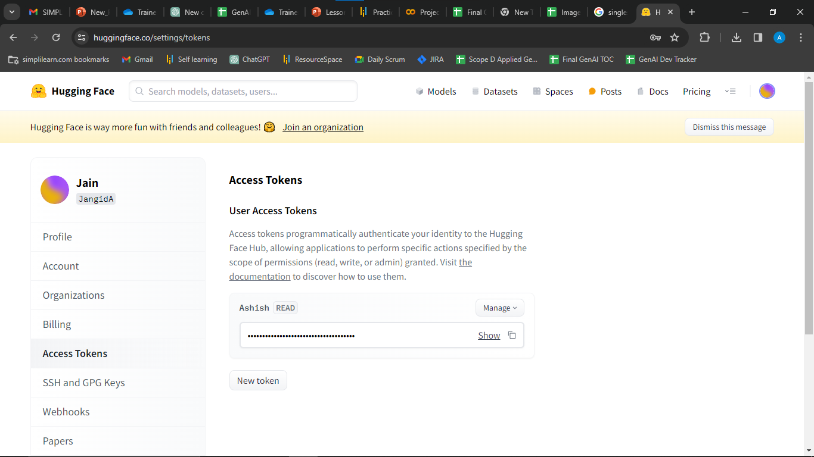

Treat your access token like a password. Keep it secure and avoid sharing it publicly. It's your key to access Hugging Face's API.
Insert the token you copied into your file.

