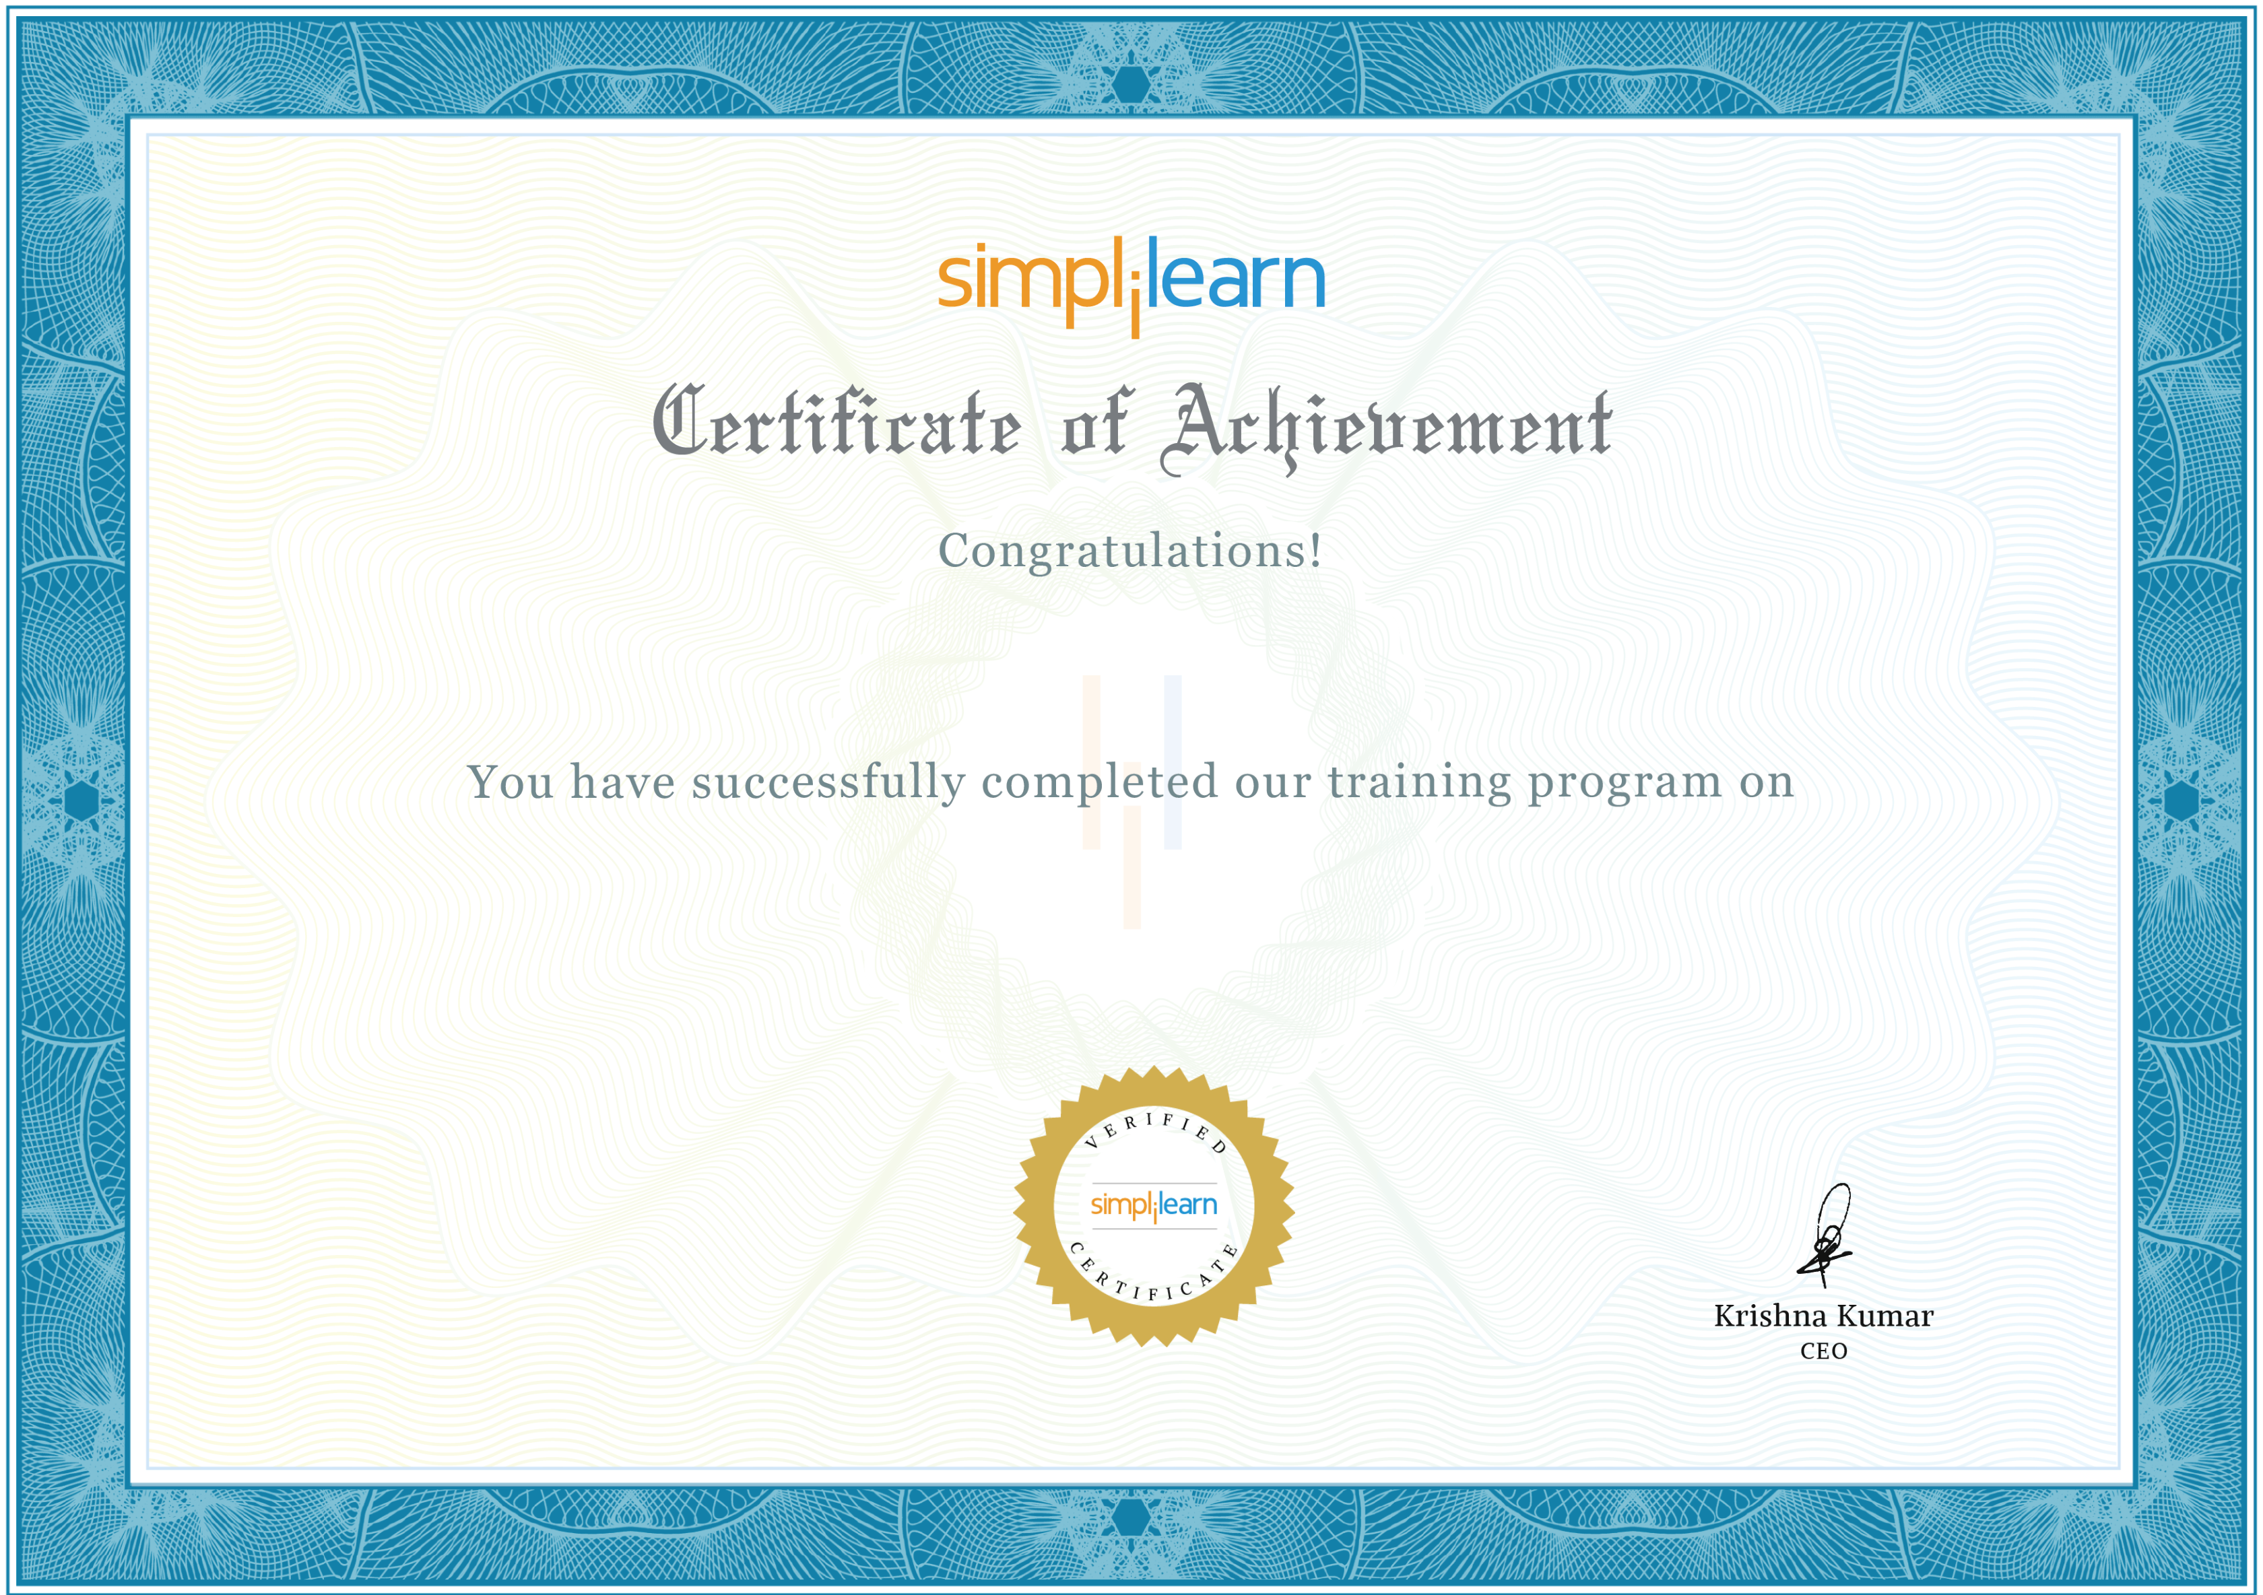
Deepak Pandey
IG AI: Programming Fundamentals
1 Project passed
5th April 2025
Certificate code :8129294

