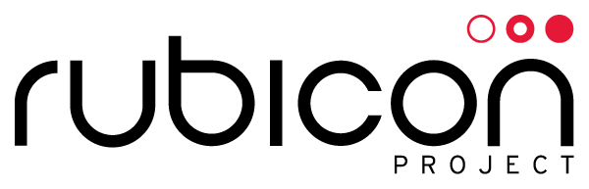

**Subject Access Request – Affidavit**

I, the undersigned Data Subject, do hereby swear, certify, and attest that:

1. I am a citizen and/or resident of ____________________________________, which is located within the European Economic Area;
2. I own and operate a mobile device with the following Device Identifier(s): ____________________________________;
3. I own and operate a device on which is stored at least one cookie labeled “ruid,” set by the rubiconproject.com domain, which contains the following string(s) of text: ____________________________________;
4. I own and operate a device on which is stored at least one cookie labeled “_t,” set by the chango.com domain, which contains the following string(s) of text:

____________________________________;

1. I have the authority under relevant laws, rules, and regulations, to submit a subject access request for personal data associated with the above-listed identifiers; and
2. I am not requesting this information for any fraudulent, criminal, malicious, or otherwise unlawful purpose.

I declare under penalty of perjury that the foregoing is true and correct.

Data Subject:

_________________________  
Signature

_________________________  
Name

_________________________  
Date