DBeaver for Exploring Enterprise IT
DBeaver is a tool for connecting to, querying, and managing various relational databases. It appears quite fit for allowing consultants to survey what data is collected and used. DBeaver is an open-source application with commercial support. I’m guessing commercial users would buy either the “Enterprise” or “Cloud” version. Consultants to those companies could then use DBeaver in the short term to explore data for use in analyses, creating CSV files (or JSON, etc.) for download.
For long-term use, consultants would likely skip DBeaver and go straight to running against the DBs using the DBs native SQL interface (or similar). DBeaver helps in that work too by providing information you’d need to make the connection; see section Using DBeaver Connection Settings to Learn How to Connect below. My dbeaver-exp git repository has a Jupyter notebook that demonstrates connecting to DBeaver demo SQLite database. See https://github.com/pdenno/dbeaver-exp/blob/main/sqlite-connection.ipynb.) The demo DB is unprotected. Before trying things like this with a commercial concern, consultants should work out the details with the customer.
I think it makes sense to have people doing consulting-like work to start with DBeaver because it provides read permission across many DBs for exploration… I guess(!); I’m just learning it today!

Though DBeaver has an AI tool to help you write SQL (see the little blue “AI” button to the left of the SQL editing region), I doubt it is active in most deployment because it sends the request outside (to OpenAI).
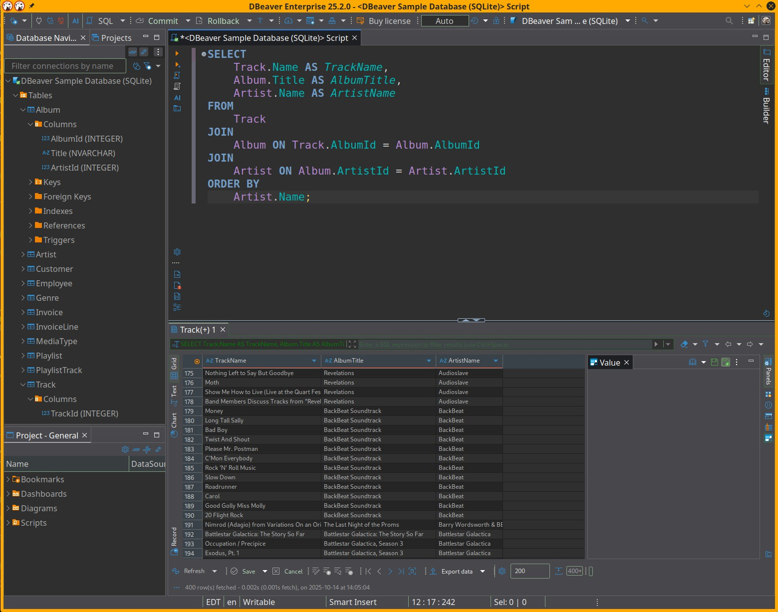Figure 1: Here I am exploring the DBeaver demo DB with the Enterprise edition. I chose the "DBeaver Sample Database (SQLite) found in upper left of the figure. I wrote the SQL at the top center, and ran it using one of the buttons to the left of the SQL editor (hover over those buttons to see what they do). It returned the data in the bottom center.
Below I right clicked on the data region and selected the “Export data” menu item to save the result of the query.

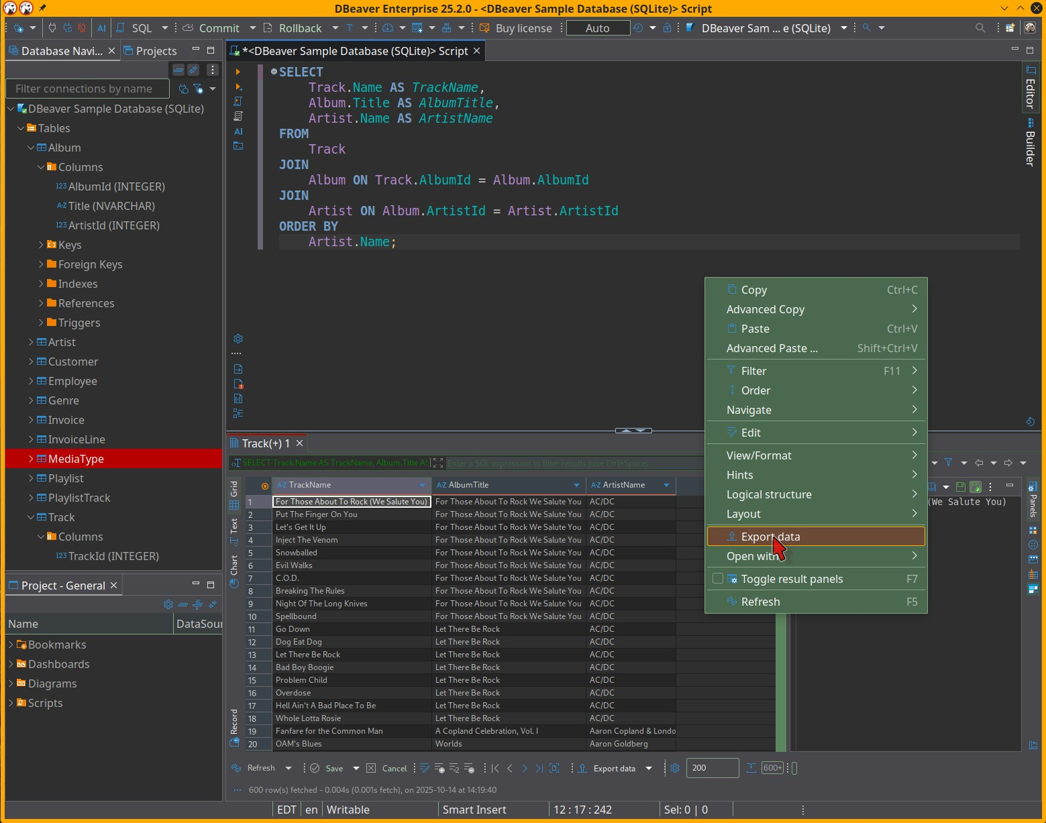Figure 2: First step in exporting data
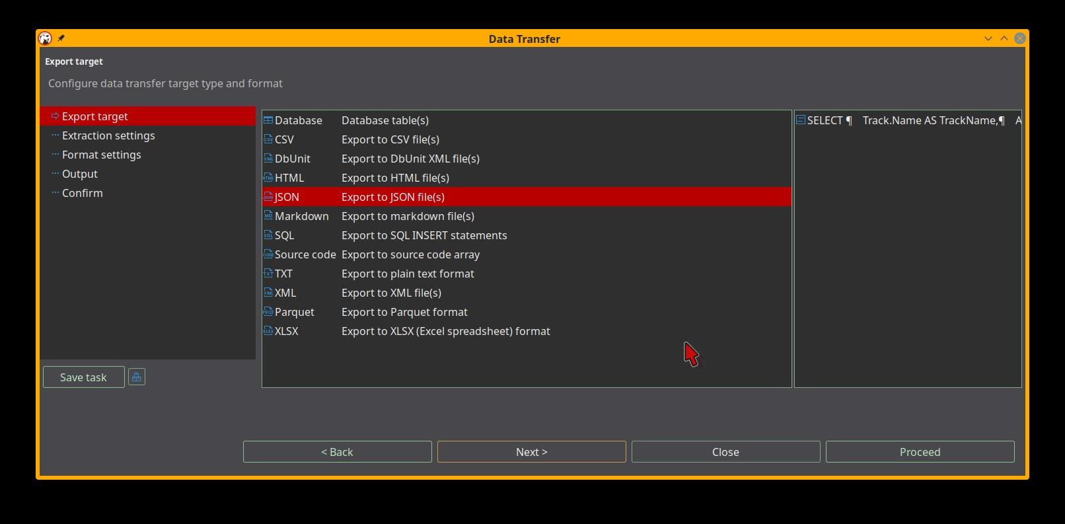Figure 3: There are several dialogs to control how data is written; lots of features.

Using DBeaver Connection Settings to Learn How to Connect
You can reach the “Connection settings” dialog in the figure below by right clicking on the database (“DBeaver Sample Database (SQLite)” in red in the upper left) and selecting “Edit connection”. For this example at least, the multi-tab dialog provided sufficient information to allow me to connect to the database with an application program. I’ll send an example Jupyter notebook where I connected to this SQLite database with Python.

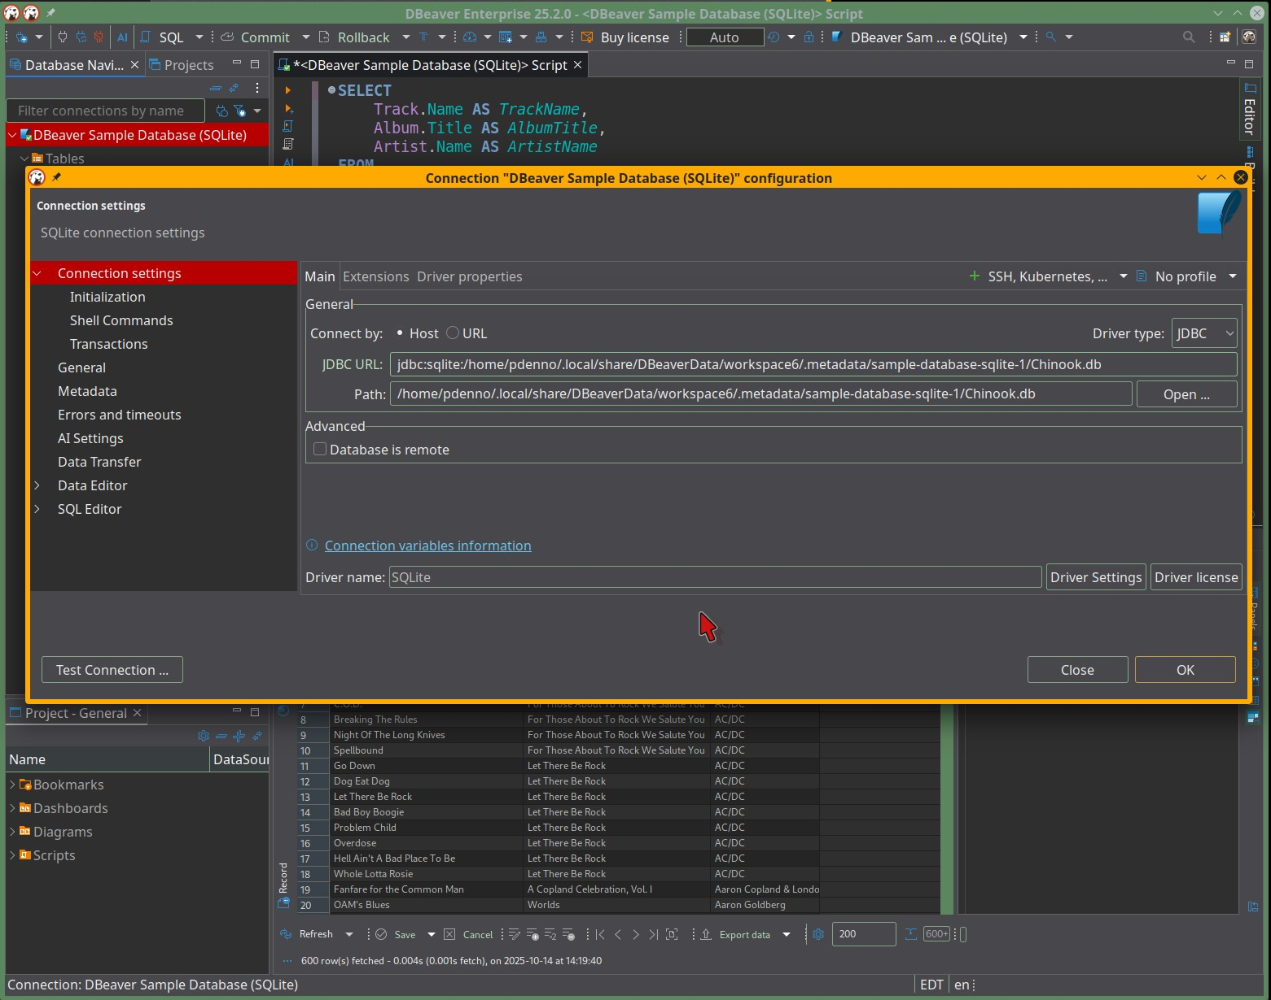Figure 4: Information needed by applications that intend to query this database.
Below is a screenshot from the Jupyter notebook I mentioned above.
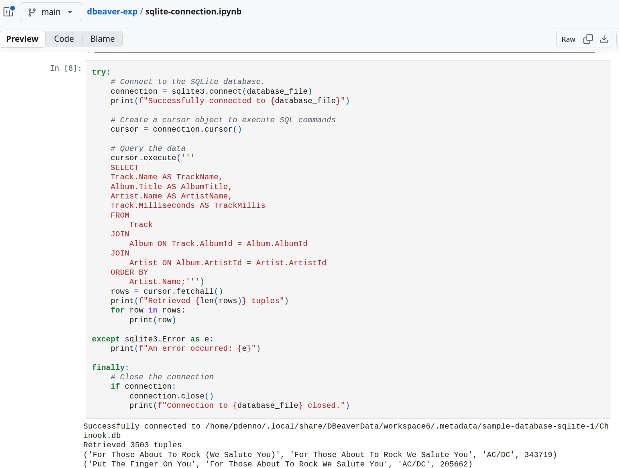Figure 5: A query against the DBeaver demo notebook.

