

**DEPARTMENT OF COMPUTER SCIENCE AND ENGINEERING**

**SCHOOL OF TECHNOLOGY**

**Pandit Deendayal Energy University**

**SESSION 2025-26**

**Computer Network LAB(20CP301P)**



**Name: Princekumar V Patel**

**Roll No: 23BCP002**

**Division: 1 Group: 1x**

**EXPERMINET NO 1**

**Aim:** To understand and implement different Topologies in Computer Network

**Tools:** Cisco Packet Tracer

**Setup and Theory:**

* **Bus Topology**

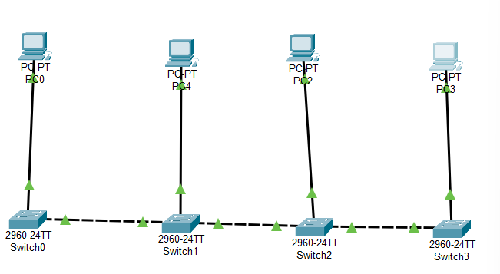

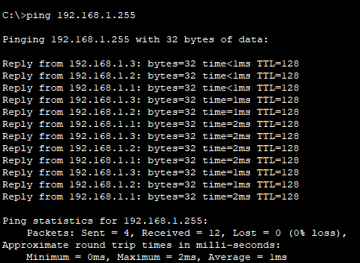

In a Bus topology, all devices are connected to a single central cable known as the backbone. Data sent by a device is broadcast to all devices on the network, but only the target device accepts and processes it. This topology operates on a single communication channel and requires that devices take turns to transmit to avoid data collisions.

**Advantages**

• Simple and cost-effective setup

• Requires minimal cabling

**Disadvantages**

• Poor scalability

• Entire network fails if the backbone is damage

* **Ring Topology**

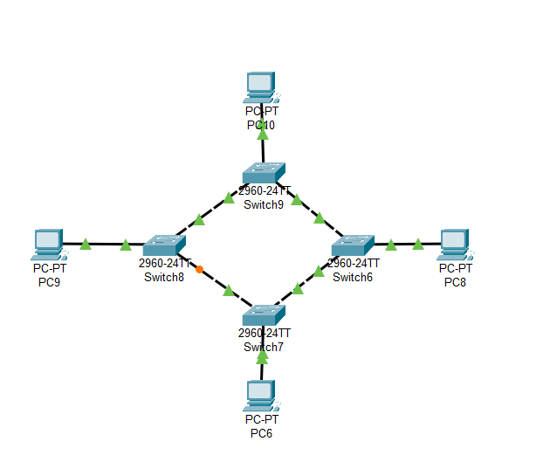

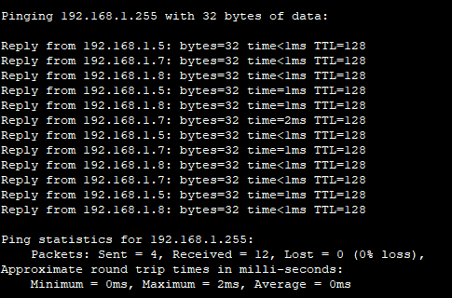

In a **Ring topology**, each device connects to exactly two other devices, forming a closed loop. Data travels in a specific direction and passes through each device until it reaches its destination. This structure ensures orderly data transmission but lacks fault tolerance unless a dual-ring setup is used.

**Advantages**

• Equal data access for all devices

• Predictable data flow reduces collisions

**Disadvantages**

• A single failure can break the loop

• Troubleshooting and expansion are challenging

* **Star Topology**

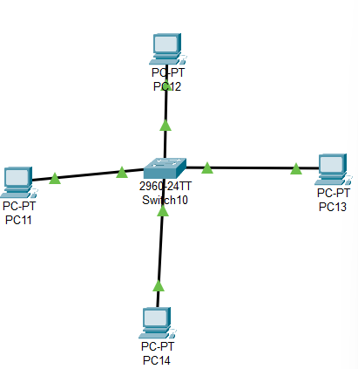

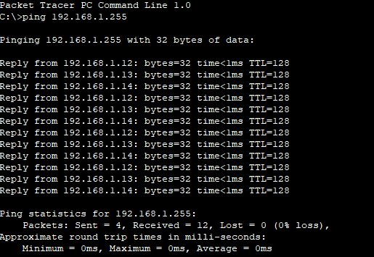

In a **Star topology**, all devices are individually connected to a central hub or switch. The central device manages and directs data traffic. Each node communicates only with the hub, making fault isolation simple and minimizing the impact of individual device failures.

**Advantages**

• Easy to install, manage, and troubleshoot

• Failure of one device or cable doesn’t affect others

**Disadvantages**

• Central device is a single point of failure

• Requires more cabling than bus or ring topologies

* **Mesh Topology**

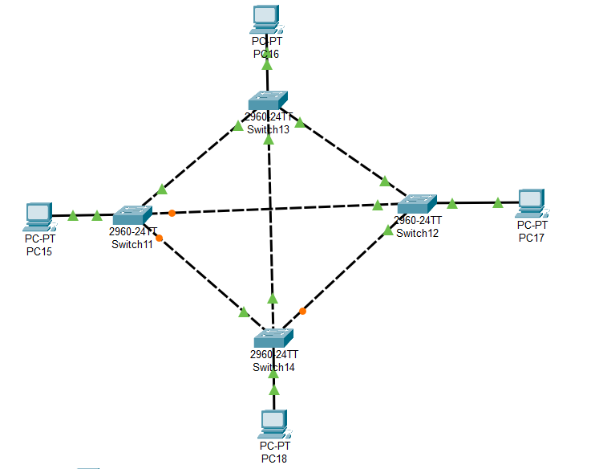

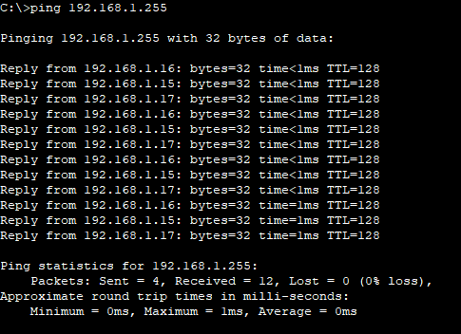

A **Mesh topology** features direct connections between every pair of devices. Each device can communicate with any other through multiple pathways, offering high redundancy and fault tolerance. Mesh topologies are best suited for critical applications where uptime is essential.

**Advantages**

• Extremely reliable and fault-tolerant

• Supports multiple simultaneous data paths

**Disadvantages**

• High cost due to excessive cabling

• Complex installation and management

* **Hybrid Topology**

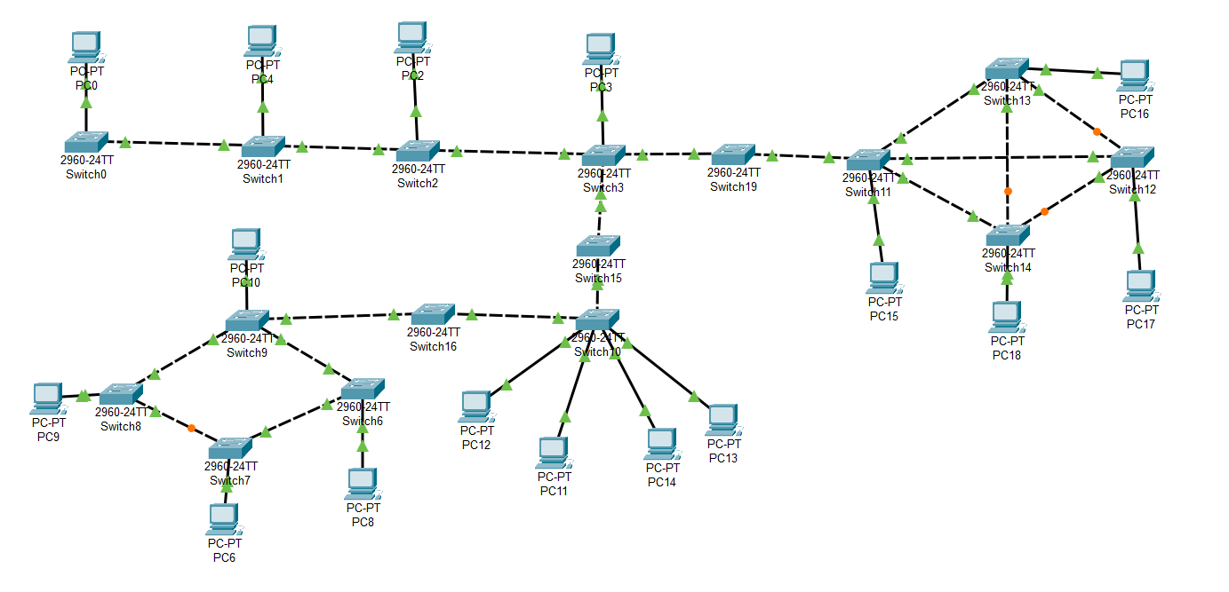

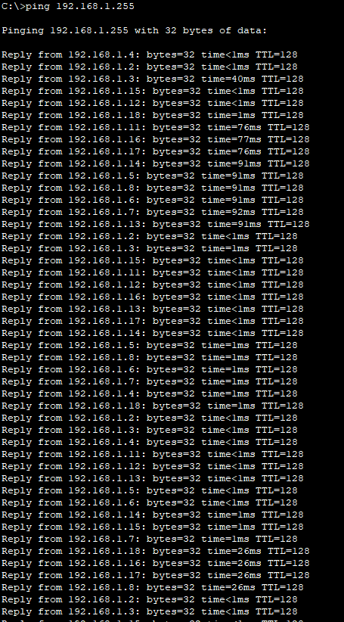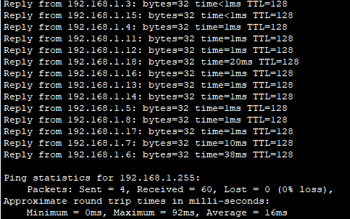

**Tree topology** is a hierarchical structure combining

multiple star topologies connected to a central backbone,

similar to a bus. It is highly scalable and suitable for

networks with layered administration, like universities or

large enterprises.

**Advantages**

• Supports network expansion efficiently

• Combines advantages of star and bus topologies

**Disadvantages**

• Backbone failure can impact multiple branches

• Increased complexity in design and management

**Conclusion:**

Each network topology offers distinct advantages and trade-offs:

• Bus is economical for small setups but has limited scalability.

• Ring ensures structured data flow but is vulnerable to failures.

• Star is widely used for its simplicity and manageability.

• Mesh delivers maximum reliability at the cost of complexity and expense.

• Tree and Hybrid offer scalability and flexibility, making them ideal for large organizations.

**EXPERMINET NO 2**

**Aim:** To study and configure VLAN (Virtual Local Area Network) in a network to understand how it segments network traffic, improves performance, and enhances security.

**Tools:** Cisco Packet Tracer

**Setup and Theory:**

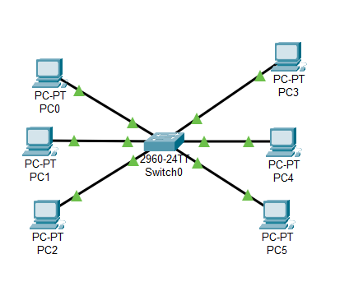

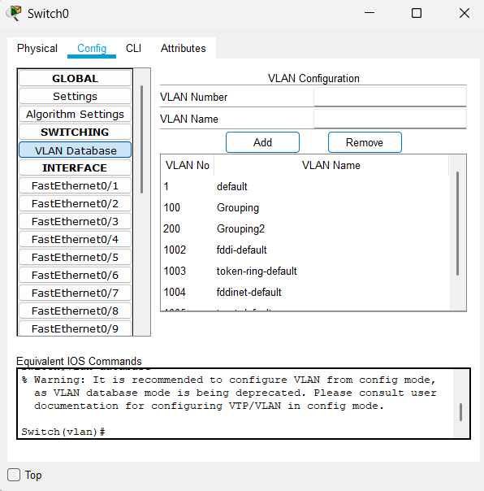

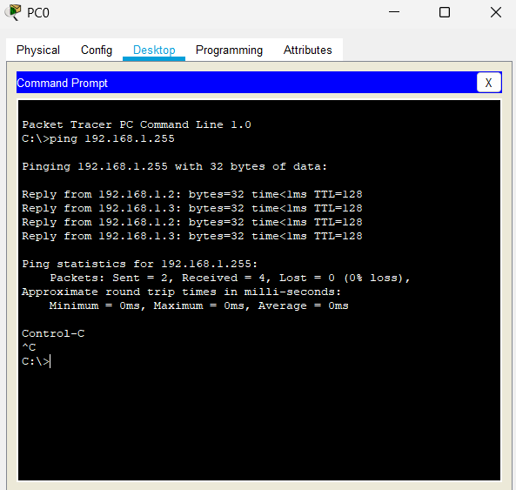

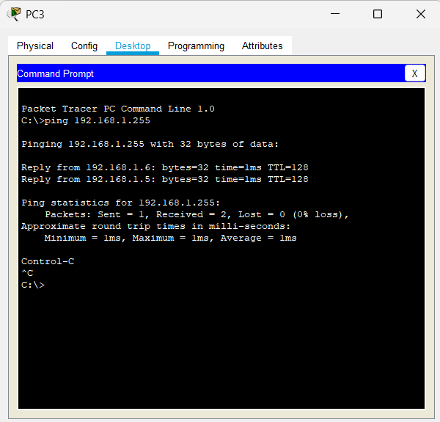

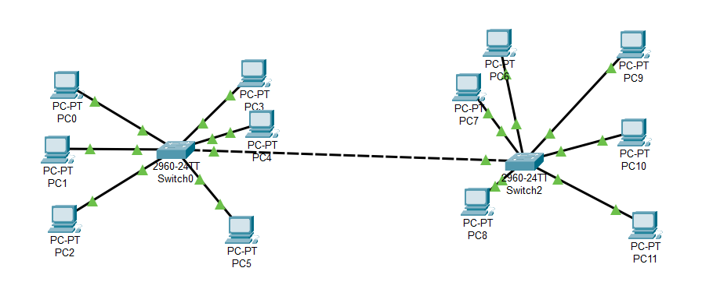

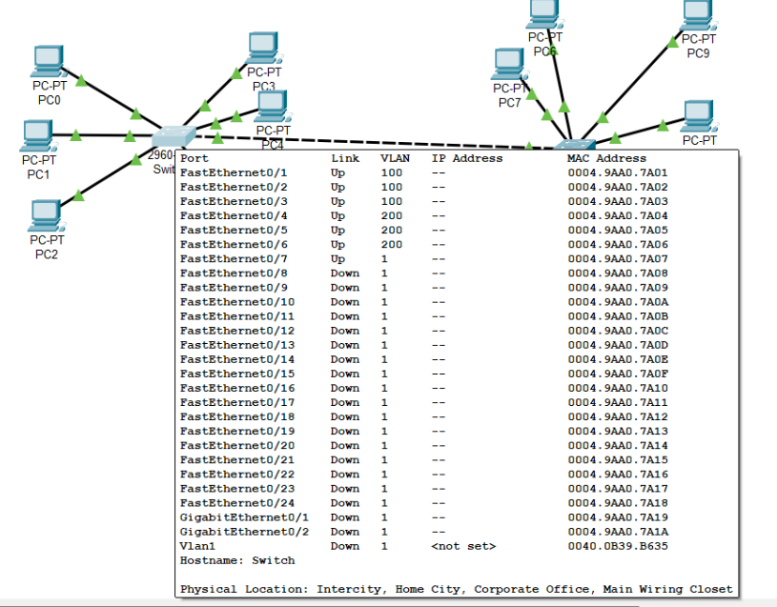

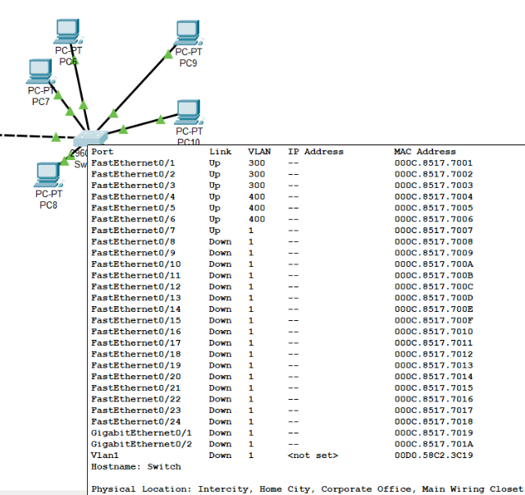

A **VLAN (Virtual Local Area Network)** is a logical grouping of devices in a LAN, configured to communicate as if they are on the same physical network, regardless of their actual location. VLANs operate at **Layer 2 (Data Link Layer)** of the OSI model.

**Key Concepts:**

* **Segmentation**: VLANs logically divide a single physical network into multiple isolated broadcast domains.
* **Broadcast Domain Isolation**: Devices in different VLANs cannot communicate directly without a Layer 3 device (router or Layer 3 switch).
* **Trunking**: Trunk ports carry traffic from multiple VLANs across a single physical link using tagging protocols like **IEEE 802.1Q**.

**Benefits of VLAN:**

* **Improved Security**: Sensitive data can be isolated within specific VLANs.
* **Reduced Congestion**: Smaller broadcast domains mean less unnecessary traffic.
* **Improved Performance**: Network efficiency is increased through logical segmentation.
* **Flexibility and Scalability**: Devices can be moved across VLANs without changing physical connections.

**Conclusion:**

**VLANs** are essential in modern networking for creating logical groupings of devices, improving network security, managing broadcast domains, and optimizing performance. By implementing VLANs, network administrators can reduce congestion, enhance data privacy, and scale networks efficiently. The practical configuration of VLANs reinforces the understanding of how Layer 2 segmentation is achieved in enterprise networks.

**EXPERMINET NO 2**

**Aim:** To understand and implement different Topologies in Computer Network

**Tools:** Cisco Packet Tracer

**Setup and Theory:**

**Conclusion:**