GIT

**Version control system**

Version control is a system that records changes to a file or set of files over time so that you can recall specific versions later.

Types of VCS

1. Local

Many people’s version-control method of choice is to copy files into another directory (perhaps a time-stamped directory, if they’re clever). This approach is very common because it is so simple, but it is also incredibly error prone.

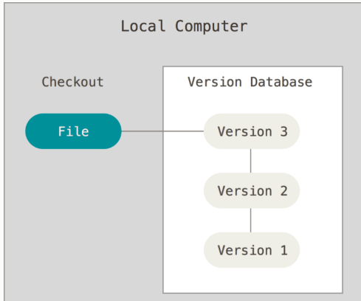

It is easy to forget which directory you’re in and accidentally write to the wrong file or copy over files you don’t mean to.To deal with this issue, programmers long ago developed local VCSs that had a simple database that kept all the changes to files under revision control.

1. Centralized

These systems (such as CVS, Subversion, and Perforce) have a single server that contains all the versioned files, and a number of clients that check out files from that central place.

However, this setup also has some serious downsides. The most obvious is the single point of failure that the centralized server represents. If that server goes down for an hour, then during that hour nobody can collaborate at all or save versioned changes to anything they’re working on.

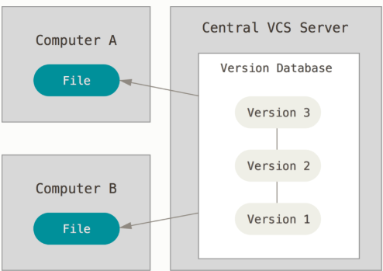

1. Distributed

This is where Distributed Version Control Systems (DVCSs) step in. In a DVCS (such as Git, Mercurial, Bazaar or Darcs), clients don’t just check out the latest snapshot of the files; rather, they fully mirror the repository, including its full history. Thus, if any server dies, and these systems were collaborating via that server, any of the client repositories can be copied back up to the server to restore it. Every clone is really a full backup of all the data.

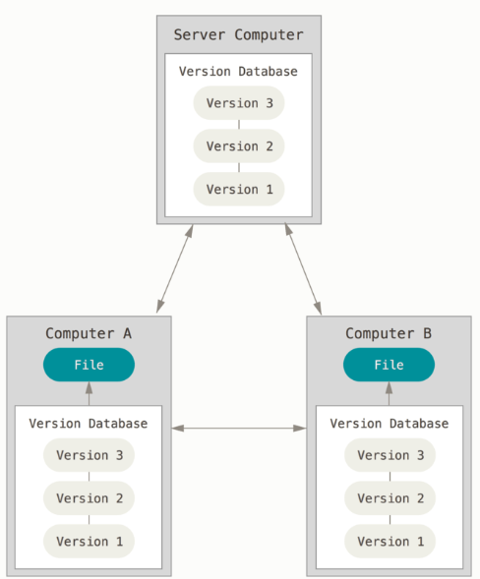

Difference between GIT and other VCS

Main difference between GIT and other VCS is that GIT takes snapshot not differences.

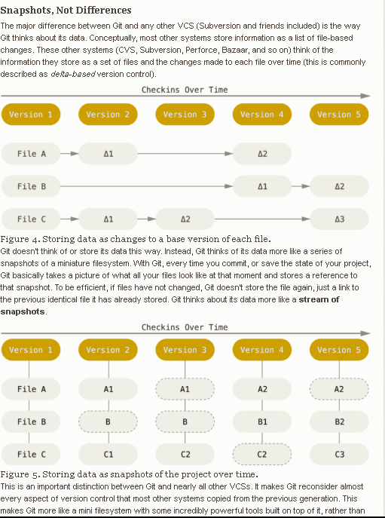

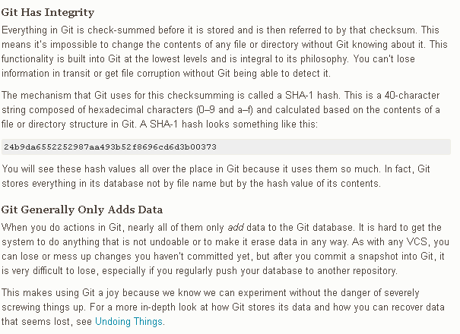

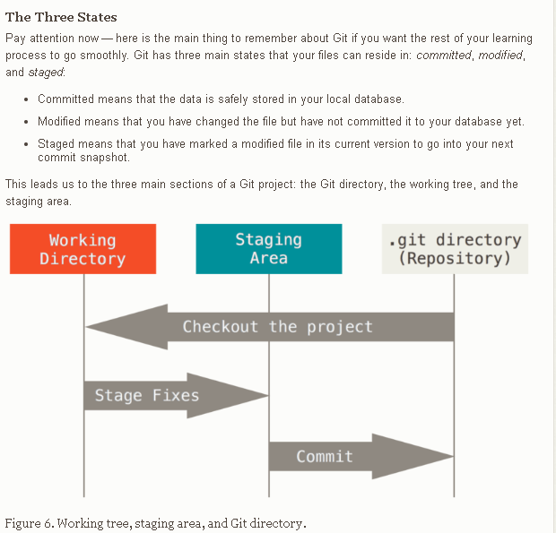

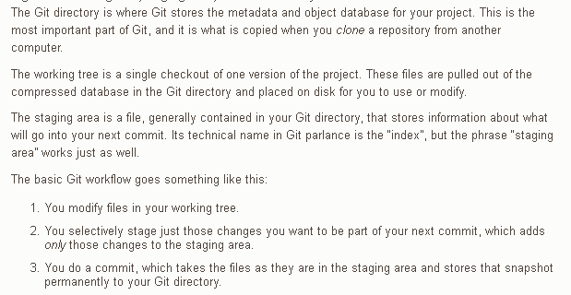

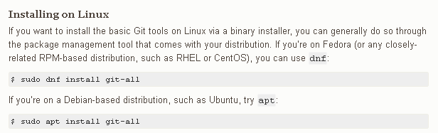

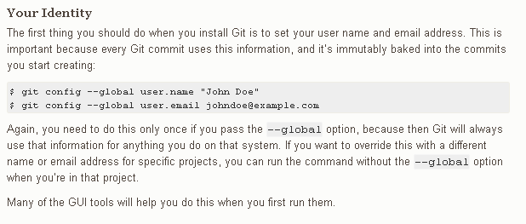

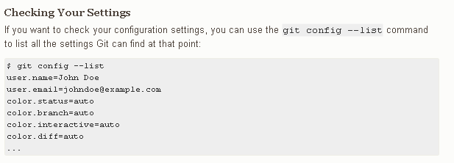

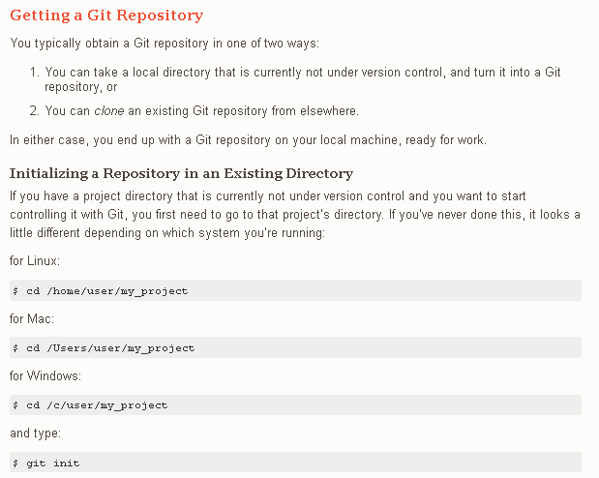

**Adding and committing:**

Git add –A

Git commit –m ‘message”

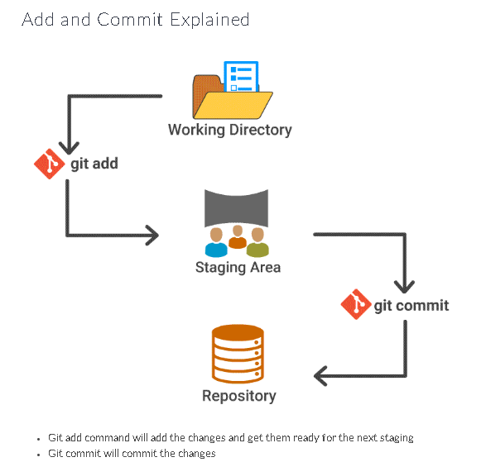

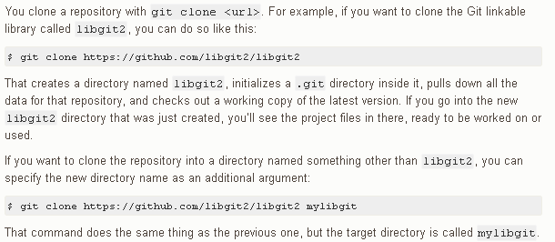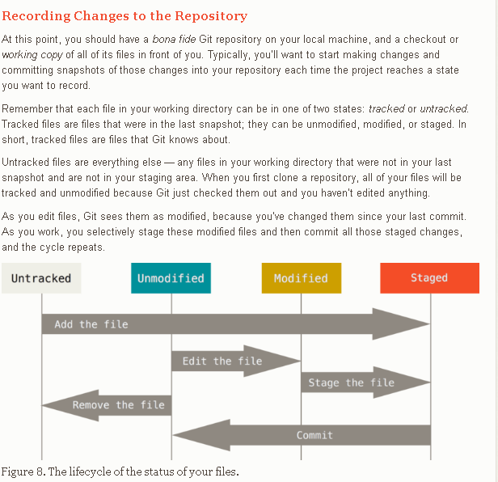

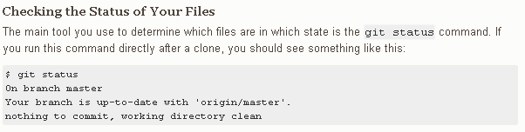

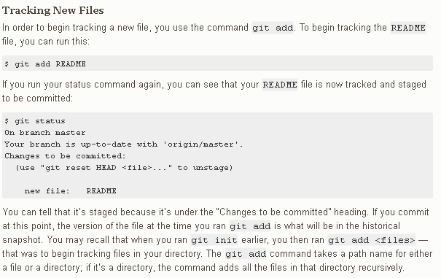

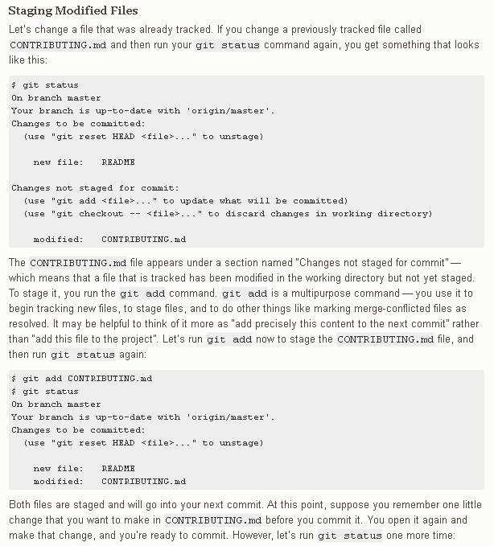

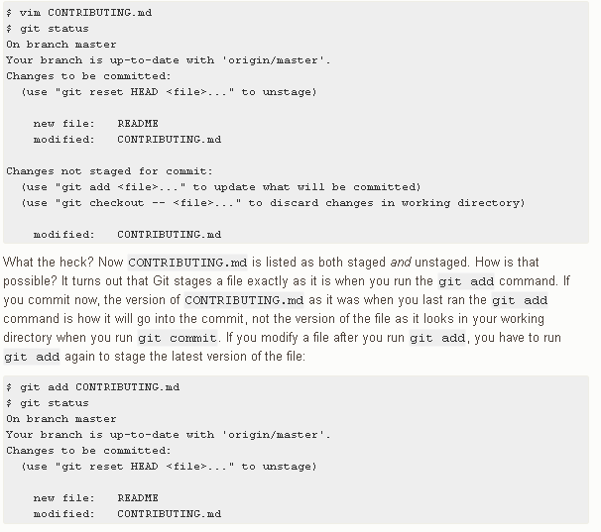

For short status : git status –s

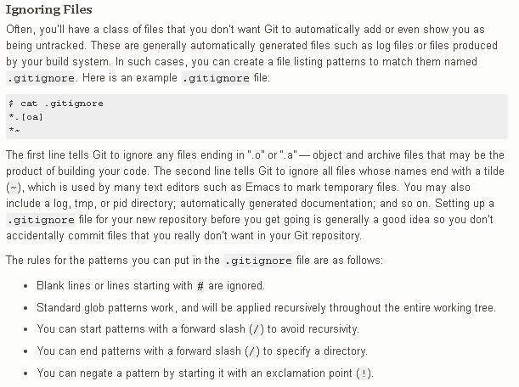

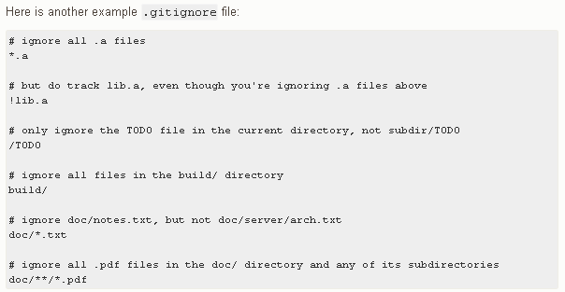

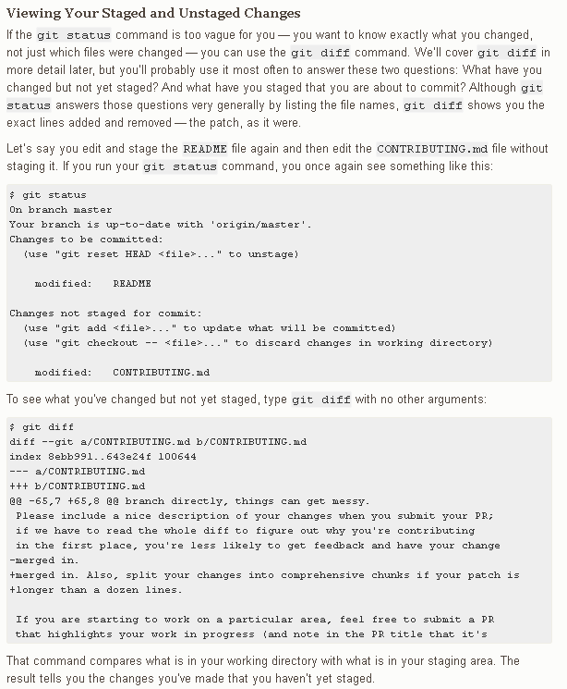

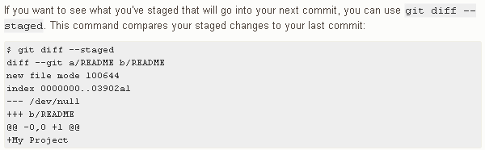

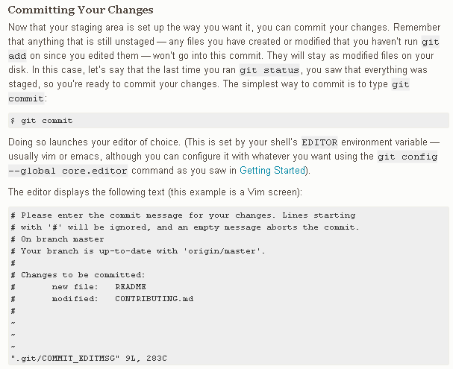

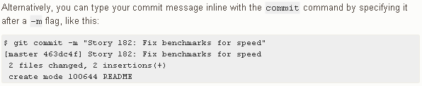

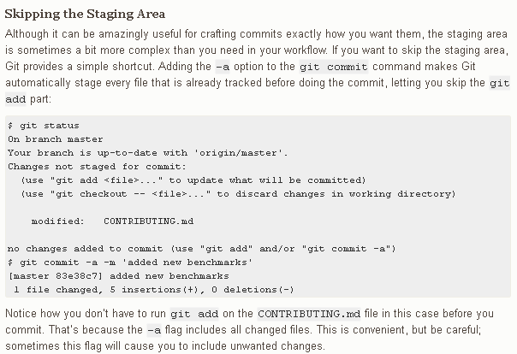

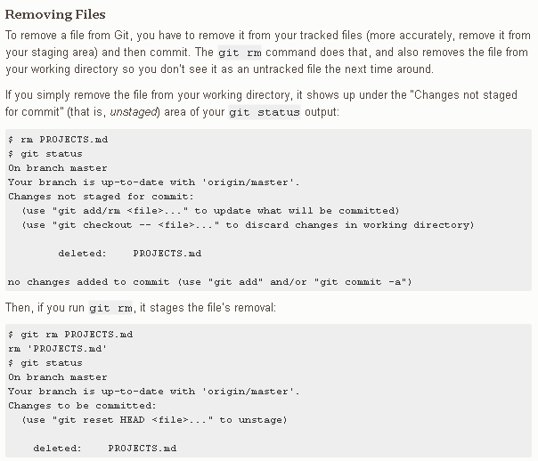

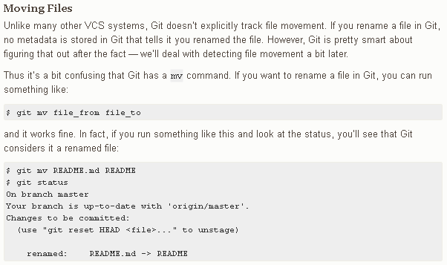



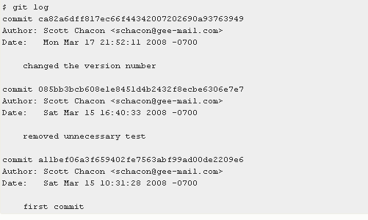

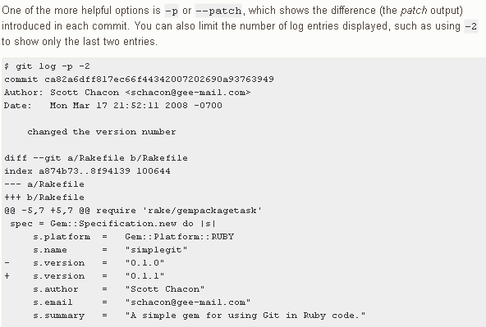

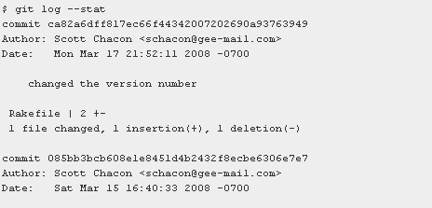

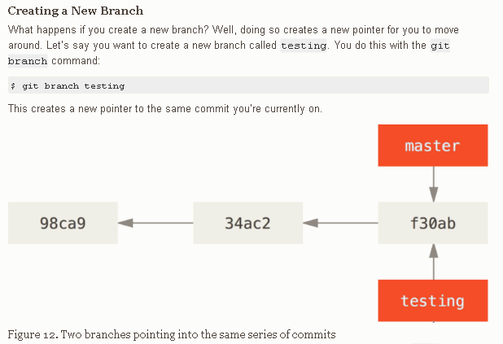

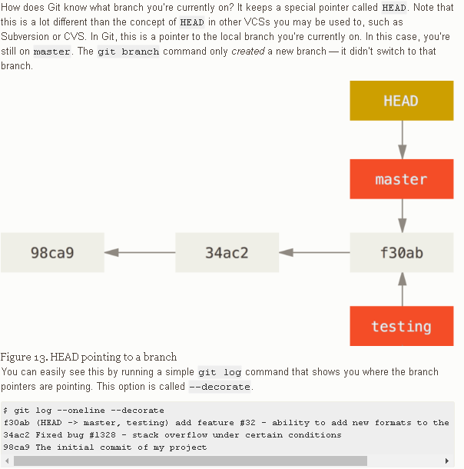

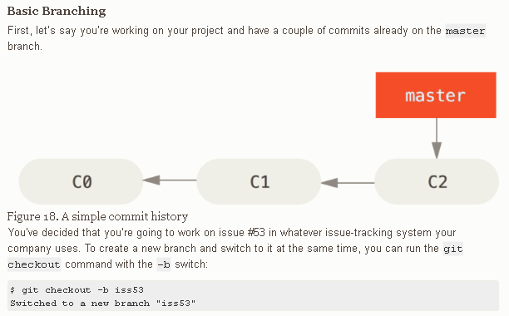

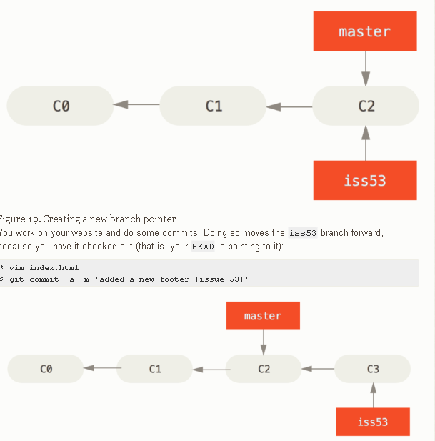

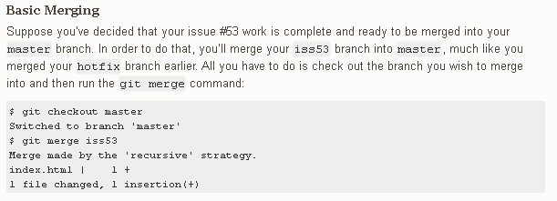

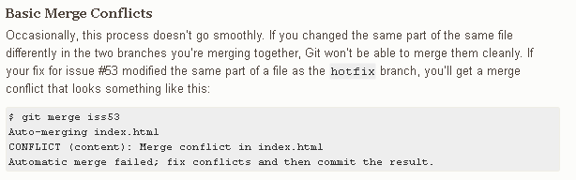

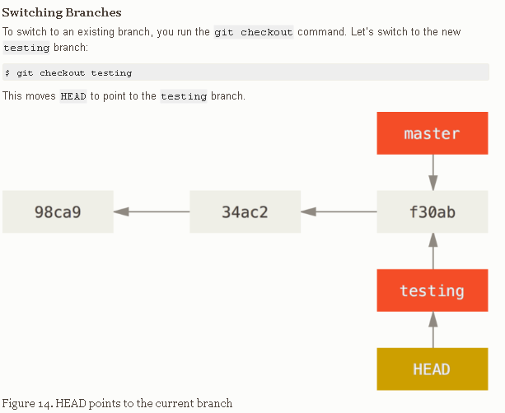

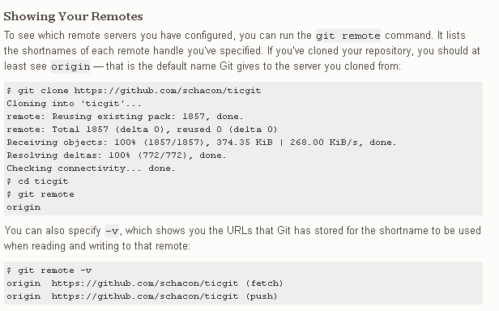

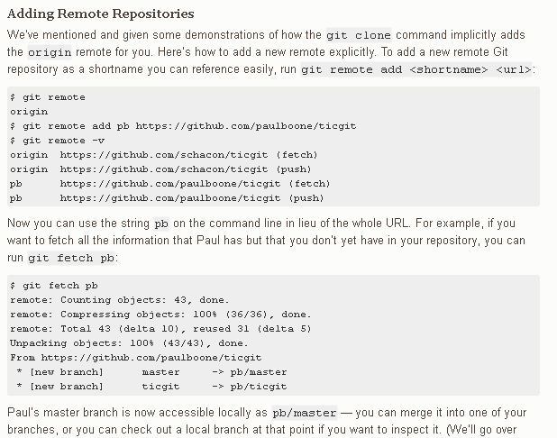

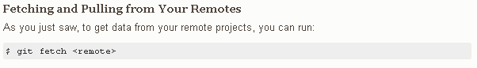

**Difference between fetch and pull**

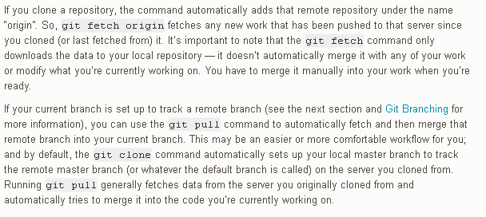

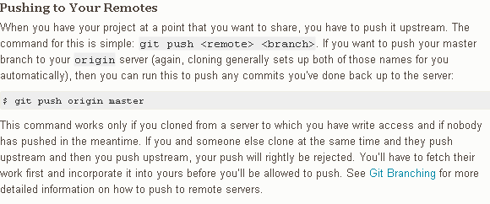

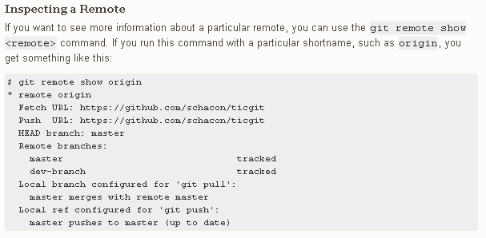

**GIT Rebasing**

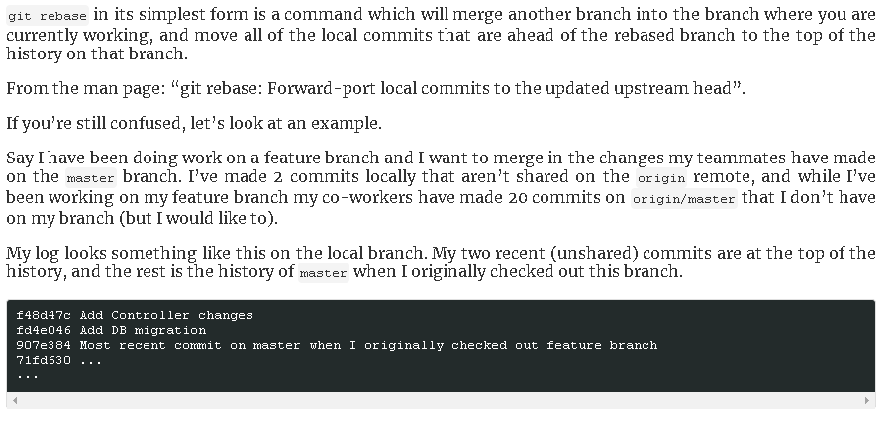





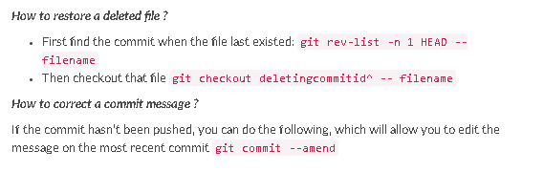

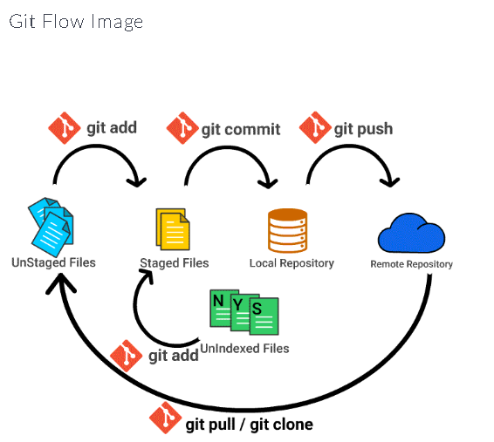

**Hands-on:**

[1]+ Stopped apt install git-all

root@0cbe633f852b:/#

root@0cbe633f852b:/#

root@0cbe633f852b:/#

root@0cbe633f852b:/#

root@0cbe633f852b:/#

root@0cbe633f852b:/#

root@0cbe633f852b:/# git --version

git version 2.7.4

root@0cbe633f852b:/#

root@0cbe633f852b:/#

root@0cbe633f852b:/#

root@0cbe633f852b:/# ls -lart

total 100

drwxr-xr-x 2 root root 4096 Apr 12 2016 home

drwxr-xr-x 2 root root 4096 Apr 12 2016 boot

drwxr-xr-x 1 root root 4096 Feb 28 2018 usr

drwxr-xr-x 2 root root 4096 Feb 28 2018 srv

drwxr-xr-x 2 root root 4096 Feb 28 2018 opt

drwxr-xr-x 2 root root 4096 Feb 28 2018 mnt

drwxr-xr-x 2 root root 4096 Feb 28 2018 media

drwxr-xr-x 2 root root 4096 Feb 28 2018 lib64

-rwxr-xr-x 1 root root 0 Aug 31 11:17 .dockerenv

drwxr-xr-x 1 root root 4096 Aug 31 11:17 ..

drwxr-xr-x 1 root root 4096 Aug 31 11:17 .

dr-xr-xr-x 71 root root 0 Aug 31 11:17 proc

dr-xr-xr-x 13 root root 0 Aug 31 11:17 sys

drwxr-xr-x 5 root root 360 Aug 31 11:17 dev

drwxr-xr-x 1 root root 4096 Aug 31 11:19 var

drwxr-xr-x 1 root root 4096 Aug 31 11:19 lib

drwxr-xr-x 1 root root 4096 Aug 31 11:19 bin

drwxr-xr-x 1 root root 4096 Aug 31 11:20 sbin

drwxr-xr-x 1 root root 4096 Aug 31 11:20 run

drwx------ 1 root root 4096 Aug 31 11:20 root

drwxr-xr-x 1 root root 4096 Aug 31 11:20 etc

drwxrwxrwt 1 root root 4096 Aug 31 11:20 tmp

root@0cbe633f852b:/# mkdir /home/git

root@0cbe633f852b:/#

root@0cbe633f852b:/# cd /home/git

root@0cbe633f852b:/home/git#

root@0cbe633f852b:/home/git# git init

Initialized empty Git repository in /home/git/.git/

root@0cbe633f852b:/home/git#

root@0cbe633f852b:/home/git# ls --lart

ls: unrecognized option '--lart'

Try 'ls --help' for more information.

root@0cbe633f852b:/home/git# ls -lart

total 12

drwxr-xr-x 1 root root 4096 Aug 31 11:22 ..

drwxr-xr-x 3 root root 4096 Aug 31 11:22 .

drwxr-xr-x 7 root root 4096 Aug 31 11:22 .git

root@0cbe633f852b:/home/git#

root@0cbe633f852b:/home/git#

root@0cbe633f852b:/home/git#

root@0cbe633f852b:/home/git#

root@0cbe633f852b:/home/git#

root@0cbe633f852b:/home/git#

root@0cbe633f852b:/home/git#

root@0cbe633f852b:/home/git# ls -lart

total 12

drwxr-xr-x 1 root root 4096 Aug 31 11:22 ..

drwxr-xr-x 3 root root 4096 Aug 31 11:22 .

drwxr-xr-x 7 root root 4096 Aug 31 11:22 .git

root@0cbe633f852b:/home/git#

root@0cbe633f852b:/home/git#

root@0cbe633f852b:/home/git#

root@0cbe633f852b:/home/git#

root@0cbe633f852b:/home/git#

root@0cbe633f852b:/home/git#

root@0cbe633f852b:/home/git# echo "this is 1st git file">test.txt

root@0cbe633f852b:/home/git# ls -lart

total 16

drwxr-xr-x 1 root root 4096 Aug 31 11:22 ..

drwxr-xr-x 7 root root 4096 Aug 31 11:22 .git

-rw-r--r-- 1 root root 21 Aug 31 11:24 test.txt

drwxr-xr-x 3 root root 4096 Aug 31 11:24 .

root@0cbe633f852b:/home/git#

root@0cbe633f852b:/home/git# git add -A

root@0cbe633f852b:/home/git#

root@0cbe633f852b:/home/git# git status

On branch master

Initial commit

Changes to be committed:

(use "git rm --cached <file>..." to unstage)

new file: test.txt

root@0cbe633f852b:/home/git# echo "this is modified file">>test.txt

root@0cbe633f852b:/home/git#

root@0cbe633f852b:/home/git# git status

On branch master

Initial commit

Changes to be committed:

(use "git rm --cached <file>..." to unstage)

new file: test.txt

Changes not staged for commit:

(use "git add <file>..." to update what will be committed)

(use "git checkout -- <file>..." to discard changes in working directory)

modified: test.txt

root@0cbe633f852b:/home/git# git commit -m "this is my 1st commit"

*** Please tell me who you are.

Run

git config --global user.email "you@example.com"

git config --global user.name "Your Name"

to set your account's default identity.

Omit --global to set the identity only in this repository.

fatal: unable to auto-detect email address (got 'root@0cbe633f852b.(none)')

root@0cbe633f852b:/home/git#

root@0cbe633f852b:/home/git# git config --global user.email "dpsingh.singh95@gmail.com"

root@0cbe633f852b:/home/git#

root@0cbe633f852b:/home/git# git config --global user.name "Devendra Pratap Singh"

root@0cbe633f852b:/home/git#

root@0cbe633f852b:/home/git# git commit -m "this is my 1st commit"

[master (root-commit) 8286274] this is my 1st commit

1 file changed, 1 insertion(+)

create mode 100644 test.txt

root@0cbe633f852b:/home/git#

root@0cbe633f852b:/home/git# git status

On branch master

Changes not staged for commit:

(use "git add <file>..." to update what will be committed)

(use "git checkout -- <file>..." to discard changes in working directory)

modified: test.txt

no changes added to commit (use "git add" and/or "git commit -a")

root@0cbe633f852b:/home/git#

root@0cbe633f852b:/home/git#

root@0cbe633f852b:/home/git# git checkout test.txt

root@0cbe633f852b:/home/git#

root@0cbe633f852b:/home/git# git status

On branch master

nothing to commit, working directory clean

root@0cbe633f852b:/home/git#

root@0cbe633f852b:/home/git# git log -p --oneline --graph --decorate

* 8286274 (HEAD -> master) this is my 1st commit

diff --git a/test.txt b/test.txt

new file mode 100644

index 0000000..73f0173

--- /dev/null

+++ b/test.txt

@@ -0,0 +1 @@

+this is 1st git file

root@0cbe633f852b:/home/git#

root@0cbe633f852b:/home/git# echo "this is modified file">>test.txt

root@0cbe633f852b:/home/git# git status

On branch master

Changes not staged for commit:

(use "git add <file>..." to update what will be committed)

(use "git checkout -- <file>..." to discard changes in working directory)

modified: test.txt

no changes added to commit (use "git add" and/or "git commit -a")

root@0cbe633f852b:/home/git#

root@0cbe633f852b:/home/git# git commit -m "this is second commit"

On branch master

Changes not staged for commit:

modified: test.txt

no changes added to commit

root@0cbe633f852b:/home/git#

root@0cbe633f852b:/home/git# git add -A

root@0cbe633f852b:/home/git#

root@0cbe633f852b:/home/git# git status

On branch master

Changes to be committed:

(use "git reset HEAD <file>..." to unstage)

modified: test.txt

root@0cbe633f852b:/home/git#

root@0cbe633f852b:/home/git# git commit -m "this is second commit"

[master fd7770f] this is second commit

1 file changed, 1 insertion(+)

root@0cbe633f852b:/home/git#

root@0cbe633f852b:/home/git#

root@0cbe633f852b:/home/git#

root@0cbe633f852b:/home/git# git log -p --oneline --graph --decorate

* fd7770f (HEAD -> master) this is second commit

| diff --git a/test.txt b/test.txt

| index 73f0173..bc76608 100644

| --- a/test.txt

| +++ b/test.txt

| @@ -1 +1,2 @@

| this is 1st git file

| +this is modified file

* 8286274 this is my 1st commit

diff --git a/test.txt b/test.txt

new file mode 100644

index 0000000..73f0173

--- /dev/null

+++ b/test.txt

@@ -0,0 +1 @@

+this is 1st git file

root@0cbe633f852b:/home/git# git diff

root@0cbe633f852b:/home/git#

root@0cbe633f852b:/home/git# git status

On branch master

nothing to commit, working directory clean

root@0cbe633f852b:/home/git#

root@0cbe633f852b:/home/git#

root@0cbe633f852b:/home/git# git diff --staged

root@0cbe633f852b:/home/git#

root@0cbe633f852b:/home/git# echo "this is third modification">test.txt

root@0cbe633f852b:/home/git#

root@0cbe633f852b:/home/git# git status

On branch master

Changes not staged for commit:

(use "git add <file>..." to update what will be committed)

(use "git checkout -- <file>..." to discard changes in working directory)

modified: test.txt

no changes added to commit (use "git add" and/or "git commit -a")

root@0cbe633f852b:/home/git#

root@0cbe633f852b:/home/git# ls -lart

total 16

drwxr-xr-x 1 root root 4096 Aug 31 11:22 ..

drwxr-xr-x 3 root root 4096 Aug 31 11:32 .

-rw-r--r-- 1 root root 27 Aug 31 11:42 test.txt

drwxr-xr-x 8 root root 4096 Aug 31 11:42 .git

root@0cbe633f852b:/home/git# cat test.txt

this is third modification

root@0cbe633f852b:/home/git#

root@0cbe633f852b:/home/git#

root@0cbe633f852b:/home/git#

root@0cbe633f852b:/home/git# git diff

diff --git a/test.txt b/test.txt

index bc76608..1b70772 100644

--- a/test.txt

+++ b/test.txt

@@ -1,2 +1 @@

-this is 1st git file

-this is modified file

+this is third modification

root@0cbe633f852b:/home/git# git diff --staged

root@0cbe633f852b:/home/git#

root@0cbe633f852b:/home/git#

root@0cbe633f852b:/home/git# git add -A

root@0cbe633f852b:/home/git#

root@0cbe633f852b:/home/git# git status

On branch master

Changes to be committed:

(use "git reset HEAD <file>..." to unstage)

modified: test.txt

root@0cbe633f852b:/home/git# git diff --staged

diff --git a/test.txt b/test.txt

index bc76608..1b70772 100644

--- a/test.txt

+++ b/test.txt

@@ -1,2 +1 @@

-this is 1st git file

-this is modified file

+this is third modification

root@0cbe633f852b:/home/git# git rm test.txt

error: the following file has changes staged in the index:

test.txt

(use --cached to keep the file, or -f to force removal)

root@0cbe633f852b:/home/git#

root@0cbe633f852b:/home/git# git status

On branch master

Changes to be committed:

(use "git reset HEAD <file>..." to unstage)

modified: test.txt

root@3450e412e805:/home/git# git clone https://github.com/pdev2991/dev.git

Cloning into 'dev'...

remote: Counting objects: 3, done.

remote: Total 3 (delta 0), reused 0 (delta 0), pack-reused 0

Unpacking objects: 100% (3/3), done.

Checking connectivity... done.

root@3450e412e805:/home/git# ls -lart

total 16

drwxr-xr-x 1 root root 4096 Aug 31 14:49 ..

drwxr-xr-x 7 root root 4096 Aug 31 14:49 .git

drwxr-xr-x 4 root root 4096 Aug 31 14:49 .

drwxr-xr-x 3 root root 4096 Aug 31 14:49 dev

root@3450e412e805:/home/git#

root@3450e412e805:/home/git# echo "1st test file">test.txt

root@3450e412e805:/home/git#

root@3450e412e805:/home/git# git status

On branch master

Initial commit

Untracked files:

(use "git add <file>..." to include in what will be committed)

dev/

test.txt

nothing added to commit but untracked files present (use "git add" to track)

root@3450e412e805:/home/git# git add test.txt

root@3450e412e805:/home/git#

root@3450e412e805:/home/git# git status

On branch master

Initial commit

Changes to be committed:

(use "git rm --cached <file>..." to unstage)

new file: test.txt

Untracked files:

(use "git add <file>..." to include in what will be committed)

dev/

root@3450e412e805:/home/git# git log --decorate --graph --oneline

fatal: your current branch 'master' does not have any commits yet

root@3450e412e805:/home/git#

root@3450e412e805:/home/git# git commit -m "1st commit"

*** Please tell me who you are.

Run

git config --global user.email "you@example.com"

git config --global user.name "Your Name"

to set your account's default identity.

Omit --global to set the identity only in this repository.

fatal: unable to auto-detect email address (got 'root@3450e412e805.(none)')

root@3450e412e805:/home/git# git config --global user.email "dpsingh.singh95@gmail.com"

root@3450e412e805:/home/git# git config --global user.name "Devendra Pratap Singh"

root@3450e412e805:/home/git# git commit -m "1st commit"

[master (root-commit) 41c7643] 1st commit

1 file changed, 1 insertion(+)

create mode 100644 test.txt

root@3450e412e805:/home/git#

root@3450e412e805:/home/git# git log --decorate --graph --oneline

* 41c7643 (HEAD -> master) 1st commit

root@3450e412e805:/home/git#

root@3450e412e805:/home/git# git branch testing

root@3450e412e805:/home/git# git log --decorate --graph --oneline

* 41c7643 (HEAD -> master, testing) 1st commit

root@3450e412e805:/home/git# git clone https://github.com/pdev2991/dev.git

Cloning into 'dev'...

remote: Counting objects: 3, done.

remote: Total 3 (delta 0), reused 0 (delta 0), pack-reused 0

Unpacking objects: 100% (3/3), done.

Checking connectivity... done.

root@3450e412e805:/home/git# ls -lart

total 16

drwxr-xr-x 1 root root 4096 Aug 31 14:49 ..

drwxr-xr-x 7 root root 4096 Aug 31 14:49 .git

drwxr-xr-x 4 root root 4096 Aug 31 14:49 .

drwxr-xr-x 3 root root 4096 Aug 31 14:49 dev

root@3450e412e805:/home/git#

root@3450e412e805:/home/git# echo "1st test file">test.txt

root@3450e412e805:/home/git#

root@3450e412e805:/home/git# git status

On branch master

Initial commit

Untracked files:

(use "git add <file>..." to include in what will be committed)

dev/

test.txt

nothing added to commit but untracked files present (use "git add" to track)

root@3450e412e805:/home/git# git add test.txt

root@3450e412e805:/home/git#

root@3450e412e805:/home/git# git status

On branch master

Initial commit

Changes to be committed:

(use "git rm --cached <file>..." to unstage)

new file: test.txt

Untracked files:

(use "git add <file>..." to include in what will be committed)

dev/

root@3450e412e805:/home/git# git log --decorate --graph --oneline

fatal: your current branch 'master' does not have any commits yet

root@3450e412e805:/home/git#

root@3450e412e805:/home/git# git commit -m "1st commit"

*** Please tell me who you are.

Run

git config --global user.email "you@example.com"

git config --global user.name "Your Name"

to set your account's default identity.

Omit --global to set the identity only in this repository.

fatal: unable to auto-detect email address (got 'root@3450e412e805.(none)')

root@3450e412e805:/home/git# git config --global user.email "dpsingh.singh95@gmail.com"

root@3450e412e805:/home/git# git config --global user.name "Devendra Pratap Singh"

root@3450e412e805:/home/git# git commit -m "1st commit"

[master (root-commit) 41c7643] 1st commit

1 file changed, 1 insertion(+)

create mode 100644 test.txt

root@3450e412e805:/home/git#

root@3450e412e805:/home/git# git log --decorate --graph --oneline

* 41c7643 (HEAD -> master) 1st commit

root@3450e412e805:/home/git#

root@3450e412e805:/home/git# git branch testing

root@3450e412e805:/home/git# git log --decorate --graph --oneline

* 41c7643 (HEAD -> master, testing) 1st commit

checkout

root@3450e412e805:/home/git# git checkout testing

Switched to branch 'testing'

root@3450e412e805:/home/git#

root@3450e412e805:/home/git# git merge testing

Already up-to-date.

root@3450e412e805:/home/git# git checkout master

Switched to branch 'master'

root@3450e412e805:/home/git# git merge testing

Updating 41c7643..c78f2cd

Fast-forward

test2.txt | 1 +

1 file changed, 1 insertion(+)

create mode 100644 test2.txt

root@3450e412e805:/home/git#

root@3450e412e805:/home/git# ls -lart

total 28

drwxr-xr-x 1 root root 4096 Aug 31 14:49 ..

drwxr-xr-x 3 root root 4096 Aug 31 14:49 dev

-rw-r--r-- 1 root root 14 Aug 31 14:50 test.txt

-rw-r--r-- 1 root root 30 Aug 31 14:56 test1.txt

-rw-r--r-- 1 root root 33 Aug 31 15:15 test2.txt

drwxr-xr-x 8 root root 4096 Aug 31 15:15 .git

drwxr-xr-x 4 root root 4096 Aug 31 15:15 .

root@3450e412e805:/home/git#

oot@68f760b9cd82:/home/git# git log --stat

commit 080cbe7beee3ffe7c61ef67ca1e0fa3485627895

Author: Devendra pratap Singh <dpsingh.singh95@gmail.com>

Date: Mon Sep 3 12:48:06 2018 +0000

1st commit

test.txt | 1 +

1 file changed, 1 insertion(+)

root@68f760b9cd82:/home/git#

root@68f760b9cd82:/home/git#

root@68f760b9cd82:/home/git# echo "modifeid new test fil">>test.txt

root@68f760b9cd82:/home/git# git add -A

root@68f760b9cd82:/home/git#

root@68f760b9cd82:/home/git# git commit -m"new modified commit"

[master 364a04c] new modified commit

1 file changed, 1 insertion(+)

root@68f760b9cd82:/home/git#

root@68f760b9cd82:/home/git# git log --stat

commit 364a04cba295e89e8b59a901678db7be91834b74

Author: Devendra pratap Singh <dpsingh.singh95@gmail.com>

Date: Mon Sep 3 12:49:43 2018 +0000

new modified commit

test.txt | 1 +

1 file changed, 1 insertion(+)

commit 080cbe7beee3ffe7c61ef67ca1e0fa3485627895

Author: Devendra pratap Singh <dpsingh.singh95@gmail.com>

Date: Mon Sep 3 12:48:06 2018 +0000

1st commit

test.txt | 1 +

1 file changed, 1 insertion(+)

root@68f760b9cd82:/home/git#

root@68f760b9cd82:/home/git# git diff

root@68f760b9cd82:/home/git#

root@68f760b9cd82:/home/git# git branch -b testing

error: unknown switch `b'

usage: git branch [<options>] [-r | -a] [--merged | --no-merged]

or: git branch [<options>] [-l] [-f] <branch-name> [<start-point>]

or: git branch [<options>] [-r] (-d | -D) <branch-name>...

or: git branch [<options>] (-m | -M) [<old-branch>] <new-branch>

or: git branch [<options>] [-r | -a] [--points-at]

Generic options

-v, --verbose show hash and subject, give twice for upstream branch

-q, --quiet suppress informational messages

-t, --track set up tracking mode (see git-pull(1))

--set-upstream change upstream info

-u, --set-upstream-to <upstream>

change the upstream info

--unset-upstream Unset the upstream info

--color[=<when>] use colored output

-r, --remotes act on remote-tracking branches

--contains <commit> print only branches that contain the commit

--abbrev[=<n>] use <n> digits to display SHA-1s

Specific git-branch actions:

-a, --all list both remote-tracking and local branches

-d, --delete delete fully merged branch

-D delete branch (even if not merged)

-m, --move move/rename a branch and its reflog

-M move/rename a branch, even if target exists

--list list branch names

-l, --create-reflog create the branch's reflog

--edit-description edit the description for the branch

-f, --force force creation, move/rename, deletion

--merged <commit> print only branches that are merged

--no-merged <commit> print only branches that are not merged

--column[=<style>] list branches in columns

--sort <key> field name to sort on

--points-at <object> print only branches of the object

root@68f760b9cd82:/home/git# git checkout -b testing

Switched to a new branch 'testing'

root@68f760b9cd82:/home/git#

root@68f760b9cd82:/home/git# git log

commit 364a04cba295e89e8b59a901678db7be91834b74

Author: Devendra pratap Singh <dpsingh.singh95@gmail.com>

Date: Mon Sep 3 12:49:43 2018 +0000

new modified commit

commit 080cbe7beee3ffe7c61ef67ca1e0fa3485627895

Author: Devendra pratap Singh <dpsingh.singh95@gmail.com>

Date: Mon Sep 3 12:48:06 2018 +0000

1st commit

root@68f760b9cd82:/home/git# git status

On branch testing

nothing to commit, working directory clean

root@68f760b9cd82:/home/git#

root@68f760b9cd82:/home/git# echo "testing file in testing branch">testing.txt

root@68f760b9cd82:/home/git# git add -A

root@68f760b9cd82:/home/git#

root@68f760b9cd82:/home/git# git commit -m"commit in testing branch"

[testing 3bbd7c7] commit in testing branch

1 file changed, 1 insertion(+)

create mode 100644 testing.txt

root@68f760b9cd82:/home/git#

root@68f760b9cd82:/home/git# git log --stat

commit 3bbd7c7c934f6a526cdd6b113d8e8c62a446a22e

Author: Devendra pratap Singh <dpsingh.singh95@gmail.com>

Date: Mon Sep 3 12:52:35 2018 +0000

commit in testing branch

testing.txt | 1 +

1 file changed, 1 insertion(+)

commit 364a04cba295e89e8b59a901678db7be91834b74

Author: Devendra pratap Singh <dpsingh.singh95@gmail.com>

Date: Mon Sep 3 12:49:43 2018 +0000

new modified commit

test.txt | 1 +

1 file changed, 1 insertion(+)

commit 080cbe7beee3ffe7c61ef67ca1e0fa3485627895

Author: Devendra pratap Singh <dpsingh.singh95@gmail.com>

Date: Mon Sep 3 12:48:06 2018 +0000

1st commit

test.txt | 1 +

1 file changed, 1 insertion(+)

root@68f760b9cd82:/home/git#

root@68f760b9cd82:/home/git# ls -lart

total 20

drwxr-xr-x 1 root root 4096 Sep 3 12:45 ..

-rw-r--r-- 1 root root 35 Sep 3 12:49 test.txt

-rw-r--r-- 1 root root 31 Sep 3 12:52 testing.txt

drwxr-xr-x 3 root root 4096 Sep 3 12:52 .

drwxr-xr-x 8 root root 4096 Sep 3 12:52 .git

root@68f760b9cd82:/home/git# git log --graph --oneline --decorate

* 3bbd7c7 (HEAD -> testing) commit in testing branch

* 364a04c (master) new modified commit

* 080cbe7 1st commit

root@68f760b9cd82:/home/git# git checkout master

Switched to branch 'master'

root@68f760b9cd82:/home/git# ls -lrt

total 4

-rw-r--r-- 1 root root 35 Sep 3 12:49 test.txt

root@68f760b9cd82:/home/git#

root@68f760b9cd82:/home/git# ls -lrt

total 4

-rw-r--r-- 1 root root 35 Sep 3 12:49 test.txt

root@68f760b9cd82:/home/git#

root@68f760b9cd82:/home/git# git merge testing

Updating 364a04c..3bbd7c7

Fast-forward

testing.txt | 1 +

1 file changed, 1 insertion(+)

create mode 100644 testing.txt

root@68f760b9cd82:/home/git#

root@68f760b9cd82:/home/git# ls -lart

total 20

drwxr-xr-x 1 root root 4096 Sep 3 12:45 ..

-rw-r--r-- 1 root root 35 Sep 3 12:49 test.txt

-rw-r--r-- 1 root root 31 Sep 3 12:54 testing.txt

drwxr-xr-x 8 root root 4096 Sep 3 12:54 .git

drwxr-xr-x 3 root root 4096 Sep 3 12:54 .

root@68f760b9cd82:/home/git#

root@68f760b9cd82:/home/git#

root@68f760b9cd82:/home/git#

root@68f760b9cd82:/home/git#

root@68f760b9cd82:/home/git#

root@68f760b9cd82:/home/git#

root@68f760b9cd82:/home/git# git chekout testing

git: 'chekout' is not a git command. See 'git --help'.

Did you mean this?

checkout

root@68f760b9cd82:/home/git# git checkout testing

Switched to branch 'testing'

root@68f760b9cd82:/home/git#

root@68f760b9cd82:/home/git# echo "testing2.txt file">testing2.txt

root@68f760b9cd82:/home/git# git add -A

root@68f760b9cd82:/home/git#

root@68f760b9cd82:/home/git# git rebase master

Cannot rebase: Your index contains uncommitted changes.

Please commit or stash them.

root@68f760b9cd82:/home/git#

root@68f760b9cd82:/home/git# git commit -m"testing2.txt file commit"

[testing 817a0bf] testing2.txt file commit

1 file changed, 1 insertion(+)

create mode 100644 testing2.txt

root@68f760b9cd82:/home/git#

root@68f760b9cd82:/home/git#

root@68f760b9cd82:/home/git# git rebase master

Current branch testing is up to date.

root@68f760b9cd82:/home/git#

root@68f760b9cd82:/home/git# ls -lrt

total 12

-rw-r--r-- 1 root root 35 Sep 3 12:49 test.txt

-rw-r--r-- 1 root root 31 Sep 3 12:54 testing.txt

-rw-r--r-- 1 root root 18 Sep 3 12:56 testing2.txt

root@68f760b9cd82:/home/git#

root@68f760b9cd82:/home/git#

root@68f760b9cd82:/home/git# git log --graph --oneline --decorate

* 817a0bf (HEAD -> testing) testing2.txt file commit

* 3bbd7c7 (master) commit in testing branch

* 364a04c new modified commit

* 080cbe7 1st commit

root@68f760b9cd82:/home/git#

root@68f760b9cd82:/home/git#

root@68f760b9cd82:/home/git# git checkout master

Switched to branch 'master'

root@68f760b9cd82:/home/git#

root@68f760b9cd82:/home/git# echo "new test file">new.txt

root@68f760b9cd82:/home/git#

root@68f760b9cd82:/home/git# git add -A

root@68f760b9cd82:/home/git#

root@68f760b9cd82:/home/git# git commit -m"new commit for new.txt"

[master 06fe9ef] new commit for new.txt

1 file changed, 1 insertion(+)

create mode 100644 new.txt

root@68f760b9cd82:/home/git#

root@68f760b9cd82:/home/git# goit

bash: goit: command not found

root@68f760b9cd82:/home/git# git chekout testing

git: 'chekout' is not a git command. See 'git --help'.

Did you mean this?

checkout

root@68f760b9cd82:/home/git# git checkout testing

Switched to branch 'testing'

root@68f760b9cd82:/home/git#

root@68f760b9cd82:/home/git# git rebase master

First, rewinding head to replay your work on top of it...

Applying: testing2.txt file commit

root@68f760b9cd82:/home/git#

root@68f760b9cd82:/home/git# git log --graph --oneline --decorate

* e6f782e (HEAD -> testing) testing2.txt file commit

* 06fe9ef (master) new commit for new.txt

* 3bbd7c7 commit in testing branch

* 364a04c new modified commit

* 080cbe7 1st commit

root@68f760b9cd82:/home/git#

Progress: [ 99%] [#################################################################################]

Selecting previously unselected package libclass-singleton-perl.