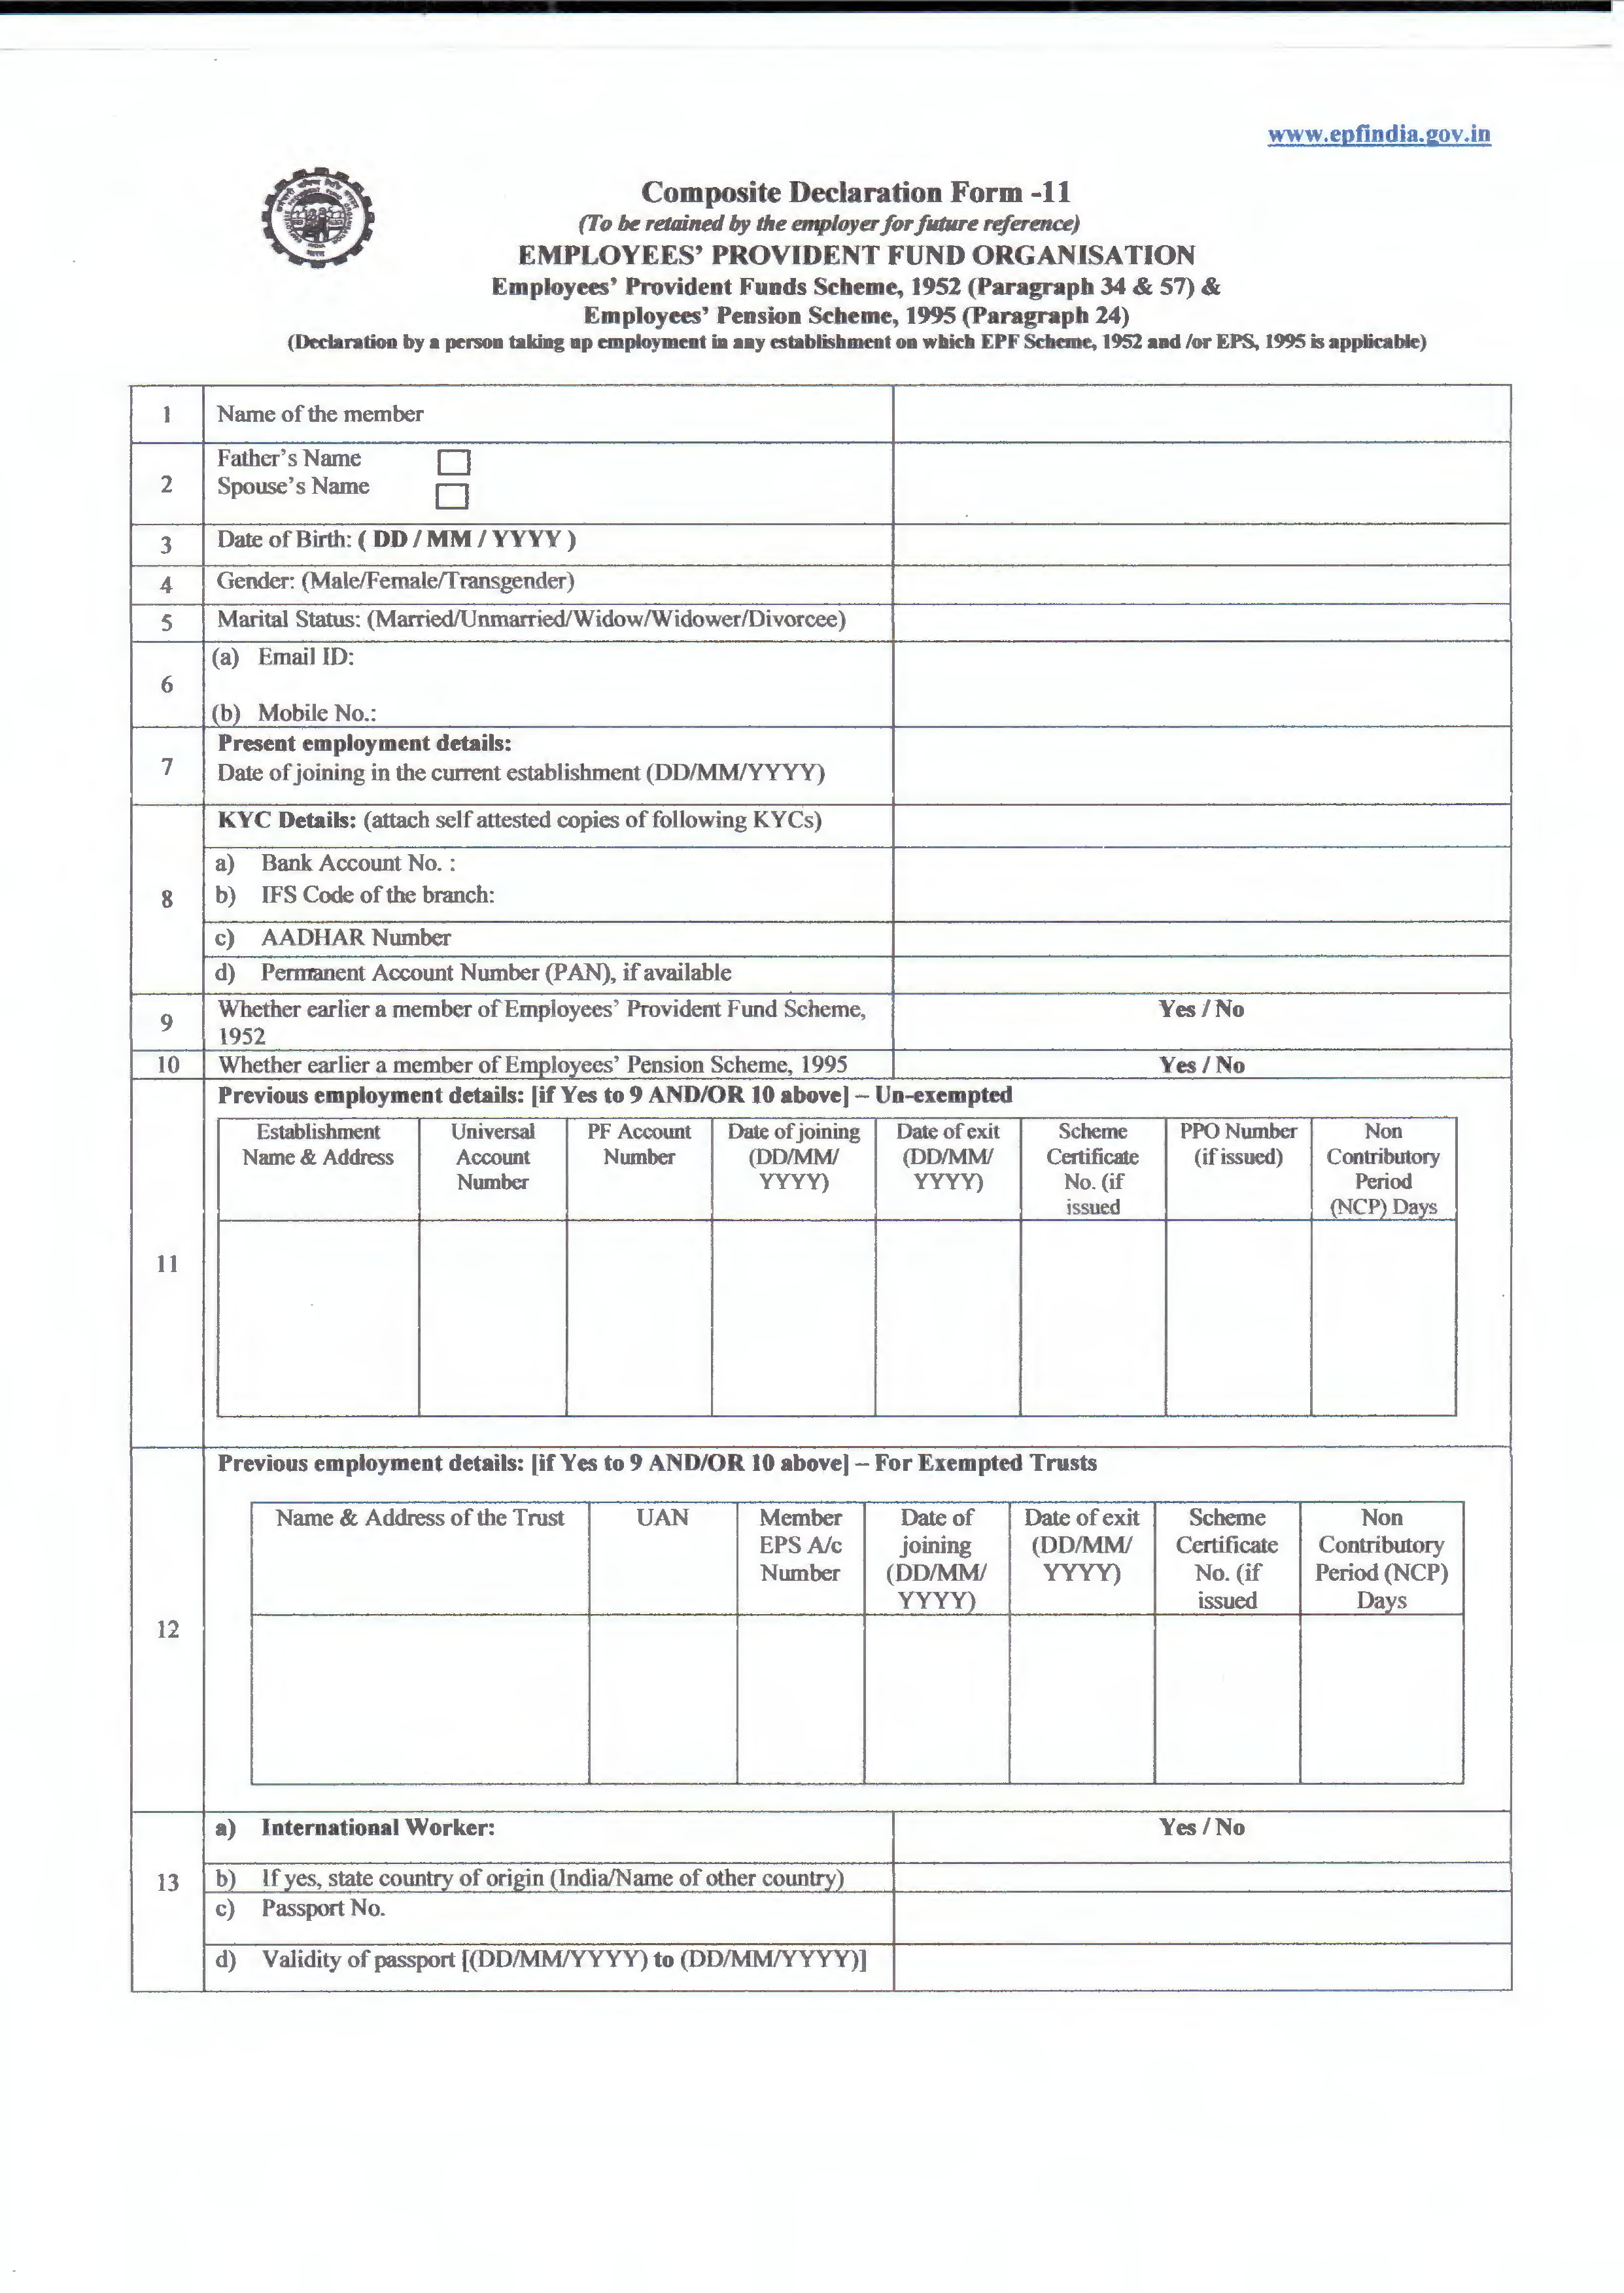



`

to

UNDERTAKING

- Certified that the particulars are hue to the best of my knowledge.
2) I authorize EPFO to use my Aadhar for verification/authentication/e--KYC purpose for service delivery.
- Kindly transfer the funds and service details, if applicable, from the previous PF account as declared above to the present P.F. Account as I am an Aadbar veriited employee in my previous PF Account. •
- In case of changes in above details, the same will be intimated to employer at the earliest.

Date:
Place: Signature of Member

DECLARATION BY PRESENT EMPLOYER

A. The member Mr/Ms/Mrs ·····························································-·····h·a··s··joined on ......................................... and has been

allotted PF No. ·······-·-····································-········.·a···n··d··U··A·N........·-··············································-······································
  - In case the person was earlier not a member of EPF Scheme, 1952 and EPS, 1995:

Please Tick the Appropriate Option:
The KYC details of the above member in the UAN database
D Have not been uploaded
D Have been uploaded but not approved
D Have been uploaded and approved with DSC/e-sign.

  - In case the person was earlier a member of EPF Scheme, 1952 and EPS, 1995:

Please Tick the Appropriate Option: -
0 The KYC details of the above member in the UAN database have been approved with E-sign/Digital Signature Certificate and transfer request has been generated on portal.
D The Previous Account of the member is not Aadhar verified and hence physical transfer form shall be initiated.

Date: Signature of Employer with Seal of
Establishment

• Auto transfer of previous PF account would be possible in respect of Aadbar verified employees only. Other employees are requested to file physical claim (Fonn-13) for transfer of account from the previous establishment.

