## Principles of Uncertainty Analysis

The Guide to the expression of Uncertainty in Measurement (GUM 2008) provides a framework for how to determine and express the uncertainty of the measured value of a given measurand (the quantity which is being measured). The International Vocabulary of Metrology (VIM 2008) defines measurement uncertainty as:

*“a non-negative parameter characterizing the dispersion of the quantity values*

*being attributed to a measurand, based on the information used.”*

The standard uncertainty is the measurement uncertainty expressed as a standard deviation. Please note this is a separate concept to measurement error, which is also defined in the VIM as:

*“the measured quantity value minus a reference quantity value.”*

Generally, the “reference quantity” is considered to be the “true value” of the measurand and is therefore unknown. Figure 2‑1 illustrates these concepts.

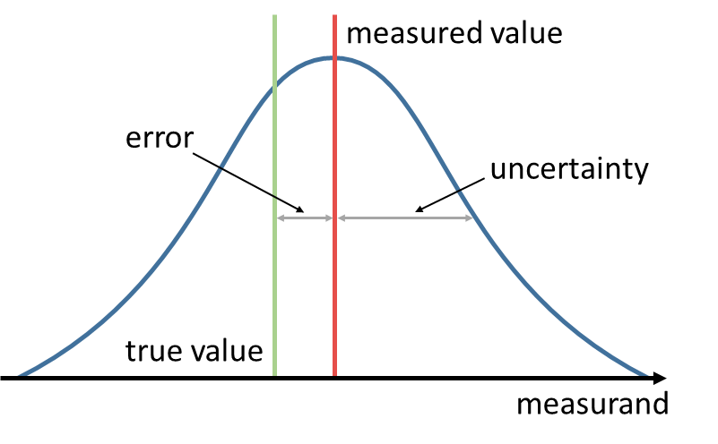

Figure 2‑1 - Diagram illustrating the different concepts of measured value and true value, uncertainty and error.

Within the GUM framework uncertainty analysis begins with understanding the measurement function. The measurement function establishes the mathematical relationship between all known input quantities (e.g. instrument counts) and the measurand itself (e.g. radiance). Generally, this may be written as

$$y=f\left(x_{i},…, x_{N}\right)$$

where:

* $y$ is the measurand;
* $x_{i}$ are the input quantities.

Uncertainty analysis is then performed by considering in turn each of these different input quantities to the measurement function, this process is represented in Figure 2‑2. Each input quantity may be influenced by one or more error effects which are described by an uncertainty distribution. These separate distributions may then be combined to determine the uncertainty of the measurand, $u^{2}(Y)$, using the *Law of Propagation of Uncertainties* (GUM, 2008),

$$u^{2}\left(y\right)=cS\left(x\right)c^{T}$$

where:

* $C$ is the vector of sensitivity coefficients, $∂Y/∂X_{i}$;
* $S(x)$ is the error covariance matrix for the input quantities.



Figure 2‑2 - Conceptual process of uncertainty propagation.

In a series of measurements (for example each pixel in a remote sensing Level 1 (L1) data product) it is vital to consider how the errors between the measurements in the series are correlated. This is crucial when evaluating the uncertainty of a result derived from these data (for example a Level 2 (L2) retrieval of geophysical parameter from a L1 product). In their vocabulary the Horizon 2020 FIDUCEO[1] (Fidelity and uncertainty in climate data records from Earth observations) project (see FIDUCEO Vocabulary, 2018) define three broad categories of error correlation effects important to satellite data products, as follows:

* **Random effects**: *“those causing errors that cannot be corrected for in a single measured value, even in principle, because the effect is stochastic. Random effects for a particular measurement process vary unpredictably from (one set of) measurement(s) to (another set of) measurement(s). These produce random errors which are entirely uncorrelated between measurements (or sets of measurements) and generally are reduced by averaging.”*
* **Structured random effects**: *“means those that across many observations there is a deterministic pattern of errors whose amplitude is stochastically drawn from an underlying probability distribution; “structured random” therefore implies “unpredictable” and “correlated across measurements”…”*
* **Systematic (or common) effects**: *“those for a particular measurement process that do not vary (or vary coherently) from (one set of) measurement(s) to (another set of) measurement(s) and therefore produce systematic errors that cannot be reduced by averaging.”*

1. See: <https://www.fiduceo.eu>