Sakai Grader

Downloading a student assignment
Assignments Grade
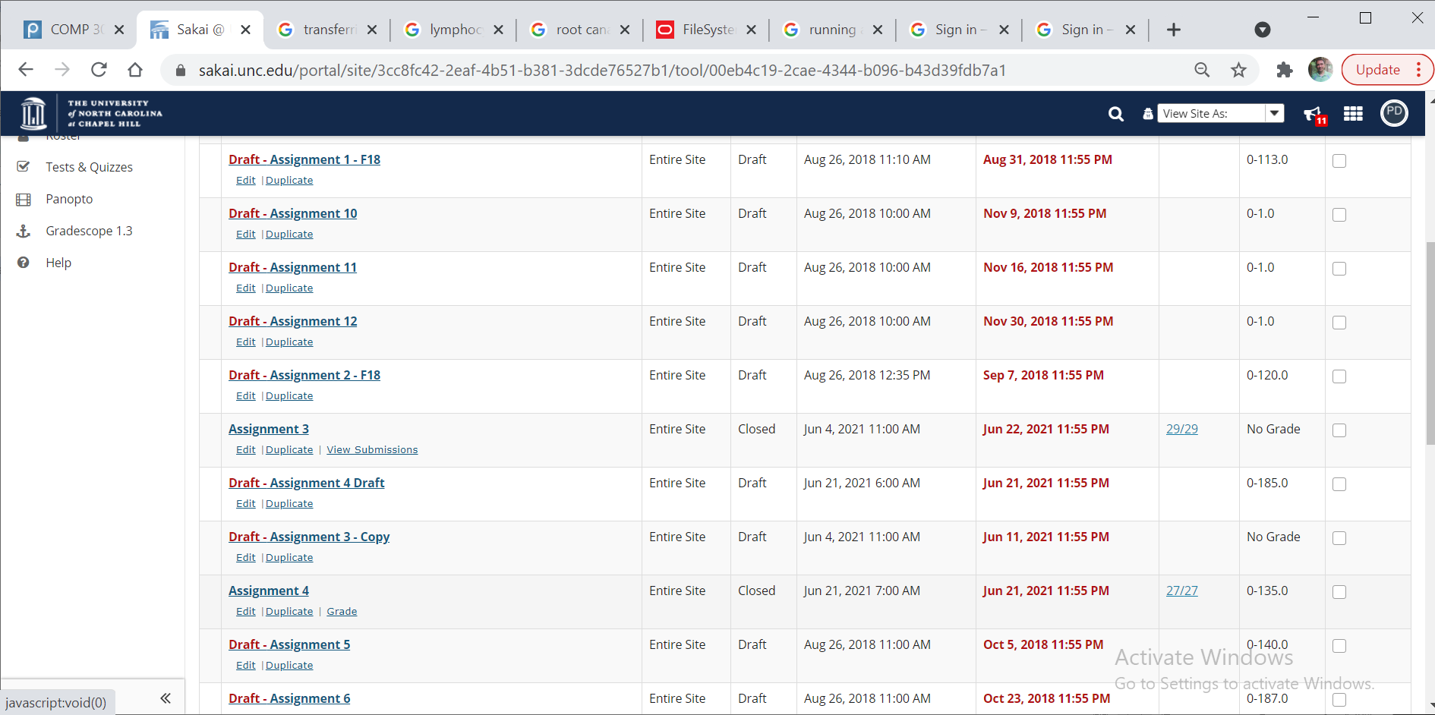

Download all but not student who have not submitted
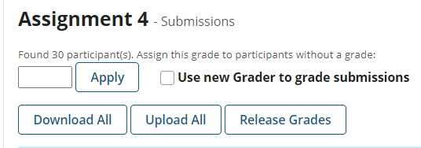
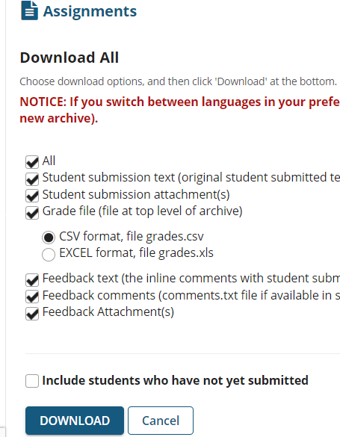

Unzip the project.
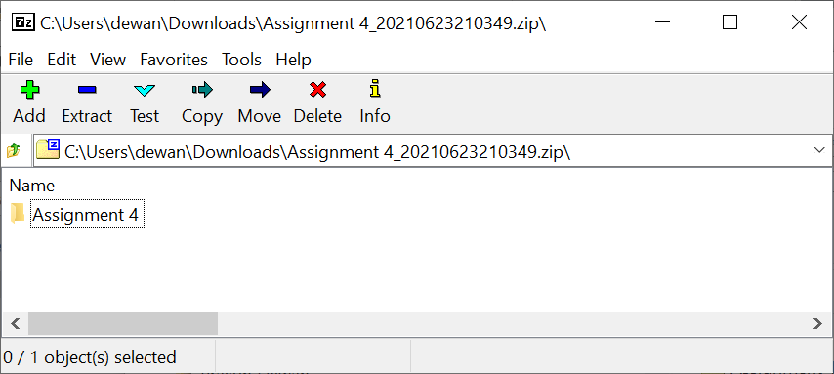

You should have a directory whose same is the same as the assignment. Do not change its name.

This is the structure of a Sakai assignment directory:
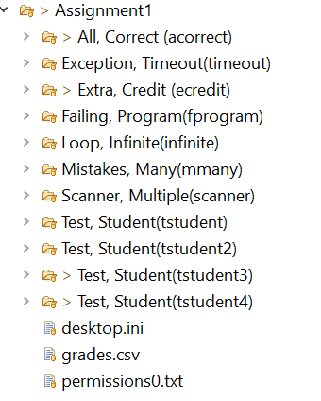
This is a mock directory, each subdirectory corresponds to a student project directory whose name has the format:
LastName, firstName (onyen)
The directory also contains a grades.csv file, which will be the file we upload to Sakai after grading is complete.
It has the format:
Assignment 1 | Points
Display ID | ID | Last Name | First Name | grade
acorrect | acorrect | All | Correct | 63
ecredit | ecredit | Extra | Credit | 49.35
mmany | mmany | Mistakes | Many | 23.1
tstudent | tstudent | Test | Student | 47.25
tstudent2 | tstudent2 | Test | Student2 | 34.65
tstudent3 | tstudent23 | Test | Student3 | 73.5
tstudent4 | tstudent4 | Test | Student4 | 123.9
infinite | infinite | Loop | Infinite | 25
scanner | scanner | Scanner | Multiple | 105
timeout | timeout | Exception | Timeout | 16
fprogram | fprogram | Failing | Program | 132.3
After you grade each student, this file should be updated.
Each student directory has the following structure:
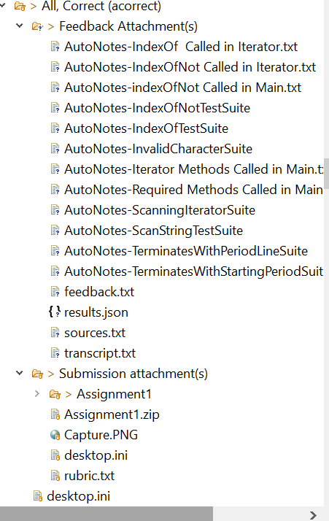
Submission attachments contains what they submitted. Feedback attachment contains what files we generate, including any notes you make. These can be viewed by them.

It is best to store all assignment directories under one parent course directory (e.g. Comp301SS21Assignments).
The course directory should be a child of your grading directory (e.g. ManualGrading).
An example of this directory structure is at:
https://drive.google.com/open?id=1rEsa5uPtH15zhZn-5lkAqbX5PP7Gf9zP&authuser=dewan%40cs.unc.edu&usp=drive_fs

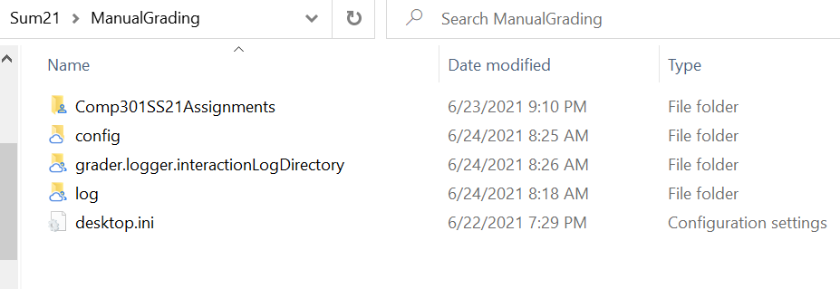
The grader created the log and grader.logger.interactionLogdirectory in the example above. Please do not delete this directories – it has stats we can use later about the effort required per student to grade. The grader also creates the config directory if you do not have one, but copy the one from the shared folder.
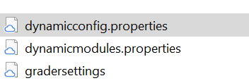
The first file, dynamicconfig.properties, is the important one. The other two files are generated.
Here is a sample file:

#do not change these
saveInteractiveSettings = false
navigationKind = Manual
starterUI = false
maxPrintedTraces = 2000
editor = C:\\Program Files (x86)\\Notepad++\\notepad++.exe
#lower case for module and problem
currentModule = comp301ss21
problem = assignment4
#The main their assignent is supposed to call
entryPoint = main.Assignment4
#The sakai unzipped folder containing student assignents
path = G:\\My Drive\\401-f15\\Comp401TA\\Sum21\\ManualGrading\\Comp301SS21Assignments\\Assignment 4
#The start onyen of onyen range you will be grading, ^ denotes the first onyen
start = ^
#The end onyen of onyen range you will be grading, $denotes the first onyen
end = $
#The src of the local project in which you want to download their code if necessary
testProjectSrc = D:\\TestProject\\src
#course and assignment specific settings with property names preceded with course name
#comp401f18.assignmet4.path = G:\\My Drive\\SakaiDownloads\\comp401\\Fall18\\Assignment 12
#comp401f18.start = ^
#comp401f18.end = $
#comp401f18.navigationKind = Manual
# is the comment starter
Each line sets a property. A line such as:
start = ^
sets a default global property for all courses.
A line such as :
Comp401f18.assignment4.start = alice
Sets a local property for a specific course or assignment, which overrides the default global property.
It may be easiest to deal only with global properties which you will have to change for every assignment.
The start and end properties define the start and end onyens of the onyen range you are grading. ^ and $ indicate the first and last onyen.
If multiple graders are grading the same assignment, then you can put specific onyens for your ranges.
Study the comments carefully to understand the purpose of each line you have to change. Do not change the initial lines, which are not explained.

Time to bring the grader into the picture. The jar file for the grader is Comp524All.jar and is available at: https://drive.google.com/open?id=1UvUUvs7pGanwYe1HqHNm-mdW4QDgtpDg&authuser=dewan%40cs.unc.edu&usp=drive_fs

It would probably be best to run the grader from the command line.
Cd to the grading directory, the one containing config and execute the jar in this directory:
$ pwd
/g/My Drive/401-f15/Comp401TA/Sum21/ManualGrading

dewan@DEWANX380YOGA MINGW64 /g/My Drive/401-f15/Comp401TA/Sum21/ManualGrading
$ java -jar "/g/My Drive/comp301shared/downloads/advanced/Comp524GraderAll.jar"

The grader has to unzip each student project and do a host of other things, and it does it pretty inefficiently, so this operation will take some time.
You will see the following console text:
ments/assignment 4/gopal, maya theresa(mayather)/submission attachment(s)/assignment4
Project folder:G:\My Drive\401-f15\Comp401TA\Sum21\ManualGrading\Comp301SS21Assignments\Assignment 4\Gopal, Maya Theresa(mayather)\Submission attachment(s)\Assignment4
Project folder:G:\My Drive\401-f15\Comp401TA\Sum21\ManualGrading\Comp301SS21Assignments\Assignment 4\Frellick, Reed(reedfrel)\Submission attachment(s)\A4(1)\bin
Project folder:G:\My Drive\401-f15\Comp401TA\Sum21\ManualGrading\Comp301SS21Assignments\Assignment 4\Mandal, Shriya(shriyam)\Submission attachment(s)\A4\A4
Project folder:G:\My Drive\401-f15\Comp401TA\Sum21\ManualGrading\Comp301SS21Assignments\Assignment 4\Wingler, Drayton(wdrayton)\Submission attachment(s)\Assignment4 (2)\Assignment4
Project folder:G:\My Drive\401-f15\Comp401TA\Sum21\ManualGrading\Comp301SS21Assignments\Assignment 4\Alsadoon, Wid(wid)\Submission attachment(s)\A4 (5)\A4
Project folder:G:\My Drive\401-f15\Comp401TA\Sum21\ManualGrading\Comp301SS21Assignments\Assignment 4\Wigger, Alexander(wigalex)\Submission attachment(s)\A4 3\A4
Project folder:G:\My Drive\401-f15\Comp401TA\Sum21\ManualGrading\Comp301SS21Assignments\Assignment 4\Zhang, Xiaoyue(xiaoyue)\Submission attachment(s)\A4\A4
Project folder:G:\My Drive\401-f15\Comp401TA\Sum21\ManualGrading\Comp301SS21Assignments\Assignment 4\Yanaga, Felipe(yanaga)\Submission attachment(s)\A4\A4
Buffer traced messages =true
Calculating credit/penalty for submission at:2021-06-23T18:11:21.000-04:00
Multiplier:2021-06-23T18:11:21.000-04:00
ObjectEditor(Version 22, built on Fri Mar 19 10:20:34 EDT 2021). Copyright Prasun Dewan, 2012, All rights reserved. US Patent Appl. No.: 12/532,327
Grading elapsed time (seconds):16.645
A GUI should finally appear:
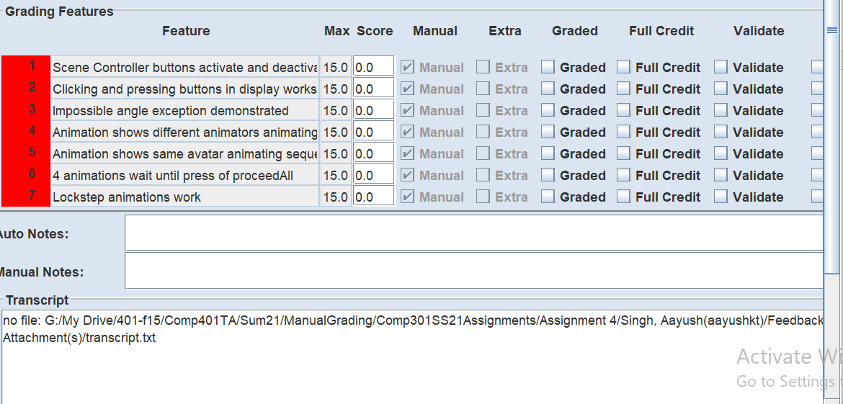

Your job is to turn the scores for the red entries into green ones by editing them.
Full Credit gives them the maximum credit, this is what you will use if their solution has the feature.
Validate says the current score is correct, which should turn red to green. This is what you will use if they do not demo the feature, to say 0 is good.
In either case you do not have to edit the score. You can always enter an intermediate value by editing it.
Checking features require running of the program, for which we need the command panel:
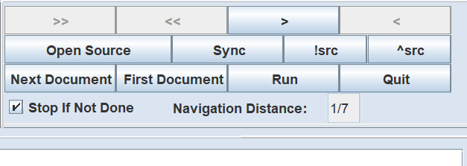
Run should run the program. You can even use the console to provide input to it asks for it.
You can cliclk on !src to download the code to the directory you specified in the configuration file. (It did not work for me I think because the file path was too long). I fthis is the directory of an eclipse prohect, you can now run it through the debugger.
The Stop if not done boolean determined if you can move to the next student until all reds are gone. Setthe checkbox to false if this is a problem.

Once you have filled all scores, or validated a zero score, press > to go to the next directory. This takes time. On the console you should see text saying the grades.csv file has been updated.
You can look at the source without downloading it by viewing the source tab:
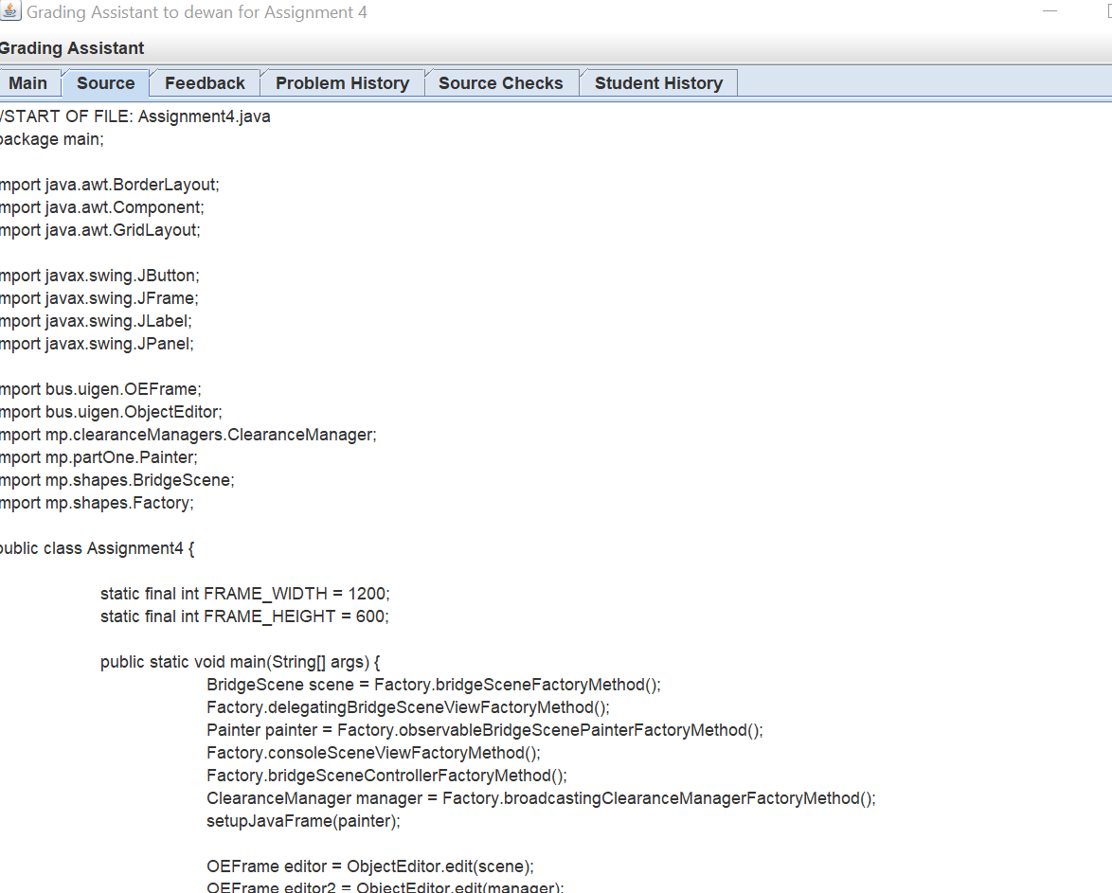
Hit quit to stop the session.

This is it.

